It’s been a while. I hope you are all well. Shall we make some charts?

About this time last year, one of my life-long dreams came true when I was told that I could work from home indefinitely. One effect of this – I won’t say downside – is that I don’t get through as many podcast episodes as I used to. Only a select few podcasts make the cut, and one of those is *99% Invisible*.

I first heard Florence Nightingale and her Geeks Declare War on Death, an episode of the *Cautionary Tales* podcast, premiered as a special episode of *99% Invisible*. It discusses Nightingale’s work as a statistician and in particular, her visualisation of mortality causes in the Crimean War using the famous “rose chart”, or polar area diagram.

The shorter answer: a pretty good approximation of her chart can be achieved like so.

library(tidyverse) library(histData)

Nightingale %>%

select(Date, Month, Year, contains("rate")) %>%

pivot_longer(cols = 4:6, names_to = "Cause", values_to = "Rate") %>% mutate(Cause = gsub(".rate", "", Cause),

period = ifelse(Date <= as.Date("1855-03-01"), "April 1854 to March 1855", "April 1855 to March 1856"),

Month = fct_relevel(Month, "Jul", "Aug", "Sep", "Oct", "Nov", "Dec",

"Jan", "Feb", "Mar", "Apr", "May", "Jun")) %>% ggplot(aes(Month, Rate)) +

geom_col(aes(fill = Cause), width = 1, position = "identity") + coord_polar() +

facet_wrap(~period) +

scale_fill_manual(values = c("skyblue3", "grey30", "firebrick")) + scale_y_sqrt() +

theme_void() +

theme(axis.text.x = element_text(size = 9), strip.text = element_text(size = 11), legend.position = "bottom",

plot.background = element_rect(fill = alpha("cornsilk", 0.5)), plot.margin = unit(c(10, 10, 10, 10), "pt"),

plot.title = element_text(vjust = 5)) +

ggtitle("Diagram of the Causes of Mortality in the Army in the East")

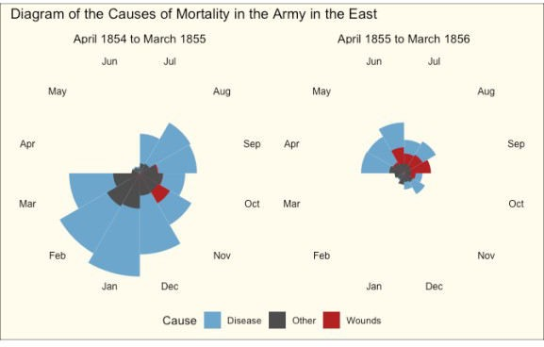

A couple of things to note in the code:

The polar area diagram is just a bar (column) chart, projected onto polar coordinates Relevelling of factors to get the months in the right place (can also be achieved using the *start* argument to coord_polar)

scale_y_sqrt is required to make the smaller wedges visible

position = identity is required to achieve the same relative wedge heights as seen in Nightingale’s original chart