Why is eXtreme Gradient Boosting in R?
Popular in machine learning challenges.
Fast and accurate
Can handle missing values.
Is it requires numeric inputs?
Yes, eXtreme Gradient Boosting requires a numeric matrix for its input.

Load Library
library(xgboost)
library(magrittr)
library(dplyr)
library(Matrix)

Getting Data
data <- read.csv("D:/RStudio/NaiveClassifiaction/binary.csv", header = T)
str(data)
'data.frame': 400 obs. of 4 variables:
$ admit: int 0 1 1 1 0 1 1 0 1 0 ...
$ gre : int 380 660 800 640 520 760 560 400 540 700 ...
$ gpa : num 3.61 3.67 4 3.19 2.93 3 2.98 3.08 3.39 3.92 ...
$ rank : int 3 3 1 4 4 2 1 2 3 2 ...
Data set contains total 400 obsevations and 4 variables. eXtreme Boosting requires numerical variable, so just convert rank data into factor variables.
data$rank <- as.factor(data$rank)

Partition data
Let’s partition the data sets into train data and test data.
set.seed(1234)
ind <- sample(2, nrow(data), replace = T, prob = c(0.8, 0.2))
train <- data[ind==1,]
test <- data[ind==2,]

Matrix Creation
In this case Rank variable is factor variable required hot encoding for the same. Based on hot encoding factor variables convert into dummy variable.
trainm <- sparse.model.matrix(admit ~ .-1, data = train)
head(trainm)
6 x 6 sparse Matrix of class "dgCMatrix"
gre gpa rank1 rank2 rank3 rank4
1 380 3.61 . . 1 .
2 660 3.67 . . 1 .
3 800 4.00 1 . . .
4 640 3.19 . . . 1
6 760 3.00 . 1 . .
7 560 2.98 1 . . .
train_label <- train[,"admit"]
train_matrix <- xgb.DMatrix(data = as.matrix(trainm), label = train_label)
Now we converted train data sets in to necessary format., sameway we need to convert into test data also.
testm <- sparse.model.matrix(admit~.-1, data = test)
test_label <- test[,"admit"]
test_matrix <- xgb.DMatrix(data = as.matrix(testm), label = test_label)

Parameters
nc <- length(unique(train_label))
Basically 2 different classes in the train label datset
xgb_params <- list("objective" = "multi:softprob",
"eval_metric" = "mlogloss",
"num_class" = nc)
watchlist <- list(train = train_matrix, test = test_matrix)
watch list will help us to identify the error in each iteration.

Gradient Boosting in R
bst_model <- xgb.train(params = xgb_params,
data = train_matrix,
nrounds = 1000,
watchlist = watchlist,
eta = 0.001,
max.depth = 3,
gamma = 0,
subsample = 1,
colsample_bytree = 1,
missing = NA,
seed = 333)
##### xgb.Booster
raw: 2.4 Mb
call:
xgb.train(params = xgb_params, data = train_matrix, nrounds = 1000,
watchlist = watchlist, eta = 0.001, max.depth = 3, gamma = 0,
subsample = 1, colsample_bytree = 1, missing = NA, seed = 333)
params (as set within xgb.train):
objective = "multi:softprob", eval_metric = "mlogloss", num_class = "2", eta = "0.001",
ax_depth = "3", gamma = "0", subsample = "1", colsample_bytree = "1", missing = "NA", seed =
333", validate_parameters = "TRUE"
xgb.attributes:
niter
callbacks:
cb.print.evaluation(period = print_every_n)
cb.evaluation.log()
# of features: 6
niter: 1000
nfeatures : 6
evaluation_log:
iter train_mlogloss test_mlogloss
1 0.692889 0.692974
2 0.692631 0.692793
---
999 0.556583 0.625728
1000 0.556514 0.625710

Training & test error plot
e <- data.frame(bst_model$evaluation_log)
plot(e$iter, e$train_mlogloss, col = 'blue')
lines(e$iter, e$test_mlogloss, col = 'red')

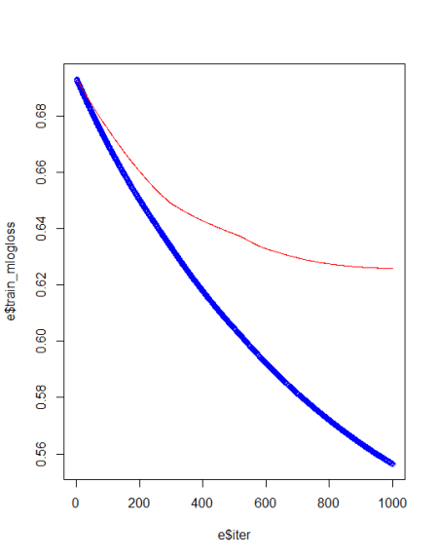

For avoiding overfiiting and best model creation we need to identify best iteration and eta values.
min(e$test_mlogloss)
e[e$test_mlogloss == 0. 613294,]
We can rerun the model based on above values.

Gradient Boosting in R
bst_model <- xgb.train(params = xgb_params,
data = train_matrix,
nrounds = 2,
watchlist = watchlist,
eta = 0.613294,
max.depth = 3,
gamma = 0,
subsample = 1,
colsample_bytree = 1,
missing = NA,
seed = 333)
Feature importance
imp <- xgb.importance(colnames(train_matrix), model = bst_model)
print(imp)
Feature Gain Cover Frequency
1: gpa 0.48632797 0.47722628 0.35714286
2: gre 0.23495920 0.32849509 0.42857143
3: rank1 0.23432569 0.17282919 0.14285714
4: rank2 0.04438714 0.02144944 0.07142857
xgb.plot.importance(imp)

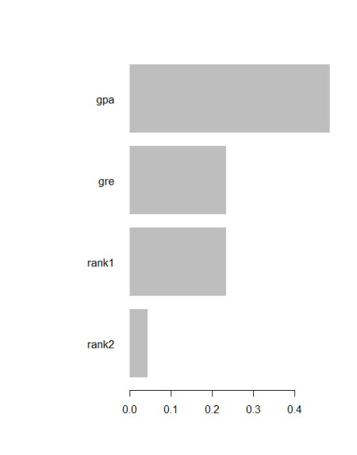

Prediction & confusion matrix
p <- predict(bst_model, newdata = test_matrix)

Pred <- matrix(p, nrow = nc, ncol = length(p)/nc) %>%
t() %>%
data.frame() %>%
mutate(label = test_label, max_prob = max.col(., "last")-1)
X1 X2 label max_prob
1 0.7780407 0.2219593 0 0
2 0.6580867 0.3419133 0 0
3 0.6111851 0.3888150 0 0
4 0.4440117 0.5559883 1 1
5 0.6111851 0.3888150 1 0
6 0.4345139 0.5654861 1 1
7 0.7780407 0.2219593 1 0
8 0.7780407 0.2219593 1 0
9 0.6580867 0.3419133 0 0
10 0.6580867 0.3419133 1 0
11 0.6159363 0.3840637 0 0
12 0.6580867 0.3419133 0 0
13 0.7780407 0.2219593 0 0
14 0.5099485 0.4900515 1 0
15 0.4440117 0.5559883 1 1
16 0.7780407 0.2219593 0 0
17 0.5099485 0.4900515 0 0
18 0.6111851 0.3888150 1 0
19 0.7780407 0.2219593 1 0
20 0.7780407 0.2219593 0 0
21 0.7780407 0.2219593 0 0
22 0.6580867 0.3419133 1 0
23 0.7780407 0.2219593 0 0
24 0.8379621 0.1620379 0 0
25 0.1789861 0.8210139 1 1
26 0.6111851 0.3888150 1 0
27 0.7780407 0.2219593 1 0
28 0.6111851 0.3888150 0 0
29 0.6580867 0.3419133 1 0
30 0.1789861 0.8210139 1 1
31 0.5099485 0.4900515 0 0
32 0.7780407 0.2219593 0 0
33 0.6111851 0.3888150 0 0
34 0.6111851 0.3888150 0 0
35 0.7581326 0.2418674 0 0
36 0.6111851 0.3888150 1 0
37 0.6111851 0.3888150 0 0
38 0.6580867 0.3419133 0 0
39 0.6111851 0.3888150 0 0
40 0.6111851 0.3888150 0 0
41 0.6580867 0.3419133 1 0
42 0.6111851 0.3888150 1 0
43 0.6111851 0.3888150 0 0
44 0.7780407 0.2219593 0 0
45 0.6111851 0.3888150 0 0
46 0.7780407 0.2219593 0 0
47 0.6111851 0.3888150 0 0
48 0.6580867 0.3419133 0 0
49 0.6111851 0.3888150 0 0
50 0.6111851 0.3888150 0 0
51 0.7780407 0.2219593 0 0
52 0.6111851 0.3888150 0 0
53 0.6111851 0.3888150 1 0
54 0.6159363 0.3840637 0 0
55 0.6111851 0.3888150 0 0
........................
75 0.5099485 0.4900515 0 0
0 indicates student not admitted and 1 indicates students admitted in the program.
table(Prediction = pred$max_prob, Actual = pred$label)
Actual
Prediction 0 1
0 49 20
1 1 5

Conclusion
Based on this tutorial you can make use of eXtreme Gradient Boosting machine algorithm applications very easily, in this case model accuracy is around 72%.

