Introduction Data

Basic principles of {ggplot2}

Create plots with {ggplot2}

Scatter plot Line plot

Combination of line and points Histogram

Density plot

Combination of histogram and densities Boxplot

Barplot

Further personalization Labels

Axis ticks

Log transformations Limits

Legend

Shape, color, size and transparency Smooth and regression lines Facets

Themes

Interactive plot with {plotly} Combine plots with {patchwork} Flip coordinates

Save plot

To go further

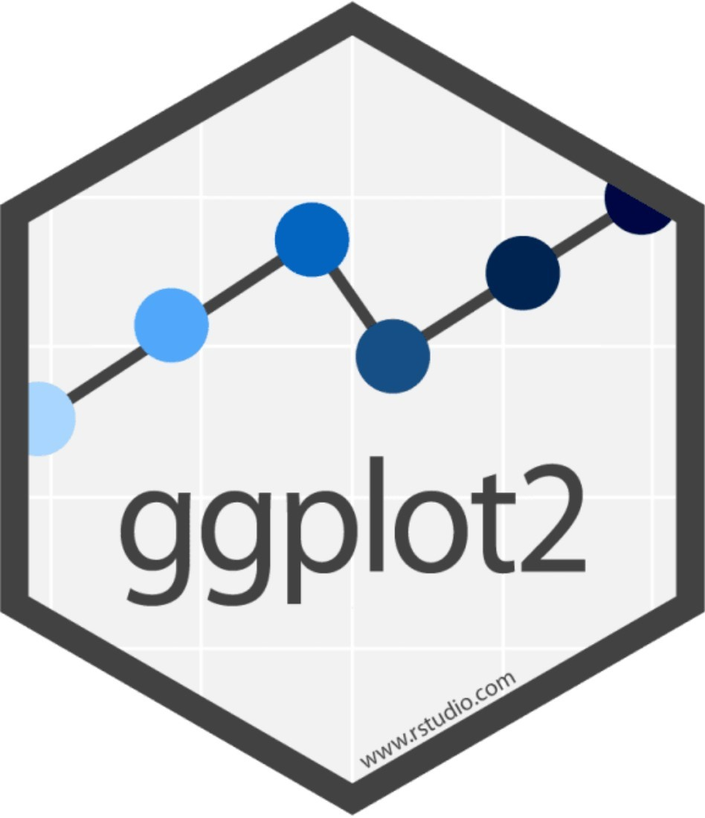

# Introduction

R is known to be a really powerful programming language when it comes to graphics and visualizations (in addition to statistics and data science of course!).

To keep it short, graphics in R can be done in two ways, via the:

1. {graphics} package (the base graphics in R, loaded by default)
2. {ggplot2} package (which needs to be installed and loaded beforehand)

The {graphics} package comes with a large choice of plots (such as plot, hist, barplot, boxplot, pie, mosaicplot, etc.) and additional related features (e.g., abline, lines, legend, mtext, rect, etc.). It is often the preferred way to draw plots for most R users, and in particular for beginners to intermediate users.

Since its creation in 2005 by Hadley Wickham, **{ggplot2}** has grown in use to become one of the most popular R packages and the **most popular package for graphics and data visualizations**. The

{ggplot2} package is a much more modern approach to creating professional-quality graphics. More information about the package can be found at ggplot2.tidyverse.org.

In this article, we will see how to create common plots such as scatter plots, line plots, histograms, boxplots, barplots, density plots in R with this package.

# Data

To illustrate plots with the {ggplot2} package we will use the mpg dataset available in the package. The dataset contains observations collected by the US Environmental Protection Agency on fuel economy from 1999 to 2008 for 38 popular models of cars (run ?mpg for more information about the data):

library(ggplot2) dat <- ggplot2::mpg

Before going further, let’s transform the cyl, drv, fl, year and class variables in factor with the

transform() function:

dat <- transform(dat, cyl = factor(cyl), drv = factor(drv), fl = factor(fl), year = factor(year), class = factor(class)

)

# Basic principles of {ggplot2}

The {ggplot2} package is based on the principles of “The Grammar of Graphics” (hence “gg” in the name of {ggplot2}), that is, a coherent system for describing and building graphs. The main idea is to **design a graphic as a succession of layers**.

The main layers are:

1. The **dataset** that contains the variables that we want to represent. This is done with the ggplot()

function and comes first.

1. The **variable(s)** to represent on the x and/or y-axis, and the aesthetic elements (such as color, size, fill, shape and transparency) of the objects to be represented. This is done with the aes() function (abbreviation of aesthetic).
2. The **type of graphical representation** (scatter plot, line plot, barplot, histogram, boxplot, etc.). This is done with the functions geom_point(), geom_line(), geom_bar(), geom_histogram(), geom_boxplot(), etc.
3. If needed, additional layers (such as labels, annotations, scales, axis ticks, legends, themes, facets, etc.) can be added to personalize the plot.

To create a plot, we thus first need to specify the data in the ggplot() function and then add the required layers such as the variables, the aesthetic elements and the type of plot:

ggplot(data) +

aes(x = var_x, y = var_y) + geom_x()

data in ggplot() is the name of the data frame which contains the variables var_x and var_y. The + symbol is used to indicate the different layers that will be added to the plot. Make sure to write the + *symbol at the end of the line* of code and not at the beginning of the line, otherwise R throws an error.

The layer aes() indicates what variables will be used in the plot and more generally, the aesthetic elements of the plot.

Finally, x in geom_x() represents the type of plot.

Other layers are usually not required unless we want to personalize the plot further. Note that it is a good practice to write one line of code per layer to improve code readability.

# Create plots with {ggplot2}

In the following sections we will show how to draw the following plots:

scatter plot line plot histogram density plot boxplot barplot

In order to focus on the construction of the different plots and the use of {ggplot2}, we will restrict ourselves to drawing basic (yet beautiful) plots without unnecessary layers. For the sake of completeness, we will briefly discuss and illustrate different layers to further personalize a plot at the end of the article

Note that if you still struggle to create plots with {ggplot2} after reading this tutorial, you may find the

{esquisse} addin useful. This addin allows you to **interactively** (that is, by dragging and dropping variables) create plots with the {ggplot2} package. Give it a try!

## Scatter plot

We start by creating a scatter plot using geom_point. Remember that a scatter plot is used to visualize the relation between two quantitative variables.

1. We start by specifying the data:

ggplot(dat) # data





1. Then we add the variables to be represented with the aes() function:

ggplot(dat) + # data

aes(x = displ, y = hwy) # variables

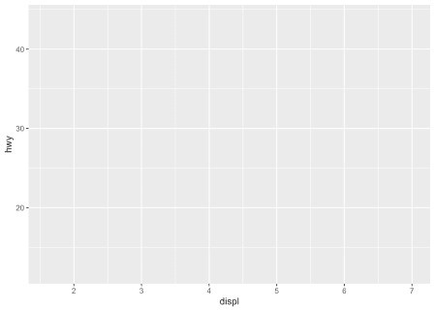

1. Finally, we indicate the type of plot:

ggplot(dat) + # data

aes(x = displ, y = hwy) + # variables geom_point() # type of plot

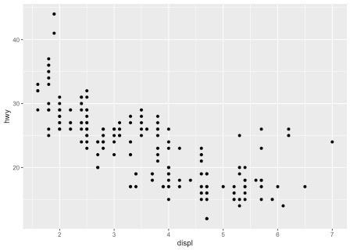

You will also sometimes see the aesthetic elements (aes() with the variables) inside the ggplot() function in addition to the dataset:

ggplot(mpg, aes(x = displ, y = hwy)) + geom_point()

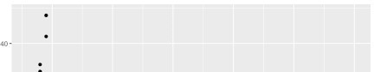

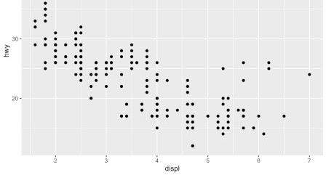

This second method gives the exact same plot than the first method. I tend to prefer the first method over the second for better readability, but this is more a matter of taste so the choice is up to you.

## Line plot

Line plots, particularly useful in time series or finance, can be created similarly but by using geom_line(): ggplot(dat) +

aes(x = displ, y = hwy) + geom_line()

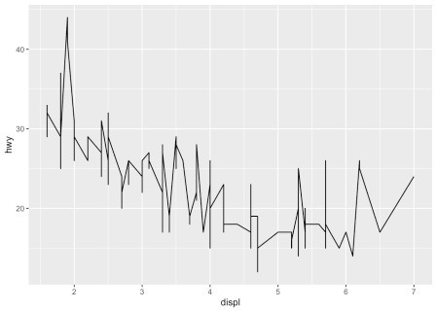

## Combination of line and points

An advantage of {ggplot2} is the ability to combine several types of plots and its flexibility in designing it. For instance, we can add a line to a scatter plot by simply adding a layer to the initial scatter plot:

ggplot(dat) +

aes(x = displ, y = hwy) + geom_point() + geom_line() # add line

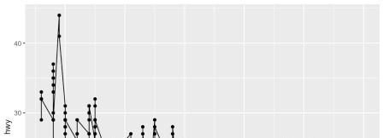

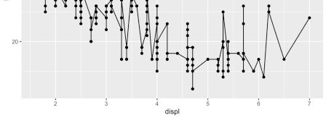

## Histogram

A histogram (useful to visualize distributions) can be plotted using geom_histogram(): ggplot(dat) +

aes(x = hwy) + geom_histogram()

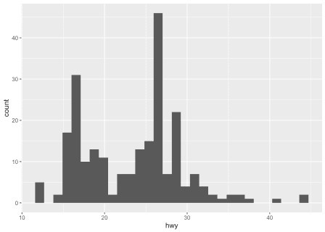

By default, the number of bins is equal to 30. You can change this value using the bins argument inside the

geom_histogram() function:

ggplot(dat) + aes(x = hwy) +

geom_histogram(bins = sqrt(nrow(dat)))

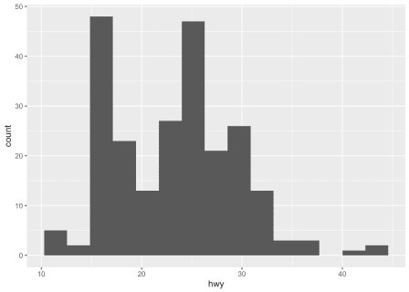

Here I specify the number of bins to be equal to the square root of the number of observations (following Sturge’s rule) but you can specify any numeric value.

## Density plot

Density plots can be created using geom_density(): ggplot(dat) +

aes(x = hwy) + geom_density()

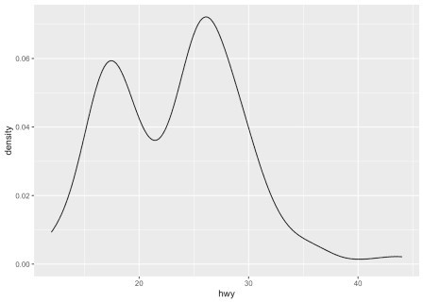

## Combination of histogram and densities

We can also superimpose a histogram and a density curve on the same plot:

ggplot(dat) +

aes(x = hwy, y = ..density..) + geom_histogram() + geom_density()

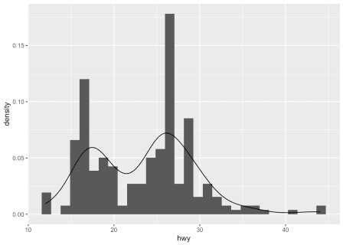

Or superimpose several densities:

ggplot(dat) +

aes(x = hwy, color = drv, fill = drv) + geom_density(alpha = 0.25) # add transparency

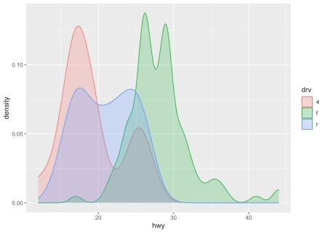

The argument alpha = 0.25 has been added for some transparency.

## Boxplot

A boxplot (also very useful to visualize distributions) can be plotted using geom_boxplot(): # Boxplot for one variable

ggplot(dat) +

aes(x = "", y = hwy) + geom_boxplot()

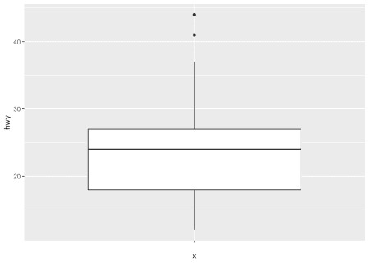

# Boxplot by factor ggplot(dat) +

aes(x = drv, y = hwy) + geom_boxplot()

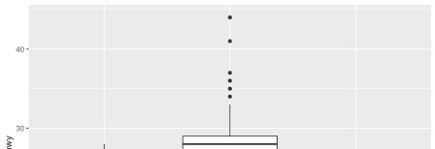

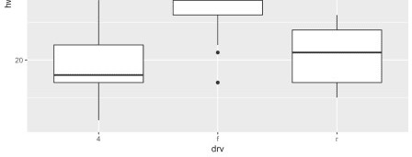

It is also possible to plot the points on the boxplot with geom_jitter(), and to vary the width of the boxes according to the size (i.e., the number of observations) of each level with varwidth = TRUE:

ggplot(dat) +

aes(x = drv, y = hwy) +

geom_boxplot(varwidth = TRUE) + # vary boxes width according to n obs. geom_jitter(alpha = 0.25, width = 0.2) # adds random noise and limit its width

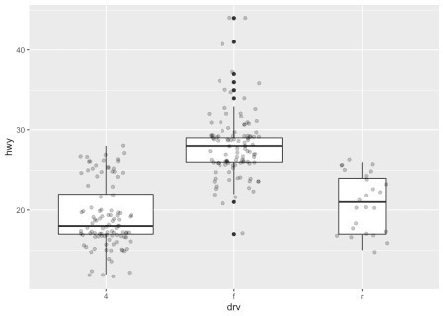

The geom_jitter() layer adds some random variation to each point in order to prevent them from overlapping (an issue known as overplotting).1 Moreover, the alpha argument adds some transparency to the points to keep the focus on the boxes and not on the points.

Finally, it is also possible to divide boxplots into several panels according to the levels of a qualitative variable:

ggplot(dat) +

aes(x = drv, y = hwy) +

geom_boxplot(varwidth = TRUE) + # vary boxes width according to n obs. geom_jitter(alpha = 0.25, width = 0.2) + # adds random noise and limit its

width

facet_wrap(~year) # divide into 2 panels

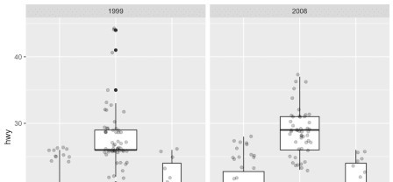

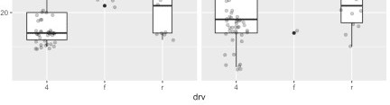

For a visually more appealing plot, it is also possible to use some colors for the boxes depending on the x variable:

ggplot(dat) +

aes(x = drv, y = hwy, fill = drv) + # add color to boxes with fill geom_boxplot(varwidth = TRUE) + # vary boxes width according to n obs. geom_jitter(alpha = 0.25, width = 0.2) + # adds random noise and limit its

width

facet_wrap(~year) + # divide into 2 panels theme(legend.position = "none") # remove legend

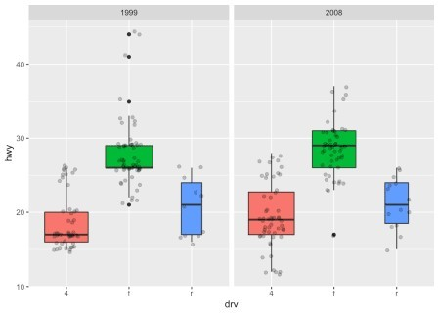

In that case, it best to remove the legend as it becomes redundant.

## Barplot

A barplot (useful to visualize qualitative variables) can be plotted using geom_bar(): ggplot(dat) +

aes(x = drv) + geom_bar()

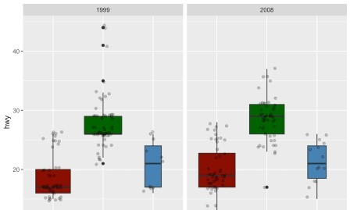



By default, the heights of the bars correspond to the observed frequencies for each level of the variable of interest (drv in our case).

Again, for a more appealing plot, we can add some colors to the bars with the fill argument:

ggplot(dat) +

aes(x = drv, fill = drv) + # add colors to bars geom_bar() +

theme(legend.position = "none") # remove legend

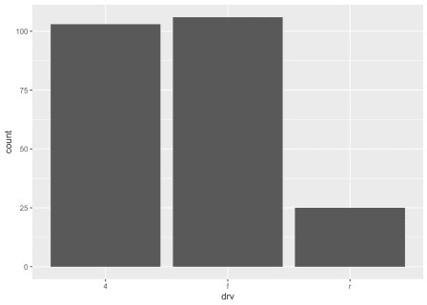

We can also create a barplot with two qualitative variables:

ggplot(dat) +

aes(x = drv, fill = year) + # fill by years geom_bar()

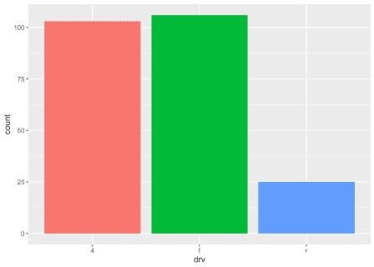

In order to compare proportions across groups, it is best to make each bar the same height using position

= "fill":

ggplot(dat) +

geom_bar(aes(x = drv, fill = year), position = "fill")



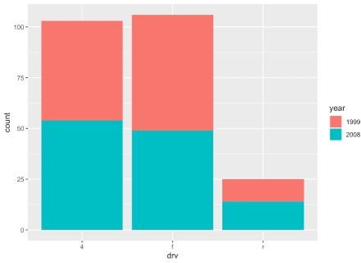

To draw the bars next to each other for each group, use position = "dodge":

ggplot(dat) +

geom_bar(aes(x = drv, fill = year), position = "dodge")

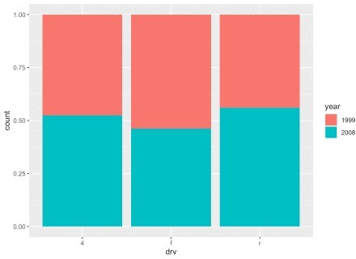

## Further personalization

### Labels

The first things to personalize in a plot is the labels to make the plot more informative to the audience. We can easily add a title, subtitle, caption and edit axis titles with the labs() function:

p <- ggplot(dat) +

aes(x = displ, y = hwy) + geom_point()

p + labs(

title = "Fuel efficiency for 38 popular models of car", subtitle = "Period 1999-2008",

caption = "Data: ggplot2::mpg. ", x = "Engine displacement (litres)",

y = "Highway miles per gallon (mpg)"

)



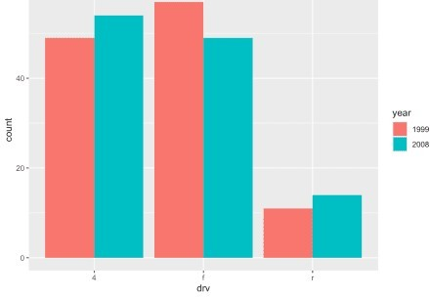

As you can see in the above code, you can save one or more layers of the plot in an object for later use. This way, you can save your “main” plot, and add more layers of personalization until you get the desired output. Here we saved the main scatter plot in an object called p and we will refer to it for the subsequent personalizations.

### Axis ticks

Axis ticks can be adjusted using scale_x_continuous() and scale_y_continuous() for the x and y-axis, respectively:

# Adjust ticks

p + scale_x_continuous(breaks = seq(from = 1, to = 7, by = 0.5)) + # x-axis scale_y_continuous(breaks = seq(from = 10, to = 45, by = 5)) # y-axis

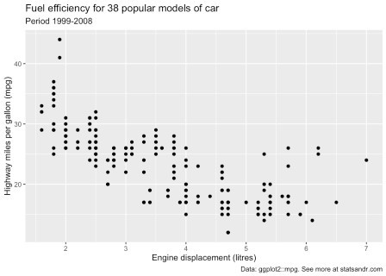

### Log transformations

In some cases, it is useful to plot the log transformation of the variables. This can be done with the

scale_x_log10() and scale_y_log10() functions:

p + scale_x_log10() + scale_y_log10()

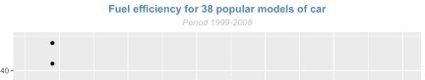

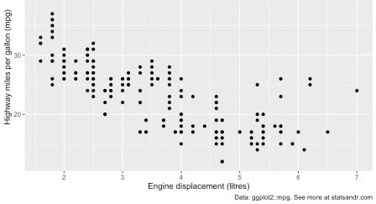

### Limits

The most convenient way to control the limits of the plot is to use again the scale_x_continuous() and

scale_y_continuous() functions in addition to the limits argument:

p + scale_x_continuous(limits = c(3, 6)) + scale_y_continuous(limits = c(20, 30))

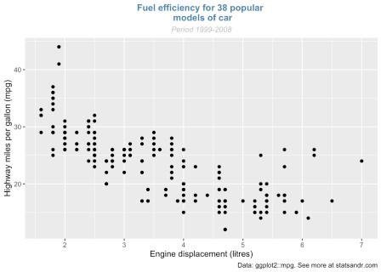

It is also possible to simply take a subset of the dataset with the subset() or filter() function.

### Legend

By default, the legend is located to the right side of the plot (when there is a legend to be displayed of course). To control the position of the legend, we need to use the theme() function in addition to the legend.position argument:

p + aes(color = class) + theme(legend.position = "top")

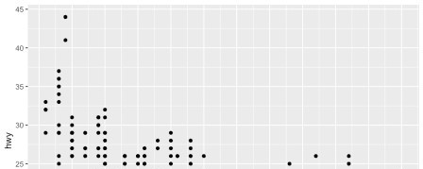

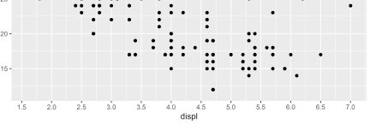

Replace "top" by "left" or "bottom" to change its position and by "none" to remove it. The title of the legend can be removed with legend.title = element_blank():

p + aes(color = class) + theme(

legend.title = element_blank(), legend.position = "bottom"

)

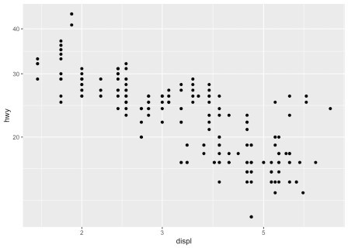

The legend now appears at the bottom of the plot, without the legend title.

### Shape, color, size and transparency

There are a very large number of options to improve the quality of the plot or to add additional information. These include:

shape, size, color, and

alpha (transparency).

We can for instance change the shape of all points in a scatter plot by adding shape to geom_point(), or vary the shape according to the values taken by another variable (in that case, the shape argument must be inside aes()):2

# Change shape of all points ggplot(dat) +

aes(x = displ, y = hwy) + geom_point(shape = 4)

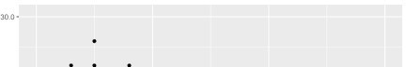

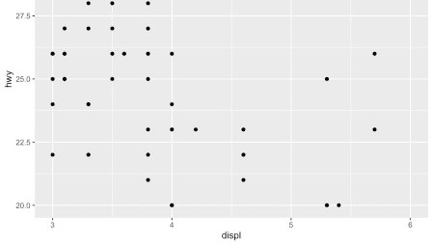

# Change shape of points based on a categorical variable ggplot(dat) +

aes(x = displ, y = hwy, shape = drv) + geom_point()

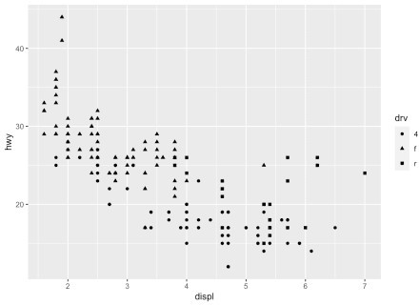

Following the same principle, we can modify the color, size and transparency of the points based on a qualitative or quantitative variable. Here are some examples:

p <- ggplot(dat) +

aes(x = displ, y = hwy) + geom_point()

# Change color for all points

p + geom_point(color = "steelblue")

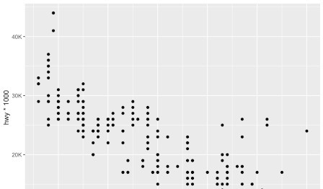



# Change color based on a qualitative variable p + aes(color = drv)



# Change color based on a quantitative variable p + aes(color = cty)

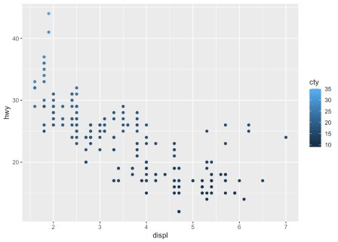

# Change color based on a criterion (median of cty variable) p + aes(color = cty > median(cty))

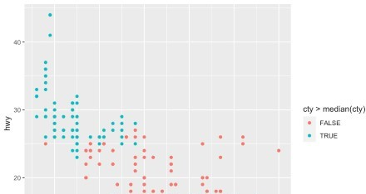

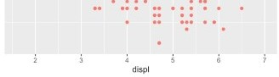

# Change size of all points p + geom_point(size = 4)

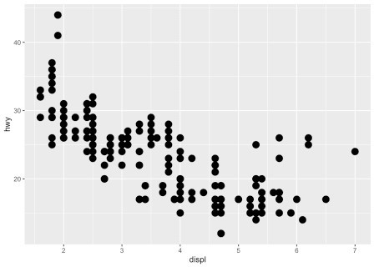

# Change size of points based on a quantitative variable p + aes(size = cty)

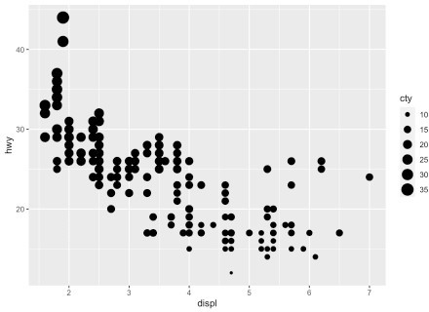

# Change transparency based on a quantitative variable p + aes(alpha = cty)

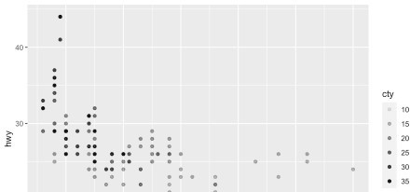

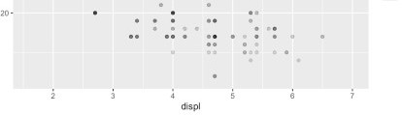

We can of course mix several options (shape, color, size, alpha) to build more complex graphics:

p + geom_point(size = 0.5) +

aes(color = drv, shape = year, alpha = cty)

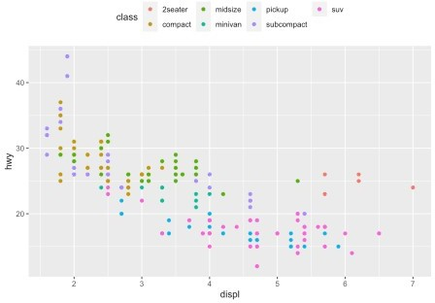

### Smooth and regression lines

In a scatter plot, it is possible to add a smooth line fitted to the data:

p + geom_smooth()

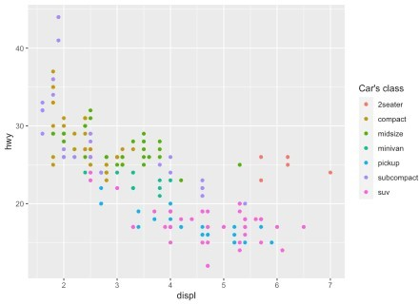

In the context of simple linear regression, it is often the case that the regression line is displayed on the plot. This can be done by adding method = lm (lm stands for linear model) in the geom_smooth() layer:

p + geom_smooth(method = lm)



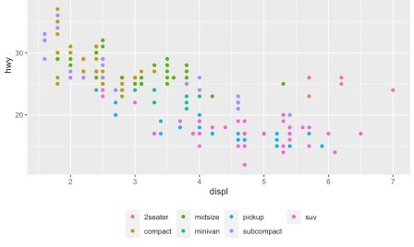

It is also possible to draw a regression line for each level of a categorical variable:

p + aes(color = drv, shape = drv) + geom_smooth(method = lm, se = FALSE)

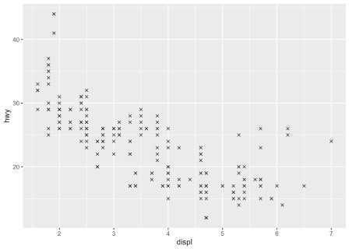

The se = FALSE argument removes the confidence interval around the regression lines.

### Facets

facet_grid allows you to divide the same graphic into several panels according to the values of one or two qualitative variables:

# According to one variable p + facet_grid(. ~ drv)

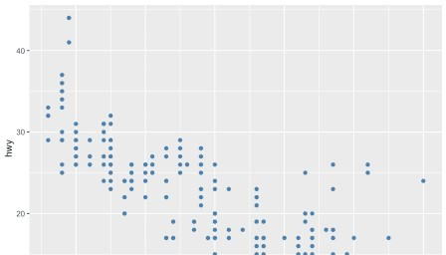

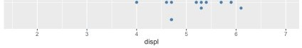

# According to 2 variables p + facet_grid(drv ~ year)

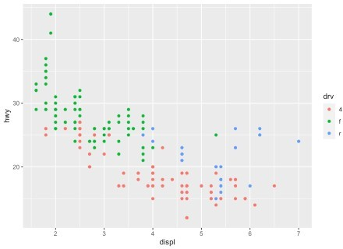

It is then possible to add a regression line to each facet:

p + facet_grid(. ~ drv) + geom_smooth(method = lm)

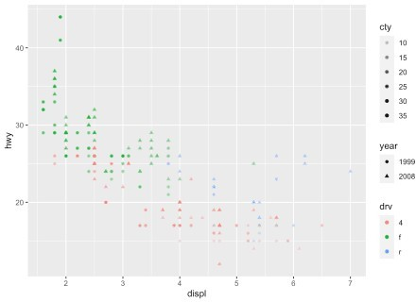

facet_wrap() can also be used

### Themes

Several functions are available in the {ggplot2} package to change the theme of the plot. The most common themes after the default theme (i.e., theme_gray()) are the black and white (theme_bw()), minimal (theme_minimal()) and classic (theme_classic()) themes:

# Black and white theme p + theme_bw()



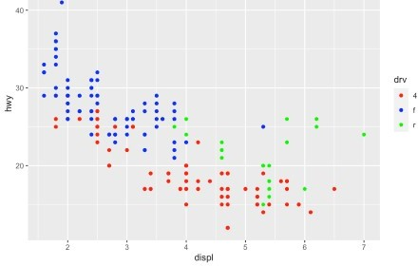

# Minimal theme

p + theme_minimal()

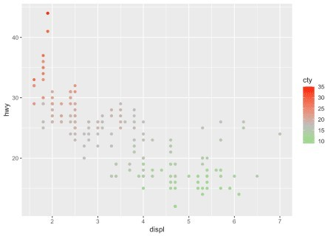

# Classic theme

p + theme_classic()

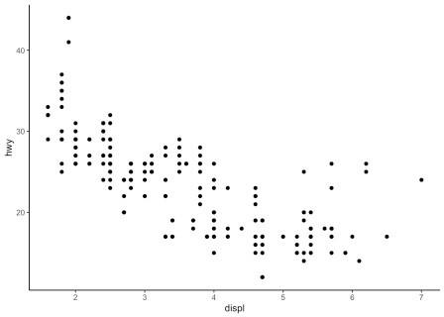

I tend to use the minimal theme for most of my R Markdown reports as it brings out the patterns and points and not the layout of the plot, but again this is a matter of personal taste. See more themes at ggplot2.tidyverse.org/reference/ggtheme.html and in the {ggthemes} package.

In order to avoid having to change the theme for each plot you create, you can change the theme for the current R session using the theme_set() function as follows:

theme_set(theme_minimal())

### Interactive plot with {plotly}

You can easily make your plots created with {ggplot2} interactive with the {plotly} package:

library(plotly)

ggplotly(p + aes(color = year))

You can now hover over a point to display more information about that point. There is also the possibility to zoom in and out, to download the plot, to select some observations, etc.

### Combine plots with {patchwork}

There are several ways to combine plots made in {ggplot2}. In my opinion, the most convenient way is with the {patchwork} package using symbols such as +, / and parentheses.

We first need to create some plots and save them:

p_a <- ggplot(dat) +

aes(x = displ, y = hwy) + geom_point()

p_b <- ggplot(dat) + aes(x = hwy) + geom_histogram()

p_c <- ggplot(dat) + aes(x = drv, y = hwy) + geom_boxplot()

Now that we have 3 plots saved in our environment, we can combine them. To have plots **next to each other** simply use the + symbol:

library(patchwork) p_a + p_b + p_c

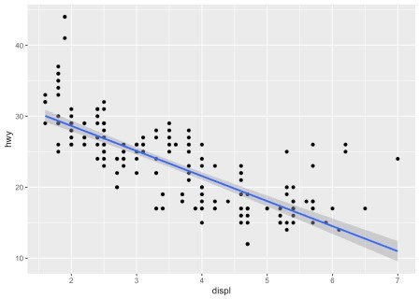

To display them **above each other** simply use the / symbol:

p_a / p_b / p_c

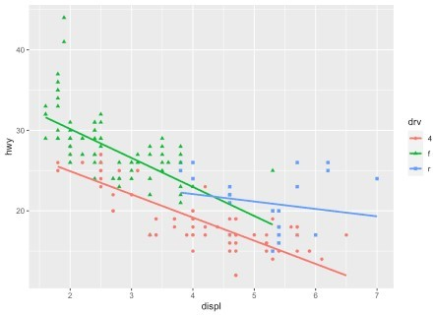

And finally, to combine them **above and next** to each other, mix +, / and parentheses:

p_a + p_b / p_c

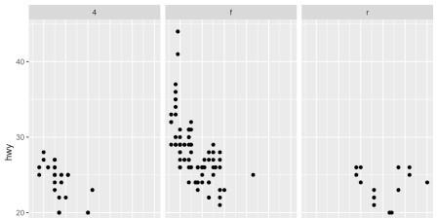

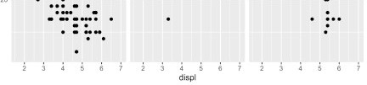

(p_a + p_b) / p_c

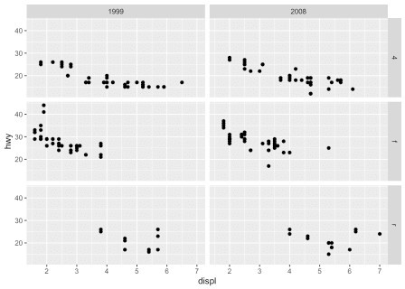

### Flip coordinates

Flipping coordinates of your plot is useful to create horizontal boxplots, or when labels of a variable are so long that they overlap each other on the x-axis. See with and without flipping coordinates below:

# without flipping coordinates p1 <- ggplot(dat) +

aes(x = class, y = hwy) + geom_boxplot()

# with flipping coordinates p2 <- ggplot(dat) +

aes(x = class, y = hwy) + geom_boxplot() + coord_flip()

library(patchwork)

p1 + p2 # left: without flipping, right: with flipping

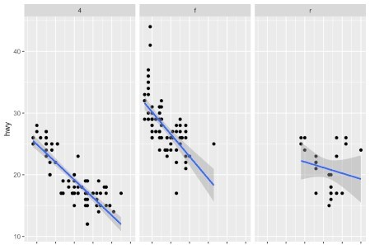



This can be done with many types of plot, not only with boxplots. For instance, if a categorical variable has many levels or the labels are long, it is usually best to flip the coordinates for a better visual:

ggplot(dat) + aes(x = class) + geom_bar() + coord_flip()

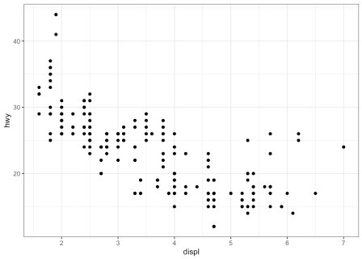

### Save plot

The ggsave() function will save the most recent plot in your current working directory unless you specify a path to another folder:

ggplot(dat) +

aes(x = displ, y = hwy) + geom_point()

ggsave("plot1.pdf")