Handling missing values in R, one of the common tasks in data analysis is handling missing values.

In R, missing values are often represented by the symbol NA (not available) or some other value that represents missing values (i.e. 99).

Impossible values (e.g., dividing by zero) are represented by the symbol NaN (not a number)

**Handling missing values in R**

You can test the missing values based on the below command in R

y <- c(1,2,3,NA)

[is.na](http://is.na)(y) # returns a vector (F F F T)

This function you can use for vector as well as data frame also.

To identify the location of NAs in a vector, you can use **which** command.

which([is.na](http://is.na)(y))

In the case of data frame, sum function will be handy

sum([is.na](http://is.na)(df))

df indicates the data frame

the function will return a total number of NA values.

In the case of data frames with multiple columns, a convenient shortcut method is colSum.

colSums([is.na](http://is.na)(df))

the summary function also can be used for finding missing values in data frames.

Suppose if you are calculating the average value then na.rm will be very useful.

x[[is.na](http://is.na)(x)] <- mean(x, na.rm = TRUE)

Sometimes values are stored as 99 that you can convert into NA using the following command.

df$v1[df$v1==99] <- NA

one of the common methods is na.omit.

The function na.omit() returns the object with listwise deletion of missing values

This function create new dataset without missing data

newdata <- na.omit(df)

Another traditional way of handling missing value is based on complele.cases.

The function complete.cases() returns a logical vector indicating which cases are complete.

This will list rows of data that have missing values

df[!complete.cases(df),]

subset with complete.cases to get complete cases

df[complete.cases(df), ]

Deleting rows containing missing values, lead to a reduction in sample size and avoid some good representative values also.

Delete Missing Data leads to the following major issues

* Data loss
* Bias data

Above mentioned methods are not handy in some cases, one of the commonly used method is to replace NA values based on average. In some cases this will be erroneous.

Imagine supposing if we have vehicle failure data with the following details

|  |  |  |
| --- | --- | --- |
| Vehicle | Month | Distance Travelled |
| 1 | 35 | 20000 |
| 2 | 24 | 18000 |
| 3 | 1 | NA |
| 4 | 12 | 6000 |

Handling missing values in R

In the above data if we are replacing NA values with 14666 (ie. average value) will be erroneous because just a one-month-old vehicle traveled this much distance is unlikely.

Now here we are going to discuss, how to deal with this kind of issue smartly!

**Load Libraries**

library(mice)

library(VIM)

**Getting Data**

data <- read.csv("D:/RStudio/MissingDataAnalysis/VehicleData.csv", header = T)

str(data)

'data.frame': 1624 obs. of  7 variables:

 $ vehicle: int  1 2 3 4 5 6 7 8 9 10 ...

 $ fm     : int  0 10 15 0 13 21 11 5 8 1 ...

 $ Mileage: int  863 4644 16330 13 22537 40931 34762 11051 7003 11 ...

 $ lh     : num  1.1 2.4 4.2 1 4.5 3.1 0.7 2.9 3.4 0.7 ...

 $ lc     : num  66.3 233 325.1 66.6 328.7 ...

 $ mc     : num  697 120 175 0 175 ...

 $ State  : chr  "MS" "CA" "WI" "OR" ...

In this dataset contains 1624 observations and 7 variables. You can access data set from [here](https://github.com/finnstats/finnstats/blob/main/VehicleData.csv).

summary(data)

vehicle             fm            Mileage            lh               lc               mc            State

Min.   :   1.0   Min.   :-1.000   Min.   :    1   Min.   : 0.000   Min.   :   0.0   Min.   :   0.0   Length:1624

1st Qu.: 406.8   1st Qu.: 4.000   1st Qu.: 5778   1st Qu.: 1.500   1st Qu.: 106.5   1st Qu.: 119.7   Class :character

Median : 812.5   Median :10.000   Median :17000   Median : 2.600   Median : 195.4   Median : 119.7   Mode  :character

Mean   : 812.5   Mean   : 9.414   Mean   :20559   Mean   : 3.294   Mean   : 242.8   Mean   : 179.4

3rd Qu.:1218.2   3rd Qu.:14.000   3rd Qu.:30061   3rd Qu.: 4.300   3rd Qu.: 317.8   3rd Qu.: 175.5

Max.   :1624.0   Max.   :23.000   Max.   :99983   Max.   :35.200   Max.   :3234.4   Max.   :3891.1

NA's   :13      NA's   :6        NA's   :8

Based on summary function as mentioned earlier we can find out the details of column contains missing values.

**Missing data**

Now we need to calculate what percentage of data is missing from each variable.

p <- function(x) {sum([is.na](http://is.na)(x))/length(x)*100}

apply(data, 2, p)

vehicle        fm   Mileage        lh        lc        mc     State

0.0     0.0000000 0.8004926 0.3694581 0.4926108 0.0000000 0.9236453

Vehicle, fm and mc contains no missing values, lh contains 0.36%, lc contains 0.49%, Mileage contains 0.80% and maximum missing in state column with 0.92%

md.pattern(data)

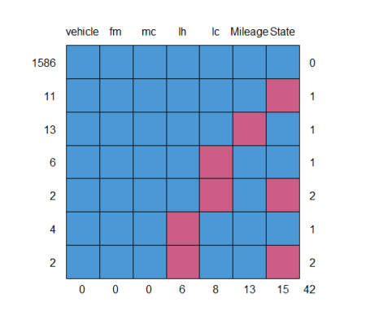

vehicle fm mc lh lc Mileage State

1586       1  1  1  1  1       1     1  0

11         1  1  1  1  1       1     0  1

13         1  1  1  1  1       0     1  1

6          1  1  1  1  0       1     1  1

2          1  1  1  1  0       1     0  2

4          1  1  1  0  1       1     1  1

2          1  1  1  0  1       1     0  2

           0  0  0  6  8      13    15 42

zero indicates missing values, for example column ‘state’ contains 11 rows with one missing values.

Similarly, 13 rows mileage values are missing.

md.pairs(data)

$rr

        vehicle   fm Mileage   lh   lc   mc State

vehicle    1624 1624    1611 1618 1616 1624  1609

fm         1624 1624    1611 1618 1616 1624  1609

Mileage    1611 1611    1611 1605 1603 1611  1596

lh         1618 1618    1605 1618 1610 1618  1605

lc         1616 1616    1603 1610 1616 1616  1603

mc         1624 1624    1611 1618 1616 1624  1609

State      1609 1609    1596 1605 1603 1609  1609

$rm

        vehicle fm Mileage lh lc mc State

vehicle       0  0      13  6  8  0    15

fm            0  0      13  6  8  0    15

Mileage       0  0       0  6  8  0    15

lh            0  0      13  0  8  0    13

lc            0  0      13  6  0  0    13

mc            0  0      13  6  8  0    15

State         0  0      13  4  6  0     0

$mr

        vehicle fm Mileage lh lc mc State

vehicle       0  0       0  0  0  0     0

fm            0  0       0  0  0  0     0

Mileage      13 13       0 13 13 13    13

lh            6  6       6  0  6  6     4

c            8  8       8  8  0  8     6

mc            0  0       0  0  0  0     0

State        15 15      15 13 13 15     0

$mm

        vehicle fm Mileage lh lc mc State

vehicle       0  0       0  0  0  0     0

fm            0  0       0  0  0  0     0

Mileage       0  0      13  0  0  0     0

lh            0  0       0  6  0  0     2

lc            0  0       0  0  8  0     2

mc            0  0       0  0  0  0     0

State         0  0       0  2  2  0    15

rr indicates how many data points are observed

rm indicates Observed and Missing

mr indicates Mossing versus observed

mm indicates Missing versus Missing

marginplot(data[,c('Mileage', 'lc')])

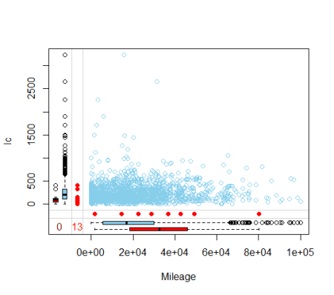

Blue values are observed values and red ones are missing values.

**Impute**

impute <- mice(data[,2:7], m=3, seed = 123)

print(impute)

Class: mids

Number of multiple imputations:  3

Imputation methods:

     fm Mileage      lh      lc      mc   State

     ""   "pmm"   "pmm"   "pmm"      ""      ""

PredictorMatrix:

        fm Mileage lh lc mc State

fm       0       1  1  1  1     0

Mileage  1       0  1  1  1     0

lh       1       1  0  1  1     0

lc       1       1  1  0  1     0

mc       1       1  1  1  0     0

State    0       0  0  0  0     0

Number of logged events:  1

  it im dep     meth   out

1  0  0     constant State

Here you can see different methods for imputation.

For example, variable fm contains no missing values and hence no method applied.

For the variable Mileage, lh and lc “pmm” method used.

pmm stands for predictive Mean Matching.

polyreg used for factor variables, polyreg stands for multinomial logistic regression.

impute$imp$Mileage

   1     2     3

19   40558 25481 21179

20   25478 13785 16319

253    138  1945   251

254  13089 16963 31078

255  26785 47232 22101

256  34822 33543 19486

861   6136 17212 75106

862   2844   243  1591

863  16319 19539 17610

1568 29262 17948 27095

1569 15299 11912  3253

1570    94   277    31

1571  3296 11000 17217

Total 3 imputations calculated here for understanding purpose, the best imputation value suited to your dataset can used for further analysis. Just look at the 20th row

data[20,]

vehicle fm Mileage  lh    lc   mc State

20      20  8      NA 1.4 87.42 1.85    NH

20th-row Mileage is missing the first imputation is represent is 25478, the second one is 13785, and the third one is 16319. So ideally the all values are always better than average.

**Complete data**

newDATA <- complete(impute, 1)

**Distribution of oberserved/imputed values**

xyplot(impute, lc ~ lh | .imp, pch = 20, cex=1.4)

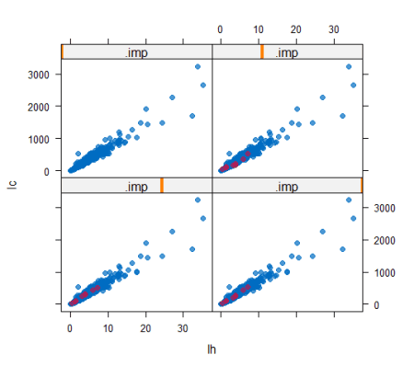

First, one is original observations and followed by impute1, 2, and 3. You can see there are no changes after imputing the observations.

**Conclusion**

Based on the mice package missing values can handle smartly, understand your data sets, and apply correct algorithms.