# Making Your First 3D Plot

## rayshader mtcars-style

*Start by making a ggplot w/ mtcars displ vs mpg*

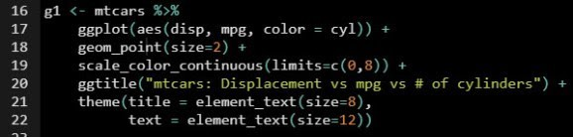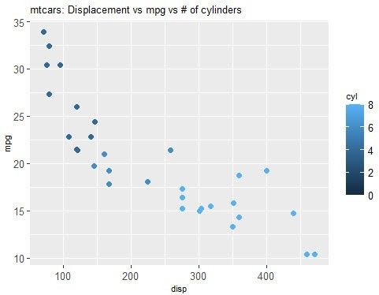

*Then unleash the AWESOME POWER * *of rayshader to make it 3D *

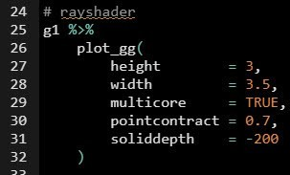

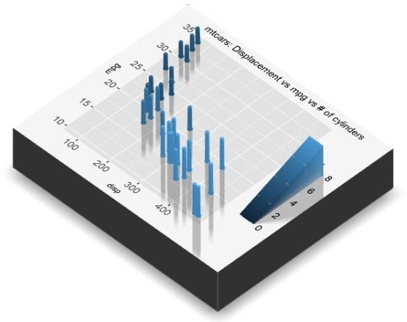

# Making Elevation Plots

## rayshader heatmap-style

What about heatmaps and volcano plots?

Sometimes you have heatmap formatted data where you have a matrix:

x/y-axis are the rows/columns

depth (z-axis) is the values in the matrix.

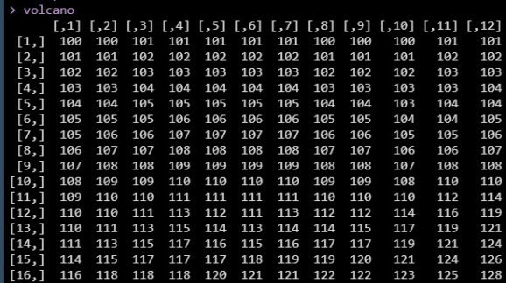

We can handle this matrix data format with:

A little bit of data wrangling with dplyr. Then make swiftly make a ggplot.

Then just like before, use rayshader.

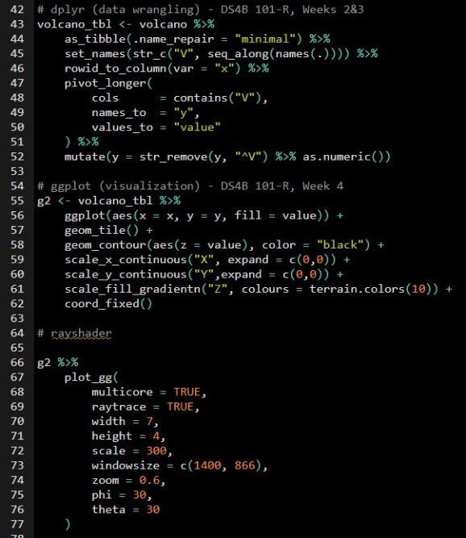

*And BOOM! We have a 3D Elevation Heat-Map Plot! *

