# Introducing semantic.dashboard

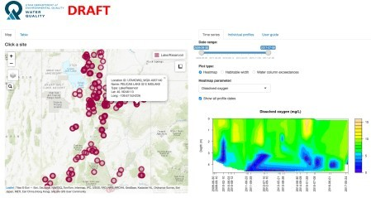Dashboards allow you to structure reports intuitively and break them down into easy-to-read chunks. As The shinydashboard R package has been out for ages, and it is a good option with a decent amount o The semantic.dashboard package is an open-source alternative to shinydashboard .For example, let’s take a look at two identical applications – the first built with shinydashboard, and th

Image 1 – Dashboard built with shinydashboard

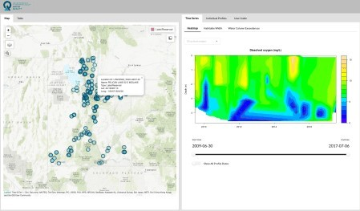

Image 2 – Dashboard built with semantic.dashboard

# Installation and Your First Dashboard

The semantic.dashboard package is available on CRAN (*Comprehensive R Archive Network*). To install:

install.packages("semantic.dashboard")

You can now proceed by creating an empty dashboard:

library(shiny) library(semantic.dashboard)

ui <- dashboardPage( dashboardHeader(), dashboardSidebar(sidebarMenu()), dashboardBody()

)

server <- function(input, output) { } shinyApp(ui, server)

Here’s the corresponding output:

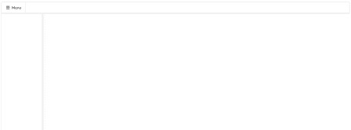

*Image 3 – Empty shiny.semantic dashboard*

The semantic.dashboard‘s app UI is made of a dashboardPage, which is further split into three ele

1. **Header** – dashboardHeader
2. **Sidebar** – dashboardSidebar
3. **Body** – dashboardBody

This structure is identical as with shinydashboard – making things easier to learn. Let’s see how to tw There are a lot of things you can do with dashboardHeader. For example, you can change the color by Here’s how to change the color from white to something less boring:

dashboardHeader(color = "blue", inverted = TRUE)

The inverted parameter sets the color to the header background instead of the header text. Here’s the corresponding output:

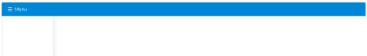

*Image 4 – Styling the header of the semantic dashboard*

Next, let’s see how to add elements to the dashboardSidebar. You can specify the sidebar size by twe Here’s how to make the sidebar wider:

dashboardSidebar( size = "wide", sidebarMenu(

menuItem(tabName = "panel1", text = "Panel 1"), menuItem(tabName = "panel2", text = "Panel 2")

)

)

Here are the results:

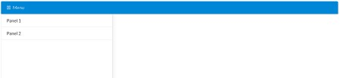

*Image 5 – Styling the sidebar of the semantic dashboard*

That adds the elements to the sidebar, but how can you display different content when the tab is clicked? Let’s add tabItems and two tabs, corresponding to two options in the sidebar. The first option is selecte

dashboardBody(

tabItems( selected = 1, tabItem(

tabName = "panel1", textOutput(outputId = "text1")

),

tabItem(

tabName = "panel2", textOutput(outputId = "text2")

)

)

)

To make this work, you’ll need to make some tweaks to the server function. You’ll have to render text o

server <- function(input, output) { output$text1 <- renderText("This is Panel 1") output$text2 <- renderText("This is Panel 2")

}

Your dashboard should look like this now:

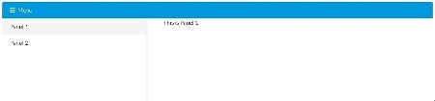

*Image 6 – Initial dashboard with two panels*

Now you know the basics of semantic.dashboard. Let’s see how to take it a step further and display

# Build a Fully Interactive Dashboard

R comes with a lot of built-in datasets, quakes being one of them. It shows geolocations of 1000 seismic

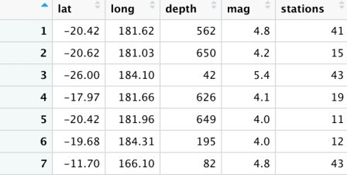

*Image 7 – First couple of rows of the Quakes dataset*

You’ll now see how to develop a semantic dashboard with the following tabs:

**Interactive map** – display geographical area near Fiji with markers representing the magnitude of

**Table** – shows the source dataset formatted as a table

You’ll create the interactive map with the leaflet package, so make sure to have it installed:

install.packages("leaflet")

The UI follows the pattern discussed in the previous section – there’s a header, sidebar, and a body. The

leafletOutput() – used to display the interactive map

dataTableOutput() – used to display the data table

To make the map as large as possible, you can set some inline CSS styles. In the code below, the height Here’s the code for the UI:

library(shiny) library(shiny.semantic) library(shinydashboard) library(leaflet)

ui <- dashboardPage( dashboardHeader(), dashboardSidebar(

size = "wide", sidebarMenu(

menuItem(tabName = "map", text = "Map", icon = icon("map")), menuItem(tabName = "table", text = "Table", icon = icon("table"))

)

),

dashboardBody( tabItems(

selected = 1, tabItem(

tabName = "map",

tags$style(type = "text/css", "#map {height: calc(100vh - 80px) !impo leafletOutput("map")

),

tabItem(

tabName = "table", fluidRow(

h1("Quakes Table"), semantic_DTOutput("quakesTable")

)

)

)

)

)

In order to make this dashboard work, you’ll have to modify the server function. Inside it lies the code fo The magnitude of the seismic activity determines the size of a marker. Every marker is clickable – showin Here’s the code for the server:

server <- function(input, output) { output$map <- renderLeaflet({ leaflet() %>%

setView(lng = 179.3355929, lat = -20.4428959, zoom = 6.5) %>% addProviderTiles("Esri.WorldStreetMap") %>%

addCircles(

data = quakes,

radius = sqrt(10^quakes$mag) * 30,

color = "#000000", fillColor = "#ffffff", fillOpacity = 0.5, popup = paste0(

"Magnitude: ", quakes$mag, "

",

"Depth (km): ", quakes$depth, "

",

"Num. stations reporting: ", quakes$stations

)

)

})

output$quakesTable <- DT::renderDataTable( semantic_DT(quakes)

)

}

And here’s the final dashboard:

