Fundamentally, there are three basic steps to optimizing a goal-based portfolio:

1. Determine your goal variables: time horizon, amount of wealth dedicated to the goal today, and future required wealth value.
2. Develop capital market expectations for your investment universe: correlations, return expectations, and volatility.
3. Run a standard optimizer with a goal-based utility function.

This post is all about how to optimize a goal based portfolio in R.

First, we need to understand the goal, what is it you want to do with the money? To keep things simple, let’s say you need $1,000 in 10 years, and you have $750 dedicated to it today. We organize this into a goal vector with the goal’s value, the required funding value ($1,000), and the time horizon (10 years). Note that the goal’s value is only relevant when optimizing your current wealth across your goals, which this post does not cover.

pool <- 750 # Total amount dedicated to this goal

goal_vector <- c(1, 1000, 10) # c(Goal value, goal funding requirement, time horizon)

Ok. Step 1 is done.

Second, we need to develop capital market expectations for our investment universe. This topic is so big numerous books have been written on it because it is a very important step. Better forecasts yield better results. Since this post isn’t about building CMEs, let’s just input something simple.

Stocks: 9% average return with 15% volatility Bonds: 4.5% average return with 5% volatility Gamble: -1% average return with 80% volatility Cash: 0.5% average return with 0.01% volatility

# Asset names

assets <- c('Stocks', 'Bonds', 'Gamble', 'Cash')

# Capital Market expectations - each is a vector in order of assets cme <- data.frame( 'Return_Forecast' = c(0.09, 0.045, -0.01, 0.005),

'Volatility Forecast' = c(0.15, 0.05, 0.80, 0.001) ) # Correlation matrix, in order of assets both sideways and vertically

|  |  |  |  |
| --- | --- | --- | --- |
| correlations <- matrix( c(1.00, | 0.10, | 0.00, | 0.00, |
| 0.10, | 1.00, | 0.00, | 0.00, |
| 0.00, | 0.00, | 1.00, | 0.00, |
| 0.00, | 0.00, | 0.00, | 1.00), |

nrow = length(assets), ncol = length(assets), byrow=T )

Note the “gamble” asset–we are going to have fun with that in a minute! Step 2 is complete.

Finally, now that we have our human-based inputs, let’s proceed with the algorithm. Load our required libraries.

library(tidyverse)

library(Rsolnp) # this is the optimizer solnp()

And build the functions we will use.

# Required Functions

# This function converts the covariance table and weight vector into a # portfolio standard deviation.

sd.f = function(weight_vector, covar_table){ covar_vector = 0

for(z in 1:length(weight_vector)){

covar_vector[z] = sum(weight_vector * covar_table[,z])

}

return( sqrt( sum( weight_vector * covar_vector) ) )

}

# This function will return the expected portfolio return, given the # forecasted returns and proposed portfolio weights

mean.f = function(weight_vector, return_vector){ return( sum( weight_vector * return_vector ) )

}

# This function will return the probability of goal achievement, given # the goal variables, allocation to the goal, expected return of the # portfolio, and expected volatiltiy of the portfolio

phi.f = function(goal_vector, goal_allocation, pool, mean, sd){

required_return = (goal_vector[2]/(pool * goal_allocation))^(1/goal_vector[3])

- 1

if( goal_allocation * pool >= goal_vector[2]){ return(1)

} else {

return( 1 - pnorm( required_return, mean, sd, lower.tail=TRUE ) )

}

}

# For use in the optimization function later, this is failure probability, # which we want to minimize.

optim_function = function(weights){

1 - phi.f(goal_vector, allocation, pool, mean.f(weights, return_vector), sd.f(weights, covar_table) )

}

# For use in the optimization function later, this allows the portfolio # weights to sum to 1.

constraint_function = function(weights){ sum(weights)

}

Since we input correlations and volatilities, we need to build a covariance table. This uses the



form (covariance of asset *i* to *j* equals the correlation of *i* and *j* times the volatility of *i* times the volatility of *j*).

# Convert correlations to covariances

covariances <- matrix( nrow = length(assets), ncol = length(assets) ) for(i in 1:length(assets)){

for(j in 1:length(assets)){

covariances[j,i] <- cme[i,2] * cme[j,2] * correlations[i,j]

}

}

All that is left is to do the optimization

# Optimization

return_vector <- cme$Return_Forecast covar_table <- covariances

allocation <- 1

starting_weights <- rep(0.25, length(assets)) # start with 25% weights result <- solnp( starting_weights, # Initialize weights

optim_function, # The function to minimize

eqfun = constraint_function, # The constraint function (

sum(weights) )

weight >= 0

weight <= 1 # Results

eqB = 1, # Constraint function must equal 1

LB = rep(0, length(assets)), # Lower bound of constraint, UB = rep(1, length(assets)) ) # Upper bound of constraint,

optimal_weights <- data.frame( 'Assets' = assets,

'Optimal Weights' = round(result$pars, 2) )

The solnp function from the Rsolnp package is quite powerful. Plus, when you are running it on complicated problems, the output makes me feel like a hacker, which is always a plus!

And we find that our optimal weights are 25% stocks, 75% bonds.

> optimal_weights Assets Optimal.Weights

1. Stocks 0.25
2. Bonds 0.75
3. Gamble 0.00

4 Cash 0.00

**So What’s Different About Goals-Based Investing?**

Now that you’ve got the basics of goals-based portfolio optimization, we may ask what is so different about GBI? Well, let’s find out!

To illustrate, let’s build allocations for various levels of starting wealth.

pool_seq <- seq(50, 1000, 50)

And empty lists to hold the various allocation results

# Empty lists of allocation to hold results stock_allocation <- 0

bond_allocation <- 0

gamble_allocation <- 0

cash_allocation <- 0

Then iterate through each starting wealth value and determine the optimal investment allocation (this code assumes you’ve run the code in the previous section).

# Loop through each level of starting wealth to determine optimal allocation for(i in 1:length(pool_seq)){

pool <- pool_seq[i]

result <- solnp( starting_weights,

optim_function,

eqfun = constraint_function, eqB = 1,

LB = rep(0, length(assets)), UB = rep(1, length(assets)) )

# Store results for this iteration

stock_allocation[i] <- result$pars[1] %>% round(digits = 2) bond_allocation[i] <- result$pars[2] %>% round(digits = 2)

gamble_allocation[i] <- result$pars[3] %>% round(digits = 2) cash_allocation[i] <- result$pars[4] %>% round(digits = 2)

}

Since I am using ggplot, I’ll now need to store the results in a long form data frame.

seq_results <- data.frame( 'Weight' = c(stock_allocation,

bond_allocation, gamble_allocation, cash_allocation ),

length(gamble_allocation)),

'Asset' = c( rep('Stock', length(stock_allocation)), rep('Bond', length(bond_allocation)), rep('Gamble',

rep('Cash', length(cash_allocation))), 'Wealth' = rep(pool_seq, length(assets)) )

And, finally, visualize the results.

ggplot( seq_results, aes(x = Wealth, y = Weight, fill = Asset))+ geom_area( linetype=1, size=0.5, color='black')+ xlab('Initial Wealth')+

ylab('Investment Weight')+ labs(fill = 'Asset',

title = 'Optimal Allocation for Various Levels of Starting Wealth', subtitle = 'Goals-based optimization')

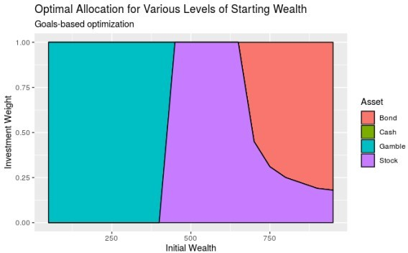

As you can see, goals-based portfolios will lean on high-variance, low return investments when your starting wealth is small enough. Technically speaking, GBI portfolios begin allocating to lottery-like investments whenever the return required to hit the goal is greater than the return offered by the mean-variance efficient frontier. In traditional mean-variance optimization, the optimizer will maintain exposure to the endpoint of the frontier, or 100% stock allocation, in our example.

As a comparison, here is the mean-variance optimizer result. As you can see, the “gamble” asset is eliminated from consideration.

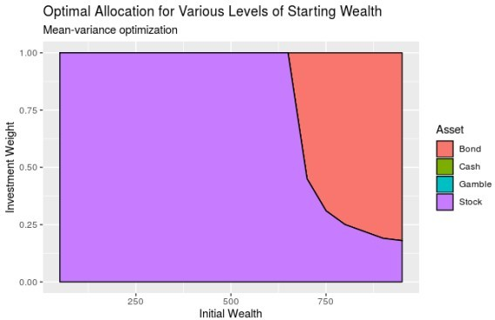

Because of this, goal-based portfolios yield higher probabilities of goal achievement than mean-variance portfolios (mean-variance portfolios are stochastically dominated by goals-based portfolios).



For all of these reasons (and more), if you have goals to achieve then you should be using goals-based portfolio theory. I hope this post helped you understand how to implement the basic framework!