**Introduction**

In this article, I show how to create a timeline of your CV in R. A CV timeline illustrates key information about your education, work experiences and extra activities. The main advantage of CV timelines compared to regular CV is that they make you stand out immediately by being visually appealing and easier to scan. It also allows you to better present your “story” by showing the chronology of your jobs and activities and thus explain how you got to where you are today.

We show below how to create such CV in R with a minimal reproducible example. Feel free to use the code and adapt it to you. CV Timeline:

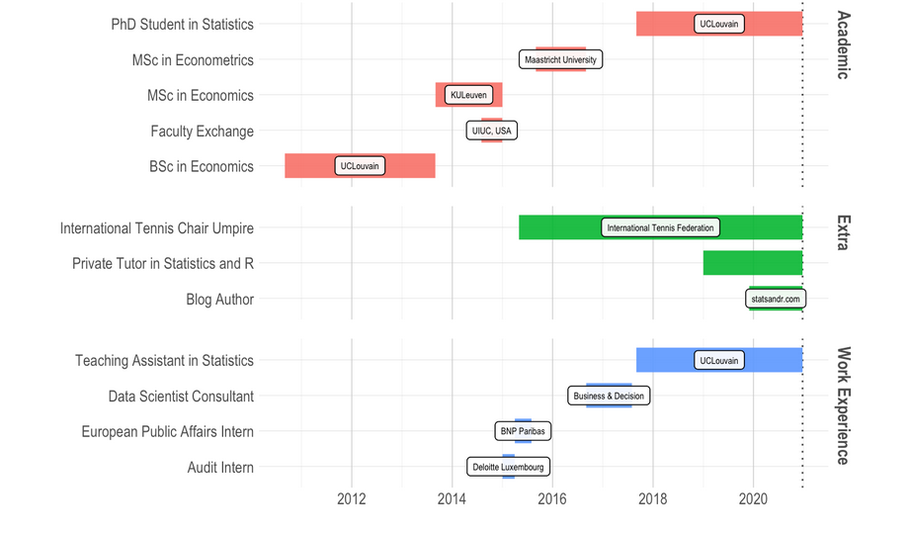

**Minimal reproducible example**

Here is the code and the result of a minimal reproducible example:

# All packages used below must be installed first

library(devtools)

# devtools::install_github("laresbernardo/lares")

library(lares)

library(ggplot2)

plot_timeline2 <- function(event, start, end = start + 1, label = NA, group = NA,

title = "Curriculum Vitae Timeline", subtitle = "Antoine Soetewey",

size = 7, colour = "orange", save = FALSE, subdir = NA) {

df <- data.frame(

Role = as.character(event), Place = as.character(label),

Start = lubridate::date(start), End = lubridate::date(end),

Type = group

)

cvlong <- data.frame(pos = rep(

as.numeric(rownames(df)),

2

), name = rep(as.character(df$Role), 2), type = rep(factor(df$Type,

ordered = TRUE

), 2), where = rep(

as.character(df$Place),

2

), value = c(df$Start, df$End), label_pos = rep(df$Start +

floor((df$End - df$Start) / 2), 2))

maxdate <- max(df$End)

p <- ggplot(cvlong, aes(

x = value, y = reorder(name, -pos),

label = where, group = pos

)) + geom_vline(

xintercept = maxdate,

alpha = 0.8, linetype = "dotted"

) + labs(

title = title,

subtitle = subtitle, x = NULL, y = NULL, colour = NULL

) +

theme_lares2() + theme(panel.background = element_rect(

fill = "white",

colour = NA

), axis.ticks = element_blank(), panel.grid.major.x = element_line(

size = 0.25,

colour = "grey80"

))

if (![is.na](http://is.na)(cvlong$type)[1] | length(unique(cvlong$type)) >

1) {

p <- p + geom_line(aes(color = type), size = size) +

facet_grid(type ~ ., scales = "free", space = "free") +

guides(colour = FALSE) +

scale_colour_hue()

}

else {

p <- p + geom_line(size = size, colour = colour)

}

p <- p + geom_label(aes(x = label_pos),

colour = "black",

size = 2, alpha = 0.7

)

if (save) {

file_name <- "cv_timeline.png"

if (![is.na](http://is.na)(subdir)) {

dir.create(file.path(getwd(), subdir), recursive = T)

file_name <- paste(subdir, file_name, sep = "/")

}

p <- p + ggsave(file_name, width = 8, height = 6)

message(paste("Saved plot as", file_name))

}

return(p)

}

order <- c("Role", "Place", "Type", "Start", "End")

today <- as.character(Sys.Date())

### Edit from here ###

cv <- data.frame(rbind(

c("PhD in Statistics", "University3", "Academic", "2017-09-01", today),

c("MSc in Econometrics", "University2", "Academic", "2015-09-01", "2017-08-31"),

c("BSc in Economics", "University1", "Academic", "2010-09-01", "2013-08-31"),

c("Job title2", "Company2", "Work Experience", "2016-09-01", today),

c("Job title1", "Company1", "Work Experience", "2013-08-31", "2015-08-31"),

c("Extra1", "Place1", "Extra", "2015-05-01", today),

c("Extra2", "Place2", "Extra", "2019-01-01", today),

c("Extra3", NA, "Extra", "2019-12-01", today)

))

### Edit until here ###

colnames(cv) <- order

colour <- c("red", "blue", "green")

plot_timeline2(

event = cv$Role,

start = cv$Start,

end = cv$End,

label = cv$Place,

group = cv$Type,

save = FALSE,

subtitle = "Antoine Soetewey" # replace with your name

)

**How to personalize it**

If you want to edit the example with your own academic, extra and work experiences you basically just have to edit the dataframe called cv in the code above. Each row of the dataset cv is a different academic program, job or activity. Rows should include:

* the name of the academic program, job title or activity
* the name of the university, school, company or workplace
* the category: academic, work experience or extra
* the starting date (dates must be in format yyyy-mm-dd)
* the ending date. If the role has not yet ended, type today instead of the date. By using today your CV timeline will automatically adapt to today’s date

Add or remove a row in the dataframe if you want to add or remove a role. Indicate NA if you do not want to specify any workplace (as it has been done for Extra3). Last, do not forget to replace my name with yours for the subtitle of the timeline at the end of the code.

Experienced R users may wish to edit the plot_timeline2 function to their needs. However, if you are happy with the template and design of the example, you only have to change things mentioned above.

Thanks for reading. I hope this article helped you to create a timeline of your CV in R.