Introduction Prerequisites Analytics

Users, page views and sessions Sessions over time

Sessions per channel Sessions per day of week Sessions per day and time Sessions per month and year Top performing pages

Time-normalized page views Page views by country

Browser information

User engagement by devices Content

Finding topics Content distribution

A small note about ads Future plans

Thank you note



# Introduction

Stats and R has been launched on December 16, 2019. Since the blog is officially one year old today and after having discussed the main benefits of maintaining a technical blog, I thought it would be a good time to share some numbers and thoughts about it.

In this article, I show how to **analyze a blog and its blog posts** with the

{googleAnalyticsR} R package (see package’s full documentation). After sharing some analytics about the blog, I will also discuss about content creation/distribution and, to a smaller extent, the future plans. This is a way to share my journey as a data science blogger and a way to give you an insight about how Stats and R is doing.

I decided to share with you some numbers through the {googleAnalyticsR} package

instead of the regular Google Analytics dashboards for several reasons:

1. There are plenty of data analysts who are much more experienced than me when it comes to analyzing Google Analytics data via their dedicated platform
2. I recently discovered the {googleAnalyticsR} package in R and I would like to present its possibilities, and perhaps convince marketing specialists familiar with R to complement their Google Analytics dashboards with some data visualizations made in R (via some ggplot2 visualizations for instance)
3. I would like to **automate the process** such in a way that I can easily **replicate** the same types of analysis across the years. This will allow to see how the blog evolves throughout the years. We know that using R is a pretty good starting point when it comes to automation and replication—especially thanks to R Markdown reports

I am not an expert in the field of marketing, but who knows, it may still give some ideas to data analysts, SEO specialists or other bloggers on how to track the performance of their own blog or website using R.

Before going further, I would like to remind that I am not making a living from my blog (far from it!) and it is definitely not my goal as I do not believe that I would be the same kind of writer if it was my main occupation.

# Prerequisites

As for any package in R, we first need to install it—with install.packages()—and load it— with library():1

# install.packages('googleAnalyticsR', dependencies = TRUE) library(googleAnalyticsR)

Next, we need to authorize the access of the Google Analytics account using the ga_auth()

function:

ga_auth()

Running this code will open a browser window on which you will be able to authorize the access. This step will save an authorization token so you only have to do it once.

Make sure to run the ga_auth() function in a R script and not in a R Markdown document. Follow this procedure if you want to use the package and its functions in a R Markdown report or in a blog post like I did for this article.

Once we have completed the Google Analytics authorization, we will need the ID of the Google Analytics account we want to access. All the available accounts linked to your email address (after authentication) are stored in ga_account_list():

accounts <- ga_account_list()

accounts

## # A tibble: 2 x 10

## accountId accountName internalWebProp… level websiteUrl type webPropertyId

##

## 1 86997981 Antoine So… 129397861 STAN… https://w… WEB UA-86997981-1

## 2 86997981 Antoine So… 218214896 STAN… https://w… WEB UA-86997981-2

## # … with 3 more variables: webPropertyName , viewId , viewName accounts$webPropertyName

## [1] "Antoine Soetewey" "statsandr.com"

As you can see I have two accounts linked to my Google Analytics profile: one for my personal website (www.antoinesoetewey.com) and one for this blog.

Of course, I select the account linked to this blog:

# select the view ID by property name

view_id <- accounts$viewId[which(accounts$webPropertyName == "statsandr.com")]

Make sure to edit the code with your own property name.

We are now finally ready to use our Google Analytics data in R for a better analysis!

# Analytics

## Users, page views and sessions

Let’s start with some general numbers, such as the number of **users, sessions and page views** for the entire site. Note that for the present article, we use data over the past year, so from December 16, 2019 to December 15, 2020:

# set date range

start_date <- as.Date("2019-12-16") end_date <- as.Date("2020-12-15")

# get Google Analytics (GA) data gadata <- google_analytics(view_id,

date_range = c(start_date, end_date),

metrics = c("users", "sessions", "pageviews"),

anti_sample = TRUE # slows down the request but ensures data isn't sampled

)

gadata

## users sessions pageviews ## 1 321940 428217 560491

In its first year, Stats and R has attracted **321,940 users**, who generated a total of **428,217 sessions** and **560,491 page views**.

For those unfamiliar with Google Analytics data and the difference between these metrics, remember that:

a **user** is the number of new and returning people who visit your site during a set period of time

a **session** is a group of user interactions with your website that take place within a given time frame

a **page view**, as the name suggests, is defined as a view of a page on your site

So if person A reads three blog posts then leave the site and person B reads one blog post, your about page then leave the site, Google Analytics data will show 2 users, 2 sessions and 5 page views.

## Sessions over time

In addition to the rather general metrics presented above, it is also interesting to illustrate the daily number of sessions **over time** in a scatterplot—together with a smoothed line—to analyze the **evolution** of the blog:

# get the Google Analytics (GA) data gadata <- google_analytics(view_id,

date_range = c(start_date, end_date),

metrics = c("sessions"), # edit for other metrics dimensions = c("date"),

anti_sample = TRUE # slows down the request but ensures data isn't sampled

)

# load required libraries library(dplyr) library(ggplot2)

# scatter plot with a trend line gadata %>%

ggplot(aes(x = date, y = sessions)) +

geom_point(size = 1L, color = "steelblue") + # change size and color of points

geom_smooth(color = "darkgrey", alpha = 0.25) + # change color of smoothed line and transparency of confidence interval

theme_minimal() + labs(

y = "Sessions", x = "",

title = "Evolution of daily sessions",

subtitle = paste0(format(start_date, "%b %d, %Y"), " to ", format(end_date, "%b %d, %Y")),

caption = "Data: Google Analytics data of statsandr.com"

) +

theme(plot.margin = unit(c(5.5, 15.5, 5.5, 5.5), "pt")) + # to avoid the plot being cut on the right edge

scale_y_continuous(labels = scales::comma) # better y labels

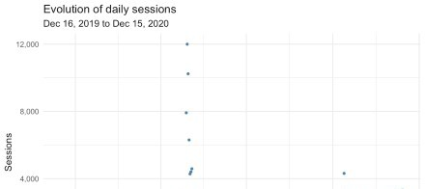

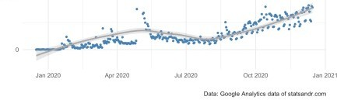

(See how to draw plots with the {ggplot2} package, or with the {esquisse} addin if you are not familiar with the package.)

As you can see, there was a huge peak of traffic around end of April, with almost 12,000 users in a single day. Yes, you read it well and there is no bug. The blog post “A package to download free Springer books during Covid-19 quarantine” went viral and generated a massive traffic for a few days. The daily number of sessions returned to a more normal level after a couple of days. We also observe an upward trend in the last months (since end of August/beginning of September), which indicates that the blog is growing in terms of number of daily sessions.

Note that I decided to focus on the number of sessions and the number of page views in this section and the following ones, but you can always change to your preferred metrics by editing metrics = c("sessions") in the code.

## Sessions per channel

Knowing **how people come to your blog** is a pretty important factor. Here is how to visualize the evolution of daily sessions per channel in a line plot:

# Get the data

trend_data <- google_analytics(view_id, date_range = c(start_date, end_date), dimensions = c("date"),

metrics = "sessions",

pivots = pivot_ga4("medium", "sessions"),

anti_sample = TRUE # slows down the request but ensures data isn't sampled

)

# edit variable names

names(trend_data) <- c("Date", "Total", "Organic", "Referral", "Direct", "Email", "Social")

# Change the data into a long format library(tidyr)

trend_long <- gather(trend_data, Channel, Sessions, -Date)

# Build up the line plot

ggplot(trend_long, aes(x = Date, y = Sessions, group = Channel)) + theme_minimal() +

geom_line(aes(colour = Channel)) + labs(

y = "Sessions", x = "",

title = "Evolution of daily sessions per channel", subtitle = paste0(format(start_date, "%b %d, %Y"), " to ",

format(end_date, "%b %d, %Y")),

caption = "Data: Google Analytics data of statsandr.com"

) +

scale_y_continuous(labels = scales::comma) # better y labels

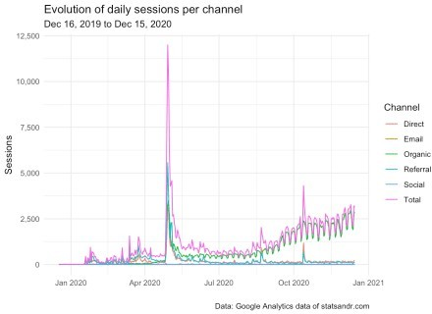

We see that a large share of the traffic is from the organic channel, which indicates that most readers visit the blog after a query on search engines (mostly Google). In my case, where most of my posts are tutorials and which help people with specific problems, it is thus not a surprise that most of my traffic comes from organic search.

We also notice some small peaks of sessions generated from the referral and direct channels, which are probably happening on the date of publication of each article.

We also see that there seems to be a recurrent pattern of ups and downs in the number of daily sessions. Those are weekly cycles, with less readers during the weekend and which indicates that people are working on improving their statistical or R knowledge mostly during the week (which actually makes sense!).

## Sessions per day of week

As shown above, traffic seems to be different depending on the **day of week**. To investigate this further, we draw a boxplot of the number of sessions for every day of the week:

# get data

gadata <- google_analytics(view_id, date_range = c(start_date, end_date), metrics = "sessions",

dimensions = c("dayOfWeek", "date"),

anti_sample = TRUE # slows down the request but ensures data isn't sampled

)

## Recoding gadata$dayOfWeek following GA naming conventions gadata$dayOfWeek <- recode_factor(gadata$dayOfWeek,

"0" = "Sunday",

"1" = "Monday",

"2" = "Tuesday",

"3" = "Wednesday",

"4" = "Thursday",

"5" = "Friday",

"6" = "Saturday"

)

## Reordering gadata$dayOfWeek to have Monday as first day of the week gadata$dayOfWeek <- factor(gadata$dayOfWeek,

levels = c(

"Monday", "Tuesday", "Wednesday", "Thursday", "Friday", "Saturday", "Sunday"

)

)

# Boxplot gadata %>%

ggplot(aes(x = dayOfWeek, y = sessions)) + geom_boxplot() +

theme_minimal() + labs(

y = "Sessions", x = "",

title = "Sessions per day of week",

subtitle = paste0(format(start_date, "%b %d, %Y"), " to ", format(end_date, "%b %d, %Y")),

caption = "Data: Google Analytics data of statsandr.com"

) +

scale_y_continuous(labels = scales::comma) # better y labels

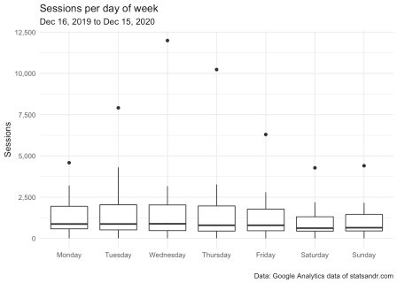

As you can see there are some outliers, probably due (in part at least) to the article that went viral. For the sake of illustration, below the same plot after removing points considered as potential outliers according to the interquartile range (IQR) criterion (i.e., points above or below

the whiskers), and after a couple of visual improvements:

# boxplot gadata %>%

filter(sessions <= 3000) %>% # filter out sessions > 3,000 ggplot(aes(x = dayOfWeek, y = sessions, fill = dayOfWeek)) + # fill

boxplot by dayOfWeek

geom_boxplot(varwidth = TRUE) + # vary boxes width according to n obs.

geom_jitter(alpha = 0.25, width = 0.2) + # adds random noise and limit its width

theme_minimal() + labs(

y = "Sessions", x = "",

title = "Sessions per day of week",

subtitle = paste0(format(start_date, "%b %d, %Y"), " to ", format(end_date, "%b %d, %Y")),

caption = "Data: Google Analytics data of statsandr.com\nPoints > 3,000 excluded"

) +

scale_y_continuous(labels = scales::comma) + # better y labels theme(legend.position = "none") # remove legend

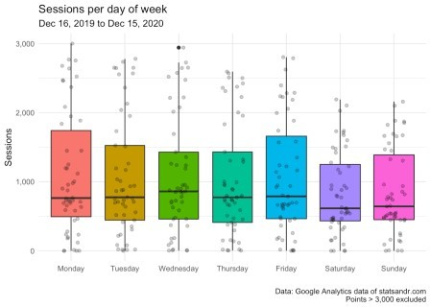

After excluding data points above 3,000, it is now easier to see that the median number of sessions (represented by the horizontal bold line in the boxes) is the highest on Wednesdays, and lowest on Saturdays and Sundays.

The difference in sessions between weekdays is, however, not as large as expected. For the interested reader, if you want to test whether there is a *significant* difference between the days in terms of number of sessions, you could perform an ANOVA.

## Sessions per day and time

We have seen the traffic per day of week. The example below shows a visualization of traffic, broken down this time by **day of week and hour of day** in a density plot. In this plot, the device

type has also been added for more insights.

## Get data by deviceCategory, day of week and hour weekly_data <- google_analytics(view_id,

date_range = c(start_date, end_date), metrics = c("sessions"),

dimensions = c("deviceCategory", "dayOfWeekName", "hour"), anti_sample = TRUE # slows down the request but ensures data isn't

sampled

)

## Manipulation using dplyr weekly_data_sessions <- weekly_data %>%

group_by(deviceCategory, dayOfWeekName, hour)

## Reordering weekly_data_sessions$dayOfWeekName to have Monday as first day of the week

weekly_data_sessions$dayOfWeekName <- factor(weekly_data_sessions$ dayOfWeekName,

levels = c(

"Monday", "Tuesday", "Wednesday", "Thursday", "Friday", "Saturday", "Sunday"

)

)

## Plotting using ggplot2 weekly_data_sessions %>%

ggplot(aes(hour, sessions, fill = deviceCategory, group = deviceCategory)) +

geom_area(position = "stack") + labs(

title = "Sessions per day and time",

subtitle = paste0(format(start_date, "%b %d, %Y"), " to ", format(end_date, "%b %d, %Y")),

caption = "Data: Google Analytics data of statsandr.com", x = "Time",

y = "Sessions",

fill = "Device" # edit legend title

) +

theme_minimal() +

facet_wrap(~dayOfWeekName, ncol = 2, scales = "fixed") + theme(

legend.position = "bottom", # move legend

axis.text = element_text(size = 7) # change font of axis text

) +

scale_y_continuous(labels = scales::comma) # better y labels

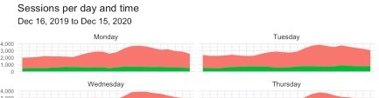

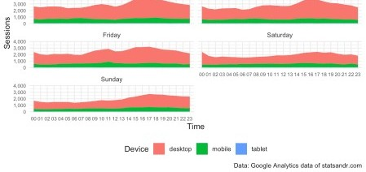

The above plot shows that:

traffic increases in the afternoon then declines in the late evening

traffic is the highest from Monday to Thursday, and lowest on Saturday and Sunday

In addition to that, thanks to the additional information on the device category, we also see that:

the number of sessions on tablet is low (it is so low compared to desktop and mobile that it is not visible on the plot), and

the number of sessions on mobile seems to be quite stable during the entire day, as opposed to sessions on desktop which are highest at the end of the day.

## Sessions per month and year

In the following code, we create a barplot of the number of **daily sessions per month and year**:

# get data

df2 <- google_analytics(view_id, date_range = c(start_date, end_date), metrics = c("sessions"),

dimensions = c("date"),

anti_sample = TRUE # slows down the request but ensures data isn't sampled

)

# add in year month columns to dataframe df2$month <- format(df2$date, "%m") df2$year <- format(df2$date, "%Y")

# sessions by month by year using dplyr then graph using ggplot2 barplot

df2 %>%

group_by(year, month) %>% summarize(sessions = sum(sessions)) %>% # print table steps by month by year

# print(n = 100) %>%

# graph data by month by year

ggplot(aes(x = month, y = sessions, fill = year)) + geom_bar(position = "dodge", stat = "identity") + theme_minimal() +

labs(

y = "Sessions", x = "Month",

title = "Sessions per month and year",

subtitle = paste0(format(start_date, "%b %d, %Y"), " to ", format(end_date, "%b %d, %Y")),

caption = "Data: Google Analytics data of statsandr.com"

) +

scale_y_continuous(labels = scales::comma) # better y labels

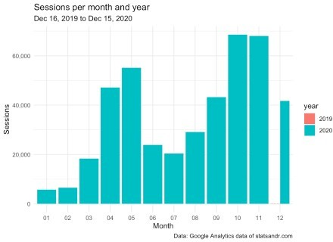

This barplot allows to easily see the evolution of the number of sessions over the months, and compare this evolution across different years.

At the moment, since the blog is online only since December 2019, the year factor is not relevant. However, I still present the visualization for other users who work on older websites, and also to remind my future self to create this interesting barplot when there will be data for more than a year.

## Top performing pages

Another important factor when measuring the performance of your blog or website is the **number of page views for the different pages**. The top performing pages in terms of page views over the year can easily be found in Google Analytics (you can access it via Behavior > Site Content > All pages).

For the interested reader, here is how to get the data in R (note that you can change n = 7 in the code to change the number of top performing pages to display):

## Make the request to GA

data_fetch <- google_analytics(view_id, date_range = c(start_date, end_date), metrics = c("pageviews"),

dimensions = c("pageTitle"),

anti_sample = TRUE # slows down the request but ensures data isn't sampled

)

## Create a table of the most viewed posts library(lubridate)

library(reactable) library(stringr)

most_viewed_posts <- data_fetch %>%

mutate(Title = str_trunc(pageTitle, width = 40)) %>% # keep maximum

40 characters

count(Title, wt = pageviews, sort = TRUE) head(most_viewed_posts, n = 7) # edit n for more or less pages to display

|  |  |  |  |  |
| --- | --- | --- | --- | --- |
| ## |  |  | Title | n |
| ## | 1 | A package to download free Springer | b... | 85684 |
| ## | 2 | Variable types and examples - Stats | a... | 44951 |
| ## | 3 | Descriptive statistics in R - Stats | a... | 43621 |
| ## | 4 | Outliers detection in R - Stats | and R | 32560 |
| ## | 5 | The complete guide to clustering an | al... | 27184 |
| ## | 6 | Correlation coefficient and correla | ti... | 21581 |
| ## | 7 | Stats | and R | 16786 |

Here is how to visualize this table of top performing pages in a barplot:

# plot

top_n(most_viewed_posts, n = 7, n) %>% # edit n for more or less pages to display

ggplot(., aes(x = reorder(Title, n), y = n)) + geom_bar(stat = "identity", fill = "steelblue") + theme_minimal() +

coord_flip() + labs(

y = "Page views", x = "Title",

title = "Top performing pages in terms of page views", subtitle = paste0(format(start_date, "%b %d, %Y"), " to ",

format(end_date, "%b %d, %Y")),

caption = "Data: Google Analytics data of statsandr.com"

) +

scale_y_continuous(labels = scales::comma) # better y labels

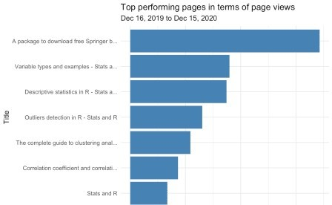



This gives me a good first overview on how posts performed in terms of page views, so in some sense, what people find useful. For instance, I never thought that the post illustrating the different types of variables that exist in statistics (ranked #2) would be so appreciated when I wrote it.

This is something I learned with this blog: at the time of writing, there are some posts which I think no one will care about (and which I mostly write as a personal note for myself), and others which I think people will find very useful. However, after a couple of weeks after publication, sometimes I realize that it is actually exactly the opposite.

**Time-normalized page views**

When it comes to **comparing blog posts**, however, this is not as simple.

Based on the above barplot and without any further analysis, I would conclude that my article about variable types is performing much better than the one about outliers detection in R.

However, if I tell you that the article on outliers detection has been published on August 11 and the one about variable types on December 30, you will agree that the comparison does not make much sense anymore since page views for these articles were counted over a different length of time. One could also argue that a recent article had less time to generate backlinks, so it is unfair to compare it with an old post which had plenty of time to be ranked high by Google.

In order to make the comparison more “fair”, we would need to compare the number of page views for each post **since their date of publication**. The following code does precisely this:2

it pulls daily data for a bunch of pages, then tries to detect their publication date,

time-normalizes the traffic for each page based on that presumed publication date, and finally, plots the daily traffic from the publication date on out, as well as overall cumulative traffic for the top *n* pages

# figure out when a page actually launched by finding the # first day where the page had at least 2 unique pageviews first_day_pageviews_min <- 2

# exclude pages that have total traffic (daily unique pageviews) that are relatively low

total_unique_pageviews_cutoff <- 500

# set how many "days since publication" we want to include in our plot days_live_range <- 180

# set number of top pages to display n <- 7

# Create a dimension filter object

# You need to update the "expressions" value to be a regular expression that filters to

# the appropriate set of content on your site

page_filter_object <- dim_filter("pagePath", operator = "REGEXP",

expressions = "/blog/.+"

)

# Now, put that filter object into a filter clause. The "operator" argument can be AND # or OR...but you have to have it be something, even though it doesn't do anything

# when there is only a single filter object.

page_filter <- filter_clause_ga4(list(page_filter_object), operator = "AND"

)

# Pull the GA data

ga_data <- google_analytics( viewId = view_id,

date_range = c(start_date, end_date), metrics = "uniquePageviews", dimensions = c("date", "pagePath"), dim_filters = page_filter,

anti_sample = TRUE # slows down the request but ensures data isn't sampled

)

# Find the first date for each post. This is actually a little tricky, so we're going to write a

# function that takes each page as an input, filters the data to just include those

# pages, finds the first page, and then puts a "from day 1" count on that data and

# returns it.

normalize_date_start <- function(page) {

# Filter all the data to just be the page being processed ga_data_single_page <- ga_data %>% filter(pagePath == page)

# Find the first value in the result that is greater than first_day_pageviews_min. In many

# cases, this will be the first row, but, if there has been testing/previews before it

# actually goes live, some noise may sneak in where the page may have been live, technically,

# but wasn't actually being considered live.

first_live_row <- min(which(ga_data_single_page$uniquePageviews > first_day_pageviews_min))

# Filter the data to start with that page ga_data_single_page <- ga_data_single_page[first_

live_row:nrow(ga_data_single_page), ]

# As the content ages, there may be days that have ZERO traffic.

Those days won't show up as

# rows at all in our data. So, we actually need to create a data frame that includes

# all dates in the range from the "publication" until the last day traffic was recorded. There's

# a little trick here where we're going to make a column with a sequence of *dates* (date) and,

# with a slightly different "seq," a "days_live" that corresponds with each date.

normalized_results <- data.frame( date = seq.Date(

from = min(ga_data_single_page$date), to = max(ga_data_single_page$date), by = "day"

),

days_live = seq(min(ga_data_single_page$date): max(ga_data_single_page$date)),

page = page

) %>%

# Join back to the original data to get the uniquePageviews left_join(ga_data_single_page) %>%

# Replace the "NAs" (days in the range with no uniquePageviews) with 0s (because

# that's exactly what happened on those days!) mutate(uniquePageviews = ifelse(is.na(uniquePageviews), 0,

uniquePageviews)) %>%

# We're going to plot both the daily pageviews AND the cumulative total pageviews,

# so let's add the cumulative total mutate(cumulative_uniquePageviews = cumsum(uniquePageviews)) %>%

# Grab just the columns we need for our visualization! select(page, days_live, uniquePageviews,

cumulative_uniquePageviews)

}

# We want to run the function above on each page in our dataset. So, we need to get a list

# of those pages. We don't want to include pages with low traffic overall, which we set

# earlier as the 'total_unique_pageviews_cutoff' value, so let's also filter our

# list to only include the ones that exceed that cutoff. We also select the top n pages

# in terms of page views to display in the visualization. library(dplyr)

pages_list <- ga_data %>% group_by(pagePath) %>%

summarise(total_traffic = sum(uniquePageviews)) %>% filter(total_traffic > total_unique_pageviews_cutoff) %>%

top_n(n = n, total_traffic)

# The first little bit of magic can now occur. We'll run our normalize_date_start function on

# each value in our list of pages and get a data frame back that has our time-normalized

# traffic by page! library(purrr)

ga_data_normalized <- map_dfr(pages_list$pagePath, normalize_date_start)

# We specified earlier -- in the `days_live_range` object -- how many "days since publication" we

# actually want to include, so let's do one final round of filtering to only include those

# rows.

ga_data_normalized <- ga_data_normalized %>% filter(days_live <= days_live_range)

Now that our data is ready, we create two visualizations:

1. **Number of page views by day since publication**: this plot shows how quickly interest in a particular piece of content drops off. If it is not declining as rapidly as the other posts, it means you are getting *sustained* value from it
2. ***Cumulative* number of page views by day since publication**: this plot can be used to compare blog posts on the same ground since number of page views is shown based on the publication date. To see which pages have generated the most traffic over time, simply look from top to bottom (at the right edge of the plot)

Note that both plots use the {plotly} package to make them interactive so that you can mouse over a line and find out exactly what page it is (together with its values). The interactivity of the plot makes it also possible to zoom in to see, for instance, the number of page views in the first days after publication (instead of the default length of 180 days),3 or zoom in to see only the evolution of the number of page views below/above a certain threshold.

# Create first plot library(ggplot2)

gg <- ggplot(ga_data_normalized, mapping = aes(x = days_live, y = uniquePageviews, color = page)) +

geom_line() + # The main "plot" operation

scale_y_continuous(labels = scales::comma) + # Include commas in the y-axis numbers

labs(

title = "Page views by day since publication", x = "Days since publication",

y = "Page views",

subtitle = paste0(format(start_date, "%b %d, %Y"), " to ", format(end_date, "%b %d, %Y")),

caption = "Data: Google Analytics data of statsandr.com"

) +

theme_minimal() + # minimal theme

theme(

legend.position = "none", # remove legend

)

# Output the plot, wrapped in ggplotly so we will get some interactivity in the plot

library(plotly)

ggplotly(gg, dynamicTicks = TRUE)

The plot above shows again a huge spike for the post that went viral (orange line). If we zoom in to include only page views below 1500, comparison between posts is easier and we see that:

The post on the top 100 R resources on Coronavirus (purple line) generated comparatively more traffic than the other posts in the first 50 days (\(\approx\) 1 month and 3 weeks) after publication. However, traffic gradually decreased up to the point that after 180 days (\(\approx\) 6 months), it attracted less traffic than other more performing posts.

The post on outliers detection in R (blue line) did not get a lot of attention in the first weeks after its publication. However, it gradually generated more and more traffic up to the point that, after 60 days (\(\approx\) 2 months) after publication, it actually generated more traffic than any other post (and by a relatively large margin).

The post on correlation coefficient and correlation test in R (green line) took approximately 100 days (\(\approx\) 3 months and 1 week) to take off, but after that it generated quite a lot of traffic. This is interesting to keep in mind when analyzing recent posts, because they may actually follow the same trend in the long run.

# Create second plot: cumulative

gg <- ggplot(ga_data_normalized, mapping = aes(x = days_live, y = cumulative_uniquePageviews, color = page)) +

geom_line() + # The main "plot" operation

scale_y_continuous(labels = scales::comma) + # Include commas in the y-axis numbers

labs(

title = "Cumulative page views by day since publication", x = "Days since publication",

y = "Cumulative page views",

subtitle = paste0(format(start_date, "%b %d, %Y"), " to ", format(end_date, "%b %d, %Y")),

caption = "Data: Google Analytics data of statsandr.com"

) +

theme_minimal() + # minimal theme theme(

legend.position = "none", # remove legend

)

# Output the plot, wrapped in ggplotly so we will get some interactivity in the plot

ggplotly(gg, dynamicTicks = TRUE)

Compared to the previous plot, this one shows the *cumulative* number of page views since the date of publication of the post.

Without taking into consideration the post that went viral and which, by the way, does not really generate much traffic anymore (which makes sense since the incredible campaign from

Springer to offer their books for free during the COVID-19 quarantine has ended), we see that:

I remember that I wrote this post because, at that time, I had to deal with the problems of outliers in R and I did not found a neat solution online. So I guess, the fact that resources on a specific topic are missing helps to attract visitors looking for an answer to their question.

The analyses so far give you already a good understanding of the performance of your blog. However, for the interested readers, we show other important metrics in the following sections.

## Page views by country

In the following we are interested in seeing **where the traffic comes from**. This is particularly interesting to get to know your audience, and even more important if you are running a business or an ecommerce.

# get GA data

data_fetch <- google_analytics(view_id, date_range = c(start_date, end_date), metrics = "pageviews",

dimensions = "country",

anti_sample = TRUE # slows down the request but ensures data isn't sampled

)

# table

countries <- data_fetch %>%

mutate(Country = str_trunc(country, width = 40)) %>% # keep maximum

40 characters

count(Country, wt = pageviews, sort = TRUE)

head(countries, n = 10) # edit n for more or less countries to display

|  |  |  |  |
| --- | --- | --- | --- |
| ## |  | Country | n |
| ## | 1 | United States | 131306 |
| ## | 2 | India | 38800 |
| ## | 3 | Belgium | 32983 |
| ## | 4 | United Kingdom | 25833 |
| ## | 5 | Brazil | 18961 |
| ## | 6 | Germany | 17851 |
| ## | 7 | Spain | 17355 |
| ## | 8 | Canada | 13880 |
| ## | 9 | Mexico | 12882 |
| ## | 10 | Philippines | 12540 |

To visualize this table of top countries in terms of page views in a barplot:

# plot

top_n(countries, n = 10, n) %>% # edit n for more or less countries to display

ggplot(., aes(x = reorder(Country, n), y = n)) + geom_bar(stat = "identity", fill = "steelblue") + theme_minimal() +

coord_flip() + labs(

y = "Page views", x = "Country",

title = "Top performing countries in terms of page views", subtitle = paste0(format(start_date, "%b %d, %Y"), " to ",

format(end_date, "%b %d, %Y")),

caption = "Data: Google Analytics data of statsandr.com"

) +

scale_y_continuous(labels = scales::comma) + # better y labels theme(plot.margin = unit(c(5.5, 7.5, 5.5, 5.5), "pt")) # to avoid the

plot being cut on the right edge

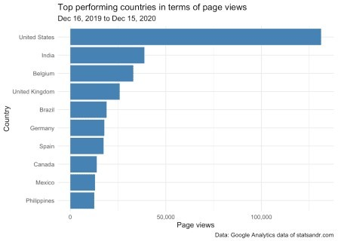

We see that readers from the US take the largest share of the number of page views (by quite a lot actually!), and Belgium (my country) comes in third place in terms of number of page views.

Given that the US population is much larger than the Belgian population (\(\approx\) 331 million people compared to \(\approx\) 11.5 million people, respectively), the above result is not really surprising. Again, for a better comparison, it would be interesting to take into consideration the size of the population when comparing countries.

Indeed, it could be that a large share of the traffic comes from a country with a large population, but that the number of page views per person (or per 100,000 inhabitants) is higher for another country. This information about top performing countries in terms of page views *per person* could give you insights on **which country do the most avid readers come from**. This is beyond the scope of this article, but you can see examples of plots which include the information on the population size in these COVID-19 visualizations. I recommend to apply the same methodology to the above plot for a better comparison.

If you are thinking about doing the extra step of including population size when comparing countries, I believe that it would be even better to take into account the information on computer access in each country as well. If we take India as example: at the time of writing this article, its population amounts to almost 1.4 *billion*. However, the percentage of Indian people having access to a computer is undoubtedly lower than in US or Belgium (again, at least at the moment). It would therefore make more sense to compare countries by comparing the number of page views *per people having access to a computer*.4

## Browser information

For more technical aspects, you could also be interested in the number of **page views by browser**. This can be visualized with the following barplot:

# get data

browser_info <- google_analytics(view_id, date_range = c(start_date, end_date), metrics = c("pageviews"),

dimensions = c("browser"),

anti_sample = TRUE # slows down the request but ensures data isn't sampled

)

# table

browser <- browser_info %>%

mutate(Browser = str_trunc(browser, width = 40)) %>% # keep maximum

40 characters

count(Browser, wt = pageviews, sort = TRUE)

# plot

top_n(browser, n = 10, n) %>% # edit n for more or less browser to display

ggplot(., aes(x = reorder(Browser, n), y = n)) + geom_bar(stat = "identity", fill = "steelblue") + theme_minimal() +

coord_flip() + labs(

y = "Page views", x = "Browser",

title = "Which browsers are our visitors using?", subtitle = paste0(format(start_date, "%b %d, %Y"), " to ",

format(end_date, "%b %d, %Y")),

caption = "Data: Google Analytics data of statsandr.com"

) +

scale_y_continuous(labels = scales::comma) # better y labels

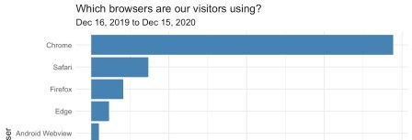

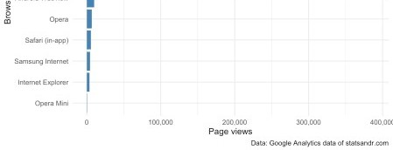

Most visits were, as expected, from Chrome, Safari and Firefox browsers.

## User engagement by devices

One may also be interested in checking **how users are engaged** on different types of devices. To do so, we plot 3 charts describing:

1. **How many sessions** were made from the different types of devices
2. The **average time on page** (in seconds) by type of device
3. The **number of page views per session** by device type

# GA data

gadata <- google_analytics(view_id, date_range = c(start_date, end_date), metrics = c("sessions", "avgTimeOnPage"), dimensions = c("date", "deviceCategory"),

anti_sample = TRUE # slows down the request but ensures data isn't sampled

)

# plot sessions by deviceCategory gadata %>%

ggplot(aes(deviceCategory, sessions)) +

geom_bar(aes(fill = deviceCategory), stat = "identity") + theme_minimal() +

labs(

y = "Sessions", x = "",

title = "Sessions per device",

subtitle = paste0(format(start_date, "%b %d, %Y"), " to ", format(end_date, "%b %d, %Y")),

caption = "Data: Google Analytics data of statsandr.com", fill = "Device" # edit legend title

) +

scale_y_continuous(labels = scales::comma) # better y labels

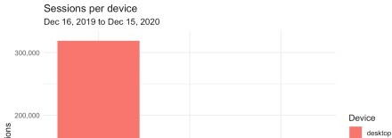

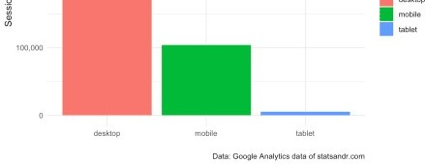

From the above plot, we see that the majority of readers visited the blog from a desktop, and a small number of readers from a tablet.

# add median of average time on page per device gadata <- gadata %>%

group_by(deviceCategory) %>% mutate(med = median(avgTimeOnPage))

# plot avgTimeOnPage by deviceCategory ggplot(gadata) +

aes(x = avgTimeOnPage, fill = deviceCategory) + geom_histogram(bins = 30L) +

scale_fill_hue() + theme_minimal() + theme(legend.position = "none") +

facet_wrap(vars(deviceCategory)) + labs(

y = "Frequency",

x = "Average time on page (in seconds)", title = "Average time on page per device",

subtitle = paste0(format(start_date, "%b %d, %Y"), " to ", format(end_date, "%b %d, %Y")),

caption = "Data: Google Analytics data of statsandr.com"

) +

scale_y_continuous(labels = scales::comma) + # better y labels geom_vline(aes(xintercept = med, group = deviceCategory),

color = "darkgrey", linetype = "dashed"

) +

geom_text(aes(

x = med, y = 90,

label = paste0("Median = ", round(med), " seconds")

),

angle = 90,

vjust = 2,

color = "darkgrey", size = 3

)

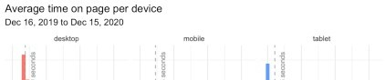

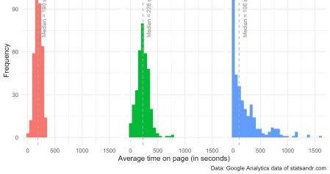

From the above plot, we see that:

for readers with a low average time spent on each page, most of them were on tablet (see the peak around 0 second in the tablet facet)

besides some outliers at around 750 seconds (= 12 minutes 30 seconds) on mobile, distributions of the average time on page for readers on desktop and mobile were quite similar, with an average time on page mostly between 100 seconds (= 1 minute 40 seconds) and 350 seconds (= 5 minutes 50 seconds)

quite surprisingly, the median of the average time spent on page is slightly higher for visitors on mobile than on desktop (see the dashed vertical lines representing the medians in the desktop and mobile facets). This indicates that, although more people visit the blog from desktop, it seems that **people on mobile spend more time per page**. I find this result quite surprising given that most of my articles include R code and require a computer to run the code. Therefore, I expected that people would spend more time on desktop than on mobile because on mobile they would quickly scan the article, while on desktop they would read the article carefully and try to reproduce the code on their computer.5

Given this result, it would be interesting to also illustrate the **number of page views during a session**, represented by device type.

Indeed, it may be the case that visitors on mobile spend, on average, more time on each page *but people on desktop visit more pages per session*. We verify this via a density plot, and for better readability we exclude data points above 2.5 page views/session and we exclude visits from a tablet:

# GA data

gadata <- google_analytics(view_id, date_range = c(start_date, end_date), metrics = c("pageviewsPerSession"), dimensions = c("date", "deviceCategory"),

anti_sample = TRUE # slows down the request but ensures data isn't sampled

)

# add median of number of page views/session gadata <- gadata %>%

group_by(deviceCategory) %>%

mutate(med = median(pageviewsPerSession))

## Reordering gadata$deviceCategory gadata$deviceCategory <- factor(gadata$deviceCategory,

levels = c("mobile", "desktop", "tablet")

)

# plot pageviewsPerSession by deviceCategory gadata %>%

filter(pageviewsPerSession <= 2.5 & deviceCategory != "tablet") %>% # filter out pageviewsPerSession > 2.5 and visits from tablet

ggplot(aes(x = pageviewsPerSession, fill = deviceCategory, color = deviceCategory)) +

geom_density(alpha = 0.5) + scale_fill_hue() + theme_minimal() +

labs(

y = "Frequency",

x = "Page views per session",

title = "Page views/session by device",

subtitle = paste0(format(start_date, "%b %d, %Y"), " to ", format(end_date, "%b %d, %Y")),

caption = "Data: Google Analytics data of statsandr.com\nPoints > 2.5 excluded",

color = "Device", # edit legend title fill = "Device" # edit legend title

) +

scale_y_continuous(labels = scales::comma) + # better y labels geom_vline(aes(xintercept = med, group = deviceCategory, color =

deviceCategory), linetype = "dashed",

show.legend = FALSE # remove legend

) +

geom_text(aes(

x = med, y = 2.75,

label = paste0("Median = ", round(med, 2), " page views/session"), color = deviceCategory

),

angle = 90,

vjust = 2,

size = 3,

show.legend = FALSE # remove legend

)

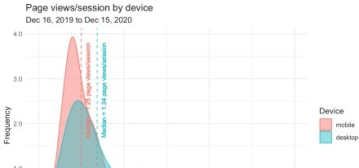

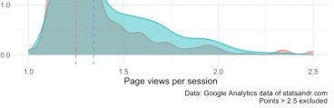

This last plot confirms our thoughts, that is, although people on mobile seem to spend more time on each page, **people on desktop tend to visit more pages per session**.

(One may wonder why I chose to compare medians instead of means. The main reason is that not all distributions considered here are bell-shaped (especially for data on tablet) and there are many outliers. In these cases, the mean is usually not the most appropriate descriptive statistics and the median is a more robust way to represent such data. For the interested reader, see a note on the difference between mean and median, and the context in which each measure is more appropriate.)

This is the end of the analytics section. Of course, many more visualizations and data analyses are possible, depending on the site that is tracked and the marketing expertise of the analyst. This was an overview of what is possible, and I hope it will give you some ideas to explore your Google Analytics data further. Next year, I may also include forecasts and make annual comparisons.

As a side note, I would like to add the following: even if tracking the performance of your blog is important to understand how you attract visitors and how they engage with your site, I also believe that **looking at your Google Analytics stats too often is not optimal**, nor sane.

Talking about personal experience: at the beginning of the blog I used to look very often at the number of visitors in real-time and the audience. I was kind of obsessed to know how many people were right now on my blog and I was constantly checking if it performed better than the day before in terms of number of visitors. I remember that I was spending so much time looking at these metrics in the first weeks that I felt I was wasting my time. And the time I was wasting looking at my Google Analytics stats was lost not creating good quality content for the blog, working on my thesis/classes, or other projects.

So when I realized that, I deleted the Google Analytics app from my smartphone and forced myself not to look at my stats more than once a month (just to make sure there is no critical issues that need to be fixed). From that moment onward, I stopped wasting my time on things I cannot control, and I got more satisfaction from writing articles because I was writing them for myself, not for the sake of seeing people reading them. This change was like a relief, and I am now more satisfied with my work on this blog compared to the first weeks or months.

Everyone is different and unique so I am not saying that you should do the same. However, if you feel that you look too much at your stats and sometimes lose motivation in writing, perhaps this is one potential solution.