# What Makes Figures Special

There’s lots of information on the web on how to optimise images for websites. Figures like line graphs, scatter plots and histograms, have to be handled a little differently than pictures. Graphs have a few distinctive characteristics.

As they usually contain text, this means we have to pay specific attention to image quality. Also, while we can resize a photograph easily, resizing a graph with text may make the axis unreadable. Furthermore, images contain thin lines and perhaps use opacity within the plot.

The core problem we are trying to solve is when we create a web page (a HTML file), the page gives a containing box with a certain width and height. We want to create a figure that matches these dimensions.

If the figure we create is too large for the box, the browser (or some clever server-side plugin) will resize your image. This has two downsides

if the client downloads the image, this will increase your page loading speed if the figure contains text, then the text will become smaller

If the figure is smaller than the box, then your figure will look pixelated and the text may become unreadable.

## The DPI issue

If you’ve ever Googled web-graphics before, you will have come across DPI or dots per inch. The typical recommendation for web-graphics is 72dpi. However, this is completely the wrong way of thinking about it. When you put a graphic/image on a website, you have a set number of pixels. This is the unit of measurement you need to consider when generating a graphic. If you are generating a graph for a PDF, then DPI is important as you can cram more points in a space. However, on a monitor you have pixels.

If your web-designer tells you to provide a 600px by 600px image – that’s what they need. DPI doesn’t actually come into this calculation!

The one caveat to the above (as we’ll see) is that dpi alters the text size when creating R images.

## Setting image dimensions

If you are creating graphics using the png() function (or a similar graphics device), then you simply need to specify the dimensions using the width and height arguments. As an example, let’s create a simple {ggplot2} scatter plot

library("ggplot2")

dd = data.frame(x = 0:10, y = 0:10) g = ggplot(dd, aes(x, y)) +

geom_point()

which we then save with dimensions of 400px by 400px:

png("figure1-400.png", width = 400, height = 400, type = "cairo-png") g

dev.off()

This creates a perfectly sized 400px by 400px image

# As we'll see below, we may have to double this resolution # for retina displays

dim(png::readPNG("figure1-400.png", TRUE)) #> [1] 400 400

When we include the scatter plot

knitr::include_graphics("figure1-400.png")

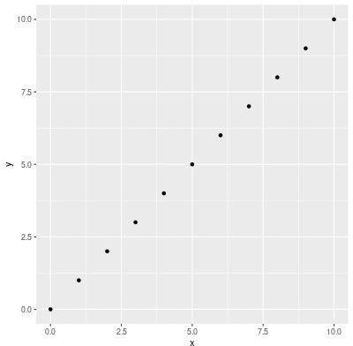

it comes out at the perfect size and resolution.

# The graphics Goldilocks principle

Suppose we create images that aren’t the correct size for the HTML container. Is it really that bad? If we create an image double the size, 800px by 800px,

png("figure1-800.png", width = 800, height = 800, type = "cairo-png") g

dev.off()

and try and squeeze it into a 400px box. The font size becomes tiny. The “quality” of the figure is fine, it’s just unreadable.

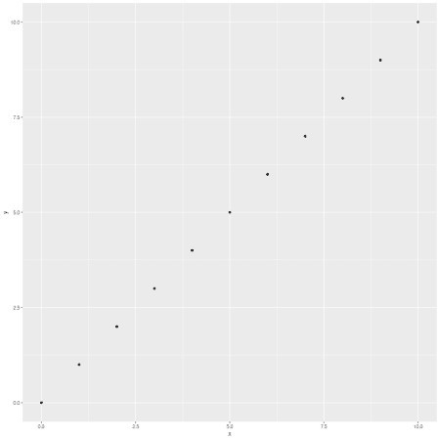

If we create an image that is only 200px, and then expanded it to fit the 400px container box, the text becomes too large and the graph is fuzzy.

png("figure1-200.png", width = 200, height = 200, type = "cairo-png") g

dev.off()

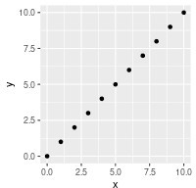

Instead, we need something not too big, not too small. But something that *just* fits.

# Setting sizes in {knitr}

Above, we created images by specifying the exact number of pixels. However in {knitr} you can’t specify the number of pixels when creating the image, instead you set the figure dimensions and also the output dimensions. The image units are hard-coded as inches within {knitr}.

The dimensions of the image are calculated via fig.height * dpi and fig.width * dpi. The fig.retina argument also comes into play, but we’ll set fig.retina = 1, which will match above, then come back to this idea at the end.

If we want to create an image with dimensions d1 and d2, then we set the {knitr} chunks to

fig.width = d1 / 72, fig.width = d2 / 72 dpi = 72 – the default fig.retina = 1

dev.args = list(type = "cairo-png") – not actually needed, but you should set it!

In theory, you should be able to set dpi to anything and get the same image, but the dpi value is passed to the res argument in png(), and that controls the text scaling. So changing dpi means your text changes. In practice, leave dpi at the default value. If you want to change the your text size, then change them in your plot.

# But what about out.width and out.height?

The {knitr} arguments out.width and out.height **don’t** change the dimensions of the png created. Instead, they control the size of the HTML container on the web-page. As we seen above, we want the container size to match the image size. By default this should happen, but you can specify the sizes explicitly out.width = "400px".

# But what about fig.retina?

When fig.retina is set to 2, the dpi is doubled, but the display sized is halved. The practical result of this is:

file sizes increase, so page loading also increases anyone with a retina display will see a crisper graph

if someone zooms into the plot on the browser, the graph should still look nice even at 200% magnification.

The defaults for fig.retina differ between {rmarkdown} and {knitr}. So rather than trying to figure it out, set it explicitly at the top of the document via

## Or 1 if you want knitr::opts_chunk$set(fig.retina = 2)

Whether you set it to 1 or 2 doesn’t affect the values you set for dpi and fig. What it **does** affect is the size of the generated image. If you don’t believe me, create two images and examine the dimensions with the png::readPNG() function.

# But what about fig.asp?

The chunk argument fig.asp controls the aspect ratio of the plot. For example, setting fig.width = fig.height would give an aspect ratio of 1. Consequently, you would only ever define **two** of fig.width, fig.height and fig.asp.

Typically I set fig.asp = 0.7 in the {knitr} header, ignore fig.height and specify the

fig.width in each chunk as needed.

# Is that all?

Unfortunately not. The following three graphics have all been using exactly the same {knitr} chunk options

fig.width = 400/72 and fig.height = 400/72

This has been our running {ggplot2} example

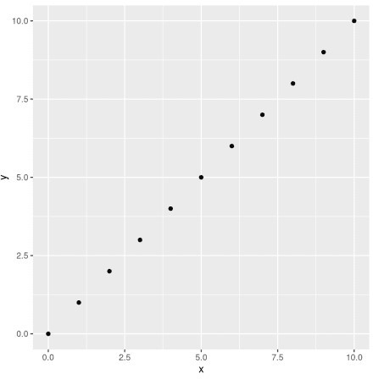

This is changing the theme via hrbrthemes::theme_ipsum() g + hrbrthemes::theme_ipsum()

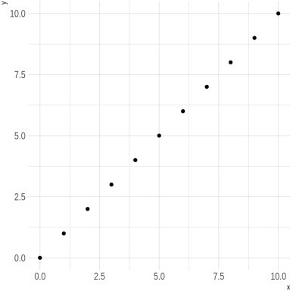

and this is standard base graphics

plot(dd$x, dd$y)

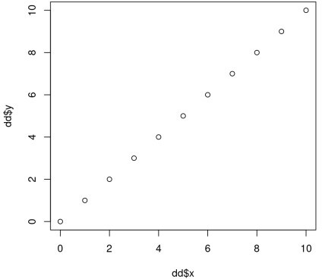

Notice that the latter two plots have a larger white space border around them. You could use a tool to automatically crop the white space, but that changes the dimensions of the image.

Instead, you should use some R code to remove the surrounding white space.



…