**Summary**: Package sf is undergoing a major change: all operations on geographical coordinates (degrees longitude, latitude) will use the s2 package, which interfaces the S2 geometry library for spherical geometry.

# sf up to 0.9-x uses mostly a flat Earth model

Suppose you work with package sf, have loaded some data

library(sf)

## Linking to GEOS 3.8.0, GDAL 3.0.4, PROJ 7.0.0

nc = read_sf(system.file("gpkg/nc.gpkg", package="sf"))

then chances are large that after running e.g.

i = st_intersects(nc)

you’ve run into the following message

## although coordinates are longitude/latitude, st_intersects assumes that they are planar

It indicates that

your data are in geographical coordinates, degrees longitude/latitude indicating a position on the globe, and

you are carrying out an operation that assumes these data lie in a flat plane, where one degree longitude equals one degree latitude, irrespective where you are on the world

This means that your data are assumed *implicitly* to be projected to the equirectangular

projection, looking like this:

library(rnaturalearth) ne <- countries110 %>%

st_as_sf() %>% st_geometry()

plot(ne, axes = TRUE)

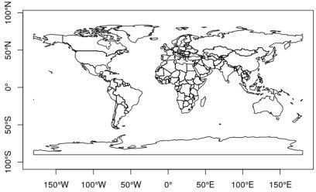

A number of operations in sf *were* actually carried out using ellipsoidal geometries, these included

computing the area of polygons, which used lwgeom::st_geod_area computing length of lines, which used lwgeom::st_geod_length computing distance between features, which used lwgeom::st_geod_distance, and

segmentizing lines along great circles, which used

lwgeom::st_geod_segmentize

but for all other operations, despite the degree symbols, everything happens just as if they were in the equivalent equirectangular projection:

st_transform(ne, "+proj=eqc") %>% plot(axes = TRUE)

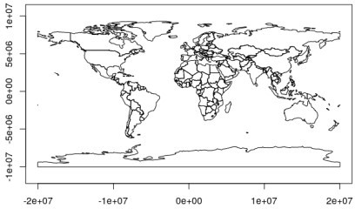

As an example, consider the polygon from

POLYGON((-150 -65, 0 -62, 120 -78, -150 -65)), drawn as a line in this

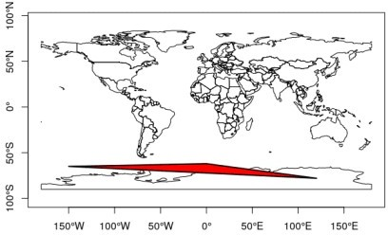

projection

corresponds to this polygon when drawn in a stereographic polar

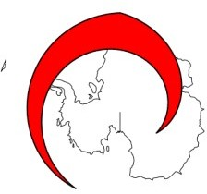

projection:

and does not include the South Pole:

pol = st_as_sfc("POLYGON((-150 -65, 0 -62, 120 -78, -150 -65))")

pole = st_as_sfc("POINT(0 -90)") st_contains(pol, pole)

## Sparse geometry binary predicate list of length 1, where the predicate was

`contains'

## 1: (empty)

(with sf 0.9-x, setting crs to 4326 will have no effect other than printing the familiar warning message)

The functions in sf up to 0.9-x that assume a flat Earth include:

all binary predicates (intersects, touches, covers, contains, equals, equals_exact, relate, …)

all geometry generating operators (centroid, intersection, union, difference, sym_difference)

st_sample

nearest functions: nearest_point, nearest_feature

functions or methods using these: st_filter, st_join,

agreggate, [, …

In addition to this, a number of ugly “hacks” needed to make things work include:

polygons and lines crossing the antimeridian (longitude +/- 180) had to be cut in two, using sf::st_wrap_dateline

polygons containing e.g. the South Pole needed to pass through (-180,-90) and (180,90)

raster data with longitude ranging from 0 to 360 could not be properly combined with -180,180 data

# sf 1.0: Goodbye flat Earth, welcome S2 spherical geometry

From version 1.0 on, wherever possible, when handling geographic coordinates package sf uses the S2 geometry

library for spatial operations. This library was written by Google, and empowers critical parts of Google Earth, Google Maps, Google Earth Engine and Google Bigquery GIS.

S2 geometry assumes that straight lines between points on the globe are not formed by straight lines in the equirectangular projection, but by great circles: the shortest path over the sphere. For the polygon above

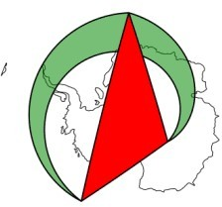

this would give:

where the light green polygon is the “straight line polygon” in equirectangular. Based on the great circle lines, this polygon now contains the South Pole:

pol = st_as_sfc("POLYGON((-150 -65, 0 -62, 120 -78, -150 -65))", crs = 4326)

pole = st_as_sfc("POINT(0 -90)", crs = 4326) st_contains(pol, pole)

## Sparse geometry binary predicate list of length 1, where the predicate was

`contains'

## 1: 1

# Where did the ellipsoid go?

Although we know that an ellipsoid better approximates the Earths’ shape, computations done with s2 are all on a spere. The ellipsoidal functions in package lwgeom (lwgeom::st_geod_area, lwgeom::st_geod_length, lwgeom::st_geod_distance, and

lwgeom::st_geod_segmentize) can, for now, still be called when setting argument use_lwgeom=TRUE to sf::st_area() etc., but in order to reduce the complexity of maintaining dependencies of package sf this

will most likely be deprecated, in which case users will have to call these functions directly when needed.

The difference between ellipsoidal and spherical computations is roughly up to 0.5%; here, for areas it is

units::set_units(1) - mean(st_area(nc) / st_area(nc, use_lwgeom = TRUE)) # difference to ellipsoidal

## 6.446441e-05 [1]

In calls to s2 measures, the radius of the Earth can be specified:

st_area(nc[1,]) # default radius: 6371010 m ## 1137107793 [m^2]

st_area(nc[1,], radius = units::set_units(1, m)) # unit sphere

## 2.801464e-05 [m^2]

# Where did my equirectangular logic go?

You can always get back the old behaviour by projecting your geographic coordinates to the equirectangular projection, and working from there,

e.g. by

nc = st_transform(nc, "+proj=eqc")

# How to test this?

The new s2 package can be installed by

remotes::install_github("r-spatial/s2")

For sf support, as shown above, you now need to install the s2

branch:

remotes::install_github("r-spatial/sf", ref = "s2")

Please report back any experiences!