The volcano3D package enables exploration of probes differentially expressed between three groups. Its main purpose is for the visualisation of differentially expressed genes in a three-dimensional volcano plot. These plots can be converted to interactive visualisations using [plotly](https://plotly.com/r/" \t "_blank):

Here I will explore a case study from the PEAC rheumatoid arthritis trial (Pathobiology of Early Arthritis Cohort).PEAC RNAseq website hosted using R Shiny and featuring volcano3D plots

This tool acts as a searchable interface to examine relationships between individual synovial and blood gene transcript levels and histological, clinical, and radiographic parameters, and clinical response at 6 months. An interactive interface allows the gene module analysis to be explored for relationships between modules and clinical parameters. The PEAC interactive web tool was creating as an [R Shiny app](https://shiny.rstudio.com/) and deployed to the web using a server.

**Getting Started**

**Prerequisites**

* R (>= 3.5)
* [ggplot2](https://cran.r-project.org/web/packages/ggplot2/index.html)
* [ggpubr](https://cran.r-project.org/web/packages/ggpubr/index.html)
* [ggrepel](https://cran.r-project.org/web/packages/ggrepel/index.html)
* [plotly](https://cran.r-project.org/web/packages/plotly/index.html)

**Install from CRAN**

install.packages("volcano3D")  
library(volcano3D)

I am pleased to present volcano3D, an R package which is now available on [CRAN](https://cran.r-project.org/web/packages/volcano3D/index.html)!

**volcano3D data**

Samples in this cohort fall into three pathotype groups:

[table](https://rdrr.io/r/base/table.html)(syn\_metadata$Pathotype)

╔═══════════╦═══════╗  
║ Pathotype ║ Count ║   
╠═══════════╬═══════╣  
║ Fibroid ║ 16 ║  
║ Lymphoid ║ 45 ║  
║ Myeloid ║ 20 ║  
╚═══════════╩═══════╝

In this example we are interested in genes that are differentially expressed between each of these groups.

First we will set up a polar object, using the polar\_coords function, which maps the expression and p-values to polar coordinates using: 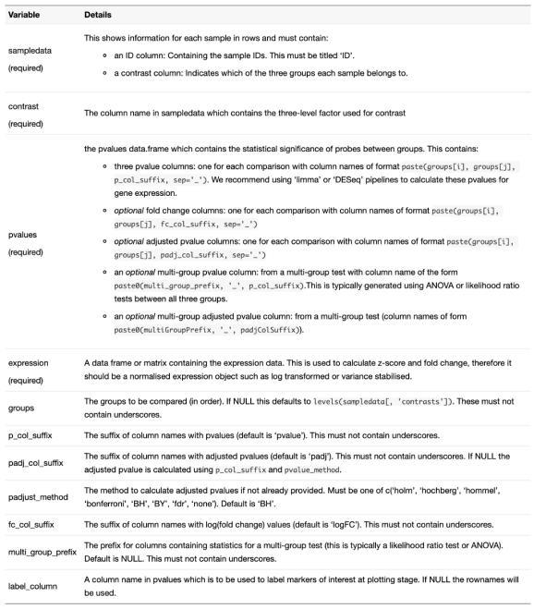

syn\_polar <- [polar\_coords](https://katrionagoldmann.github.io/volcano3D/reference/polar_coords.html)(sampledata = syn\_metadata,  
 contrast = "Pathotype",  
 pvalues = syn\_pvalues,  
 expression = syn\_rld,  
 p\_col\_suffix = "pvalue",  
 padj\_col\_suffix = "padj",  
 fc\_col\_suffix = "log2FoldChange",  
 multi\_group\_prefix = "LRT",  
 non\_sig\_name = "Not Significant",  
 significance\_cutoff = 0.01,  
 label\_column = NULL,  
 fc\_cutoff = 0.1)

This creates a polar class object with slots for: sampledata, contrast, pvalues, multi\_group\_test, expression, polar and non\_sig\_name. The pvalues slot which should have a data frame with at least two statistics for each comparison — p-value and adjusted p-value — and an optional logarithmic fold change statistic.

If there is a fold change column previously provided, we can now investigate the comparisons between pathotypes using the volcano\_trio function. This creates three [ggplot](https://ggplot2.tidyverse.org/reference/ggplot.html) outputs:

syn\_plots <-   
 [volcano\_trio](https://katrionagoldmann.github.io/volcano3D/reference/volcano_trio.html)(  
 polar = syn\_polar,  
 sig\_names = [c](https://rdrr.io/r/base/c.html)("not significant","significant",  
 "not significant","significant"),  
 colours = [rep](https://rdrr.io/r/base/rep.html)([c](https://rdrr.io/r/base/c.html)("grey60", "slateblue1"), 2),  
 text\_size = 9,  
 marker\_size=1,  
 shared\_legend\_size = 0.9,  
 label\_rows = [c](https://rdrr.io/r/base/c.html)("SLAMF6", "PARP16", "ITM2C"),  
 fc\_line = FALSE,  
 share\_axes = FALSE)

syn\_plots$All

volcano plots showing differential expression for each comparison

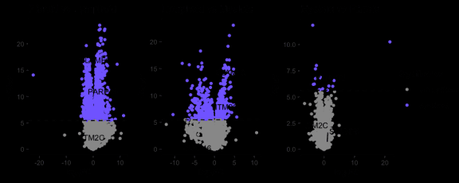

**Radial Plots**

The differential expression can now be visualised on an interactive radar plot using radial\_plotly. The labelRows variable allows any markers of interest to be labelled.

[radial\_plotly](https://katrionagoldmann.github.io/volcano3D/reference/radial_plotly.html)(polar = syn\_polar,  
 label\_rows = [c](https://rdrr.io/r/base/c.html)("SLAMF6", "PARP16", "ITM2C"))

Interactive radial plot showing the differential expression of probes between all three groups.

By hovering over certain points you can also determine genes for future interrogation.

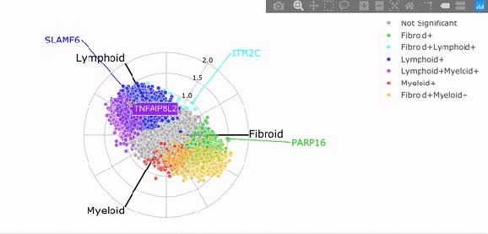

Similarly we can create a static ggplot image using radial\_ggplot:

[radial\_ggplot](https://katrionagoldmann.github.io/volcano3D/reference/radial_ggplot.html)(polar = syn\_polar,  
 label\_rows = [c](https://rdrr.io/r/base/c.html)("SLAMF6", "FMOD"),  
 marker\_size = 2.3,  
 legend\_size = 10) +  
 theme(legend.position = "right")

Using ggplot2 for a static radial plot

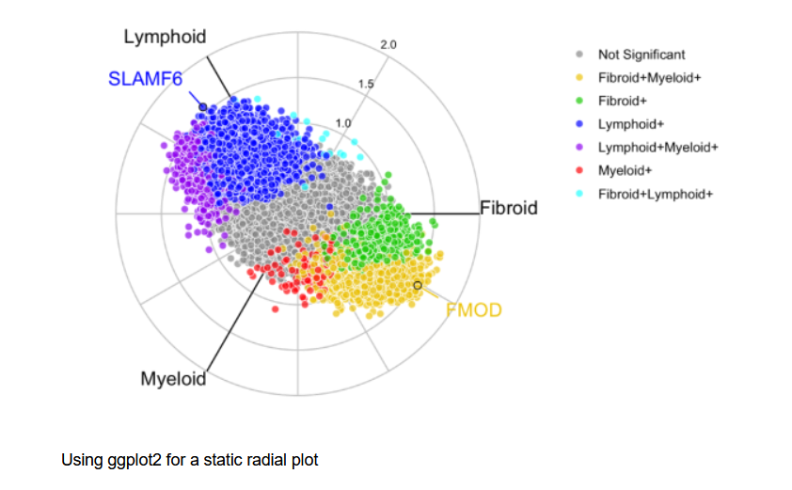

**Boxplots**

We can then interrogate any one specific variable as a boxplot, to investigate these differences. This is built using either ggplot2 or plotly so can easily be edited by the user to add features.

plot1 <- [boxplot\_trio](https://katrionagoldmann.github.io/volcano3D/reference/boxplot_trio.html)(syn\_polar,  
 value = "FAM92B",  
 text\_size = 7,  
 test = "polar\_padj",  
 levels\_order = [c](https://rdrr.io/r/base/c.html)("Lymphoid", "Myeloid", "Fibroid"),  
 box\_colours = [c](https://rdrr.io/r/base/c.html)("blue", "red", "green3"),  
 step\_increase = 0.1)  
  
plot2 <- [boxplot\_trio](https://katrionagoldmann.github.io/volcano3D/reference/boxplot_trio.html)(syn\_polar,  
 value = "SLAMF6",  
 text\_size = 7,  
 test = "polar\_multi\_padj",  
 levels\_order = [c](https://rdrr.io/r/base/c.html)("Lymphoid", "Myeloid", "Fibroid"),  
 box\_colours = [c](https://rdrr.io/r/base/c.html)("blue", "red", "green3"))  
  
plot3 <- [boxplot\_trio](https://katrionagoldmann.github.io/volcano3D/reference/boxplot_trio.html)(syn\_polar,  
 value = "PARP16",  
 text\_size = 7,  
 stat\_size=2.5,  
 test = "t.test",  
 levels\_order = [c](https://rdrr.io/r/base/c.html)("Myeloid", "Fibroid"),  
 box\_colours = [c](https://rdrr.io/r/base/c.html)("pink", "gold"))  
  
ggarrange(plot1, plot2, plot3, ncol=3)

Boxplots showing the differential expression for a specific probe or gene

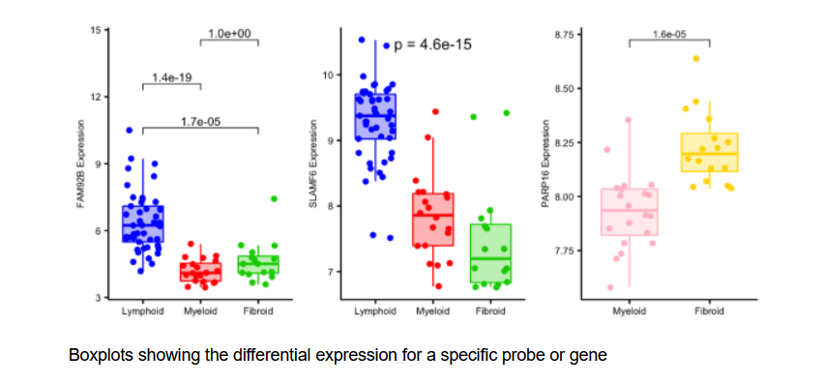

**Three Dimensional Volcano Plots**

The final thing we can look at is the 3D volcano plot which projects differential gene expression onto cylindrical coordinates.

p <- [volcano3D](https://katrionagoldmann.github.io/volcano3D/reference/volcano3D.html)(syn\_polar,  
 label\_rows = [c](https://rdrr.io/r/base/c.html)("SLAMF6", "PARP16", "ITM2C"),  
 label\_size = 10,  
 colour\_code\_labels = F,  
 label\_colour = "black",  
 xy\_aspectratio = 1,  
 z\_aspectratio = 0.9,  
 plot\_height = 800)

Interactive volcano3D showing differential expression between points

