# Modeltime Ensemble

## The time series ensemble extension to Modeltime



Modeltime Ensemble is a cutting-edge package that integrates ***3 competition-winning time series ensembling strategies***:

1. **Super Learners (Meta-Learners):** Use modeltime_fit_resamples() and

ensemble_model_spec() to create super learners (models that learn from the predictions of sub-models)

1. **Weighted Ensembles**: Use ensemble_weighted() to create weighted ensembles.
2. **Average Ensembles**: Use ensemble_average() to build simple average and median ensembles.

#### High-Performance Forecasting Stacks

Using these modeltime.ensemble, you can build high-performance forecasting stacks. Here’s a **Multi-Level Stack**, which won the *Kaggle Grupo Bimbo Inventory Demand Forecasting Competition* .

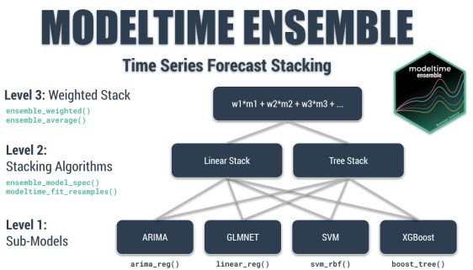

The Multi-Level Stacked Ensemble that won the Kaggle Grupo Bimbo Inventory Demand Challenge

# Ensemble Tutorial

## Forecasting Product Sales with Average Ensembles

**Today, I’ll cover forecasting Product Sales with Average and Weighted Ensembles**, which are fast to implement and can have good performance (although super-learner’s tend to have better performance).

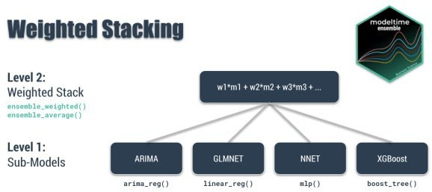

Weighted Stacking with Modeltime Ensemble

#### Ensemble Key Concepts:

The idea is that we have several sub-models (Level 1) that make predictions. We can then take these predictions and combine them using a simple average (mean), median average, or a weighted average:

**Simple Average:** Weights all models with the same proportion. Selects the average for each timestamp. Use ensemble_average(type = "mean").

**Median Average**: No weighting. Selects prediction using the centered value for each time stamp. Use ensemble_average(type = "median").

**Weighted Average:** User defines the weights (loadings). Applies a weighted average at each of the timestamps. Use ensemble_weighted(loadings = c(1, 2, 3, 4)).

#### More Advanced Ensembles:

The average and weighted ensembles are the simplest approaches to ensembling. One method that Modeltime Ensemble has integrated is ***Super Learners.*** We won’t cover these in this tutorial.

# Getting Started

## Let’s kick the tires on modeltime.ensemble

Install modeltime.ensemble. install.packages("modeltime.ensemble")

Load the following libraries.

# Time Series Modeling and Machine Learning library(tidymodels)

library(modeltime) library(modeltime.ensemble)

# Time Series and Data Wrangling library(timetk) library(tidyverse)

# Get Your Data

## Forecasting Product Sales

Our Business objective is to forecast the next 12-weeks of Product Sales given 2-year sales history.

We’ll start with a walmart_sales_weekly time series data set that includes Walmart Product Transactions from several stores, which is a small sample of the dataset from Kaggle Walmart Recruiting – Store Sales Forecasting. We’ll simplify the data set to a univariate time series with columns, “Date” and “Weekly_Sales” from Store 1 and Department 1.

store_1_1_tbl <- walmart_sales_weekly %>% filter(id == "1_1") %>%

select(Date, Weekly_Sales)

store_1_1_tbl

## # A tibble: 143 x 2

|  |  |  |  |
| --- | --- | --- | --- |
| ##  ## |  | Date | Weekly_Sales |
| ## | 1 | 2010-02-05 | 24924. |
| ## | 2 | 2010-02-12 | 46039. |
| ## | 3 | 2010-02-19 | 41596. |
| ## | 4 | 2010-02-26 | 19404. |
| ## | 5 | 2010-03-05 | 21828. |
| ## | 6 | 2010-03-12 | 21043. |
| ## | 7 | 2010-03-19 | 22137. |
| ## | 8 | 2010-03-26 | 26229. |
| ## | 9 | 2010-04-02 | 57258. |
| ## | 10 | 2010-04-09 | 42961. |

## # … with 133 more rows

Next, visualize the dataset with the plot_time_series() function. Toggle .interactive = TRUE to get a plotly interactive plot. FALSE returns a ggplot2 static plot.

store_1_1_tbl %>%

plot_time_series(Date, Weekly_Sales, .smooth_period = "3 months", .interactive = FALSE

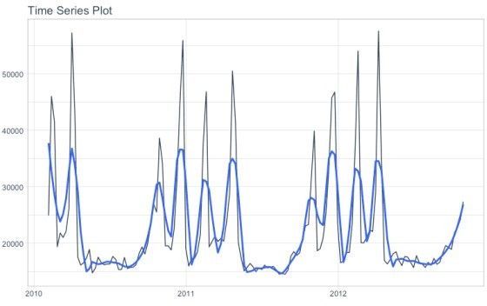

# Seasonality Evaluation

Let’s do a quick seasonality evaluation to hone in on important features using

plot_seasonal_diagnostics().

store_1_1_tbl %>% plot_seasonal_diagnostics(

Date, Weekly_Sales,

.feature_set = c("week", "month.lbl"),

.interactive = FALSE

)

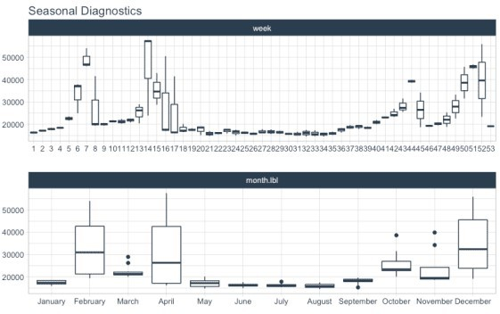

We can see that certain weeks and months of the year have higher sales. **These anomalies are**

**likely due to events.** The Kaggle Competition informed competitors that Super Bowl, Labor Day, Thanksgiving, and Christmas were special holidays. To approximate the events, week number and month may be good features. Let’s come back to this when we preprocess our data.

# Train / Test

## Split your time series into training and testing sets

Give the objective to forecast 12 weeks of product sales, we use time_series_split() to make a train/test set consisting of 12-weeks of test data (hold out) and the rest for training.

Setting assess = "12 weeks" tells the function to use the last 12-weeks of data as the testing set.

Setting cumulative = TRUE tells the sampling to use all of the prior data as the training set.

splits <- store_1_1_tbl %>%

time_series_split(assess = "12 weeks", cumulative = TRUE)

Next, visualize the train/test split.

tk_time_series_cv_plan(): Converts the splits object to a data frame plot_time_series_cv_plan(): Plots the time series sampling data using the “date” and “value” columns.

splits %>%

tk_time_series_cv_plan() %>% plot_time_series_cv_plan(Date, Weekly_Sales, .interactive

= FALSE)

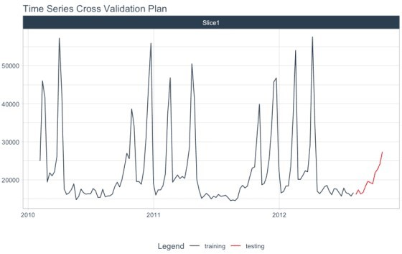

# Feature Engineering

We’ll make a number of ***calendar features*** using recipes. Most of the heavy lifting is done by

timetk::step_timeseries_signature(), which generates a series of common time

series features. We remove the ones that won’t help. After dummying we have 74 total columns, 72 of which are engineered calendar features.

recipe_spec <- recipe(Weekly_Sales ~ Date, store_1_1_tbl) %>% step_timeseries_signature(Date) %>% step_rm(matches("(iso$)|(xts$)|(day)|(hour)|(min)|

(sec)|(am.pm)")) %>%

step_mutate(Date_week = factor(Date_week, ordered = TRUE)) %>%

step_dummy(all_nominal()) %>% step_normalize(contains("index.num"), Date_year)

recipe_spec %>% prep() %>% juice() ## # A tibble: 143 x 74

## Date Weekly_Sales Date_index.num Date_year Date_half Date_quarter

##

|  |  |  |  |  |  |
| --- | --- | --- | --- | --- | --- |
| ## | 1 | 2010-02-05 | 24924. | -1.71 | -1.21 |
| 1 |  | 1 |  |  |  |
| ## | 2 | 2010-02-12 | 46039. | -1.69 | -1.21 |
| 1 |  | 1 |  |  |  |
| ## | 3 | 2010-02-19 | 41596. | -1.67 | -1.21 |
| 1 |  | 1 |  |  |  |
| ## | 4 | 2010-02-26 | 19404. | -1.64 | -1.21 |
| 1 |  | 1 |  |  |  |
| ## | 5 | 2010-03-05 | 21828. | -1.62 | -1.21 |
| 1 |  | 1 |  |  |  |
| ## | 6 | 2010-03-12 | 21043. | -1.59 | -1.21 |
| 1 |  | 1 |  |  |  |
| ## | 7 | 2010-03-19 | 22137. | -1.57 | -1.21 |
| 1 |  | 1 |  |  |  |
| ## | 8 | 2010-03-26 | 26229. | -1.54 | -1.21 |
| 1 |  | 1 |  |  |  |
| ## | 9 | 2010-04-02 | 57258. | -1.52 | -1.21 |
| 1 |  | 2 |  |  |  |
| ## | 10 | 2010-04-09 | 42961. | -1.50 | -1.21 |
| 1 |  | 2 |  |  |  |

## # … with 133 more rows, and 68 more variables: Date_month

,

## # Date_mweek , Date_week2 , Date_week3 , Date_week4 , ## # Date_month.lbl_01 , Date_month.lbl_02 , Date_month.lbl_03 ,

## # Date_month.lbl_04 , Date_month.lbl_05 , Date_month.lbl_06 ,

## # Date_month.lbl_07 , Date_month.lbl_08 , Date_month.lbl_09 ,

## # Date_month.lbl_10 , Date_month.lbl_11 , Date_week_01 , ## # Date_week_02 , Date_week_03 , Date_week_04 ,

## # Date_week_05 , Date_week_06 , Date_week_07 , ## # Date_week_08 , Date_week_09 , Date_week_10 , ## # Date_week_11 , Date_week_12 , Date_week_13 ,

|  |  |  |  |  |  |  |  |
| --- | --- | --- | --- | --- | --- | --- | --- |
| ## | # | Date_week_14 | , | Date_week_15 | , | Date_week_16 | , |
| ## | # | Date_week_17 | , | Date_week_18 | , | Date_week_19 | , |
| ## | # | Date_week_20 | , | Date_week_21 | , | Date_week_22 | , |
| ## | # | Date_week_23 | , | Date_week_24 | , | Date_week_25 | , |
| ## | # | Date_week_26 | , | Date_week_27 | , | Date_week_28 | , |
| ## | # | Date_week_29 | , | Date_week_30 | , | Date_week_31 | , |
| ## | # | Date_week_32 | , | Date_week_33 | , | Date_week_34 | , |
| ## | # | Date_week_35 | , | Date_week_36 | , | Date_week_37 | , |
| ## | # | Date_week_38 | , | Date_week_39 | , | Date_week_40 | , |
| ## | # | Date_week_41 | , | Date_week_42 | , | Date_week_43 | , |
| ## | # | Date_week_44 | , | Date_week_45 | , | Date_week_46 | , |
| ## | # | Date_week_47 | , | Date_week_48 | , | Date_week_49 | , |
| ## | # | Date_week_50 | , | Date_week_51 | , | Date_week_52 |  |

# Make Sub-Models

**Let’s make some sub-models with** Modeltime

Now for the fun part! Let’s make some models using functions from modeltime and parsnip.

### Auto ARIMA

Here’s the basic Auto ARIMA Model.

**Model Spec: arima_reg()** <– This sets up your general model algorithm and key parameters

**Set Engine: set_engine("auto_arima")** <– This selects the specific package- function to use and you can add any function-level arguments here.

**Fit Model: fit(Weekly_Sales ~ Date, training(splits))** <– All Modeltime Models require a date column to be a regressor.

model_fit_arima <- arima_reg(seasonal_period = 52) %>% set_engine("auto_arima") %>%

fit(Weekly_Sales ~ Date, training(splits))

model_fit_arima

## parsnip model object ##

## Fit time: 206ms ## Series: outcome

## ARIMA(0,0,1)(0,1,0)[52] ##

## Coefficients:

## ma1

## 0.6704

## s.e. 0.0767 ##

## sigma^2 estimated as 60063672: log likelihood=-819.37 ## AIC=1642.74 AICc=1642.9 BIC=1647.48

### Elastic Net

Making an Elastic NET model is easy to do. Just set up your model spec using linear_reg()

and set_engine("glmnet"). Note that we have not fitted the model yet (as we did in previous steps).

model_spec_glmnet <- linear_reg(penalty = 0.01, mixture = 0.5) %>%

set_engine("glmnet")

Next, make a fitted workflow:

**Start** with a workflow()

**Add a Model Spec:** add_model(model_spec_glmnet)

**Add Preprocessing:** add_recipe(recipe_spec %>% step_rm(date)) <– Note that I’m removing the “date” column since Machine Learning algorithms don’t typically know how to deal with date or date-time features

**Fit the Workflow**: fit(training(splits))

wflw_fit_glmnet <- workflow() %>% add_model(model_spec_glmnet) %>% add_recipe(recipe_spec %>% step_rm(Date)) %>% fit(training(splits))

### XGBoost

We can fit a XGBoost Model using a similar process as the Elastic Net.

model_spec_xgboost <- boost_tree() %>% set_engine("xgboost")

set.seed(123)

wflw_fit_xgboost <- workflow() %>% add_model(model_spec_xgboost) %>% add_recipe(recipe_spec %>% step_rm(Date)) %>% fit(training(splits))

### NNETAR

We can use a NNETAR model. Note that add_recipe() uses the full recipe (with the Date column) because this is a Modeltime Model.

model_spec_nnetar <- nnetar_reg( seasonal_period = 52,

non_seasonal_ar = 4,

seasonal_ar = 1

) %>%

set_engine("nnetar")

set.seed(123)

wflw_fit_nnetar <- workflow() %>% add_model(model_spec_nnetar) %>% add_recipe(recipe_spec) %>% fit(training(splits))

### Prophet w/ Regressors

We’ll build a Prophet Model with Regressors. This uses the Facebook Prophet forecasting algorithm and supplies all of the 72 features as regressors to the model. Note – Because this is a Modeltime Model we need to have a Date Feature in the recipe.

model_spec_prophet <- prophet_reg( seasonality_yearly = TRUE

) %>%

set_engine("prophet")

wflw_fit_prophet <- workflow() %>% add_model(model_spec_prophet) %>% add_recipe(recipe_spec) %>% fit(training(splits))

# Sub-Model Evaluation

Let’s take a look at our progress so far. We have 5 models. We’ll put them into a Modeltime Table to organize them using modeltime_table().

submodels_tbl <- modeltime_table( model_fit_arima, wflw_fit_glmnet, wflw_fit_xgboost, wflw_fit_nnetar, wflw_fit_prophet

)

submodels_tbl

## # Modeltime Table ## # A tibble: 5 x 3

## .model_id .model .model_desc ##

|  |  |  |  |
| --- | --- | --- | --- |
| ## | 1 | 1 | ARIMA(0,0,1)(0,1,0)[52] |
| ## | 2 | 2 | GLMNET |
| ## | 3 | 3 | XGBOOST |
| ## | 4 | 4 | NNAR(4,1,10)[52] |
| ## | 5 | 5 | PROPHET W/ REGRESSORS |

We can get the accuracy on the hold-out set using modeltime_accuracy() and table_modeltime_accuracy(). The best model is the Prophet with Regressors with a MAE of 1031.

submodels_tbl %>% modeltime_accuracy(testing(splits)) %>% table_modeltime_accuracy(.interactive = FALSE)

#### Accuracy Table

**.model_id .model_desc .type mae mape mase smape rmse rsq**

|  |  |  |  |  |  |  |
| --- | --- | --- | --- | --- | --- | --- |
| 1 | ARIMA(0,0,1)(0,1,0)[52] | Test | 1359.99 6.77 | 1.02 | 6.93 | 1721.47 0.95 |
| 2 | GLMNET | Test | 1222.38 6.47 | 0.91 | 6.73 | 1349.88 0.98 |
| 3 | XGBOOST | Test | 1089.56 5.22 | 0.82 | 5.20 | 1266.62 0.96 |

#### Accuracy Table

|  |  |  |  |
| --- | --- | --- | --- |
| 4 | NNAR(4,1,10)[52] | Test 2529.92 11.68 1.89 10.73 | 3507.55 0.93 |
| 5 | PROPHET W/ REGRESSORS | Test 1031.53 5.13 0.77 5.22 | 1226.80 0.98 |

And, we can visualize the forecasts with modeltime_forecast() and

plot_modeltime_forecast().

submodels_tbl %>% modeltime_forecast(

new_data = testing(splits), actual_data = store_1_1_tbl

) %>%

plot_modeltime_forecast(.interactive = FALSE)

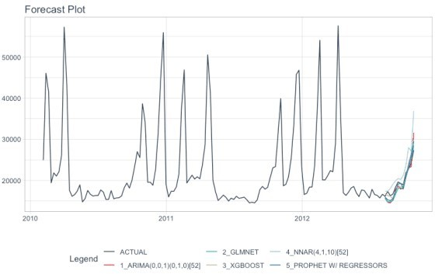

# Build Modeltime Ensembles

**This is** exciting.

**We’ll make Average, Median, and Weighted Ensembles.** If you are interested in making Super Learners (Meta-Learner Models that leverage sub-model predictions.

I’ve made it super simple to build an ensemble from a Modeltime Tables. Here’s how to use

ensemble_average().

Start with your Modeltime Table of Sub-Models Pipe into ensemble_average(type = "mean")

You now have a fitted average ensemble.

# Simple Average Ensemble ensemble_fit_avg <- submodels_tbl %>%

ensemble_average(type = "mean")

ensemble_fit_avg

## ── Modeltime Ensemble ──────────────────────────────

## Ensemble of 5 Models (MEAN) ##

## # Modeltime Table ## # A tibble: 5 x 3

## .model_id .model .model_desc ##

|  |  |  |  |
| --- | --- | --- | --- |
| ## | 1 | 1 | ARIMA(0,0,1)(0,1,0)[52] |
| ## | 2 | 2 | GLMNET |
| ## | 3 | 3 | XGBOOST |
| ## | 4 | 4 | NNAR(4,1,10)[52] |
| ## | 5 | 5 | PROPHET W/ REGRESSORS |

We can make median and weighted ensembles just as easily. Note - For the weighted ensemble I’m loading the better performing models higher.

# Simple Median Ensemble ensemble_fit_med <- submodels_tbl %>%

ensemble_average("median")

# Higher Loading on Better Models (Test RMSE) ensemble_fit_wt <- submodels_tbl %>%

ensemble_weighted(loadings = c(2, 4, 6, 1, 6))

# Ensemble Evaluation

## Let’s see how we did

We need to have Modeltime Tables that organize our ensembles before we can assess performance. Just use modeltime_table() to organize ensembles just like we did for the Sub-Models.

ensemble_models_tbl <- modeltime_table( ensemble_fit_avg, ensemble_fit_med,

ensemble_fit_wt

)

ensemble_models_tbl

## # Modeltime Table ## # A tibble: 3 x 3

## .model_id .model .model_desc

|  |  |  |  |  |
| --- | --- | --- | --- | --- |
| ## |  | | | |
| ## | 1 | 1 | ENSEMBLE | (MEAN): 5 MODELS |
| ## | 2 | 2 | ENSEMBLE | (MEDIAN): 5 MODELS |
| ## | 3 | 3 | ENSEMBLE | (WEIGHTED): 5 MODELS |

Let’s check out the Accuracy Table using modeltime_accuracy() and

table_modeltime_accuracy().

From MAE, Ensemble Model ID 1 has 1000 MAE, **a 3% improvement** over our best submodel (MAE 1031).

From RMSE, Ensemble Model ID 3 has 1228, which is on par with our best submodel.

ensemble_models_tbl %>% modeltime_accuracy(testing(splits)) %>% table_modeltime_accuracy(.interactive = FALSE)

#### Accuracy Table

**.model_id .model_desc .type mae mape mase smape rmse rsq**

|  |  |  |  |  |  |  |
| --- | --- | --- | --- | --- | --- | --- |
| 1 ENSEMBLE (MEAN): 5 MODELS | | Test | 1000.01 4.63 | 0.75 | 4.58 | 1408.68 0.97 |
| 2 ENSEMBLE (MEDIAN): 5 MODELS | | Test | 1146.60 5.68 | 0.86 | 5.77 | 1310.30 0.98 |
| 3 | ENSEMBLE (WEIGHTED): 5 MODELS | Test | 1056.59 5.15 | 0.79 | 5.20 | 1228.45 0.98 |

And finally we can visualize the performance of the ensembles.

ensemble_models_tbl %>% modeltime_forecast(

new_data = testing(splits), actual_data = store_1_1_tbl

) %>%

plot_modeltime_forecast(.interactive = FALSE)

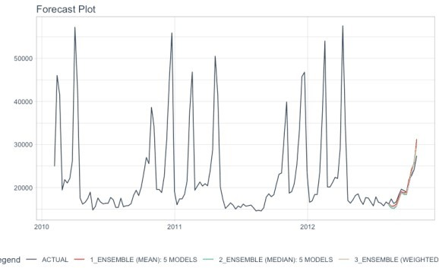

# It gets better

## You’ve just scratched the surface, here’s what’s coming…

The modeltime.ensemble package functionality is much more feature-rich than what we’ve covered here (I couldn’t possibly cover everything in this post). 

Here’s what I didn’t cover:

**Super-Learners:** We can make use resample predictions from our sub-models as inputs to a meta-learner. This can result is significantly better accuracy (5% improvement is what we achieve in my Time Series Course).

**Multi-Level Modeling:** This is the strategy that won the Grupo Bimbo Inventory Demand Forecasting Challenge where multiple layers of esembles are used.

**Refitting Sub-Models and Meta-Learners:** Refitting is special task that is needed prior to forecasting future data. Refitting requires careful attention to control the sub-model and meta-learner retraining process.

…