There are six pre-described line types available in base R. You can use those for any type of graphics, like plotting for line charts or developing simple shapes.

In R base plot functions, two options are available **lty** and **lwd**, **lty** stands for line types, and **lwd** for line width. The type of line you can be specified based on a number or a string. In R the default line type is “solid”.

In the case of **ggplot2** package, the parameters **linetype** and **size** are used to decide the type and the size of lines, respectively.

In this tutorial describes how to change line types in R for plots created using either the R base plot or from the ggplot2 package.

You will understand how to:

1. Use the different types line graphs in R.
2. Plot two lines and modify the line style for base plots and ggplot
3. Adjust the R line thickness by specifying the options lwd and size.
4. Change manually the appearance of linetype, color and size

## Different line types in R

From ggpubr package with single line of code we can show the list of line types available in R.

library(ggpubr) show_line_types()

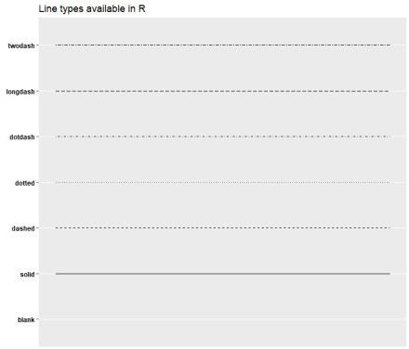

We cam make use below function and write clear labels with number and string.

LineTypes<-function(){

oldPar<-par() par(font=2, mar=c(0,0,0,0))

plot(1, pch="", ylim=c(0,6), xlim=c(0,0.7), axes=FALSE,xlab="", ylab="")

for(i in 0:6) lines(c(0.3,0.7), c(i,i), lty=i, lwd=3)

text(rep(0.1,6), 0:6, labels=c("0.'blank'", "1.'solid'", "2.'dashed'", "3.'dotted'",

"4.'dotdash'", "5.'longdash'",

"6.'twodash'"))

par(mar=oldPar$mar,font=oldPar$font )} LineTypes()

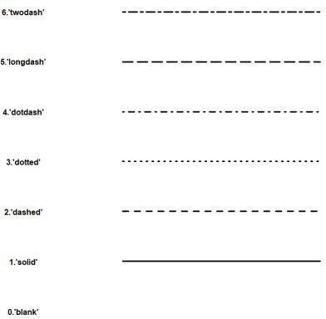

## Change R base plot line types

R lines functions:-

plot(x, y, type = "l", lty = 1). Create the main plot lines(x, y, type = "l", lty = 1). Add lines onto the plot.

**Key options:**

x, y: variables to be used for the x and y axes.

type: display the data as line and/or point. Lowed values: l (display line only), p (show point only), and b (show both).

pch and cex: setpoints shape and size, respectively. lty, lwd: set line types and thickness.

col: change the color of point and line.

xlab and ylab: for x and y-axis labels, respectively.

Create some variables for visualization,

x <- 1:20

y1 <- x*x y2 <- 1*y1

Just plot a first line based on plot function in R,

plot(x, y1, type = "b", frame = FALSE, pch = 19, col = "red", xlab = "x", ylab = "y",

lty = 1, lwd = 1)

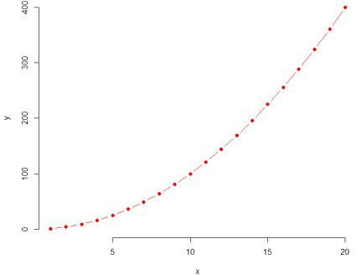

Now Add a second line

lines(x, y2, pch = 18, col = "blue", type = "b",lty = 2, lwd = 1)

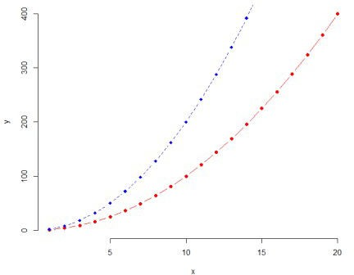

If you want you can add a legend to the plot and set legend lty

legend("topright", legend = c("Line 1", "Line 2"), col = c("red", "blue"), lty = 1:2, cex = 0.8)

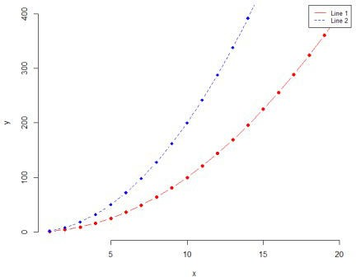

# Line Types in ggplot

First, let’s load the data set.

ToothGrowth$dose <- as.factor(ToothGrowth$dose) head(ToothGrowth)

|  |  |  |
| --- | --- | --- |
| len | supp | dose |
| 1 4.2 | VC | 0.5 |
| 2 11.5 | VC | 0.5 |
| 3 7.3 | VC | 0.5 |
| 4 5.8 | VC | 0.5 |
| 5 6.4 | VC | 0.5 |
| 6 10.0 | VC | 0.5 |

library(dplyr)

df <- ToothGrowth %>% group_by(dose) %>% summarise(len.mean = mean(len))

df

Now created average values based on group by dose.

|  |  |
| --- | --- |
| dose | len.mean |
| 1 0.5 | 10.605 |
| 2 1 | 19.735 |
| 3 2 | 26.100 |

Let’s plot the same

library(ggplot2)

ggplot(data = df, aes(x = dose, y = len.mean, group = 1)) + geom_line(linetype = "dashed")+

geom_point()

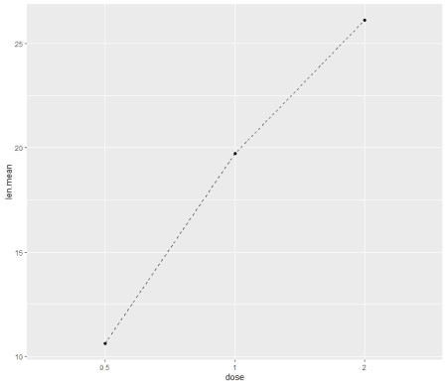

Create a line plot for multiple groups

library(dplyr)

df2 <- ToothGrowth %>% group_by(dose, supp) %>% summarise(len.mean = mean(len)) df2

dose supp len.mean 1 0.5 OJ 13.23

2 0.5 VC 7.98

3 1 OJ 22.70

4 1 VC 16.77

5 2 OJ 26.06

6 2 VC 26.14

ggplot(df2, aes(x = dose, y = len.mean, group = supp)) + geom_line(aes(linetype = supp, color = supp))+ geom_point(aes(color = supp))+theme_bw()

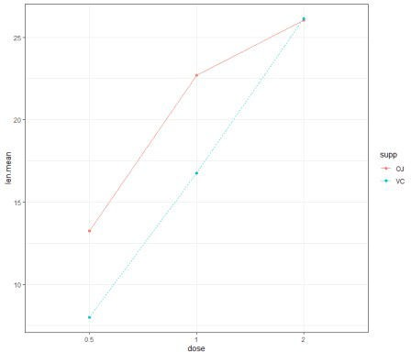

Now change line type and color manually

ggplot(df2, aes(x = dose, y = len.mean, group = supp)) + geom_line(aes(linetype = supp, color = supp))+ geom_point(aes(color = supp))+theme_bw()+ scale_linetype_manual(values=c("solid", "longdash"))+

scale_color_manual(values=c("#00AFBB","#FC4E07"))

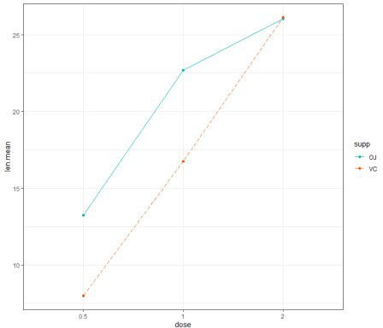

# Conclusion

Use **lty** and **lwd** options, for changing lines type and thickness in R base graphics and in ggplot

**linetype** and **size** are used.