linear discriminant analysis, originally developed by R A Fisher in 1936 to classify subjects into one of the two clearly defined groups.

It was later expanded to classify subjects into more than two groups.

Linear Discriminant Analysis (LDA) is a dimensionality reduction technique. LDA used for dimensionality reduction to reduce the number of dimensions (i.e. variables) in a dataset while retaining as much information as possible.

Basically, it helps to find the linear combination of original variables that provide the best possible separation between the groups.

The basic purpose is to estimate the relationship between a single categorical dependent variable and a set of quantitative independent variables.

The major applications or examples are

* Predicting success or failure of new products
* Accepting or rejecting admission to an applicant.
* Predicting credit risk category for a person
* Classifying patients into different categories.

Let’s look into the iris data set for further analysis.

**Load Library**

library(klaR)

library(psych)

library(MASS)

library(ggord)

library(devtools)

**Getting Data**

data("iris")

str(iris)

Total 150 observations and 5 variables contains in the iris dataset.

'data.frame':       150 obs. of  5 variables:

 $ Sepal.Length: num  5.1 4.9 4.7 4.6 5 5.4 4.6 5 4.4 4.9 ...

 $ Sepal.Width : num  3.5 3 3.2 3.1 3.6 3.9 3.4 3.4 2.9 3.1 ...

 $ Petal.Length: num  1.4 1.4 1.3 1.5 1.4 1.7 1.4 1.5 1.4 1.5 ...

 $ Petal.Width : num  0.2 0.2 0.2 0.2 0.2 0.4 0.3 0.2 0.2 0.1 ...

 $ Species     : Factor w/ 3 levels "setosa","versicolor",..: 1 1 1 1 1 1 1 1 1 1 ...

First will create a scatterplot for the first four numerical variables. The gap between the points given is zero.

pairs.panels(iris[1:4],

             gap = 0,

             bg = c("red", "green", "blue")[iris$Species],

             pch = 21)

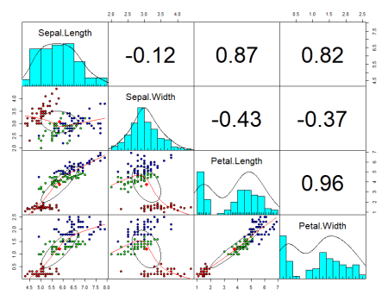

Now you can see in the plot, scatter diagram, histogram, and correlation values.

Now we want to create the best separation groups based on these species.

**Data partition**

Let’s create a training dataset and test dataset for prediction and testing purposes. 60% dataset used for training purposes and 40$ used for testing purposes.

set.seed(123)

ind <- sample(2, nrow(iris),

              replace = TRUE,

              prob = c(0.6, 0.4))

training <- iris[ind==1,]

testing <- iris[ind==2,]

**Linear discriminant analysis**

linear <- lda(Species~., training)

linear

Call:

lda(Species ~ ., data = training)

Prior probabilities of groups:

    setosa versicolor  virginica

 0.3837209  0.3139535  0.3023256

Group means:

           Sepal.Length Sepal.Width Petal.Length Petal.Width

setosa         4.975758    3.357576     1.472727   0.2454545

versicolor     5.974074    2.751852     4.281481   1.3407407

virginica      6.580769    2.946154     5.553846   1.9807692

Coefficients of linear discriminants:

                   LD1        LD2

Sepal.Length  1.252207 -0.1229923

Sepal.Width   1.115823  2.2711963

Petal.Length -2.616277 -0.7924520

Petal.Width  -2.156489  2.6956343

The proportion of trace:

   LD1    LD2

0.9937 0.0063

Based on the training dataset, 38% belongs to setosa group, 31% belongs to versicolor groups and 30% belongs to virginica groups.

The first discriminant function is a linear combination of the four variables.

Percentage separations achieved by the first discriminant function is 99.37% and second is 0.63%

attributes(linear)

[1] "prior"   "counts"  "means"   "scaling" "lev"     "svd"     "N"       "call"    "terms"

[10] "xlevels"

$class

[1] "lda"

**Histogram**

Stacked histogram for discriminant function values.

p <- predict(linear, training)

ldahist(data = p$x[,1], g = training$Species) 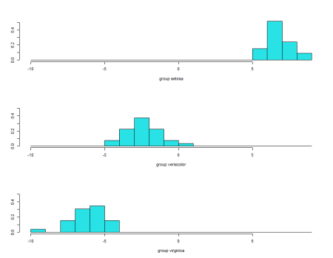

These histograms are based on ld1. It’s clearly evident that no overlaps between first and second and first and third species. But some overlap observed between the second and third species.

ldahist(data = p$x[,2], g = training$Species) 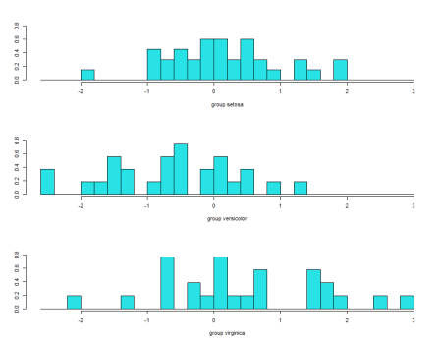

histogram based on lda2 showing complete overlap and its not good.

**Bi-Plot**

ggord(linear, training$Species, ylim = c(-10, 10)) 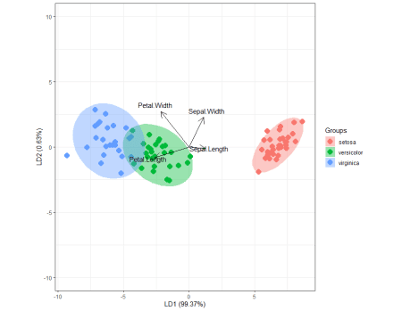

Biplot based on LD1  and LD2. Setosa separated very clearly and some overlap observed between Versicolor and virginica.

Based on arrows, Sepal width and sepal length explained more for setosa, petal width and petal length explained more for versicolor and virginica.

**Partition plot**

It provides the classification of each and every combination in the training dataset.

partimat(Species~., data = training, method = "lda")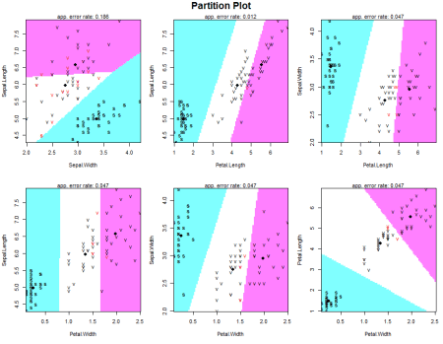

partimat(Species~., data = training, method = "qda")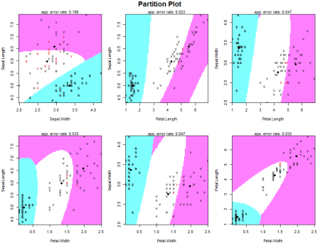

**Confusion matrix and accuracy – training data**

p1 <- predict(linear, training)$class

tab <- table(Predicted = p1, Actual = training$Species)

tab

Let’s see the correct classifications and miss classifications.

Actual

Predicted    setosa versicolor virginica

  setosa         33          0         0

  versicolor      0         26         1

  virginica       0          1        25

In the training dataset total correct classification is 33+26+25=84

sum(diag(tab))/sum(tab)

The accuracy of the model is around 0.9767442

**Confusion matrix and accuracy – testing data**

p2 <- predict(linear, testing)$class

tab1 <- table(Predicted = p2, Actual = testing$Species)

tab1

Actual

Predicted    setosa versicolor virginica

  setosa         17          0         0

  versicolor      0         22         0

  virginica       0          1        24

sum(diag(tab1))/sum(tab1)

The accuracy of the model is around .984375

**Conclusion**

Histogram and Biplot provide useful insights and helpful for interpretations and if there is not a great difference in the group covariance matrices, then the linear discriminant analysis will perform as well as quadratic. LDA is not useful for solving non-linear problems.