LEGO Mosaics have been around for a while and there is the wonderful {bricksr} package by Ryan Timpe that makes it easy to construct them based on bitmap images. So, when I ran across the relatively new LEGO Art theme sets, I was instantly hooked. The current situation favors contemplative indoor activities and puzzling some mosaics over the Holidays sounded nice.

The only drawback was that the ‘The Beatles’ Art set is the one whose color palette I found most appealing but, having tremendous respect for the fab four and all, I am more of a Stones person. In any case, the long-term plan is to use the set to create custom mosaics of people/scenes that are dear to us, so it was the nerdy aspect of making this ‘hack’ happen that created the final pull.

There already is at least one very nice online tool, the LEGO Art Remix app by Dab Banerji that allows you to convert a given bitmap image file to a mosaic obeying the tile set restrictions of the LEGO Art sets. So, initially I thought that creating custom mosaics on Beatles tiles would be a walk in the park. Time to take Keith Richard’s twitter handle image for a spin.

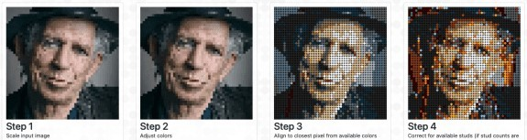

Keith remixed on The Beatles set with the LEGO Art Remix App

As you can see from the right-most mosaic above, the art sets’ tile restrictions make it very hard to create a satisfying mosaic automatically. In the end, an automated ‘first shot’ along with some manual editing tools seemed like a useful alternative approach. Here we go.

# The Task

What follows can act as a mini case study for the benefits of the open source community. I started looking into the available mosaic generators and found that very few deal with limited tiles. The ones that I found that do create mosaics that do not really look too good out-of-the box when images are less than perfect matches for the underlying tile sets. That means that manual modifications of the resulting mosaic are often required. Based on this, I thought that it would be cool to whip something up that

provides a reasonably good automated conversion of images to the restricted tile sets of the LEGO Art sets,

allows users to edit these mosaics interactively, keeping the tile restrictions in sight and ultimately prepares useful instructions to build the actual mosaic.

After my experiences with the automated conversion projects on the web I started with the interactive part. I am reasonably experienced in R and shiny so this was the platform of my choice. But, how does one build an interface for bitmap editing on shiny? My idea was to use the {leaflet} package to render the image. This is hacky as {leaflet} normally is used to render geographic data but, hey, this is supposed to be a quick toy project and I have worked with

{leaflet} before, so: Why not? Time to produce a first screen shot.

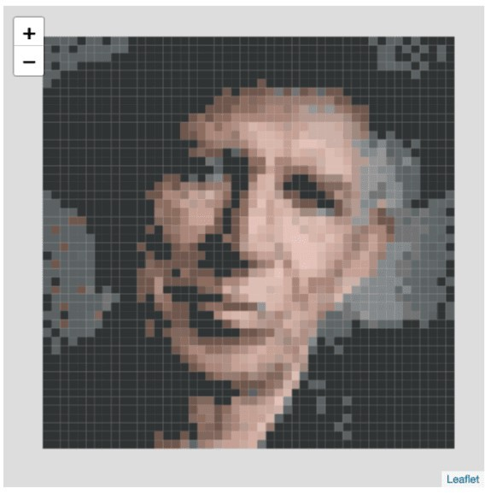

Keith as a choropleth map

How does one select pixels from the image for modification? Time to google. I reference this here not only to give its participants the credit that they deserve but too highlight the maaaanny times that I benefited from the Stack Exchange universe. This often goes unnoticed but I believe that this platform has developed to one of the most important knowledge resources for software development and even regularly informs academic research.

After selection has been taken care off, I wanted to implement flood-fill selection so that users can easily select areas that they want to convert. Flood-fill is one of these neat examples for the power of recursive algorithms and with the help of Wikipedia implementing it was almost to easy.

# This identifies areas with the same color within a 48*48 bitmap # Writes to a matrix is_area in a higher environment so this

# needs to be defined prior to calling identify_area() # as well as an img raster containing the actual data

identify_area <- function(area, x, y, color = NULL) { # https://en.wikipedia.org/wiki/Flood_fill

if (is_area[x, y] > 0) return()

if (is.null(color)) color <- img[x, y, ]

if (any(img[x, y, ] != color)) return() is_area[x, y] <<- area

if (x > 1) identify_area(area, x - 1, y, color) if (x < 48) identify_area(area, x + 1, y, color) if (y > 1) identify_area(area, x, y - 1, color) if (y < 48) identify_area(area, x, y + 1, color)

}

is_area <- array(0, dim = c(48, 48))

for(x in 1:48) {

for(y in 1:48) { identify_area(max(is_area) + 1, x, y) if (min(is_area) > 0) break()

}

if (min(is_area) > 0) break()

}

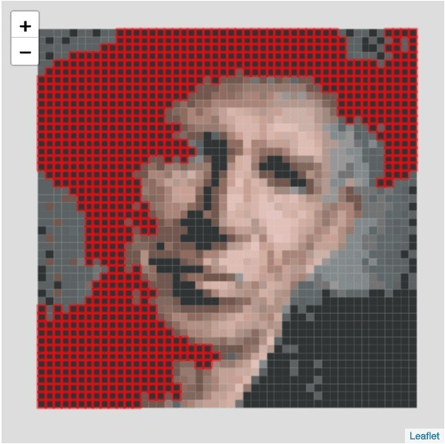

Keith, flood-filled

The next task was to identify the tile restrictions. Without help this would have been a clear road block to my toy project. I only have the Beatles set and counting all those tiles and identifying

their precise colors would have ruined my Christmas break. But I was confident that the LEGO hacker community would provide everything that I need and, sure enough, I quickly found the site rebrickable.com that provides wonderfully clean relational data on all (!) available LEGO sets. Whow!

With this out of the way I completed the editing interface. There are two additional things about it that I like and that I would never been able to achieve without the help of “random strangers on the Internet”:

First, I use a colored Drop-down selector to pick colors to accommodate that the number of available colors change of the different LEGO art sets.

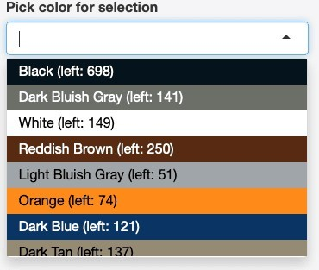

Colored drop-down to select colors

pick_text_color_for_bground <- function(color) { rgb_code <- col2rgb(color)

luminance <- (0.299*rgb_code[1] + 0.587*rgb_code[2] + 0.114*rgb_code[3])/255

ifelse(luminance > 0.5, "#000000", "#ffffff")

}

Second, after playing with the editing interface, I quickly noticed that a proper undo feature is really important for it to become usable. This looked like another road block, given my time budget for my toy project was only a few days and mostly the early hours where the rest of my family was sound asleep. I thought about ways to implement this efficiently in shiny and then I ran across this wonderful shiny module offered by Garrick Aden-Bule. Bamm!

With the second bullet point of my “specification list” knocked off, I moved on to focus on the automated conversion. Given my experiences with the web-based conversion tools available (I am entirely sure that I overlooked some) I was not optimistic. After implementing a first ‘greedy’ match, my results looked very similar. But here my day job as an applied economist came in handy. After thinking and reading about the problem a little bit,

problem can be described as a linear programming problem with each area/potential color pair being a variable that can take a binary value. Each variable has a cost attached to it. The cost is defined by the color distance (yet another topic where Wikipedia is very helpful) of the original color and the selected color multiplied with the size of the area. The objective function is to choose variables so that the overall cost of the color deviation is minimized. The restrictions are the tile set limitations and the requirement that each color area must be transformed to exactly one mosaic color.

The resulting linear programming model can become relatively large as the 48*48 images have a lot of areas at least when you have an input image with a large color depth (more than 2,000 in most cases). Taken together with the 15 colors provided by the ‘The Beatles’ set this means that you have 30,000+ variables with 2,000 + restrictions. I was concerned that the optimization of such a large model would take too long and require too much memory. I teach my students how to solve models of that class with 3 variables and 5 restrictions by hand (a fun activity, I know) and it takes quite a while 

areas <- max(is_area)

colors <- nrow(mosaic_palette) library(lpSolveAPI)

lpm <- make.lp(colors + areas, areas*colors) set.type(lpm, 1:(areas*colors), "binary")

set.rhs(lpm, c(mosaic_palette$available, rep(1, areas))) set.constr.type(lpm, c(rep("<=", colors), rep("=", areas))) dists <- vector("integer", areas*colors)

for (i in 1:areas) { for (j in 1:colors) {

set.column(lpm, (i-1)*colors + j, c(area_size[i], 1), c(j, colors +

i))

dists[(i-1)*colors + j] <- area_size[i]*color_distance(

color_of_area(i), tiles[1:3, j])

}

}

set.objfn(lpm, dists) lp.control(lpm, timeout = timeout)

rv <- solve(lpm)

Fortunately, the ‘lp_solve’ library is implemented in good-old fast C. Its new R API also allows to use sparse matrices and this helps to circumvent memory problems. Thus, the core part of my image to mosaic conversion algorithm only covers 15 lines of code. If it converges, it takes not longer than 10 seconds on normal hardware. It does not converge always but most of the time. If it fails than the editing features of the shiny app help to circumvent the conversion problem.

Time to meet Keith, converted to Beatles mosaic colors.

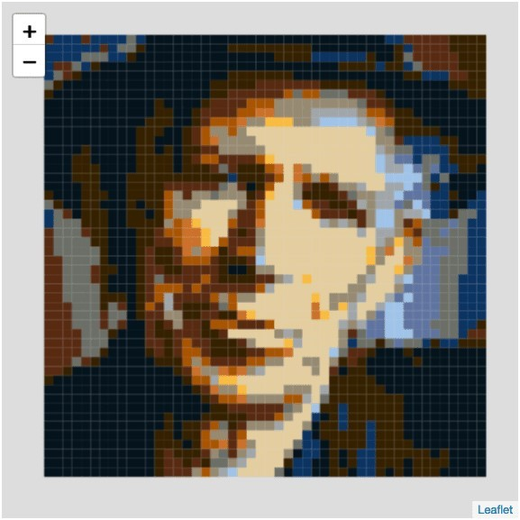

Keith as a Beatles mosaic

Now this looks better, right? I have to say that the conversion does not look that good for every image. For some images, there are simply not enough high-quality matches available. It is, however, a real improvement over the much faster greedy matching. And, given that it will take you hours to actually puzzle the mosaic, these additional 10 seconds seem like time well spent.

On to the last task, the preparation of a set of instructions. Given how perceptually close some colors are, they are really import even though you can download the transformed bitmap image. I used the original instructions from the set as inspiration and was once again amazed by the flexibility of the {ggplot2} package (sorry, base graphics).

# Putting the pieces together

Everything taken together, you get the LEGO Art Mosaic Generator. It is still a little bit rough around the edges but it works (as far as I can tell).

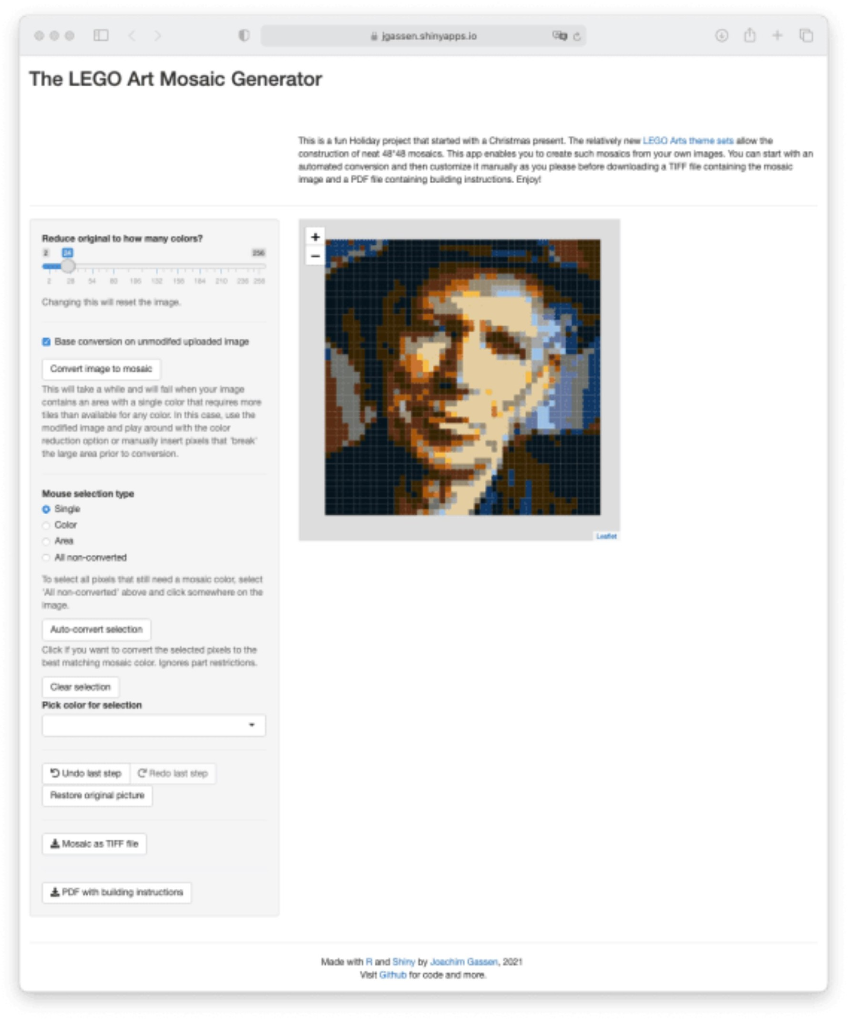

Sreenshot LEGO Art Mosaic Generator

Time for the real world. This is what puzzling Keith based on a Beatles tile set looks like.

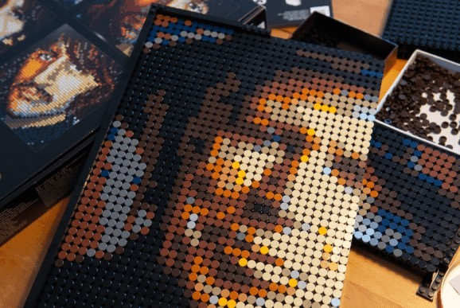

Keith in the making And here you see the final outcome. Stones 1: Beatles 0.

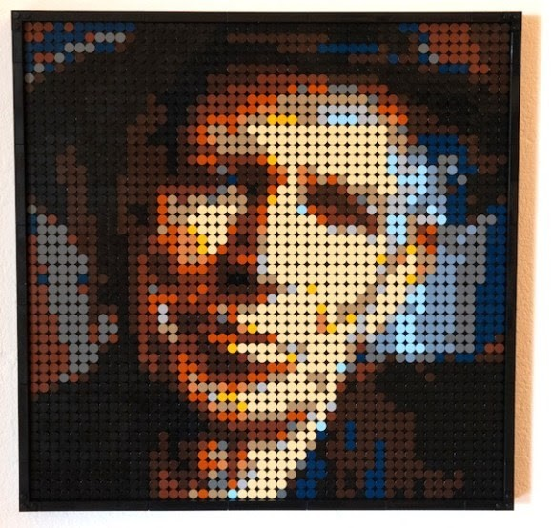

The final real-life mosaic

# Summary

I have to say that this was a fun toy project. Like always, it took me a little bit longer than I initially thought. But then again, it became bigger that I initially planned it to be. I have been around for a while and I remember software development before the Internet was a real thing and I never cease to be amazed by the productivity boost that open collaboration brings.2 Developing something like this from scratch would be a year-long project while with the help of the open-source community it can be achieved as a part-time job over a week. So, thank you very much to all of the members of this wonderful community and a happy new year everybody!

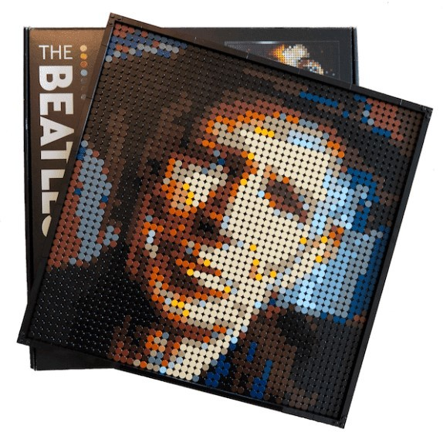

The Full R Scripts

Convert_image.R

|  |
| --- |
| library(lpSolveAPI) |
|  |  |
|  | source("utils.R") |
|  |  |
|  |  |
|  |  |
|  | greedy_mosaic <- function(orig_img, ncols, mosaic_palette) { |
|  | identify_area <- function(area, x, y, color = NULL) { |
|  | # https://en.wikipedia.org/wiki/Flood_fill |
|  | if (is_area[x, y] > 0) return() |
|  | if (is.null(color)) color <- img[x, y, ] |
|  | if (any(img[x, y, ] != color)) return() |
|  | is_area[x, y] <<- area |
|  | if (x > 1) identify_area(area, x - 1, y, color) |
|  | if (x < 48) identify_area(area, x + 1, y, color) |
|  | if (y > 1) identify_area(area, x, y - 1, color) |
|  | if (y < 48) identify_area(area, x, y + 1, color) |
|  | } |
|  |  |
|  |  |
|  | color_of_area <- function(area) { |
|  | area_pos <- which(is_area == area, arr.ind = TRUE) |
|  | img[area_pos[1, 1], area_pos[1, 2], ] |
|  | } |
|  |  |
|  | if (!is.null(ncols)) { |
|  | img <- as.integer((image_read(orig_img/255) %>% |
|  | image_quantize(ncols))[[1]]) |
|  | } else img <- orig_img |
|  |  |
|  | is_area <- array(0, dim = c(48, 48)) |
|  |  |
|  | for(x in 1:48) { |
|  | for(y in 1:48) { |
|  | identify_area(max(is_area) + 1, x, y) |
|  | if (min(is_area) > 0) break() |
|  | } |
|  | if (min(is_area) > 0) break() |
|  | } |
|  |  |
|  | area_size <- unname(as.vector(table(is_area))) |
|  | areas_by_size <- as.integer(names(sort(table(is_area), decreasing = TRUE))) |
|  |  |
|  | tiles <- rbind(col2rgb(mosaic_palette$hex), mosaic_palette$available) |
|  |  |
|  | find_best_tiles_for_area <- function(area) { |
|  | suitable_tiles <- tiles[, tiles[4,] >= area_size[area]] |
|  | if (length(suitable_tiles) == 0) stop("No suitable tiles left. Sorry.") |
|  | if (!is.array(suitable_tiles)) col = suitable_tiles[1:3] |
|  | else col <- best_color_match(color_of_area(area), suitable_tiles[1:3,]) |
|  | tiles[4, colSums(tiles[1:3,] == col) == 3] <<- |
|  | tiles[4, colSums(tiles[1:3,] == col) == 3] - area_size[area] |
|  | col |
|  | } |
|  |  |
|  | areas_color <- array(dim = c(3, length(area_size))) |
|  | for(i in areas_by_size) { |
|  | areas_color[, i] <- find_best_tiles_for_area(i) |
|  | } |
|  |  |
|  | mosaic <- array(dim = c(48, 48, 3)) |
|  |  |
|  | for(x in 1:48) { |
|  | for(y in 1:48) { |
|  | mosaic[x, y, ] <- areas_color[,is_area[x, y]] |
|  | } |
|  | } |
|  |  |
|  | return(mosaic) |
|  | } |
|  |  |
|  | optimize_mosaic <- function( |
|  | orig_img, ncols, mosaic_palette, timeout = 30, silent = FALSE |
|  | ) { |
|  | identify_area <- function(area, x, y, color = NULL) { |
|  | # https://en.wikipedia.org/wiki/Flood_fill |
|  | if (is_area[x, y] > 0) return() |
|  | if (is.null(color)) color <- img[x, y, ] |
|  | if (any(img[x, y, ] != color)) return() |
|  | is_area[x, y] <<- area |
|  | if (x > 1) identify_area(area, x - 1, y, color) |
|  | if (x < 48) identify_area(area, x + 1, y, color) |
|  | if (y > 1) identify_area(area, x, y - 1, color) |
|  | if (y < 48) identify_area(area, x, y + 1, color) |
|  | } |
|  |  |
|  |  |
|  | color_of_area <- function(area) { |
|  | area_pos <- which(is_area == area, arr.ind = TRUE) |
|  | img[area_pos[1, 1], area_pos[1, 2], ] |
|  | } |
|  |  |
|  | if (!is.null(ncols)) { |
|  | img <- as.integer((image_read(orig_img/255) %>% |
|  | image_quantize(ncols))[[1]]) |
|  |  |
|  | } else img <- orig_img |
|  |  |
|  | tiles <- rbind(col2rgb(mosaic_palette$hex), mosaic_palette$available) |
|  |  |
|  | is_area <- array(0, dim = c(48, 48)) |
|  |  |
|  | for(x in 1:48) { |
|  | for(y in 1:48) { |
|  | identify_area(max(is_area) + 1, x, y) |
|  | if (min(is_area) > 0) break() |
|  | } |
|  | if (min(is_area) > 0) break() |
|  | } |
|  |  |
|  | area_size <- unname(as.vector(table(is_area))) |
|  |  |
|  | if (max(area_size) > max(mosaic_palette$available)) { |
|  | stop(sprintf(paste( |
|  | "Largest area requires %d tiles but largest color only", |
|  | "provides %s tiles. Consider using more colors" |
|  | ), max(area_size), max(mosaic_palette$available))) |
|  | } |
|  |  |
|  | areas <- max(is_area) |
|  | colors <- nrow(mosaic_palette) |
|  |  |
|  | lpm <- make.lp(colors + areas, areas*colors) |
|  | set.type(lpm, 1:(areas*colors), "binary") |
|  | set.rhs(lpm, c(mosaic_palette$available, rep(1, areas))) |
|  | set.constr.type(lpm, c(rep("<=", colors), rep("=", areas))) |
|  | dists <- vector("integer", areas*colors) |
|  |  |
|  | for (i in 1:areas) { |
|  | for (j in 1:colors) { |
|  | set.column(lpm, (i-1)*colors + j, c(area_size[i], 1), c(j, colors + i)) |
|  | dists[(i-1)*colors + j] <- area_size[i]*color_distance(color_of_area(i), tiles[1:3, j]) |
|  | } |
|  | } |
|  | set.objfn(lpm, dists) |
|  | lp.control(lpm, timeout = timeout) |
|  |  |
|  | rv <- solve(lpm) |
|  | if (rv == 7 | rv == 1) { |
|  | if (!silent) message("linear optimization timed out") |
|  | warning(sprintf(paste( |
|  | "lp_solve timed out after %d seconds.", |
|  | "I will work with what I have got..." |
|  | ), timeout)) |
|  | } else if(rv != 0) { |
|  | if (!silent) message("linear optimization failed") |
|  | stop(sprintf(paste( |
|  | "Sorry but the linear optimization has failed with code %d.", |
|  | "Consider using more colors to generate smaller areas." |
|  | ), rv)) |
|  | } else if (!silent) message("linear optimization suceeded") |
|  |  |
|  | areas_matched_cols <- ((which(get.variables(lpm) == 1) - 1) %% colors) + 1 |
|  |  |
|  |  |
|  | areas_color <- array(dim = c(3, areas)) |
|  | for (i in 1:areas) areas_color[, i] <- col2rgb( |
|  | mosaic_palette$hex[areas_matched_cols[i]] |
|  | ) |
|  |  |
|  | mosaic <- array(dim = c(48, 48, 3)) |
|  |  |
|  | for(x in 1:48) { |
|  | for(y in 1:48) { |
|  | mosaic[x, y, ] <- areas_color[,is_area[x, y]] |
|  | } |
|  | } |
|  |  |
|  | return(mosaic) |
|  | } |

Load_Rebrickable_data.R

|  |
| --- |
| library(dplyr) |
|  | library(readr) |
|  |  |
|  | # https://rebrickable.com/downloads/ for data |
|  |  |
|  | rebrickable_data <- c("inventories", "sets", "inventory_parts", "colors") |
|  | filepaths <- paste0("data/", rebrickable_data, ".csv") |
|  |  |
|  | if (any(!file.exists(filepaths))) stop(paste( |
|  | "You need to download data form https://rebrickable.com/downloads/", |
|  | "to 'data' directory first. See code for more details." |
|  | )) |
|  |  |
|  | for (i in 1:length(rebrickable_data)) { |
|  | assign(rebrickable_data[i], read_csv(filepaths[i], col_types = cols())) |
|  | } |
|  |  |
|  |  |
|  | lego_art_palettes <- sets %>% |
|  | left_join(inventories, by = "set_num") %>% |
|  | left_join(inventory_parts, by = c("id" = "inventory_id")) %>% |
|  | filter( |
|  | theme_id == 709, |
|  | part_num == 98138 | part_num == 6141 |
|  | ) %>% |
|  | mutate(source = name) %>% |
|  | select(source, color_id, quantity) %>% |
|  | left_join(colors, by = c("color_id" = "id")) %>% |
|  | rename(available = quantity) %>% |
|  | mutate( |
|  | hex = paste0("#", rgb) |
|  | ) %>% |
|  | group_by(source, name, hex) %>% |
|  | summarise(available = sum(available), .groups = "drop") %>% |
|  | select(source, name, hex, available) |
|  |  |
|  | saveRDS(lego_art_palettes, "data/lego_art_palettes.rds") |

Server.R

|  |
| --- |
| source("utils.R") |
|  | source("convert_image.R") |
|  |  |
|  | # source("load_rebrickable_data.R") |
|  | lego_art_palettes <- read_lego_art_palettes() |
|  |  |
|  | server <- function(session, input, output){ |
|  | # On selecting multiple polygons in leaflet |
|  | # https://stackoverflow.com/questions/41104576/changing-styles-when-selecting-and-deselecting-multiple-polygons-with-leaflet-sh |
|  | rv <- reactiveValues( |
|  | picture = NULL, |
|  | image = NULL, |
|  | sel_pixels = vector(), |
|  | picked_color = NULL, |
|  | color_palette = NULL, |
|  | target_palette = NULL, |
|  | pal = NULL |
|  | ) |
|  |  |
|  | undo_app_state <- undoHistory("history", value = reactive({ |
|  | if (!is.null(rv$image)) { |
|  | return(list( |
|  | number_of_colors = input$number_of_colors, |
|  | sel_type = input$sel_type, |
|  | picture = rv$picture, |
|  | image = rv$image, |
|  | sel_pixels = rv$sel_pixels, |
|  | picked_color = rv$picked_color, |
|  | color_palette = rv$color_palette, |
|  | target_palette = rv$target_palettte, |
|  | pal = rv$pal |
|  | )) |
|  | } else return(NULL) |
|  | })) |
|  |  |
|  | observe({ |
|  | req(undo_app_state()) |
|  | updateSliderInput( |
|  | session, "number_of_colors", value = undo_app_state()$number_of_colors |
|  | ) |
|  | updateRadioButtons( |
|  | session, "sel_type", selected = undo_app_state()$sel_type |
|  | ) |
|  | rv$picture <- undo_app_state()$picture |
|  | rv$image <- undo_app_state()$image |
|  | rv$sel_pixels <- undo_app_state()$sel_pixels |
|  | rv$picked_color <- undo_app_state()$picked_color |
|  | rv$color_palette <- undo_app_state()$color_palette |
|  | rv$target_palettte <- undo_app_state()$target_palette |
|  | rv$pal <- undo_app_state()$pal |
|  | }) |
|  |  |
|  |  |
|  | color_picker_bground_color_css <- function(palette) { |
|  | # https://stackoverflow.com/questions/45375160/change-background-color-of-selectinput-in-r-shiny |
|  | css <- "" |
|  | for (i in 1:nrow(palette)) { |
|  | css <- paste(css, sprintf(paste0( |
|  | "#color_picker ~ .selectize-control .option:nth-child(%d) {", |
|  | "background-color: %s;", |
|  | "color: %s;}" |
|  | ), i, palette$hex[i], pick_text_color_for_bground(palette$hex[i]))) |
|  | } |
|  | css |
|  | } |
|  |  |
|  | select_flood_fill <- function(id, color_id = NULL) { |
|  | # https://en.wikipedia.org/wiki/Flood_fill |
|  | if (is.null(color_id)) color_id <- (rv$image$value[rv$image$id == id]) |
|  | if (rv$image$value[rv$image$id == id] != color_id) return() |
|  | if (id %in% rv$sel_pixels) return() |
|  | if (rv$image$value[rv$image$id == id] == color_id) { |
|  | rv$sel_pixels <- c(rv$sel_pixels, id) |
|  | } |
|  | if (id %% 48 != 1) select_flood_fill(id - 1, color_id) |
|  | if (id %% 48 != 0) select_flood_fill(id + 1, color_id) |
|  | if (id > 48) select_flood_fill(id - 48, color_id) |
|  | if (id <= 47 * 48) select_flood_fill(id + 48, color_id) |
|  | } |
|  |  |
|  | output$ui_color_picker <- renderUI({ |
|  | req(rv$color_palette) |
|  | target_palette <- rv$color_palette %>% filter(source != "Image") |
|  | choices_vec <- target_palette$value |
|  | names(choices_vec) <- paste( |
|  | target_palette$name, |
|  | sprintf("(left: %d)", target_palette$available - target_palette$used) |
|  | ) |
|  | tagList( |
|  | tags$style(color_picker_bground_color_css( |
|  | rv$color_palette %>% filter(source != "Image") |
|  | )), |
|  | selectInput( |
|  | inputId = "color_picker", |
|  | label = "Pick color for selection", |
|  | choices = c("", choices_vec), |
|  | selected = rv$picked_color |
|  | ) |
|  | ) |
|  | }) |
|  |  |
|  | observeEvent(input$image_file, { |
|  | rv$picture <- image_read(input$image_file$datapath) %>% |
|  | image_resize("48x48!") |
|  | }) |
|  |  |
|  | observeEvent(input$rotate_image, { |
|  | rv$picture <- image_rotate(rv$picture, 90) |
|  | }) |
|  |  |
|  | observe({ |
|  | req(rv$picture, input$number_of_colors, input$target) |
|  | pic <- rv$picture %>% |
|  | image_quantize(max = input$number_of_colors) |
|  |  |
|  | rv$target_palette <- lego_art_palettes %>% filter(source == input$target) |
|  |  |
|  | rv$color_palette <- get_palette_from_image( |
|  | pic, rv$target_palette |
|  | ) |
|  |  |
|  | hex <- isolate(rv$color_palette$hex) |
|  | color_ids <- isolate(rv$color_palette$value) |
|  |  |
|  | rv$pal <- colorFactor(hex, factor(color_ids, levels = color_ids)) |
|  |  |
|  | r <- raster(ncol = 48, nrow = 48, xmn = 0.1, xmx = 4.8, ymn = 0.1, ymx = 4.8) |
|  | values(r) <- get_raster_values_from_image(pic, isolate(rv$color_palette)) |
|  |  |
|  | sp <- st_as_sf(rasterToPolygons(r)) |
|  | cn = st_coordinates(st_transform(st_centroid(sp), 4326)) |
|  | sp = st_transform(sp, 4326) |
|  | sp = cbind(sp, cn) |
|  | sp$id <- 1:nrow(sp) |
|  | colnames(sp)[1] <- "value" |
|  |  |
|  | rv$image = sp |
|  | }) |
|  |  |
|  | # https://stackoverflow.com/questions/30704487/interactive-plotting-with-r-raster-values-on-mouseover |
|  | output$mosaic <- renderLeaflet({ |
|  | req(rv$image) |
|  | leaflet() %>% |
|  | setView(2.4, 2.4, 7) |
|  | }) |
|  |  |
|  | output$selection_size <- renderText({ |
|  | if (length(rv$sel_pixels) > 0) { |
|  | sprintf(paste( |
|  | "%d", ifelse(length(rv$sel_pixels) == 1, "pixel", "pixels"), "selected." |
|  | ), length(rv$sel_pixels)) |
|  | } |
|  | }) |
|  |  |
|  | observeEvent(rv$image, { |
|  | p <- leafletProxy("mosaic") %>% |
|  | clearGroup("image") %>% |
|  | addPolygons( |
|  | data = rv$image, |
|  | stroke = FALSE, |
|  | fillColor = ~rv$pal(rv$image$value), |
|  | fillOpacity = 1, |
|  | layerId = rv$image$id, |
|  | group = "image" |
|  | ) |
|  | if (length(rv$sel_pixels) > 0) { |
|  | sp_data <- rv$image[rv$image$id %in% rv$sel_pixels,] |
|  |  |
|  | p <- p %>% |
|  | clearGroup("selected") %>% |
|  | addPolygons( |
|  | data = sp_data, |
|  | fillOpacity = 0, |
|  | weight = 3, |
|  | color = "red", |
|  | stroke = TRUE, |
|  | group = "selected", |
|  | layerId = sp_data$id |
|  | ) |
|  | } |
|  |  |
|  | if (!any(rv$color_palette$source[unique(rv$image$value)] == "Image") & |
|  | !any(rv$color_palette$used[unique(rv$image$value)] > |
|  | rv$color_palette$available[unique(rv$image$value)])) { |
|  | enable("download_inst") |
|  | } else { |
|  | disable("download_inst") |
|  | } |
|  |  |
|  | p |
|  | }) |
|  |  |
|  |  |
|  | observeEvent(rv$sel_pixels, { |
|  | if (length(rv$sel_pixels) > 0) { |
|  | sp_data <- rv$image[rv$image$id %in% rv$sel_pixels,] |
|  |  |
|  | leafletProxy("mosaic") %>% |
|  | clearGroup("selected") %>% |
|  | addPolygons( |
|  | data = sp_data, |
|  | fillOpacity = 0, |
|  | weight = 3, |
|  | color = "red", |
|  | stroke = TRUE, |
|  | group = "selected", |
|  | layerId = sp_data$id |
|  | ) |
|  | } else { |
|  | leafletProxy("mosaic") %>% |
|  | clearGroup("selected") |
|  | } |
|  | }, ignoreNULL = FALSE) |
|  |  |
|  |  |
|  | observeEvent(input$mosaic_shape_click, { |
|  | click_id = input$mosaic_shape_click$id |
|  |  |
|  | if (input$sel_type == "single") { |
|  | if (click_id %in% rv$sel_pixels) { |
|  | rv$sel_pixels <- rv$sel_pixels[! rv$sel_pixels %in% click_id] |
|  | } else { |
|  | rv$sel_pixels <- c(rv$sel_pixels, click_id) |
|  | } |
|  | } else if (input$sel_type == "color") { |
|  | sel_color_id <- rv$image$value[rv$image$id == click_id] |
|  | rv$sel_pixels <- rv$image$id[rv$image$value == sel_color_id] |
|  | } else if (input$sel_type == "area") { |
|  | rv$sel_pixels <- vector() |
|  | select_flood_fill(click_id) |
|  | } else if (input$sel_type == "all") { |
|  | img_color_ids <- rv$color_palette %>% |
|  | filter(source == "Image") %>% |
|  | pull(value) |
|  | rv$sel_pixels <- rv$image$id[rv$image$value %in% img_color_ids] |
|  | } |
|  |  |
|  | if (length(rv$sel_pixels) > 0) { |
|  | sel_color_ids <- unique(rv$image$value[rv$image$id %in% rv$sel_pixels]) |
|  | if (length(sel_color_ids) == 1 & |
|  | rv$color_palette$source[sel_color_ids[1]] != "Image") { |
|  | rv$picked_color <- sel_color_ids[1] |
|  | } else rv$picked_color <- "" |
|  | } |
|  | }) |
|  |  |
|  | observeEvent(input$convert_image, { |
|  | time_in <- Sys.time() |
|  | withProgress({ |
|  | if (input$use_orig_img) { |
|  | img <- as.integer(rv$picture[[1]]) |
|  | ncols <- NULL |
|  | } else { |
|  | img <- aperm(array( |
|  | col2rgb(rv$color_palette$hex[rv$image$value]), |
|  | dim = c(3, 48, 48) |
|  | ), dim = c(2, 3, 1)) |
|  | ncols <- input$number_of_colors |
|  | } |
|  | ci <- try( |
|  | optimize_mosaic(img, ncols, isolate(rv$target_palette)), |
|  | silent = FALSE |
|  | ) |
|  | }, message = "Converting image...", value = 0.5) |
|  |  |
|  | if (inherits(ci, "try-error")) { |
|  | session$sendCustomMessage( |
|  | type = 'note', |
|  | message = paste( |
|  | "The conversion failed. Sorry. This is likely because of a too large color", |
|  | "area or because the optimalization did not converge. Try to modify", |
|  | "the image, breaking large color areas to see whether it helps." |
|  | ) |
|  | ) |
|  | } else { |
|  | if (Sys.time() - time_in > 30) { |
|  | session$sendCustomMessage( |
|  | type = 'note', |
|  | message = paste( |
|  | "The conversion timed out. The resulting mosaic will not be optimal.", |
|  | "Try to modify the image, breaking large color areas to see whether", |
|  | "it helps." |
|  | ) |
|  | ) |
|  | } |
|  | hex <- as.vector(apply( |
|  | ci/255, c(2, 1), function(x) rgb(x[1], x[2], x[3]) |
|  | )) |
|  | rv$image$value <- match(hex, isolate(rv$color_palette$hex)) |
|  | rv$color_palette$used <- unname( |
|  | table(factor(rv$image$value, 1:nrow(rv$color_palette))) |
|  | ) |
|  | } |
|  | }) |
|  |  |
|  | observeEvent(input$sel_clear, { |
|  | req(rv$sel_pixels) |
|  | rv$sel_pixels <- vector() |
|  | leafletProxy("mosaic") %>% |
|  | clearGroup("selected") |
|  | }) |
|  |  |
|  |  |
|  | observeEvent(input$auto_conversion, { |
|  | if (length(rv$sel_pixels) > 0) { |
|  | sel_pixels <- rv$image$id %in% rv$sel_pixels |
|  | old_colors <- rv$color_palette$hex[rv$image$value[sel_pixels]] |
|  | avail_colors <- rv$color_palette %>% |
|  | filter(source != "Image") %>% pull(hex) |
|  | new_colors <- sapply( |
|  | unique(old_colors), best_color_match, avail_colors, USE.NAMES = F |
|  | ) |
|  | new_values <- match( |
|  | new_colors[match(old_colors, unique(old_colors))], rv$color_palette$hex |
|  | ) |
|  | rv$image$value[rv$image$id %in% rv$sel_pixels] <- new_values |
|  | rv$color_palette$used <- unname( |
|  | table(factor(rv$image$value, 1:nrow(rv$color_palette))) |
|  | ) |
|  |  |
|  | if (length(new_colors) == 1) rv$picked_color <- new_colors |
|  | else rv$picked_color_name <- "" |
|  | } |
|  | }) |
|  |  |
|  |  |
|  | observeEvent(input$color_picker, { |
|  | if (length(rv$sel_pixels) > 0 & |
|  | input$color_picker != "" & |
|  | !isolate( |
|  | !is.null(rv$picked_color) && |
|  | (rv$picked_color == input$color_picker))) { |
|  |  |
|  | color_id <- as.integer(input$color_picker) |
|  | rv$image$value[rv$image$id %in% rv$sel_pixels] <- color_id |
|  |  |
|  | rv$color_palette$used <- unname( |
|  | table(factor(rv$image$value, 1:nrow(rv$color_palette))) |
|  | ) |
|  |  |
|  | rv$picked_color <- color_id |
|  | } |
|  | }) |
|  |  |
|  |  |
|  | observeEvent(input$restore_original, { |
|  | pic <- rv$picture %>% |
|  | image_quantize(max = input$number_of_colors) |
|  | rv$image$value <- get_raster_values_from_image(pic, rv$color_palette) |
|  | rv$sel_pixels <- vector() |
|  | }) |
|  |  |
|  |  |
|  | output$download_inst <- downloadHandler( |
|  | filename = "mosaic_instructions.pdf", |
|  | content = function(file) { |
|  | img_mat <- aperm(array( |
|  | col2rgb(rv$color_palette$hex[rv$image$value]), |
|  | dim = c(3, 48, 48) |
|  | ), dim = c(2, 3, 1)) |
|  |  |
|  | produce_inst_pdf(img_mat, rv$target_palette, file) |
|  | } |
|  | ) |
|  |  |
|  | output$download_mosaic <- downloadHandler( |
|  | filename = "mosaic.tiff", |
|  | content = function(file) { |
|  | img_mat <- aperm(array( |
|  | col2rgb(rv$color_palette$hex[rv$image$value]), |
|  | dim = c(3, 48, 48) |
|  | )/255, dim = c(2, 3, 1)) |
|  |  |
|  | tiff::writeTIFF(img_mat, file) |
|  | } |
|  | ) |
|  | } |

Test_conversion.R

|  |
| --- |
| source("utils.R") |
|  | source("convert_image.R") |
|  |  |
|  |  |
|  |  |
|  |  |
|  |  |
|  | download.file( |
|  | "https://pbs.twimg.com/profile_images/925768757716373504/3SwABEqS_400x400.jpg", |
|  | "data/keith_richards_400x400.jpg", mode = "wb" |
|  | ) |
|  | magick_pic <- image_read("data/keith_richards_400x400.jpg") %>% |
|  | image_resize("48") |
|  |  |
|  | img <- as.integer(magick_pic[[1]]) |
|  |  |
|  |  |
|  | # Pick your Lego Arts set |
|  |  |
|  | mosaic_palette <- read_lego_art_palettes() %>% filter(source == "The Beatles") |
|  |  |
|  |  |
|  | # Plot original image |
|  |  |
|  | plot_mosaic(img) |
|  |  |
|  |  |
|  | # Unconstrained mosaic |
|  | # The greedy, large area priority algorithm is much faster |
|  |  |
|  | full_palette <- mosaic_palette %>% mutate(available = 48*48) |
|  | unconstrained_mosaic_greedy <- greedy_mosaic(img, NULL, full_palette) |
|  | plot_mosaic(unconstrained_mosaic_greedy) |
|  |  |
|  | # The linear programming solution finds the same mosaic |
|  |  |
|  | unconstrained_mosaic_lp <- optimize_mosaic(img, NULL, full_palette) |
|  | plot_mosaic(unconstrained_mosaic_lp) |
|  |  |
|  | all(unconstrained_mosaic_greedy == unconstrained_mosaic_lp) |
|  |  |
|  |  |
|  | # The 'greedy' mosaic based on tile restrictions for the full color picture |
|  |  |
|  | mosaic_greedy_all_colors <- greedy_mosaic(img, NULL, mosaic_palette) |
|  | plot_mosaic(mosaic_greedy_all_colors) |
|  |  |
|  |  |
|  | # And the same for the optimal LP mosaic - it is an improvement |
|  |  |
|  | mosaic_lp_all_colors <- optimize_mosaic(img, NULL, mosaic_palette) |
|  | plot_mosaic(mosaic_lp_all_colors) |
|  |  |
|  |  |
|  | # Does color reduction help to improve the conversion of the image? |
|  | # Let's see - this takes a while! |
|  |  |
|  | res <- tibble( |
|  | ncols = 2:256, |
|  | diff_greedy = NA, |
|  | diff_optimized = NA |
|  | ) |
|  |  |
|  | for (i in 2:256) { |
|  | message(sprintf("Trying greedy mosaic with %d colors...", i)) |
|  | m <- try(greedy_mosaic(img, i, mosaic_palette)) |
|  | if(!(inherits(m, "try-error"))) res$diff_greedy[i - 1] <- mosaic_diff(img, m) |
|  | message(sprintf("Trying optimized mosaic with %d colors...", i)) |
|  | m <- try(optimize_mosaic(img, i, mosaic_palette)) |
|  | if(!(inherits(m, "try-error"))) res$diff_optimized[i - 1] <- mosaic_diff(img, m) |
|  | } |
|  |  |
|  | res <- res %>% |
|  | filter(!is.na(diff_greedy) | !is.na(diff_optimized)) %>% |
|  | pivot_longer( |
|  | cols = starts_with("diff"), names_to = "method", values_to = "diff" |
|  | ) |
|  |  |
|  | ggplot(res, aes(ncols, diff, color = method)) + |
|  | geom_line() + |
|  | geom_hline(yintercept = mosaic_diff(img, unconstrained_mosaic_greedy), color = "red") + |
|  | theme_classic() |

UI.R

|  |
| --- |
| source("utils.R") |
|  |  |
|  | lego_art_palettes <- read_lego_art_palettes() |
|  |  |
|  |  |
|  | ui <- fluidPage( |
|  | titlePanel("The LEGO Art Mosaic Generator"), |
|  | useShinyjs(), |
|  | tags$script(HTML(paste( |
|  | "Shiny.addCustomMessageHandler('note',", |
|  | "function(message) {alert(message);});" |
|  | ))), |
|  | HTML("<br><br><br>"), |
|  | fluidRow( |
|  | column(4, HTML("<br>")), |
|  | column(8, HTML( |
|  | "<p>The <a href=https://www.lego.com/en-us/themes/art/about>", |
|  | "LEGO Arts theme sets</a> allow the construction of neat 48*48 mosaics.", |
|  | "This app enables you to create such mosaics from your own images. You", |
|  | "can start with an automated conversion and then customize it", |
|  | "manually as you please before downloading a TIFF file containing the", |
|  | "mosaic image and a PDF file containing building instructions.", |
|  | "For more information, please see this", |
|  | "<a href=https://bit.ly/legoamg>blog post</a>. Enjoy!</p>" |
|  | )) |
|  | ), |
|  | hr(), |
|  | sidebarLayout( |
|  | sidebarPanel( |
|  | conditionalPanel( |
|  | "typeof output.mosaic === 'undefined'", |
|  | selectInput( |
|  | "target", |
|  | "Select the LEGO Art set that you want to develop a mosaic for", |
|  | choices = unique(lego_art_palettes$source), |
|  | selected = "The Beatles" |
|  | ), |
|  | hr(), |
|  | fileInput( |
|  | "image_file", "Upload a square image file" |
|  | ) |
|  | ), |
|  | conditionalPanel( |
|  | "typeof output.mosaic !== 'undefined'", |
|  | actionButton( |
|  | "rotate_image", |
|  | "Rotate image 90° clockwise" |
|  | ), |
|  | helpText("Rotating will reset the image."), |
|  | div(style="margin-bottom:10px"), |
|  | hr(), |
|  | checkboxInput( |
|  | "use_orig_img", |
|  | "Base conversion on unmodifed uploaded image", |
|  | value = TRUE |
|  | ), |
|  | actionButton( |
|  | "convert_image", |
|  | "Convert image to mosaic" |
|  | ), |
|  | helpText( |
|  | "This will take a while and will fail when your image", |
|  | "contains an area with a single color that requires more", |
|  | "tiles than available for any color.", |
|  | "In this case, use the modified image and play around with the color", |
|  | "reduction option or manually insert pixels that 'break' the large", |
|  | "area prior to conversion." |
|  | ), |
|  | hr(), |
|  | sliderInput( |
|  | "number_of_colors", "Reduce image to how many colors?", |
|  | min = 2, max = 256, value = 24 |
|  | ), |
|  | helpText("This will reset the image. Reducing the image colors", |
|  | "makes manual conversion easier."), |
|  | hr(), |
|  | radioButtons( |
|  | "sel_type", "Mouse selection type", |
|  | c("Single" = "single", |
|  | "Color" = "color", |
|  | "Area" = "area", |
|  | "All non-converted" = "all") |
|  | ), |
|  | helpText( |
|  | "To select all pixels that still need a mosaic color,", |
|  | "select 'All non-converted'", |
|  | "above and click somewhere on the image." |
|  | ), |
|  | actionButton( |
|  | "auto_conversion", "Auto-convert selection" |
|  | ), |
|  | helpText( |
|  | "Click if you want to convert the selected pixels", |
|  | "to the best matching mosaic color. Ignores", |
|  | "part restrictions." |
|  | ), |
|  | actionButton("sel_clear", "Clear selection"), |
|  | uiOutput("ui_color_picker"), |
|  | hr(), |
|  | undoHistoryUI( |
|  | "history", |
|  | back_text = "Undo last step", |
|  | fwd_text = "Redo last step" |
|  | ), |
|  | actionButton("restore_original", "Restore original picture"), |
|  | hr(), |
|  | downloadButton("download_mosaic", "Mosaic as TIFF file"), |
|  | hr(), |
|  | downloadButton( |
|  | "download_inst", "PDF with building instructions", |
|  | ), |
|  | helpText( |
|  | "Download becomes available when all image colors are converted to", |
|  | "mosaic colors and all tile limitations are met." |
|  | ) |
|  | ) |
|  | ), |
|  | mainPanel( |
|  | leafletOutput("mosaic", width = 500, height = 500), |
|  | textOutput("selection_size") |
|  | ) |
|  | ), |
|  | fluidRow( |
|  | column( |
|  | 12, |
|  | hr(), |
|  | HTML( |
|  | "<p><center>Made with <a href=https://www.r-project.org>R</a>", |
|  | "and <a href=https://shiny.rstudio.com>Shiny</a> by", |
|  | "<a href=https://twitter.com/JoachimGassen> Joachim Gassen</a>, 2021", |
|  | "<br>Visit", |
|  | "<a href=https://github.com/joachim-gassen/legoartmosaic>Github</a>", |
|  | "for code and more.</center></p>") |
|  | ) |
|  | ) |
|  | ) |

Utils.R

|  |
| --- |
| library(raster) |
|  | library(sf) |
|  | library(tidyverse) |
|  | library(leaflet) |
|  | library(shiny) |
|  | library(shinyjs) |
|  | library(magick) |
|  |  |
|  |  |
|  | # devtools::install_github("gadenbuie/shinyThings") |
|  | library(shinyThings) |
|  |  |
|  |  |
|  | read_lego_art_palettes <- function() { |
|  | if (!file.exists("data/lego_art_palettes.rds")) stop( |
|  | "You need to source 'load_rebrickable_data.R' once to create palette data." |
|  | ) |
|  | readRDS("data/lego_art_palettes.rds") |
|  | } |
|  |  |
|  |  |
|  | get_palette_from_image <- function(img, target_palette) { |
|  | img_mat <- as.integer(img[[1]])/255 |
|  | hex <- as.vector(apply( |
|  | img_mat, c(1, 2), function(x) rgb(x[1], x[2], x[3]) |
|  | )) |
|  | a <- table(hex) |
|  | img_palette <- tibble( |
|  | source = "Image", |
|  | name = "", |
|  | hex = names(a), |
|  | available = 0, |
|  | used = unname(a) |
|  | ) %>% |
|  | full_join( |
|  | target_palette %>% |
|  | rename( |
|  | source_target = source, |
|  | name_target = name, |
|  | available_target = available), |
|  | by = "hex" |
|  | ) %>% |
|  | mutate( |
|  | name = ifelse(!is.na(name_target), name_target, name), |
|  | source = ifelse(!is.na(name_target), source_target, source), |
|  | available = ifelse(!is.na(name_target), available_target, 0), |
|  | used = ifelse(!is.na(used), used, 0), |
|  | value = row_number() |
|  | ) %>% |
|  | dplyr::select(1:5, 9) |
|  | } |
|  |  |
|  |  |
|  | get_raster_values_from_image <- function(img, palette) { |
|  | img_mat <- as.integer(img[[1]])/255 |
|  | hex <- as.vector(apply( |
|  | img_mat, c(2, 1), function(x) rgb(x[1], x[2], x[3]) |
|  | )) |
|  | return(match(hex, palette$hex)) |
|  | } |
|  |  |
|  |  |
|  | color_distance <- function(x, y, method = "redmean") { |
|  | if (method == "euclidian") { |
|  | dist <- sqrt((y[1] - x[1])^2 + (y[2] - x[2])^2 + (y[3] - x[3])^2) |
|  | } else if (method == "redmean") { |
|  | # https://en.wikipedia.org/wiki/Color_difference |
|  | dist <- ifelse( |
|  | 0.5*(y[1] + x[1]) < 128, |
|  | sqrt(2*(y[1] - x[1])^2 + 4*(y[2] - x[2])^2 + 3*(y[3] - x[3])^2), |
|  | sqrt(3*(y[1] - x[1])^2 + 4*(y[2] - x[2])^2 + 2*(y[3] - x[3])^2) |
|  | ) |
|  | } else stop(sprintf("Method '%s' is not implemented.")) |
|  | dist |
|  | } |
|  |  |
|  |  |
|  | best_color_match <- function(x, y, method = "redmean") { |
|  | if (length(x) == 1) data <- "col" else data <- "rgb" |
|  | if (data == "col") { |
|  | x <- col2rgb(x) |
|  | y <- col2rgb(y) |
|  | } |
|  | if (method == "euclidian") { |
|  | dist <- sqrt((y[1,] - x[1])^2 + (y[2,] - x[2])^2 + (y[3,] - x[3])^2) |
|  | } else if (method == "redmean") { |
|  | # https://en.wikipedia.org/wiki/Color_difference |
|  | dist <- ifelse( |
|  | 0.5*(y[1,] + x[1]) < 128, |
|  | sqrt(2*(y[1,] - x[1])^2 + 4*(y[2,] - x[2])^2 + 3*(y[3,] - x[3])^2), |
|  | sqrt(3*(y[1,] - x[1])^2 + 4*(y[2,] - x[2])^2 + 2*(y[3,] - x[3])^2) |
|  | ) |
|  | } else stop(sprintf("Method '%s' is not implemented.")) |
|  | y <- y[, match(min(dist), dist)] |
|  | if (data == "col") { |
|  | return(rgb(y[1], y[2], y[3], maxColorValue = 255)) |
|  | } |
|  | else return(y) |
|  | } |
|  |  |
|  |  |
|  | pick_text_color_for_bground <- function(color) { |
|  | # https://stackoverflow.com/questions/1855884/determine-font-color-based-on-background-color |
|  | rgb_code <- col2rgb(color) |
|  | luminance <- (0.299*rgb_code[1] + 0.587*rgb_code[2] + 0.114*rgb_code[3])/255 |
|  | ifelse(luminance > 0.5, "#000000", "#ffffff") |
|  | } |
|  |  |
|  |  |
|  | mosaic_diff <- function(m, i) { |
|  | diff <- 0 |
|  | for(x in 1:48) { |
|  | for(y in 1:48) { |
|  | diff <- diff + color_distance(m[x, y, ], i[x, y, ]) |
|  | } |
|  | } |
|  | diff/48^2 |
|  | } |
|  |  |
|  |  |
|  | plot_mosaic <- function(img) { |
|  | plot(c(100, 580), c(100, 580), type = "n", xlab = "", ylab = "") |
|  | rasterImage(img/255, 100, 100, 580, 580, interpolate = FALSE) |
|  | } |
|  |  |
|  |  |
|  | save_mosaic <- function(img, file) { |
|  | tiff::writeTIFF(img/255, file) |
|  | } |
|  |  |
|  |  |
|  | plot_instruction_pic <- function(img, palette, part = NULL) { |
|  | hex <- as.vector(apply( |
|  | img/255, c(2, 1), function(x) rgb(x[1], x[2], x[3]) |
|  | )) |
|  |  |
|  | df <- expand_grid( |
|  | y = 1:ncol(img), |
|  | x = 1:nrow(img) |
|  | ) %>% mutate( |
|  | tile = factor( |
|  | match(hex, palette$hex), 1:nrow(palette), |
|  | labels = paste0(1:nrow(palette), ": ", palette$name) |
|  | ) |
|  | ) |
|  |  |
|  | df$y <- rev(df$y) |
|  | df$color_text <- factor( |
|  | sapply(palette$hex[df$tile], pick_text_color_for_bground), |
|  | levels = c("#000000", "#ffffff") |
|  | ) |
|  |  |
|  | ggplot(df, aes(x, y, fill = tile, label = as.integer(tile))) + |
|  | geom_point(pch=21, size=8, color = "black") + |
|  | scale_fill_manual(values = palette$hex, drop = FALSE) + |
|  | labs( |
|  | x = "", y = "", fill = "Tile", |
|  | title = ifelse(!is.null(part), paste("Part", part), "") |
|  | ) + |
|  | geom_text(aes( |
|  | color = color_text |
|  | ), size = 3, show.legend = FALSE) + |
|  | scale_color_manual(values = c("black", "white"), drop = FALSE) + |
|  | theme_minimal() |
|  | } |
|  |  |
|  |  |
|  | plot_instruction_start <- function(img, palette) { |
|  | hex <- as.vector(apply( |
|  | img/255, c(2, 1), function(x) rgb(x[1], x[2], x[3]) |
|  | )) |
|  |  |
|  | df <- expand_grid( |
|  | y = 1:ncol(img), |
|  | x = 1:nrow(img) |
|  | ) %>% mutate( |
|  | tile = factor( |
|  | match(hex, palette$hex), 1:nrow(palette), |
|  | labels = paste0(1:nrow(palette), ": ", palette$name) |
|  | ) |
|  | ) |
|  |  |
|  | df$y <- rev(df$y) |
|  |  |
|  | pg <- tibble( |
|  | xmin = c(0.5, 16.5, 32.5, 0.5, 16.5, 32.5, 0.5, 16.5, 32.5), |
|  | xmax = c(16.5, 32.5, 48.5, 16.5, 32.5, 48.5, 16.5, 32.5, 48.5), |
|  | ymin = c(32.5, 32.5, 32.5, 16.5, 16.5, 16.5, 0.5, 0.5, 0.5), |
|  | ymax = c(48.5, 48.5, 48.5, 32.5, 32.5, 32.5, 16.5, 16.5, 16.5), |
|  | label = 1:9 |
|  | ) |
|  |  |
|  | p <- ggplot() + |
|  | geom_point( |
|  | data = df, aes(x, y, fill = tile), pch = 21, size = 2, color = "black" |
|  | ) + |
|  | geom_rect( |
|  | data = pg, aes(xmin = xmin, xmax = xmax, ymin = ymin, ymax = ymax), |
|  | fill = "white", alpha = 0.5, color = "black" |
|  | ) + |
|  | geom_text( |
|  | data = pg, |
|  | aes(x = xmin+(xmax - xmin)/2, y = ymin + (ymax - ymin)/2, label = label), |
|  | size = 8 |
|  | ) + |
|  | scale_fill_manual(values = palette$hex, drop = FALSE) + |
|  | theme_void() + |
|  | labs( |
|  | x = NULL, y = NULL, title = NULL, |
|  | caption = paste( |
|  | "Created by the LEGO Art Mosaics shiny app.\n", |
|  | "See https://github.com/joachim-gassen/legoartmosaic for more." |
|  | ) |
|  | ) + |
|  | theme( |
|  | legend.position = "none", |
|  | plot.margin = margin(1, 1, 2, 7, "cm"), |
|  | plot.title.position = "plot", |
|  | plot.title = element_text(hjust = -0.4) |
|  | ) |
|  |  |
|  | title.grob <- grid::textGrob( |
|  | label = sprintf( |
|  | "LEGO Art Mosaic based on '%s' set", unique(palette$source) |
|  | ), |
|  | x = unit(1, "lines"), |
|  | y = unit(-1, "lines"), |
|  | hjust = 0, vjust = 0, |
|  | gp = grid::gpar(fontsize = 16)) |
|  |  |
|  | gridExtra::arrangeGrob(p, top = title.grob) |
|  | } |
|  |  |
|  |  |
|  |  |
|  | produce_inst_pdf <- function(m, p, fname) { |
|  | pdf(fname, width = 7.5, height = 6) |
|  | grid::grid.draw(plot_instruction_start(m, p)) |
|  | for (r in 1:3) { |
|  | for (c in 1:3) { |
|  | print(plot_instruction_pic( |
|  | m[(1 + 16*(r - 1)):(16*r), (1 + 16*(c - 1)):(16*c), ], |
|  | p, part = (r - 1)*3 + c |
|  | )) |
|  | } |
|  | } |
|  | dev.off() |
|  | } |