# Following up on within-state variation in deaths in the United States, here’s a quick look at all-cause mortality rates across twenty countries, courtesy of the excellent work of the demographers who maintain the Human Mortality Database. The panels show death rates across twenty countries. Within each panel you can compare the overall death rate for the first thirty weeks of 2020 (shown in red) with the death rates for each of the previous five years (shown in gray). Across panels, you can see differences in the relative severity of COVID-19 and also baseline differences in mortality rates on average. I’ve arranged the panels so that, from top left to bottom right, they run from the country with the lowest average mortality rate to the country with the highest.

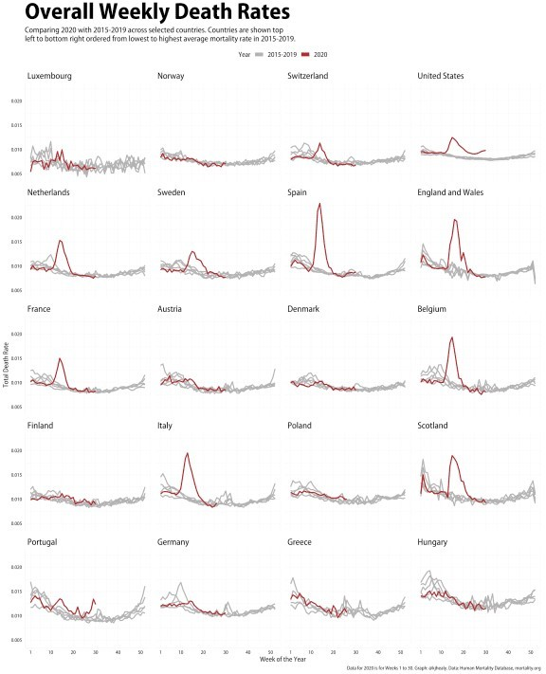

Comparing mortality rates within and across countries.

# To draw a version of this figure in R, install the covdata package along with the tidyverse tools, and then do this:

1. library(tidyverse)
2. library(covdata)

3

4

rate_rank <- stmf %>%

filter(sex == "b", year > 2014 & year < 2020) %>%

1. group_by(country_code) %>%
2. summarize(mean_rate = mean(rate_total, na.rm = TRUE)) %>%
3. mutate(rate_rank = rank(mean_rate)) 8

9

10 rate_max_rank <- stmf %>%

11 filter(sex == "b", year == 2020) %>%

1. group_by(country_code) %>%
2. summarize(covid_max = max(rate_total, na.rm = TRUE)) %>%
3. mutate(covid_max_rank = rank(covid_max)) 15

16

1. stmf %>%
2. filter(sex == "b", year > 2014,
3. country_code %in% c("AUT", "BEL", "CHE", "DEUTNP", "DNK", "ESP", "FIN",
4. "FRATNP", "GBR_SCO", "GBRTENW", "GRC", "HUN",
5. "ITA", "LUX", "POL", "NLD", "NOR", "PRT", "SWE",

22 "USA")) %>%

23 filter(!(year == 2020 & week > 30)) %>%

1. group_by(cname, year, week) %>%
2. mutate(yr_ind = year %in% 2020) %>% 26 slice(1) %>%
3. left_join(rate_rank, by = "country_code") %>%
4. left_join(rate_max_rank, by = "country_code") %>%
5. ggplot(aes(x = week, y = rate_total, color = yr_ind, group = year)) +
6. scale_color_manual(values = c("gray70", "firebrick"), labels = c("2015-2019",

31 "2020")) +

32 scale_x_continuous(limits = c(1, 52),

33 breaks = c(1, seq(10, 50, 10)),

1. labels = as.character(c(1, seq(10, 50, 10)))) +
2. facet_wrap(~ reorder(cname, rate_rank, na.rm = TRUE), ncol = 4) +
3. geom_line(size = 0.9) +
4. guides(color = guide_legend(override.aes = list(size = 3))) +
5. labs(x = "Week of the Year",
6. y = "Total Death Rate",
7. color = "Year",
8. title = "Overall Weekly Death Rates",
9. subtitle = "Comparing 2020 with 2015-2019 across selected countries.
10. Countries are shown top\nleft to bottom right ordered from lowest to highest 44 average mortality rate in 2015-2019.",
11. caption = "Data for 2020 is for Weeks 1 to 30. Graph: @kjhealy. Data: Human
12. Mortality Database, mortality.org") +
13. theme(legend.position = "top",
14. plot.title = element_text(size = rel(3.6)),
15. plot.subtitle = element_text(size = rel(1.25)),
16. strip.text = element_text(size = rel(1.1), hjust = 0),
17. legend.text = element_text(size = rel(1.1)), legend.title = element_text(size = rel(1.1)))

…