Basic functionality

I added a more extensive readme, and all the functions are documented too. But in this short blogpost I wanted to show some examples.

With {pinboardr} you can see what you and other people used as tags for a page:

**library**(pinboardr)

caption **<-** "package {pinboardr}"

**pb_posts_suggest**(url**=**"https://blog.rmhogervorst.nl/blog/2020/04/08/scraping-gdpr-fines/")

tag popular recommended

1 Twitter FALSE TRUE

**pb_posts_suggest**("[http://neverssl.com](http://neverssl.com/)") tag popular recommended

1. ssl TRUE TRUE
2. wifi TRUE TRUE
3. public FALSE TRUE
4. Airport FALSE TRUE
5. captiveportal FALSE TRUE
6. coffee FALSE TRUE
7. connect FALSE TRUE
8. connection FALSE TRUE
9. help FALSE TRUE
10. IFTTT FALSE TRUE

Get recent bookmarks with a specific type

**library**(tidyverse)

recent **<- pb_posts_recent**(tags **=** "r",count**=**4)

**names**(recent)

[1] "href" "title" "description" "meta" "hash"

[6] "time" "public" "toread" "tags" recent **%>% select**(title, tags)

title

1. wttr.in/README.md at master · chubin/wttr.in
2. Automatic Code Cleaning in R with Rclean
3. \U0001f4fb Radio 538 playlist / afspeellijst van donderdag
4. package_idea r
5. r tools
6. blogidea r
7. visualisation r interview

Find out when you bookmarked things.

(I think many bookmarks have the same date because I imported and exported from one tool to another)

dates **<- pb_posts_dates**() dates **%>%**

**mutate**(dates**= as.POSIXct**(date)) **%>% ggplot**(**aes**(dates, count)) **+ geom_col**()**+**

**labs**(title**=**"bookmarks per date", caption**=**caption)

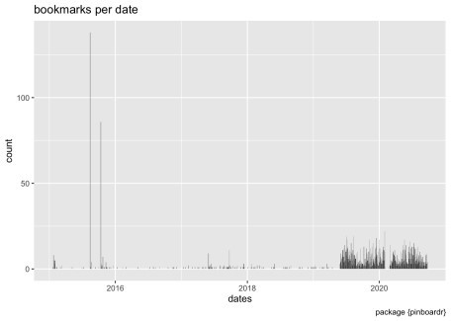

Can you guess when I was on the other side of the world with very spotty internet?

dates **%>%**

**mutate**(dates**= as.POSIXct**(date)) **%>% filter**(dates **>** "2019-08-01") **%>% ggplot**(**aes**(dates, count)) **+ geom_col**()**+**

**labs**(title**=**"bookmarks per date", subtitle **=** "zoomed in", caption**=**caption)

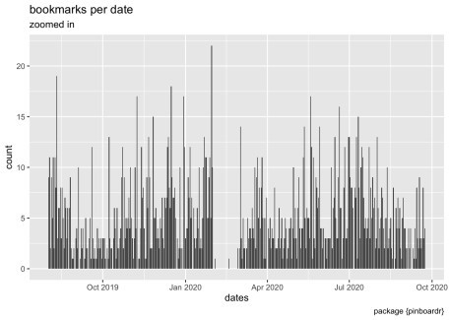

So, see if you like it and check it out at github **Reproducibility** sessioninfo**::session_info**()

— Session info ──────────────────────────────────────────────────────────── setting value

version R version 3.6.3 (2020-02-29)

os macOS Mojave 10.14.6 system x86_64, darwin15.6.0 ui X11

language (EN) collate en_US.UTF-8 ctype en_US.UTF-8 tz Europe/Amsterdam date 2020-05-11

— Packages ──────────────────────────────────────────────────────────── package * version date lib source

assertthat 0.2.1 2019-03-21 [1] CRAN (R 3.6.0)

backports 1.1.5 2019-10-02 [1] CRAN (R 3.6.0)

broom 0.5.5 2020-02-29 [1] CRAN (R 3.6.0)

cellranger 1.1.0 2016-07-27 [1] CRAN (R 3.6.0)

cli 2.0.2 2020-02-28 [1] CRAN (R 3.6.0)

colorspace 1.4-1 2019-03-18 [1] CRAN (R 3.6.0)

crayon 1.3.4 2017-09-16 [1] CRAN (R 3.6.0)

curl 4.3 2019-12-02 [1] CRAN (R 3.6.0)

DBI 1.1.0 2019-12-15 [1] CRAN (R 3.6.0)

dbplyr 1.4.2 2019-06-17 [1] CRAN (R 3.6.0)

digest 0.6.25 2020-02-23 [1] CRAN (R 3.6.0)

dplyr * 0.8.5 2020-03-07 [1] CRAN (R 3.6.0)

ellipsis 0.3.0 2019-09-20 [1] CRAN (R 3.6.0)

evaluate 0.14 2019-05-28 [1] CRAN (R 3.6.0)

fansi 0.4.1 2020-01-08 [1] CRAN (R 3.6.0)

farver 2.0.3 2020-01-16 [1] CRAN (R 3.6.0)

forcats * 0.5.0 2020-03-01 [1] CRAN (R 3.6.0)

fs 1.3.2 2020-03-05 [1] CRAN (R 3.6.0)

generics 0.0.2 2018-11-29 [1] CRAN (R 3.6.0)

ggplot2 * 3.3.0 2020-03-05 [1] CRAN (R 3.6.0)

glue 1.4.0 2020-04-03 [1] CRAN (R 3.6.2)

gtable 0.3.0 2019-03-25 [1] CRAN (R 3.6.0)

haven 2.2.0 2019-11-08 [1] CRAN (R 3.6.0)

hms 0.5.3 2020-01-08 [1] CRAN (R 3.6.0)

htmltools 0.4.0 2019-10-04 [1] CRAN (R 3.6.0)

httr 1.4.1 2019-08-05 [1] CRAN (R 3.6.0)

jsonlite 1.6.1 2020-02-02 [1] CRAN (R 3.6.0)

knitr 1.28 2020-02-06 [1] CRAN (R 3.6.0)

labeling 0.3 2014-08-23 [1] CRAN (R 3.6.0)

|  |  |  |  |  |  |
| --- | --- | --- | --- | --- | --- |
| lattice 0.20-38 | 2018-11-04 | [1] | CRAN | (R | 3.6.3) |
| lifecycle 0.2.0 | 2020-03-06 | [1] | CRAN | (R | 3.6.0) |
| lubridate 1.7.4 | 2018-04-11 | [1] | CRAN | (R | 3.6.0) |

magrittr 1.5 2014-11-22 [1] CRAN (R 3.6.0

modelr 0.1.6 2020-02-22 [1] CRAN (R 3.6.0

munsell 0.5.0 2018-06-12 [1] CRAN (R 3.6.0

nlme 3.1-144 2020-02-06 [1] CRAN (R 3.6.3)

pillar 1.4.4 2020-05-05 [1] CRAN (R 3.6.3)

pinboardr * 0.0.0.9000 2020-05-11 [1] local

pkgconfig 2.0.3 2019-09-22 [1] CRAN (R 3.6.0)

purrr * 0.3.4 2020-04-17 [1] CRAN (R 3.6.2)

R6 2.4.1 2019-11-12 [1] CRAN (R 3.6.0)

Rcpp 1.0.4.6 2020-04-09 [1] CRAN (R 3.6.3)

readr * 1.3.1 2018-12-21 [1] CRAN (R 3.6.0)

readxl 1.3.1 2019-03-13 [1] CRAN (R 3.6.0)

reprex 0.3.0 2019-05-16 [1] CRAN (R 3.6.0)

rlang 0.4.6 2020-05-02 [1] CRAN (R 3.6.2)

rmarkdown 2.1 2020-01-20 [1] CRAN (R 3.6.0)

rstudioapi 0.11 2020-02-07 [1] CRAN (R 3.6.0)

rvest 0.3.5 2019-11-08 [1] CRAN (R 3.6.0)

scales 1.1.0 2019-11-18 [1] CRAN (R 3.6.0)

sessioninfo 1.1.1 2018-11-05 [1] CRAN (R 3.6.0)

stringi 1.4.6 2020-02-17 [1] CRAN (R 3.6.0)

stringr * 1.4.0 2019-02-10 [1] CRAN (R 3.6.0)

tibble * 3.0.1 2020-04-20 [1] CRAN (R 3.6.2)

tidyr * 1.0.2 2020-01-24 [1] CRAN (R 3.6.0)

tidyselect 1.0.0 2020-01-27 [1] CRAN (R 3.6.0)

tidyverse * 1.3.0 2019-11-21 [1] CRAN (R 3.6.0)

vctrs 0.2.4 2020-03-10 [1] CRAN (R 3.6.0)

withr 2.1.2 2018-03-15 [1] CRAN (R 3.6.0)

xfun 0.13 2020-04-13 [1] CRAN (R 3.6.2)

xml2 1.2.2 2019-08-09 [1] CRAN (R 3.6.0)

yaml 2.2.1 2020-02-01 [1] CRAN (R 3.6.0)

[1] /Library/Frameworks/R.framework/Versions/3.6/Resources/library…