# The data.table backend to dplyr

**There’s a new R package in town.** It’s called dtplyr. It’s the data.table backend to

dplyr. And, what it get’s you is truly amazing:

Enjoy the 3X to 5X data.table speedup with grouped summarizations

### All from the comfort of dplyr

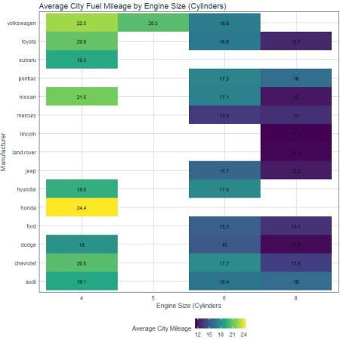

**Make insanely fast grouped summaries by leveraging data.table with dtplyr then quickly visualize your summaries with ggplot2.**

# Before we get started, get the Cheat Sheet

The most powerful tool in my arsenal is NOT my knowledge of the key R packages, but it’s

### knowing where to find R packages and documentation.

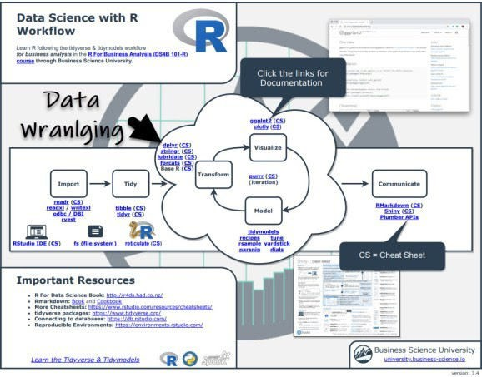

If you tab through to page 3, you’ll see a section called “Speed and Scale”. You can quickly see options to help including data.table, dtplyr, furrr, sparkly, and disk.frame. Enjoy.

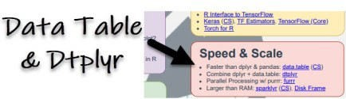

# Get started with dtplyr

The first thing you’ll want to do is **set up a Lazy Data Table** usng the lazy_dt() function.

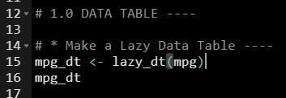

**So what happened?** We now have a pointer to a data.table. This is a special connection that we can use to write dplyr code that gets converted to data.table code.

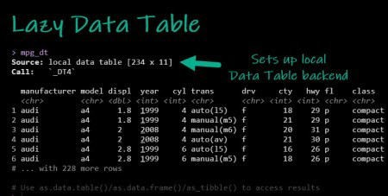

# Translating dplyr to data.table

This idea of a data.table backend to dplyr is insanely powerful. Here’s an example of a dplyr grouped-summarization that gets translated to data.table for a speedup.

Start with lazy datatable connection object

**Group by** the manufacturer and cylinder columns **Summarize** with the new dplyr::across() function **Ungroup** the lazy data.table

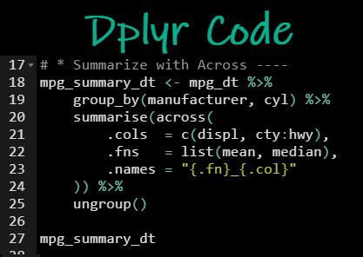

The dtplyr backend does the heavy-lifting, converting your dplyr code into data.table code.

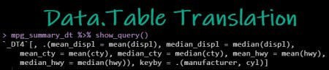

# When your done wrangling…

**Just collect and visualize**

Use the collect() function or as_tibble() function to apply the data.table translation to your lazy data table and extract the results.

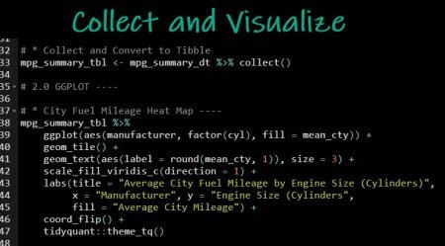

The ggplot2 code produces this visualization. We can easily see:

Honda has the highest City Mileage in small engine cars (24.4 MPG) Audi has the highest City Mileage in large engine cars (16 MPG)



# Learning Data Wrangling with Dplyr

It should be obvious now that **learning dplyr is insanely powerful**. Not only is it beginner- friendly, it unlocks data.table, the fastest in-memory data wrangling tool. Here are a few tips.

## Pro Tip 1 – Use the Cheat Sheet



**Clicking the “CS”** opens the Data Transformation with Dplyr Cheat Sheet. Now you’re ready to begin learning Dplyr.

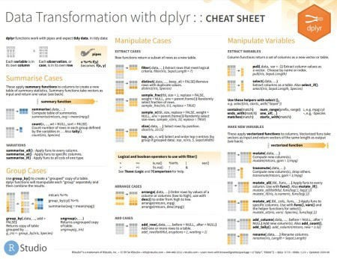

## PRO TIP 2 – Learn Dplyr in my Business Analysis with R Course

It might be difficult to learn Dplyr on your own. I have a course that walks you through the entire process from analysis to reporting.

# In Summary

You just sliced and diced data with dtplyr – the data.table backend to dplyr.