







data("AirPassengers") AP <- AirPassengers str(AP)

Time-Series [1:144] from 1949 to 1961: 112

118 132 129 121 135 148 148 136 119 ...





ts(AP, frequency = 12, start=c(1949,1))

Jan Feb Mar Apr May Jun Jul Aug Sep Oct Nov Dec

1949 112 118 132 129 121 135 148 148 136 119

104 118

1950 115 126 141 135 125 149 170 170 158 133

114 140

1951 145 150 178 163 172 178 199 199 184 162

146 166

1952 171 180 193 181 183 218 230 242 209 191

172 194

1953 196 196 236 235 229 243 264 272 237 211

180 201

1954 204 188 235 227 234 264 302 293 259 229

203 229

1955 242 233 267 269 270 315 364 347 312 274

237 278

1956 284 277 317 313 318 374 413 405 355 306

271 306

1957 315 301 356 348 355 422 465 467 404 347

305 336

1958 340 318 362 348 363 435 491 505 404 359

310 337

1959 360 342 406 396 420 472 548 559 463 407

362 405

1960 417 391 419 461 472 535 622 606 508 461

390 432

plot(AP)

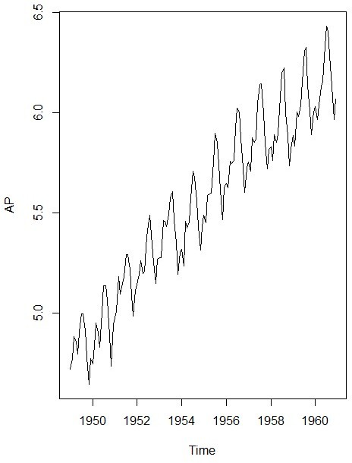







AP <- log(AP)

plot(AP)

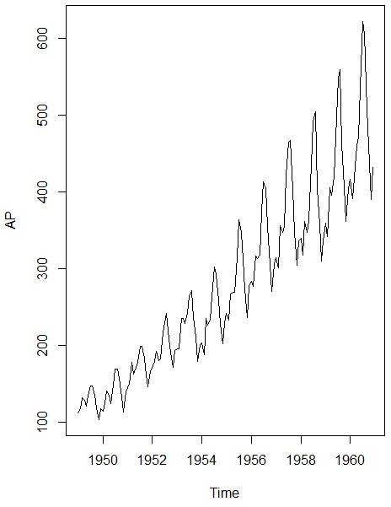



decomp <- decompose(AP) decomp$figure

|  |  |  |  |
| --- | --- | --- | --- |
| [1] -0.085815019 -0.114412848 | | | 0.018113355 |
| -0.013045611 | -0.008966106 | 0.115392997 | |
| 0.210816435 | 0.204512399 | 0.064836351 | |
| -0.075271265 | -0.215845612 | -0.100315075 | |

plot(decomp$figure, type = 'b', xlab = 'Month',

ylab = 'Seasonality Index', col = 'blue',

las = 2)

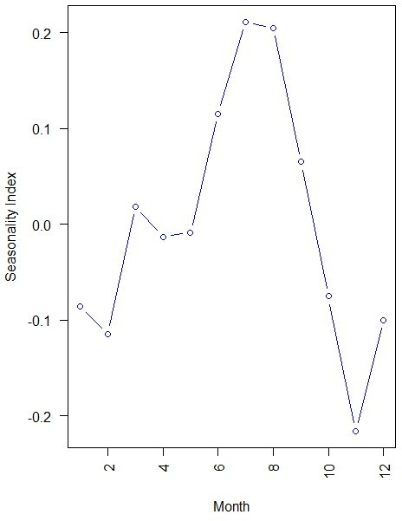



plot(decomp)

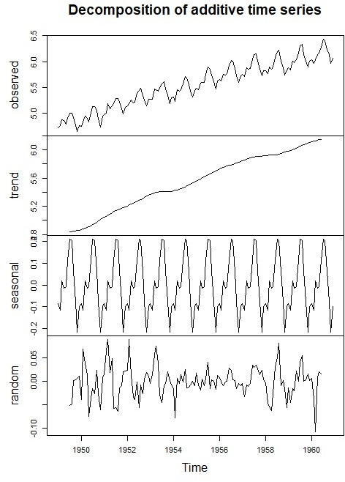





library(forecast) model <- auto.arima(AP) model

Series: AP ARIMA(0,1,1)(0,1,1)[12]

Coefficients:

ma1 sma1

-0.4018 -0.5569

s.e. 0.0896 0.0731

sigma^2 estimated as 0.001371: log likelihood=244.7

AIC=-483.4 AICc=-483.21 BIC=-474.77





acf(model$residuals, main = 'Correlogram')

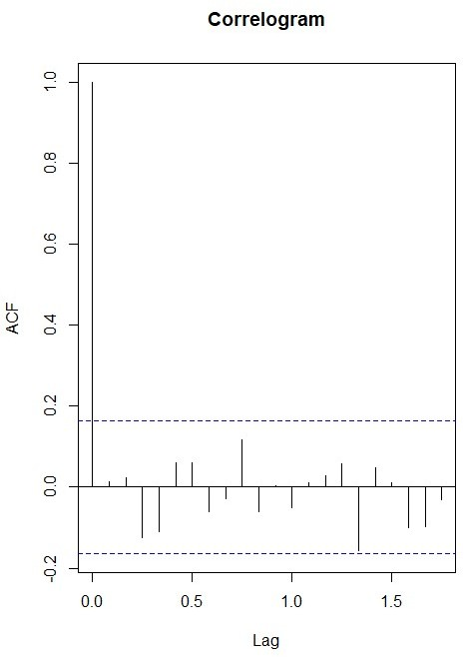





pacf(model$residuals, main = 'Partial Correlogram' )

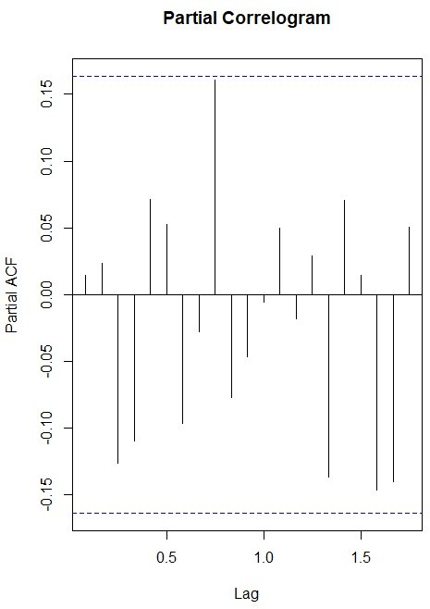





Bo la ty

=

L

Bo

Box-Ljung test

data: model$residuals

X-squared = 17.688, df = 20, p-value = 0.6079





hist(model$residuals, col = 'red', xlab = 'Error',

main = 'Histogram of Residuals', freq = FALSE)

lines(density(model$residuals))

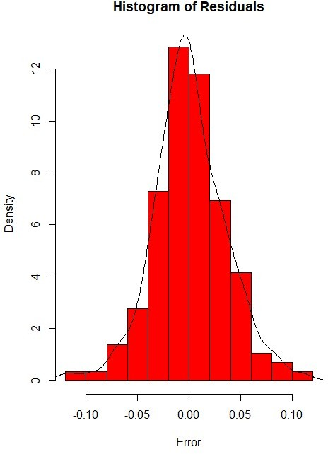



f <- forecast(model, 48) library(ggplot2) autoplot(f)

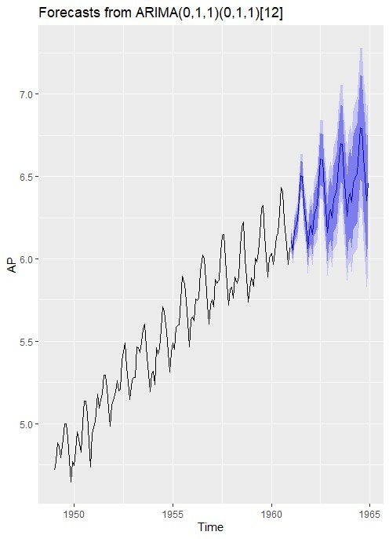

accuracy(f)

MAE

ACF1

MPE

ME

MAPE

RMSE

MASE

Training set 0.0005730622 0.03504883

0.02626034 0.01098898 0.4752815 0.2169522

0.01443892







data <- read.table("D:/RStudio

/TimeseriesAnalysis

/synthetic_control.data.txt", header = F, sep = "")

str(data)

'data.frame': 600 obs. of 60 variables:

plot(data[,60], type = 'l')

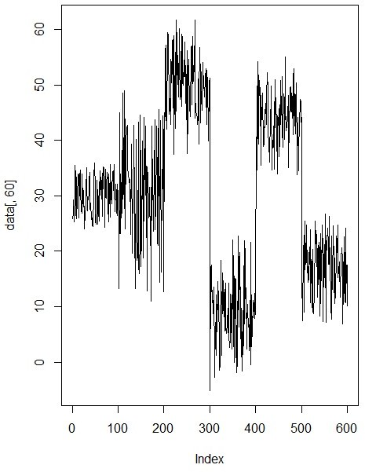

j <- c(5, 105, 205, 305, 405, 505)

sample <- t(data[j,]) plot.ts(sample,

main = "Time-series Plot", col = 'blue',

type = 'b')

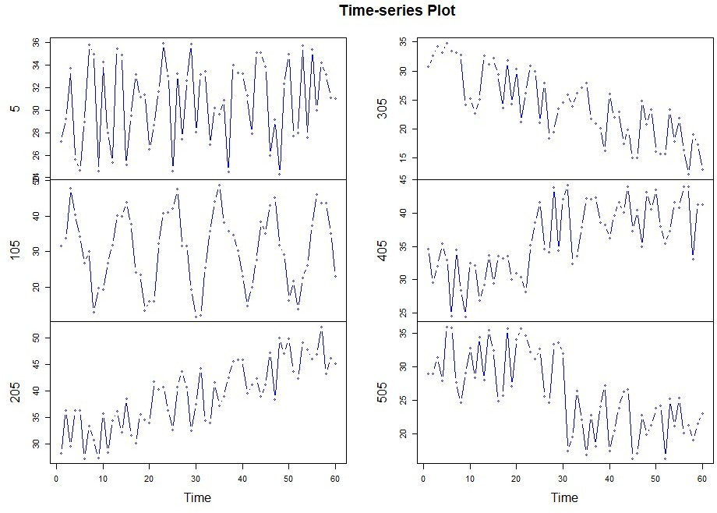



n <- 10

s <- sample(1:100, n)

i <- c(s,100+s, 200+s, 300+s, 400+s, 500+s)

d <- data[i,] str(d)

pattern <- c(rep('Normal', n),

rep('Cyclic', n), rep('Increasing trend', n), rep('Decreasing trend', n), rep('Upward shift', n), rep('Downward shift', n))



library(dtw)

distance <- dist(d, method = "DTW")



hc <- hclust(distance, method = 'average') plot(hc,

labels = pattern, cex = 0.7,

hang = -1, col = 'blue')

rect.hclust(hc, k=4)

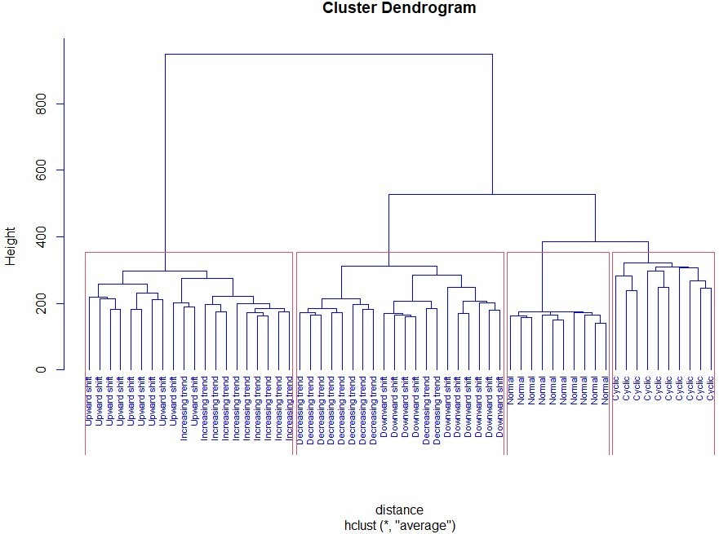





pattern100 <- c(rep('Normal', 100),

rep('Cyclic', 100),

rep('Increasing trend', 100),

rep('Decreasing trend', 100),

rep('Upward shift', 100),

rep('Downward shift', 100)) newdata <- data.frame(data, pattern100) str(newdata)

newdata$pattern100<-factor(newdata$pattern100)



library(party)

tree <- ctree(pattern100~., newdata)



tab <- table(Predicted = predict(tree, newdata), Actual = newdata$pattern100)

Actual

Predicted

Cyclic Decreasing trend

Downward shift Increasing trend Normal

Cyclic 97

0

3

Decreasing trend

0

0

0

99 8 0 0

|  |  |  |  |  |  |  |
| --- | --- | --- | --- | --- | --- | --- |
|  | Downward | shift | 0 |  | | |
| 1 |  | 89 |  | 0 | | 0 |
| Increasing trend 2 | | | |  |  |  |
| 0 0 | | | |  | 96 | 0 |
| Normal 1 | | | |  |  |  |
| 0 0 | | | |  | 0 | 100 |
| Upward shift 0 | | | |  |  |  |
| 0 0 | | | |  | 4 | 0 |
| Actual | | | |  |  |  |
| Predicted Upward | | | | shift |  |  |
| Cyclic | | | | 0 |  |  |
| Decreasing trend | | | | 0 |  |  |
| Downward shift | | | | 0 |  |  |
| Increasing trend | | | | 6 |  |  |
| Normal | | | | 4 |  |  |
| Upward shift | | | | 90 |  |  |

sum(diag(tab))/sum(tab) 0.9516667

