# Plotting multiple time series in a single plot

Recently a person posed a question on Stackoverflow about how to combine multiple time series into a single plot within the ggplot2 package. The question referenced another Stackoverflow answer for a similar type of question, but the person who posted the new question wasn’t able to apply the other answer in a way that produced the desired chart.

As specified in the question, data for various stock symbols is loaded into R via the quantmod::getSymbols() function, where the adjusted closing stock prices are extracted and saved to a vector.

library(quantmod) library(TSclust) library(ggplot2)

# download financial data

symbols = c('ASX', 'AZN', 'BP', 'AAPL')

start = as.Date("2014-01-01") until = as.Date("2014-12-31")

stocks = lapply(symbols, function(symbol) {

adjust = getSymbols(symbol,src='yahoo', from = start, to = until, auto.assign = FALSE)[, 6]

names(adjust) = symbol adjust

})

At this point the symbols object is a list that contains four xts (extensible time series) objects.

qplot(symbols, value, data = as.data.frame(stocks), geom = "line", group = variable) +

facet_grid(variable ~ ., scale = "free_y")

* qplot(symbols, value, data = as.data.frame(stocks), geom = "line", group = variable) +

+ facet_grid(variable ~ ., scale = "free_y")

Error: At least one layer must contain all faceting variables: `variable`.

* Plot is missing `variable`
* Layer 1 is missing `variable`

Run `rlang::last_error()` to see where the error occurred.

The qplot() fails because there is no column called variable in the data that is passed to the plot function. Additionally, in order to produce the desired chart we need to extract the dates from the xts objects generated by quantmod::getSymbols() so we can use them as the x axis variable on the chart.

# A solution with Base R

With a few adjustments, the code posted in the original question can be edited to produce the desired results.

Convert the xts objects to objects of type data.frame

Rename columns and save the stock ticker symbols as a distinct column, resulting in a wide format tidy data frame

Extract the rownames() that represent the time periods into another column

The revised code produces a list of data frames, one per stock ticker.

stocks = lapply(symbols, function(symbol) {

aStock = as.data.frame(getSymbols(symbol,src='yahoo', from = start, to = until,

auto.assign = FALSE)) colnames(aStock) <- c("Open","High","Low","Close","Volume","Adjusted") aStock$Symbol <- symbol

aStock$Date <- as.Date(rownames(aStock),"%Y-%m-%d") aStock

})

We use rbind() to consolidate the list into a single data frame.

stocksDf <- do.call(rbind,stocks)

We use a combination of qplot() and helper functions from the ggeasy package to customize how the dates are rendered as x axis labels.

library(ggeasy)

qplot(Date, Adjusted, data = stocksDf, geom = "line", group = Symbol) + facet_grid(Symbol ~ ., scale = "free_y") + scale_x_date(date_breaks = "14 days") + easy_rotate_x_labels(angle = 45, side = "right")

Having corrected the errors in the original code, the qplot() produces the desired output.

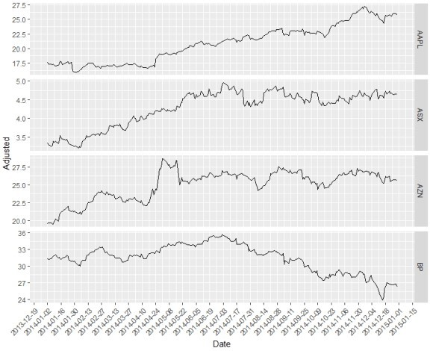

**An *xts-friendly* solution**

One of the wonderful but sometimes frustrating aspects of R is that there is always more than one way to accomplish a given task, and plotting multiple time series on a single chart is no exception. Another answer was also plotted for this post.

Key differences in the two solutions include:

1. Load the stock ticker data into an environment, and then use merge() with lapply() to combine only the adjusted closing stock prices from all objects in the environment into one xts object
2. Remove .Adjusted from the column names via gsub()
3. Convert the xts object to a long form tidy data frame via ggplot2::fortify()

The fortify() function converts a model object to a data frame, and the melt = 'TRUE' argument converts the data from wide format to long format.

library(quantmod) library(ggplot2)

symbols <- c("ASX", "AZN", "BP", "AAPL")

start <- as.Date("2014-01-01") until <- as.Date("2014-12-31")

# import data into an environment e <- new.env()

getSymbols(symbols, src = "yahoo", from = start, to = until, env = e)

# extract the adjusted close and merge into one xts object stocks <- do.call(merge, lapply(e, Ad))

# Remove the ".Adjusted" suffix from each symbol column name colnames(stocks) <- gsub(".Adjusted", "", colnames(stocks), fixed = TRUE)

# convert the xts object to a long data frame stocks_df <- fortify(stocks, melt = TRUE)

The data frame generated by fortify() contains three columns, Index representing a date, Series

representing the stock ticker, and Value, representing the Adjusted closing price on a given date.

* head(stocks_df)

|  |  |  |
| --- | --- | --- |
| Index | Series | Value |
| 1 2014-01-02 | AZN | 19.53932 |
| 2 2014-01-03 | AZN | 19.63607 |
| 3 2014-01-06 | AZN | 19.64608 |
| 4 2014-01-07 | AZN | 19.51931 |
| 5 2014-01-08 | AZN | 19.52265 |
| 6 2014-01-09 | AZN | 19.80621 |

The last step in the process is to generate the facetted qplot(). # plot the data

qplot(Index, Value, data = stocks_df, geom = "line", group = Series) + facet_grid(Series ~ ., scale = "free_y")

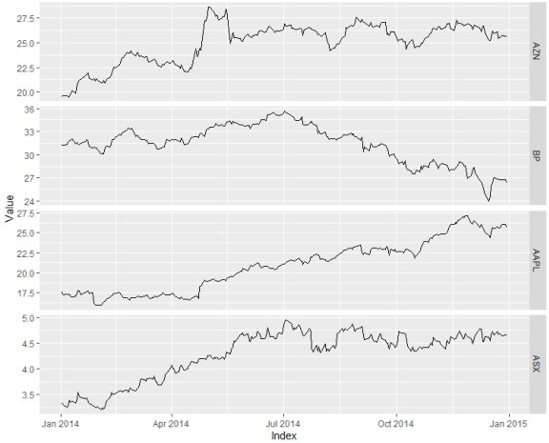

# Observations

I’m not a frequent user of quantmod. The fact that getSymbols() returns xts objects where the column dimension includes a ticker symbol along with the actual column name has led me to use lapply() to separate the ticker names from the columns and immediately convert the objects to data frames, an object type with which I am more familiar.

Joshua’s solution helped me realize that by retaining the xts object type and using merge(), I can avoid converting row names to a date column and defer separation of the stock ticker symbol from the column name.

Second, R is constantly changing. As I reviewed Joshua’s code, I discovered that ggplot2::fortify() is being deprecated. The current tidyverse function that replicates the behavior of fortify() is broom::tidy(), and it enables us to avoid the gsub() step because it automatically tidies the column names.

stocks <- do.call(merge, lapply(e, Ad)) head(stocks)

* head(stocks)

|  |  |  |  |  |
| --- | --- | --- | --- | --- |
|  | AZN.Adjusted | BP.Adjusted | AAPL.Adjusted | ASX.Adjusted |
| 2014-01-02 | 19.53932 | 31.31375 | 17.65500 | 3.338105 |
| 2014-01-03 | 19.63607 | 31.24196 | 17.26720 | 3.302056 |
| 2014-01-06 | 19.64608 | 31.32681 | 17.36135 | 3.244379 |
| 2014-01-07 | 19.51931 | 31.68575 | 17.23719 | 3.287637 |
| 2014-01-08 | 19.52265 | 31.80323 | 17.34635 | 3.395782 |
| 2014-01-09 | 19.80621 | 31.88154 | 17.12484 | 3.352525 |

library(broom)

a_tibble <- tidy.zoo(stocks) head(a_tibble)

* head(a_tibble) # A tibble: 6 x 3

|  |  |  |
| --- | --- | --- |
| index | series | value |
| 1 2014-01-02 | AZN | 19.5 |
| 2 2014-01-03 | AZN | 19.6 |
| 3 2014-01-06 | AZN | 19.6 |
| 4 2014-01-07 | AZN | 19.5 |
| 5 2014-01-08 | AZN | 19.5 |
| 6 2014-01-09 | AZN | 19.8 |