# Library Overview

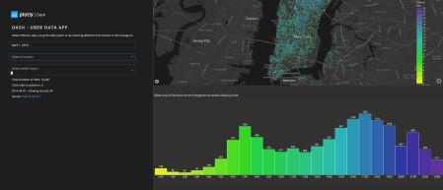Let’s start with Python’s Dash. It is a Python framework used for building web applications. Here’s an example dashboard you can create with Dash:

*Image 1 – New York Uber Rides Dash Dashboard*

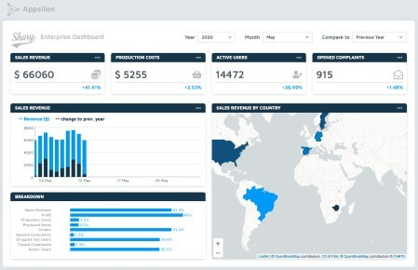On the other hand, R Shiny is an open-source package for building web applications with R. It provides a Here’s an example dashboard you can create with Shiny:

*Image 2 – Shiny Enterprise Dashboard*

**Winner: Tie.** You can develop identical solutions with both Dash and Shiny.

# Boilerplate Comparison

Every web framework comes with a chunk of code needed for the application to run. You can’t avoid writi H3. Let’s begin with Dash.

import dash

import dash_html_components as html

app = dash.Dash( name ) app.layout = html.Div(children=[

html.H3('Dash App')

])

if __name == ' main ': app.run_server(debug=True)

Here’s the corresponding application:

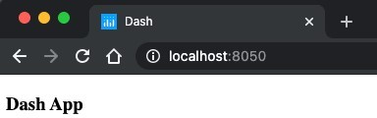

Image 3 – Basic Dash application

So eleven lines in total, and you haven’t imported any data visualization library. Three lines are empty – u

library(shiny)

ui <- fluidPage( tags$h3("Shiny App")

)

server <- function(input, output) { } shinyApp(ui, server)

Only nine lines here, of which three are empty. Here’s the corresponding application:

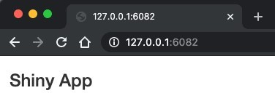

Image 4 – Basic Shiny application

**Winner: R Shiny.** Does it really matter much, though? It’s only boilerplate code, after all. At this initial ease-of-use throughout the article.

# Creating UI Elements

Let’s continue our comparison by taking a look at UI elements. The goal is to create the same form-base Let’s start with Python’s Dash. All of the core UI components are available in the dash_core_compone Here’s the code for a simple form-based application:

import dash

import dash_core_components as dcc import dash_html_components as html

app = dash.Dash( name ) app.layout = html.Div(children=[

html.H1('Heading 1'), html.Label('Filter by level:'), dcc.Dropdown(

options=[

{'label': 'Junior', 'value': 'junior'},

{'label': 'Mid level', 'value': 'mid'},

{'label': 'Senior', 'value': 'senior'}

],

value='junior'

),

html.Label('Filter by skills:'), dcc.Dropdown(

options=[

{'label': 'Python', 'value': 'python'},

{'label': 'R', 'value': 'r'},

{'label': 'Machine learning', 'value': 'ml'}

],

value=['python', 'ml'], multi=True

),

html.Label('Experience level:'), dcc.RadioItems(

options=[

{'label': '0-1 years of experience', 'value': '01'},

{'label': '2-5 years of experience', 'value': '25'},

{'label': '5+ years of experience', 'value': '5plus'}

],

value='25'

),

html.Label('Additional:'), dcc.Checklist(

options=[

{'label': 'Married', 'value': 'married'},

{'label': 'Has kids', 'value': 'haskids'}

],

value=['married']

),

html.Label('Overall impression:'), dcc.Slider(

min=1,

max=10, value=5

),

html.Label('Anything to add?'), dcc.Input(type='text')

])

if __name == ' main ': app.run_server(debug=True)

And here’s the corresponding application:

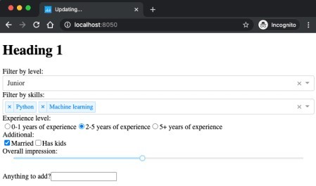

*Image 5 – Simple form-based application in Python’s Dash*

Yeah, not the prettiest. Dash doesn’t include too many styles by default.

Let’s replicate the same application with R and Shiny:

library(shiny)

ui <- fluidPage( tags$h1("Heading 1"), selectInput(

inputId = "selectLevel", label = "Filter by level:",

choices = c("Junior", "Mid level", "Senior"), selected = c("Junior")

),

selectInput(

inputId = "selectSkills", label = "Filter by skills:",

choices = c("Python", "R", "Machine learning"), selected = c("Python", "Machine learning"), multiple = TRUE

),

radioButtons(

inputId = "radioExperience",

label = "Experience level:",

choices = c("0-1 years of experience", "2-5 years of experience", "5+ yea experience"),

selected = c("2-5 years of experience")

),

checkboxGroupInput(

inputId = "cbxAdditional", label = "Additional:",

choices = c("Married", "Has kids"), selected = c("Married")

),

sliderInput(

inputId = "slider",

label = "Overall impression:", value = 5,

min = 1,

max = 10

),

textInput(

inputId = "textAdditional", label = "Anything to add?"

)

)

server <- function(input, output) { }

shinyApp(ui, server)

Here’s the corresponding application:

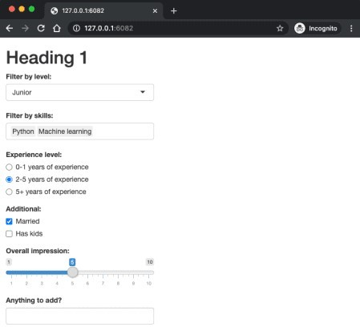

*Image 6 – Simple form-based application in R Shiny*

As you can see, Shiny includes a ton more styling straight out of the box. Shiny applications look better t

**Winner: R Shiny.** You can create a better-looking application with less code.

# Styling UI with Custom CSS

Nobody likes a generic-looking application. The aesthetics of your app are tied directly with how users Still, adding a touch of syle through CSS is more or less a must for your app. This section compares how A CSS file for the Dash application goes to the assets folder and in the www folder for Shiny apps. Here’s the complete CSS for both Dash and Shiny – called main.css:

@import url('https://fonts.googleapis.com/css2?family=Lato:wght@400;700&display=swap');

* {

margin: 0;

padding: 0;

box-sizing: border-box;

font-family: 'Lato', sans-serif;

}

.wrapper {

padding: 1rem 2rem; background-color: #f2f2f2; height: 100vh;

}

.main-title {

font-size: 3rem;

}

.paragraph-lead {

font-size: 1.25rem; color: #777777;

}

.card {

background-color: #ffffff; margin-top: 1.5rem; padding: 1rem 1.25rem;

border: 0.1rem solid #c4c4c4; border-radius: 0.3rem;

min-height: 12rem;

}

.card-title {

margin-bottom: 1rem;

}

.card-text {

margin-bottom: 3.5rem;

}

.card-button {

background-color: #0099f9; color: #ffffff;

font-weight: bold;

border: 0.2rem solid #0099f9; border-radius: 0.5rem; padding: 1rem 1.5rem;

cursor: pointer; transition: all 0.15s;

}

.card-button:hover { background-color: #ffffff; color: #0099f9;

}

Let’s now use it to create a simple styled application – first with Dash:

import dash

import dash_html_components as html

app = dash.Dash( name ) app.layout = html.Div(

className='wrapper', children=[

html.H3('Dash App', className='main-title'),

html.P('A simple Python dashboard', className='paragraph-lead'), html.Div(

className='card', children=[

html.H3('A simple card', className='card-title'), html.P('Card text', className='card-text'), html.A('Button', className='card-button')

]

)

])

if __name == ' main ': app.run_server(debug=True)

Here’s the corresponding application:

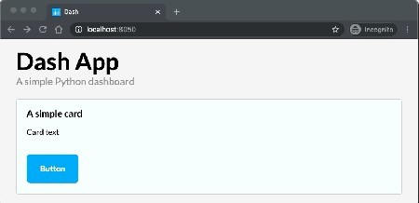

*Image 7 – Styled Dash application*

As you can see, the stylings work just as for any regular web application. That’s because Dash didn’t add Here’s the code for a styled R Shiny app:

library(shiny)

ui <- fluidPage( theme = "main.css", class = "wrapper",

tags$h3("Shiny App", class = "main-title"),

tags$p("A simple Shiny dashboard", class = "paragraph-lead"), tags$div(

class = "card",

tags$h3("A simple card", class = "card-text"), tags$p("Card text", class = "card-text"), tags$a("Button", class = "card-button")

)

)

server <- function(input, output) { }

shinyApp(ui, server)

And here’s the corresponding dashboard:

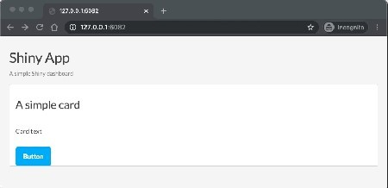

*Image 8 – Styled Shiny application*

Well, that obviously doesn’t look right. The more elaborate default Shiny styling is conflicting with our cus basic level.

**Winner: Dash**. This doesn’t mean you can’t make Shiny apps look fantastic, though.

# Styling UI with Bootstrap

Let’s discuss CSS frameworks. Bootstrap’s been one of the most popular frameworks for years, so natur “standard” appearance. Anyone who has been in web design/development for more than a short period k

Including Bootstrap in Dash is easy. You just have to install the dash_bootstrap_components library

import dash

import dash_html_components as html import dash_bootstrap_components as dbc

app = dash.Dash( external_stylesheets=[dbc.themes.BOOTSTRAP]

)

navbar = dbc.NavbarSimple( children=[

dbc.NavItem(dbc.NavLink('About', href='#')), dbc.NavItem(dbc.NavLink('Products', href='#')), dbc.DropdownMenu(

children=[

dbc.DropdownMenuItem('More pages', header=True), dbc.DropdownMenuItem('Page 2', href='#'),

dbc.DropdownMenuItem('Page 3', href='#'),

],

nav=True, in_navbar=True, label='More',

),

],

brand='Bootstrap NavBar', brand_href='#', color='#0099f9', dark=True,

)

jumbotron = dbc.Jumbotron([ html.H1('Welcome', className='display-3'),

html.P('This is a sample jumbotron', className='lead'), html.Hr(className='my-2'),

html.P('Additional dummy text'),

html.P(dbc.Button('Learn more', color='primary'), className='lead'),

])

app.layout = html.Div([ navbar,

jumbotron

])

if __name == ' main ': app.run_server(debug=True)

Here’s the corresponding application:

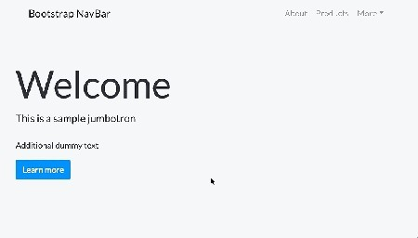

*Image 9 – Dash and Bootstrap*

R Shiny is different. It comes with Bootstrap out of the box, but not with the most recent version.

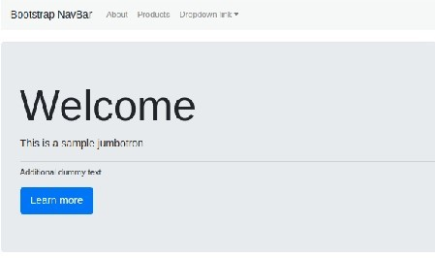

*Image 10 – Shiny and Bootstrap*

As you can see, it is a code-heavy solution. It requires you to specify every CSS class and other properties

**Winner: Dash.** Using Bootstrap is much cleaner in Dash than in Shiny.

# Reactivity

Dashboards shouldn’t look and behave like plain reports. They have to be interactive. Users won’t like yo components, delay updates until the button is pressed, etc. We’ll stick to the basics and perform the upd

For our example, you’ll have a single text input and two dropdown menus. Their values determine how th Let’s start with Python and Dash. Here’s the code:

import dash

import dash_core_components as dcc import dash_html_components as html

from dash.dependencies import Input, Output import plotly.express as px

import statsmodels.api as sm import pandas as pd

data = pd.DataFrame(sm.datasets.get_rdataset('mtcars', 'datasets', cache=True external_stylesheets = ['https://codepen.io/chriddyp/pen/bWLwgP.css']

app = dash.Dash( name , external_stylesheets=external_stylesheets) app.layout = html.Div([

html.Label('Plot title:'),

dcc.Input(id='input-title', value='MTCars visualization', type='text'), html.Br(),

html.Label('X-axis:'), dcc.Dropdown(

id='dropdown-x',

options=[{'label': col, 'value': col} for col in data.columns], value='mpg'

),

html.Br(), html.Label('Y-axis:'), dcc.Dropdown(

id='dropdown-y',

options=[{'label': col, 'value': col} for col in data.columns], value='mpg'

),

html.Br(), html.Div(

dcc.Graph(id='chart')

)

], style={'padding': '30px'})

@app.callback( Output('chart', 'figure'),

Input('input-title', 'value'),

Input('dropdown-x', 'value'),

Input('dropdown-y', 'value'))

def update_output(title, x_axis, y_axis):

fig = px.scatter(data, x=x_axis, y=y_axis, title=title) return fig

if __name == ' main ': app.run_server(debug=True)

And here’s the corresponding dashboard:

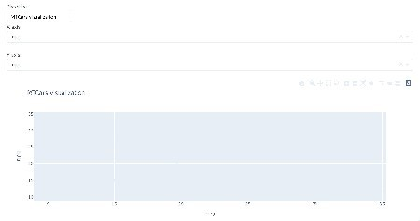

*Image 11 – Reactivity demonstration with Python and Dash*

It’s a simple dashboard but requires a fair amount of code. Nevertheless, the code is simple to read and R Shiny is a bit simpler. It requires significantly less code to produce the same output.

Here’s the code for producing the identical dashboard:

library(shiny) library(ggplot2) library(plotly)

ui <- fluidPage( tags$div(

class = "wrapper",

tags$style(type = "text/css", ".wrapper {padding: 30px}"), textInput(inputId = "inputTitle", label = "Plot title:", value = "MTCars varSelectInput(inputId = "dropdownX", label = "X-axis", data = mtcars), varSelectInput(inputId = "dropdownY", label = "Y-axis", data = mtcars), plotlyOutput(outputId = "chart")

)

)

server <- function(input, output) { output$chart <- renderPlotly({

col_x <- sym(input$dropdownX) col_y <- sym(input$dropdownY)

p <- ggplot(mtcars, aes(x = !!col_x, y = !!col_y)) + geom_point() +

labs(title = input$inputTitle) ggplotly(p)

})

}

shinyApp(ui, server)

Here’s the corresponding dashboard:

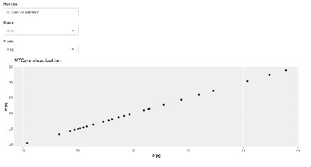

*Image 12 – Reactivity demonstration with R Shiny*

**Winner: R Shiny.** Shiny requires less code than Dash for better-looking output.

# Conclusion

The final results are in:

R Shiny – 3 points Python Dash – 2 points Tie – 1 point

It looks like R shiny is ahead by a single point. Does this mean that R Shiny better for everyone and ever