# Getting the data

First we load the needed libraries:

library(tidyverse) library(sf)

Reading in spatial data into R can be easily done using the st_read function. The function support a large number of formats by using the GDAL driver in the background. We will use an example dataset from the Flemish region of Belgium, downloading a zip file with all the shapefiles, unzipping it and loading it into R:

# define a target directory in your laptop target_dir <- "./"

# put this as the working directory setwd(target_dir)

# download the files download.file("https://downloadagiv.blob.core.windows.net/referentiebestand-gemeenten/ VoorlopigRefBestandGemeentegrenzen_2016-01-29/Voorlopig_referentiebestand_ gemeentegrenzen_toestand_29_01_2016_GewVLA_Shape.zip", destfile = "municipality.zip")

# unzip it

unzip(zipfile = "municipality.zip")

# read in the Flemish province shapefile province <- st_read("Shapefile/Refprv.shp")

## Reading layer `Refprv' from data source `D:\Documents\Programming_ stuff\_posts_data\r_as_gis\Shapefile\Refprv.shp' using driver `ESRI Shapefile'

## Simple feature collection with 5 features and 8 fields ## geometry type: MULTIPOLYGON

## dimension: XY

## bbox: xmin: 21991.38 ymin: 153049.4 xmax: 258878.5 ymax:

244027.1

## projected CRS: Belge 1972 / Belgian Lambert 72

The function tells us that te dataset is made of 5 features (rows) each having 8 fields (columns). We also get some infos on the bounding box and the Coordinate Reference System (CRS).

The function returns an object of class sf that looks like a data.frame:

province

## Simple feature collection with 5 features and 8 fields ## geometry type: MULTIPOLYGON

## dimension: XY

## bbox: xmin: 21991.38 ymin: 153049.4 xmax: 258878.5 ymax:

244027.1

## projected CRS: Belge 1972 / Belgian Lambert 72

|  |  |  |  |  |  |  |  |  |
| --- | --- | --- | --- | --- | --- | --- | --- | --- |
| ## | UIDN | OIDN | TERRID | NAAM | NISCODE | NUTS2 | LENGTE | OPPERVL |
| ## | 1 6 | 2 | 357 | Antwerpen | 10000 | BE21 | 409906.2 | 2876444170 |
| ## | 2 7 | 4 | 359 | Vlaams Brabant | 20001 | BE24 | 507999.1 | 2118893799 |
| ## | 3 9 | 5 | 356 | Oost-Vlaanderen | 40000 | BE23 | 404985.3 | 3008166146 |

|  |  |  |  |  |  |  |  |  |
| --- | --- | --- | --- | --- | --- | --- | --- | --- |
| ## | 4 | 10 | 1 | 355 | Limburg | | 70000 | BE22 397732.6 2428024237 |
| ## | 5 | 11 | 3 | 351 | West-Vlaanderen | | 30000 | BE25 356653.0 3197075771 |
| ## |  |  |  |  | geometry | |  |  |
| ## | 1 | MULTIPOLYGON | | (((178133.9 | | 24... | | |
| ## | 2 | MULTIPOLYGON | | (((200484.9 | | 19... | | |
| ## | 3 | MULTIPOLYGON | | (((142473.9 | | 22... | | |
| ## | 4 | MULTIPOLYGON | | (((231635.6 | | 21... | | |
| ## | 5 | MULTIPOLYGON | | (((80189.16 | | 22... | | |

The important difference with a standard data.frame is the “geometry” column that contains the vector informations using the well-known text representation. This column is sticky, it will stay in the R object unless explicitely dropped (check ?st_drop_geometry).

# Manipulating sf object

The dplyr functions can be used to manipulate sf objects, for instance we will rename the “NAAM” column, create a new “area” column and sort the rows by the area descending:

province %>%

rename(name = NAAM) %>% mutate(area = OPPERVL / 1e6) %>% select(name, area) %>% arrange(desc(area)) -> province

# Coordinate Reference System

Every spatial data comes with a Coordinate reference system (CRS in short) that describes how the data are represented on the surface of the earth. An in-depth definition of CRS is beyond the scope of this post, here we will just see how to get CRS information from sf object and how to transform them into new reference system.

CRS are defined in sf by their epsg code, for instance the classical GPS/WGS84 CRS has the 4326 code, let's explore this:

# get CRS st_crs(province)

## Coordinate Reference System:

## User input: Belge 1972 / Belgian Lambert 72 ## wkt:

## PROJCRS["Belge 1972 / Belgian Lambert 72", ## BASEGEOGCRS["Belge 1972",

## DATUM["Reseau National Belge 1972",

## ELLIPSOID["International 1924",6378388,297, ## LENGTHUNIT["metre",1]],

## ID["EPSG",6313]],

## PRIMEM["Greenwich",0,

## ANGLEUNIT["Degree",0.0174532925199433]]],

## CONVERSION["unnamed",

## METHOD["Lambert Conic Conformal (2SP)", ## ID["EPSG",9802]],

## PARAMETER["Latitude of false origin",90,

## ANGLEUNIT["Degree",0.0174532925199433],

## ID["EPSG",8821]],

## PARAMETER["Longitude of false origin",4.36748666666667, ## ANGLEUNIT["Degree",0.0174532925199433],

## ID["EPSG",8822]],

## PARAMETER["Latitude of 1st standard parallel",49.8333339, ## ANGLEUNIT["Degree",0.0174532925199433],

## ID["EPSG",8823]],

## PARAMETER["Latitude of 2nd standard parallel",51.1666672333333,

## ANGLEUNIT["Degree",0.0174532925199433],

## ID["EPSG",8824]],

## PARAMETER["Easting at false origin",150000.01256, ## LENGTHUNIT["metre",1],

## ID["EPSG",8826]],

## PARAMETER["Northing at false origin",5400088.4378, ## LENGTHUNIT["metre",1],

## ID["EPSG",8827]]],

## CS[Cartesian,2],

## AXIS["(E)",east, ## ORDER[1],

## LENGTHUNIT["metre",1,

## ID["EPSG",9001]]],

## AXIS["(N)",north, ## ORDER[2],

## LENGTHUNIT["metre",1,

## ID["EPSG",9001]]]]

# re-project into the European CRS province <- st_transform(province, 3035)

When working with spatial data it is key to make sure that the CRS are adequate, for instance computing areas or distances make more sense in projected CRS rather than in geographic CRS. Also, when doing spatial operations on several spatial objects all the CRS have to be identical.

# Plotting spatial data

sf objects can be, very convinently, plotted using ggplot2: # a simple plot of the province

# colored by their surface ggplot() +

geom_sf(data = province, aes(fill = area)) + geom_sf_label(data = province, aes(label = name)) + scale_fill_continuous(type = "viridis",

name = "Area [km²]") + labs(title = "Flemish provinces",

x = "",

y = "") +

theme(panel.background = element_blank(), axis.text = element_blank(), axis.ticks = element_blank())

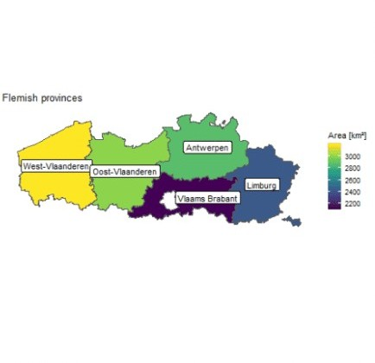

# Geometrical operations

Several types of geometrical operations are implemented in sf

## Unary operations returning a geometry

These operations take a single sf object and return geometries, these include getting a buffer around geometries or the centroid of polygons. We will explore this with a dataset of the Flemish municipalities:

# load the municipality shapefile

municipality <- st_read("Shapefile/Refgem.shp")

## Reading layer `Refgem' from data source `D:\Documents\Programming_ stuff\_posts_data\r_as_gis\Shapefile\Refgem.shp' using driver `ESRI Shapefile'

## Simple feature collection with 308 features and 9 fields ## geometry type: MULTIPOLYGON

## dimension: XY

## bbox: xmin: 21991.38 ymin: 153049.4 xmax: 258878.5 ymax:

244027.1

## projected CRS: Belge 1972 / Belgian Lambert 72

# re-project municipality data municipality <- st_transform(municipality

st_crs(province))

# make a buffer of 5000m around the city of Antwerpen

ant_buffer <- st_buffer(municipality[municipality$NAAM == "Antwerpen",], dist = 5000)

# get the centroids of the municipalities municipality_cent <- st_centroid(municipality

## Warning in st_centroid.sf(municipality): st_centroid assumes attributes are

## constant over geometries of x

# plot the different objects ggplot() +

geom_sf(data = municipality) +

geom_sf(data = ant_buffer, alpha = 0.5, fill = "orange") + geom_sf(data = municipality_cent, color = "green")

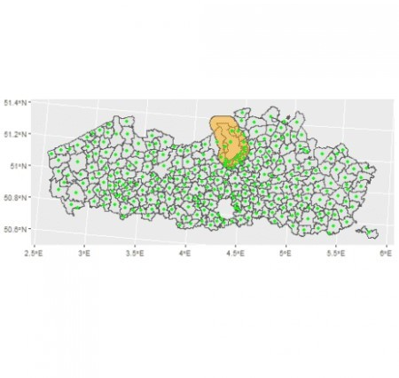

## Binary logical operations

These geometrical operation take two geometries and return logical information, for instance we can check which of the city centroids are within the 5km buffer of the city of Antwerpen

st_within(municipality_cent, ant_buffer)

## Sparse geometry binary predicate list of length 308, where the predicate was `within'

## first 10 elements: ## 1: (empty)

## 2: (empty)

## 3: (empty)

## 4: (empty)

## 5: 1

## 6: (empty)

## 7: (empty)

## 8: (empty)

## 9: (empty)

## 10: (empty)

The function returns a list where each element represent the centroid of one of the 308 municipalities, an “(empty)” value means that the centroid was not within the buffer while a value of “1” indicate that it was within the buffer. We can also get this output as a logical vector/matrix:

st_within(municipality_cent, ant_buffer, sparse = FALSE)[1:10,]

## [1] FALSE FALSE FALSE FALSE TRUE FALSE FALSE FALSE FALSE FALSE

This can be used to filter the municipality dataset to only keep the cities whose centroid are within the buffer:

municipality %>%

filter(st_within(municipality_cent, ant_buffer, sparse = FALSE)) ## Simple feature collection with 20 features and 9 fields

## geometry type: MULTIPOLYGON ## dimension: XY

## bbox: xmin: 3912907 ymin: 3123760 xmax: 3941971 ymax:

3156259

## projected CRS: ETRS89-extended / LAEA Europe ## First 10 features:

## UIDN OIDN TERRID NISCODE NAAM DATPUBLBS NUMAC LENGTE

## 1 313 5 140 11001 Aartselaar 1982-12-29 1982001920

22122.90

## 2 370 62 124 11029 Mortsel 1982-12-29 1982001920

13450.48

|  |  |  |  |  |  |  |  |
| --- | --- | --- | --- | --- | --- | --- | --- |
| ## 3 | 379 | 71 | 85 | 11040 | Schoten | 1831-02-07 | 28983.56 |
| ## 4 | 399 | 91 | 122 | 11004 | Boechout | 1976-01-23 | 1975123003 |
| 26307.31 | | | | | | | |
| ## 5 | 400 | 92 | 117 | 11007 | Borsbeek | 1831-02-07 | 10035.45 |
| ## 6 | 403 | 95 | 142 | 11024 | Kontich | 1976-01-23 | 1975123003 |

29080.36

## 7 418 110 74 11023 Kapellen 1982-07-17 1982001074

29310.94

## 8 482 174 75 11044 Stabroek 1988-09-08 1988000266

21599.21

## 9 490 182 120 46013 Kruibeke 1982-12-29 1982001920

27536.07

## 10 503 195 71 11002 Antwerpen 1988-09-08 1988000266

99479.14

## OPPERVL geometry

|  |  |  |  |  |  |
| --- | --- | --- | --- | --- | --- |
| ## | 1 | 11025465 | MULTIPOLYGON | (((3929668 | 313... |
| ## | 2 | 7785306 | MULTIPOLYGON | (((3933399 | 313... |
| ## | 3 | 29513750 | MULTIPOLYGON | (((3941284 | 314... |
| ## | 4 | 20712116 | MULTIPOLYGON | (((3938920 | 313... |
| ## | 5 | 3902970 | MULTIPOLYGON | (((3935869 | 313... |
| ## | 6 | 23824644 | MULTIPOLYGON | (((3930045 | 313... |

|  |  |  |  |  |  |
| --- | --- | --- | --- | --- | --- |
| ## | 7 | 37238543 | MULTIPOLYGON | (((3932909 | 315... |
| ## | 8 | 21536451 | MULTIPOLYGON | (((3929829 | 315... |
| ## | 9 | 33587947 | MULTIPOLYGON | (((3924151 | 313... |
| ## | 10 | 204283071 | MULTIPOLYGON | (((3926991 | 315... |

All of these operations follow the same logic, st_*operation*(A, B) checks for each combinations of the geometries in A and B whether A *operation* B is true or false. For instance st_within(A, B) checks whether the geometries in A are *within* B, this is similar to st_contains(B, A), the difference between the two being the shape of the returned object. If A has n geometries and B has m, st_contains(B, A) returns a list of length m where each elements contains the row IDs (numbers between 1 and n) of the geometries in A satisfying the operation. By using sparse=FALSE the functions returns matrices, like st_within(A, B, sparse=FALSE) returns a n x m matrix, st_within(B, A, sparse=FALSE) returns a m x n matrix. Note that running st_*operation*(A, A) checks the operation between all geometries of the object, so returning a n x n matrix.

There are a large number of such operations implemented in sf, you can check

?st_intersects for a list of options. These functions work for any type of geometries (points, lines, polygons).

Another example of such binary operations would be to count how many municipalities are within each province:

mat <- st_contains(province, municipality_cent, sparse = FALSE province$municipality_count <- apply(mat, 1, sum)

province

## Simple feature collection with 5 features and 3 fields ## geometry type: MULTIPOLYGON

## dimension: XY

## bbox: xmin: 3799513 ymin: 3074638 xmax: 4032508 ymax:

3167919

## projected CRS: ETRS89-extended / LAEA Europe

## name area geometry

|  |  |  |  |  |  |  |
| --- | --- | --- | --- | --- | --- | --- |
| ## | 1 | West-Vlaanderen | 3197.076 | MULTIPOLYGON | (((3859766 | 316... |
| ## | 2 | Oost-Vlaanderen | 3008.166 | MULTIPOLYGON | (((3921616 | 315... |
| ## | 3 | Antwerpen | 2876.444 | MULTIPOLYGON | (((3958497 | 316... |
| ## | 4 | Limburg | 2428.024 | MULTIPOLYGON | (((4009899 | 313... |
| ## | 5 | Vlaams Brabant | 2118.894 | MULTIPOLYGON | (((3976903 | 311... |
| ## |  | municipality_count | | | | |
| ## | 1 | 64 | | | | |
| ## | 2 | 65 | | | | |
| ## | 3 | 69 | | | | |
| ## | 4 | 44 | | | | |
| ## | 5 | 65 | | | | |

## Binary operation returning a geometry

These operations extend the functions seen in the previous section by returning the corresponding geometries, for instance if we want to compute the areas of the intersection of the 5km buffer around Antwerpen with the municipalities:

municipality %>%

st_intersection(., st_geometry(ant_buffer)) %>% mutate(area = st_area(.)) %>%

mutate(prop_area = as.numeric(area / OPPERVL)) %>% arrange(prop_area) -> municipality_inter

## Warning: attribute variables are assumed to be spatially constant ## throughout all geometries

municipality_inter

## Simple feature collection with 29 features and 11 fields ## geometry type: GEOMETRY

## dimension: XY

## bbox: xmin: 3916863 ymin: 3124856 xmax: 3942025 ymax:

3157429

## projected CRS: ETRS89-extended / LAEA Europe ## First 10 features:

|  |  |  |  |  |  |  |  |  |
| --- | --- | --- | --- | --- | --- | --- | --- | --- |
| ## | UIDN | OIDN | TERRID | NISCODE | NAAM | DATPUBLBS | NUMAC | LENGTE |
| ## | 1 352 | 44 | 133 | 12021 | Lier | 1982-12-29 | 1982001920 | 54049.33 |
| ## | 2 487 | 179 | 128 | 46025 | Temse | 1982-12-29 | 1982001920 | 36505.16 |
| ## | 3 554 | 246 | 154 | 12007 | Bornem | 1976-01-23 | 1975123003 | 34757.33 |
| ## | 4 499 | 191 | 64 | 11022 | Kalmthout | 1982-12-29 | 1982001920 | 44002.17 |
| ## | 5 589 | 281 | 146 | 11025 | Lint | 1869-06-30 | 13603.12 | |
| ## | 6 358 | 50 | 104 | 11035 | Ranst | 1982-12-29 | 1982001920 32714.08 | |
| ## | 7 392 | 84 | 88 | 11039 | Schilde | 1982-12-29 | 1982001920 33382.47 | |
| ## | 8 443 | 135 | 163 | 11005 | Boom | 1831-02-07 | 12224.58 | |
| ## | 9 387 | 79 | 155 | 11037 | Rumst | 1982-12-29 | 1982001920 | 29597.17 |
| ## | 10 592 | 284 | 76 | 46003 | Beveren | 1982-12-29 | 1982001920 | 63007.70 |

## OPPERVL area prop_area geometry

## 1 49856712 69998.32 [m^2] 0.00140399 POLYGON ((3938357 3130414,

...

## 2 40111036 478231.03 [m^2] 0.01192268 MULTIPOLYGON (((3920096

313...

## 3 46197971 898380.83 [m^2] 0.01944633 POLYGON ((3922951 3128162,

...

## 4 59441394 1430014.45 [m^2] 0.02405755 POLYGON ((3934127 3153756,

...

## 5 5627892 319806.05 [m^2] 0.05682520 POLYGON ((3934665 3129181,

...

## 6 43665536 5457104.05 [m^2] 0.12497509 POLYGON ((3940083 3133253,

...

## 7 36095176 6511826.42 [m^2] 0.18040711 POLYGON ((3942004 3137363,

...

## 8 7199506 1427152.64 [m^2] 0.19822923 POLYGON ((3926726 3125739,

...

## 9 20142693 5249294.65 [m^2] 0.26060541 POLYGON ((3929559 3126868,

...

## 10 153050589 84895066.28 [m^2] 0.55468631 POLYGON ((3921616 3153206,

...

The important difference with these function is that the geometry column returned correspond not to the geometry column of the inputted objects but to the geometry of the operation itself. The different operations available can be found by checking ?st_intersection. An important

point to consider is that the attributes (the columns) of the inputted objects are passed to the results of the operation assuming that the attributes values remains constant. For instance, in the example above the column “OPPERVL” represent the area of the municipalities and is passed on the intersections with no changes.

We can check the returned geometries:

ggplot() +

geom_sf(data = subset(municipality, NAAM %in% municipality_inter$NAAM)) +

geom_sf(data = municipality_inter, aes(fill = prop_area), alpha = 0.3)

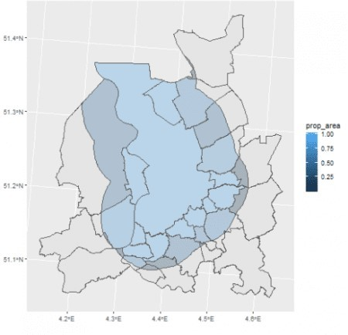

# Joins (spatial and non-spatial)

With sf objects different types of joins can be performed, (i) on the attributes (columns) and (ii) on the geometries (spatial).

First we can see joins based on attributes adding population data to the municipality dataset:

# load population file

population <- read.csv("https://raw.githubusercontent.com/ master/_posts_data/r_as_gis/population_flanders.csv")

# join to the municipality municipality %>%

left_join(population) -> municipality_pop ## Joining, by = "NAAM"

For this one can use all the different types of *joints* available within tidyverse.

More interesting in this context are spatial joins, for instance joining the province and municipality datasets based on whether the municipalities geometries are within the province geometries:

# slightly adapt names in province

names(province)[1:2] <- paste(names(province)[1:2], "province", sep="_")

# slightly adapt names province names(municipality_pop)[5] <- "name_municipality"

# joins, using municipality within provinces municipality_province <- st_join(municipality_pop[,c(5, 10)],

province, join = st_within)

# plot the results ggplot() +

geom_sf(data = municipality_province, aes(fill = name_province)) +

geom_sf(data = province, color = "red", alpha = 0.2)

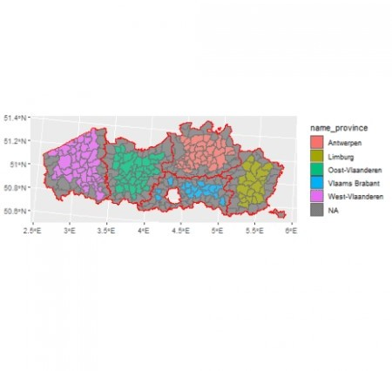

We can use for the spatial joins any of the binary logical operations, see ?st_intersects for all the options. These joins are then defined by the join= argument of the function. These joins also works for any types of vector data (point, line, polygon). Here with our examples some of the municipalities were not found to be within any provinces, these were municipalities at the

border of the provinces where most likely the borders of the municipalities touched or maybe slightly overflowed out of the provinces.

# Use case

To sum up all the things we saw up to know, let's put them in practice by looking at how many inhabitants of Flanders are within 10km of Seveso sites, sites where dangerous (chemical) substances are stored. To do so we will load a dataset containing the geometries of the registered Seveso sites, create buffers, interset this with the municipalities geometries, then assuming that inhabitants are homogeneously distributed over the municipality compute how many inhabitants are in the different intersections.

Let's go:

# load seveso data

seveso <- st_read("https://raw.githubusercontent.com/ master/_posts_data/r_as_gis/seveso.geojson")

## Reading layer `seveso' from data source `https://raw.githubusercontent.com/ /master/_posts_data/r_as_gis/seveso.geojson' using driver

`GeoJSON'

## Simple feature collection with 291 features and 2 fields ## geometry type: MULTIPOLYGON

## dimension: XY

## bbox: xmin: 3809095 ymin: 3082887 xmax: 4012066 ymax:

3164945

## projected CRS: ETRS89-extended / LAEA Europe

# create 10km buffers

seveso_buffer <- st_buffer(seveso, 10000) # create intersection with municipality

municipality_seveso <- st_intersection(municipality_pop, seveso_buffer)create 10km buffers

## Warning: attribute variables are assumed to be spatially constant ## throughout all geometries

# compute areas and population within the intersection # and compute sums

municipality_seveso %>%

mutate(area_intersection = as.numeric(st_area(.))) %>% mutate(pop_intersection = (area_intersection /

OPPERVL) * population) %>% st_drop_geometry() %>% # we drop the geometry column summarise(S_seveso = sum(pop_intersection, na.rm = TRUE),

S_population = sum(population, na.rm = TRUE)) %>% mutate(prop = S_seveso / S_population)

## S_seveso S_population prop ## 1 70455290 136289905 0.5169516

Based on the simplified assumptions that municipality population is homogeneously distributed across the municipality area we found that more than half of the inhabitants in Flanders are within 10km of a Seveso site …