# Introduction

R compiler, write R codes on your device. You can easily execute basic statistical analysis in mobile itself.

This is ideal for learning and testing code snippets.

R compiler released in Aug 2018 and the latest version upgraded in March 2021. When you are using an upgrade (paid) version following features are available

No Ads Unlimited plots Install packages Latest compilers

# Features

Compile and Run your R program Plot your Graphs

View your program output

Advanced source code editor with syntax highlighting and line numbers Support different R compiler versions namely, 3.4, 3.5, 3.6 and 4.0 Open, save, import, and share R files

Language reference

Access around a thousand packages Install Additional packages Customize editor

# Limitations

Internet connection required for compilation Maximum program running time 20 second

Some file system, network, and graphics functions may be limited Interactive programs are not supported

# R compiler Installation

Here we are going to show how to install the application and basic data loading from a mobile folder.

Step 1:- Go to the play store and download the R compiler

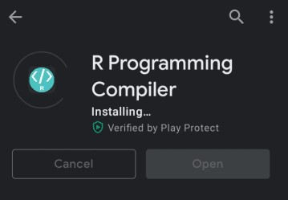

Step 2:- Sample script will be available on the screen

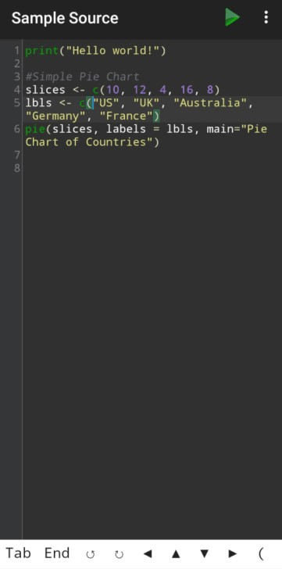

Step 3:- Select the script

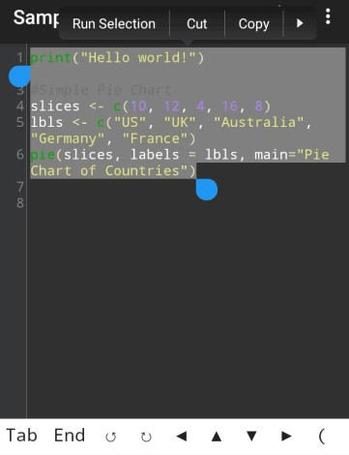

Step 4:- Click on … dots and Click Run Selection

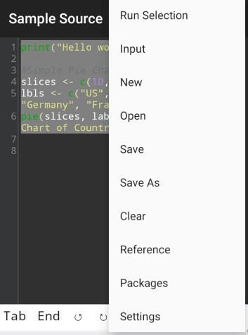

Step 5:- Output Screen

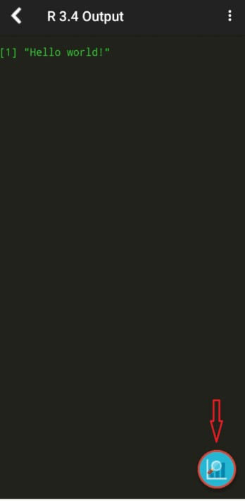

Step 6:-Output Image displayed on right side bottom

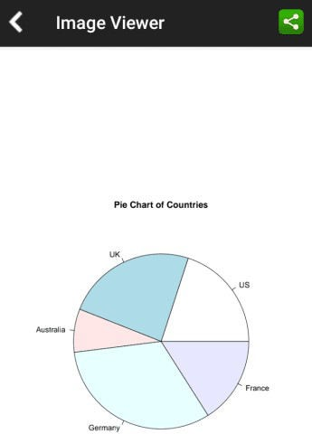

**How to load CSV file in R compiler**

Step 7: Click … dots on right side top and Click input option

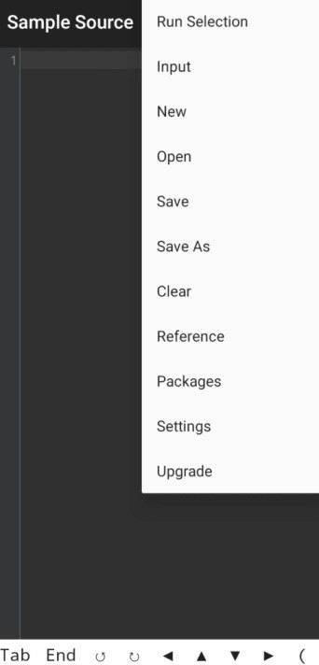

Step8:- Click Open file and choose csv file

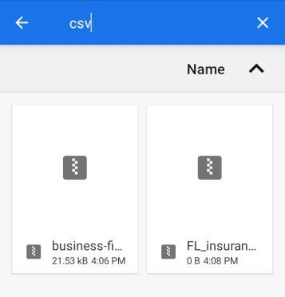

Step 9:- read CSV terminal display

Based on read.csv, you can read the data set read.csv(file=”stdin”,head=TRUE, sep=",") You can see your loaded data points.

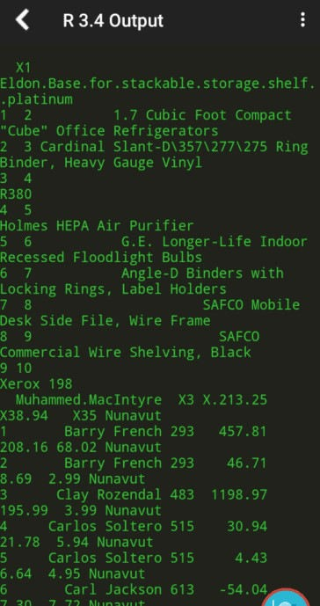

Step10:-Quick Introduction

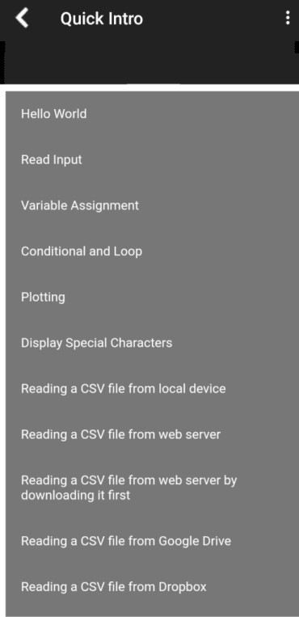

# Conclusion

Yes, Sometimes a laptop or computer is not available and wants to execute some basic analysis then it’s really handy…