# What is a Rolling Regression

The rolling regression is simply a dynamic regression within a rolling moving window. Assuming that we have 5 observations and a rolling window of 3 observations. Then we will run 3 regression models as we can see from my perfect picture below 

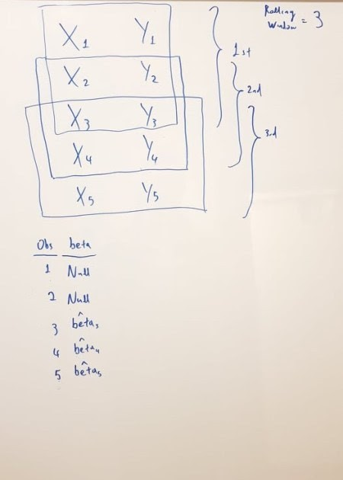

# Rolling Regression with Co-Integrated Pairs

I found that the NFLX and AMZN stocks are co-integrated for the period of **2020-01-01** to **2021-01-03**. Let’s see how beta coefficient evolve across time by considering a rolling window of 30 observations.

library(rollRegres) library(tidyverse) library(tseries) library(quantmod)

mySymbols <- c('AMZN', 'NFLX'

myStocks <-lapply(mySymbols, function(x) {getSymbols(x,

from = "2020-01-01",

to = "2021-01-03",

periodicity = "daily", auto.assign=FALSE)} )

names(myStocks)<-mySymbols

closePrices <- lapply(myStocks, Cl) closePrices <- do.call(merge, closePrices)

names(closePrices)<-sub("\\.Close", "", names(closePrices)) # get the logarithm of the prices

closePrices<-log(closePrices) head(closePrices)

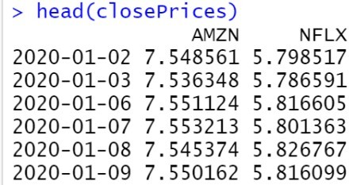

Run the Rolling Regression with a moving window of 30 observations and get the intercept and the beta coefficient.

my_rollregression<-roll_regres(NFLX ~ AMZN, closePrices, width = 30, do_compute = c("sigmas", "r.squareds", "1_step_forecasts"))

tail(my_rollregression$coefs)

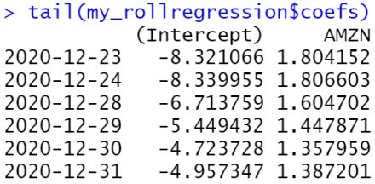

# Get the Rolling Betas in Chart

Let’s have a look at the rolling betas.

my_coef<-as.data.frame(my_rollregression$coefs) my_coef<-rownames_to_column(my_coef, "Date")%>%na.omit() my_coef$Date<-as.Date(my_coef$Date) my_coef%>%ggplot(aes(x=Date, y=AMZN))+

geom_point()+geom_line()+ylab("Rolling Beta")+ ggtitle("Rolling Beta of NFLX vs AMZN")

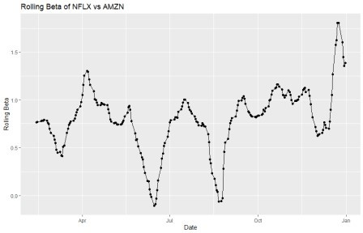

# The Takeaway

When you want to do pairs trading, a good approach is to run rolling regressions so that to monitor dynamically the relationship of the pairs. Also, you can test if the pairs are indeed co-integrated in every rolling window.