I decided to remake this experiment and check out, if my findings are still true.

# Why do we may need double dispatch?

In most cases, when writing R scripts or even creating R packages, it is enough to use standard functions or S3 methods. However, there is one important field that forces us to consider **double dispatch** question: **arithmetic operators**.

Suppose we’d like to create a class, which fits the problem we’re currently working on. Let’s name such class **beer**.

beer <- function(type){

structure(list(type = type),class = "beer")

}

opener <- function(){ structure(list(), class = "opener")

}

pilsner <- beer("pilnser") my_opener <- opener(

Then, we create an operator which defines some non-standard behaviour.

if we add an opener to the beer, we get an **opened_beer**. adding a **numeric** *x*, we get a case of beers (which even contain a negative number of bees, i.e. our debt…)

if second argument is different than a or **opener** or **numeric**, we get… untouched beer

Let’s demonstrate, how does it work:

`+.beer` <- function(a, b){

if (inherits(b, "opener")) { return(structure(list(

name = paste("opened", a$name)

), class = "opened_beer"))

} else if (inherits(b, "numeric")) {

print("It's magic! You've got a case of beers!") return(structure(list(

n_beers = 1 + b

), class = "case_of_beers"))

} else { return(a)

}

}

pilsner + my_opener ## $name

## [1] "opened " ##

## attr(,"class") ## [1] "opened_beer"

pilsner + -0.1

## [1] "It's magic! You've got a case of beers!" ## $n_beers

## [1] 0.9 ##

## attr(,"class")

## [1] "case_of_beers"

Don’t you think, that such operations should be **commutative**?

my_opener + pilsner

## list()

## attr(,"class")

## [1] "opener"

What did happen here? This is an example of the way the R interpreter handles arithmetic operator.

Briefly speaking, in this particular case R engine matched method to the second argument (not to the first one), because there is no +.opener S3 method. What about such trick:

`+.opener` <- function(a, b) b + a

After that, the result is different:

my_opener + pilsner

## Warning: Incompatible methods ("+.opener", "+.beer") for "+"

## Error in my_opener + pilsner: non-numeric argument to binary operator

We crashed our function call. When both objects have the + method defined and these methods are not the same, R is trying to resolve the conflict by applying an internal +. It obviously cannot work. This

case could be easily solved using more ‘ifs’ in the +.beer beer function body. But let’s face a different situation.

-0.1 + pilsner

## [1] -0.1

What a mess! Simple S3 methods are definitely not the best solution when we need the double dispatch.

# S4 class: a classic approach

To civilize such code, we can use classic R approach, S4 methods. We’ll start from S4 classes declaration.

.S4_beer <- setClass("S4_beer", representation(type = "character"))

.S4_opened_beer <- setClass("S4_opened_beer", representation(type = "character"))

.S4_opener <- setClass("S4_opener", representation(ID = "numeric"))

.S4_case_of_beers <- setClass("S4_case_of_beers", representation(n_beers = "numeric"))

Then, we can two otptions, how to handle + operators. I didn’t mention about it in the previous example, but both S3 and S4 operators are grouped as so-called **group generic functions.**

We can set a S4 method for a single operator and that looks as follows:

setMethod("+", c(e1 = "S4_beer", e2 = "S4_opener"), function(e1, e2){

if (inherits(e2, "S4_opener")) {

return(.S4_opened_beer(type = paste("opened", e1@type)))

} else if (inherits(e2, "numeric")) {

print("It's magic! You've got a case of beers!") return(.S4_case_of_beers(n_beers = 1 + e2))

} else { return(e1)

}

})

setMethod("+", c(e1 = "S4_opener", e2 = "S4_beer"), function(e1, e2) e2 + e1)

Alternatively, we can define a method for Arith geneneric and check, what method is exactly called at the moment. I decided to use the second approach, because it’s more similar to the way the double dispatch is implemented in the **vctrs** library.

.S4_fun <- function(e1, e2){

if (inherits(e2, "S4_opener")) {

return(.S4_opened_beer(type = paste("opened", e1@type)))

} else if (inherits(e2, "numeric")) {

print("It's magic! You've got a case of beers!") return(.S4_case_of_beers(n_beers = 1 + e2))

} else { return(e1)

}

}

setMethod("Arith", c(e1 = "S4_beer", e2 = "S4_opener"), function(e1, e2)

{

op = .Generic[[1]] switch(op,

`+` = .S4_fun(e1, e2), stop("undefined operation")

)

})

setMethod("Arith", c(e1="S4_opener", e2="S4_beer"), function(e1, e2)

{

op = .Generic[[1]] switch(op,

`+` = e2 + e1, stop("undefined operation")

)

})

Let’s create our class instances and do a piece of math.

S4_pilsner <- .S4_beer(type = "Pilsner") S4_opener <- .S4_opener(ID = 1)

S4_pilsner + S4_opener

## An object of class "S4_opened_beer" ## Slot "type":

## [1] "opened Pilsner"

S4_opener + S4_pilsner

## An object of class "S4_opened_beer" ## Slot "type":

## [1] "opened Pilsner"

Declared methods are clear, and, the most important: they work correctly.

# vctrs library: a tidyverse approach

**vctrs** is an interesting library,

thought as a remedy for a couple of R disadvantages. It delivers, among others, a custom double-dispatch system based on well-known S3 mechanism.

At the first step we declare class ‘constructors’.

library(vctrs)

.vec_beer <- function(type){

new_vctr(.data = list(type = type), class = "vec_beer")

}

.vec_opened_beer <- function(type){

new_vctr(.data = list(type = type), class = "vec_opened_beer")

}

.vec_case_of_beers <- function(n_beers){ new_vctr(.data = list(n_beers = n_beers), class =

"vec_case_of_beers")

}

.vec_opener <- function(){

new_vctr(.data = list(), class = "vec_opener")

}

Then, we create class instances.

vec_pilsner <- .vec_beer("pilnser") vec_opener <- .vec_opener() print(class(vec_pilsner))

## [1] "vec_beer" "vctrs_vctr" "list" print(class(vec_opener))

## [1] "vec_opener" "vctrs_vctr" "list"

At the end, we write a double-dispatched methods **in vctrs style**. As you can see,

.fun <- function(a, b){

if (inherits(b, "vec_opener")) {

return(.vec_opened_beer(type = paste("opened", a$type)))

} else if (inherits(b, "numeric")) {

print("It's magic! You've got a case of beers!") return(.vec_case_of_beers(n_beers = 1 + b))

} else { return(a)

}

}

vec_arith.vec_beer <- function(op, x, y, ...) { UseMethod("vec_arith.vec_beer", y)

}

vec_arith.vec_opener <- function(op, x, y, ...) { UseMethod("vec_arith.vec_opener", y)

}

vec_arith.vec_beer.vec_opener <- function(op, x, y, ...){ switch(op,

`+` = .fun(x, y), stop_incompatible_op(op, x, y)

)

}

vec_arith.vec_opener.vec_beer <- function(op, x, y, ...){ y + x

}

vec_pilsner + vec_opener ##

## type

## opened pilnser

vec_opener + vec_pilsner ##

## type

## opened pilnser

It works properly, too.

# Benchmark

I’ve created all the classes and methods above not only to demonstate, how to implement double dispatch in R. My main goal is to benchmark both approaches and check, which one has smaller overhead. The hardware I used for the test looks as follows:

## $vendor_id

## [1] "GenuineIntel" ##

## $model_name

## [1] "Intel(R) Core(TM) i3 CPU M 350 @ 2.27GHz" ##

## $no_of_cores ## [1] 4

## 8.19 GB

sessionInfo()

## R version 4.0.2 (2020-06-22)

## Platform: x86_64-pc-linux-gnu (64-bit) ## Running under: Ubuntu 18.04.2 LTS

##

## Matrix products: default

## BLAS/LAPACK: /opt/intel/compilers_and_libraries_2018.2.199/linux/ mkl/lib/intel64_lin/libmkl_rt.so

##

## locale:

## [1] LC_CTYPE=pl_PL.UTF-8 LC_NUMERIC=C

## [3] LC_TIME=pl_PL.UTF-8 LC_COLLATE=pl_PL.UTF-8

## [5] LC_MONETARY=pl_PL.UTF-8 LC_MESSAGES=en_US.utf8 ## [7] LC_PAPER=pl_PL.UTF-8 LC_NAME=C

## [9] LC_ADDRESS=C LC_TELEPHONE=C

## [11] LC_MEASUREMENT=pl_PL.UTF-8 LC_IDENTIFICATION=C ##

## attached base packages:

## [1] stats graphics grDevices utils datasets methods base ##

## other attached packages:

## [1] vctrs_0.3.4 ##

## loaded via a namespace (and not attached):

|  |  |  |  |  |
| --- | --- | --- | --- | --- |
| ## | [1] | benchmarkmeData_1.0.4 | knitr_1.30 | magrittr_1.5 |
| ## | [4] | tidyselect_1.1.0 | doParallel_1.0.15 | lattice_0.20-41 |
| ## | [7] | R6_2.4.1 | rlang_0.4.7 | foreach_1.5.0 |
| ## | [10] | httr_1.4.2 | stringr_1.4.0 | dplyr_1.0.2 |
| ## | [13] | tools_4.0.2 | parallel_4.0.2 | grid_4.0.2 |
| ## | [16] | xfun_0.18 | ellipsis_0.3.1 | htmltools_0.5.0 |
| ## | [19] | iterators_1.0.12 | yaml_2.2.1 | digest_0.6.25 |
| ## | [22] | tibble_3.0.3 | benchmarkme_1.0.4 | lifecycle_0.2.0 |
| ## | [25] | crayon_1.3.4 | Matrix_1.2-18 | purrr_0.3.4 |
| ## | [28] | codetools_0.2-16 | glue_1.4.2 | evaluate_0.14 |
| ## | [31] | rmarkdown_2.4 | stringi_1.5.3 | pillar_1.4.6 |
| ## | [34] | compiler_4.0.2 | generics_0.0.2 | pkgconfig_2.0.3 |

It’s my good old notebook, which is not a beast.

library(microbenchmark) library(ggplot2)

## Beer + opener

bm1 <- microbenchmark(

s4 = S4_pilsner + S4_opener, s3_vec = vec_pilsner + vec_opener, times = 1000

)

**R 4.0.2**

|  |  |  |  |  |  |  |
| --- | --- | --- | --- | --- | --- | --- |
| ##  ## | Unit: microseconds  expr min lq | mean | median | uq | max | neval |
| ## | s4 177.111 182.9710 | 197.09576 | 186.997 | 190.7615 | 1937.005 | 1000 |
| ## | s3_vec 68.568 74.3705 | 83.27131 | 82.710 | 84.4995 | 306.320 | 1000 |

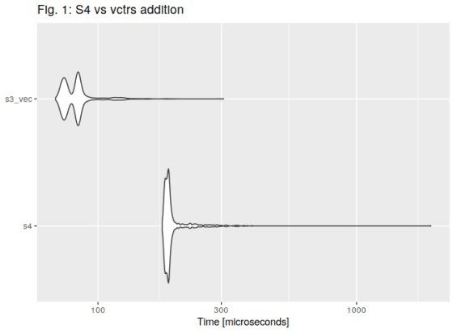

**R 3.6.1**

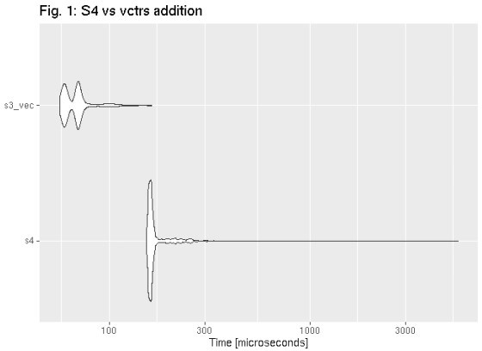

## Opener + beer

bm2 <- microbenchmark(

s4 = S4_opener + S4_pilsner, s3_vec = vec_opener + vec_pilsner,

times = 1000

)

**R 4.0.2**

## Unit: microseconds

## expr min lq mean median uq max neval ## s4 186.736 191.6060 216.6038 196.0305 200.1195 8109.925 1000

## s3_vec 87.808 92.0705 110.3604 100.2730 102.7115 6588.121 1000

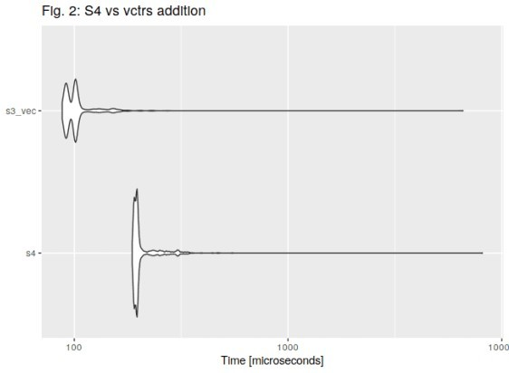

**R 3.6.1**

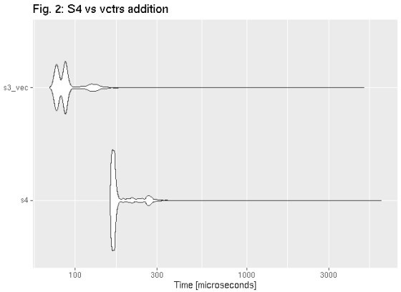

## Bonus: opener + beer vs addtion of numerics

bm3 <- microbenchmark( simple_R = 1 + 2,

s4 = S4_opener + S4_pilsner, s3_vec = vec_opener + vec_pilsner, times = 1000

)

**R 4.0.2**

|  |  |  |  |  |  |  |  |
| --- | --- | --- | --- | --- | --- | --- | --- |
| ##  ## | Unit: nanoseconds  expr min | lq | mean | median | uq | max | neval |
| ## | simple_R 133 | 374.0 | 643.296 | 722.0 | 795.0 | 2004 | 1000 |
| ## | s4 185652 | 190964.5 | 206643.130 | 195424.0 | 198756.5 | 564443 | 1000 |
| ## | s3_vec 87889 | 92022.0 | 103274.276 | 100360.5 | 102306.0 | 234482 | 1000 |

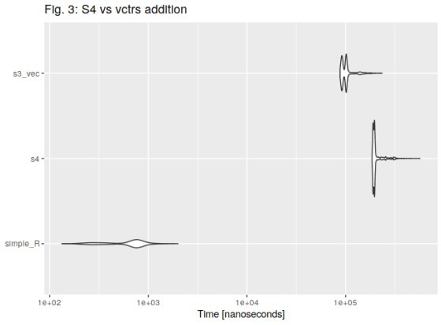

**R 3.6.1**

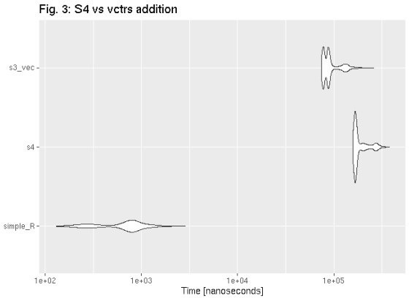

# Conclusions

Results are roughly the same as outcomes of my previous experiments run on R 3.6.1. We can state thar regarding these particular machine and

examples, **vctrs-based** performs better than **S4 methods**.