First, let’s load the required libraries. Besides the already mentioned sf package, we also load ggplot2 for visualization and magrittr, because I will use the %>% pipe operator sometimes.

library(ggplot2) library(magrittr) library(sf)

I will also use a utility function plot_map() which is capable of plotting geospatial features, zooming into certain spots and highlighting differences between two features.

# Loading and transforming our sample data

Let’s load our first example dataset. It represents the German federal state Mecklenburg- Vorpommern (or Mecklenburg-West Pomerania) that features a ragged coastline at the Baltic Sea, which is nice to show the effects of feature simplification. I will abbreviate Mecklenburg- Vorpommern by MV to spare us the complicated name.

mv <- st_read('data/mv.geojson') %>% st_geometry() %>%

st_transform(crs = '+proj=aeqd +lat_0=53.6 +lon_0=12.7') # centered at input data for low distortion

The dataset contains only a single feature (a multi-polygon, i.e. a set of polygons) with some metadata from OpenStreetMap. I use st_geometry to access this feature (i.e. dismiss the metadata) and st_transform to transform it to an Azimuthal Equidistant map projection. The latter is quite important. Most functions that I’ll use don’t work with spherical coordinates as used for example by the WGS84 (GPS) standard, where longitude and latitude in degrees describe a position on a sphere. We need to project these coordinates on a plane using a coordinate reference system (CRS) with a specific projection. All projections distort in some way, but we can choose a CRS that accurately represents certain measures. For example, I chose an equidistant CRS because it accurately represents distances up to 10,000 km from the center of projection. Another important aspect is that by using this CRS, we move from degrees to meters as units for our coordinates.

Let’s plot our projection of MV. Note the axes which represent the distance from the projection center (I chose the geographic center of MV for that) in meters.

plot_map(mv, graticules = TRUE)

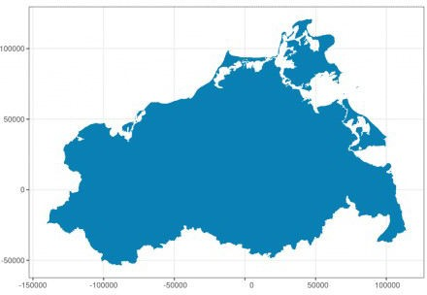

Let’s zoom in on the island of Rügen with it’s ragged coastline (west of it is the peninsula Darß, east is a part of Usedom).

plot_map(mv, graticules = TRUE, zoom_to = c(13.359, 54.413), zoom_level = 8)

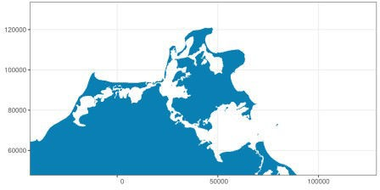

# Removing vertices with st_simplify

We can now continue to apply different simplification methods to the displayed features. We will start with – no surprise – st_simplify. This function removes vertices in lines or polygons to form simpler shapes. The function implementation uses the Douglas–Peucker algorithm for simplification and accepts a parameter dTolerance, which roughly speaking specifies the distance in which any “wiggles” will be straightened. It’s in the same unit as the input data, so in our case it’s meters (the unit used in our CRS). There’s also a parameter preserveTopology which, when set to TRUE, makes sure that polygons are not reduced to lines or even removed, or that inner holes in them are removed during the simplification process.

Let’s apply st_simplify with a tolerance of 1km:

mv_simpl <- st_simplify(mv, preserveTopology = FALSE, dTolerance = 1000)

plot_map(mv_simpl)

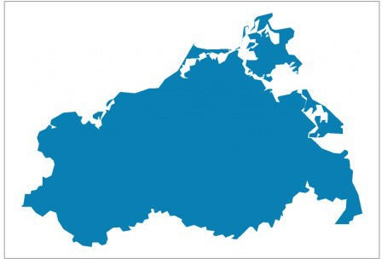

We can see that the geometry is much simpler, especially when zooming in:

plot_map(mv_simpl, zoom_to = c(13.359, 54.413), zoom_level = 8)

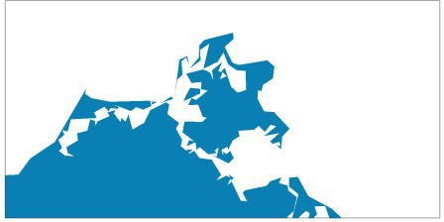

We can also confirm the memory usage is much lower for the simplified feature (shown in kilobytes):

round(c(object.size(mv), object.size(mv_simpl)) / 1024) [1] 960 13

The purple areas show the differences between the original and the simplified version. We can see for example, that some smaller islands were completely removed.

plot_map(mv, mv_simpl, zoom_to = c(13.359, 54.413), zoom_level = 8)

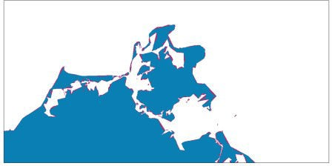

When we set preserveTopology to TRUE, we can observe that the small islands are retained:

mv_simpl <- st_simplify(mv, preserveTopology = TRUE

dTolerance = 1000)

plot_map(mv_simpl, zoom_to = c(13.359, 54.413), zoom_level = 8)

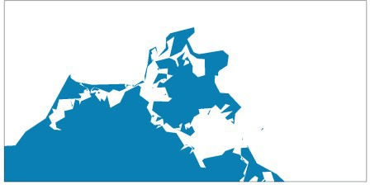

Increasing the dTolerance parameter to 10km gives us something that is more akin to a Cubistic painting:

mv_simpl <- st_simplify(mv, preserveTopology = FALSE,

dTolerance = 10000)

plot_map(mv_simpl)



plot_map(mv, mv_simpl)

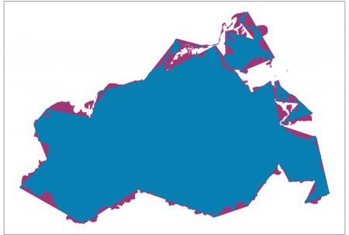

# st_simplify limitations

Using st_simplify comes with a limitation when working with multiple, adjacent features which I’d like to demonstrate using a map of the federal states in Germany.

fedstates <- read_sf('data/germany_fedstates.geojson') %>% st_transform(crs = 5243) # ETRS89 / LCC Germany (E-N)

fedstates[c('name', 'geometry')]

## Simple feature collection with 16 features and 1 field ## geometry type: MULTIPOLYGON

…

## projected CRS: ETRS89 / LCC Germany (E-N) ## # A tibble: 16 x 2

…

## 1 Baden-Württemberg (((-112269.7 -363339.8, …

|  |  |  |
| --- | --- | --- |
| ## | 2 Bavaria | (((-109036.3 -104479.2, … |
| ## | 3 Berlin | (((175933 160909.2, … |
| … |  |  |

This time, our spatial dataset contains 16 features which represent the boundaries of each federal state:

plot_map(fedstates, graticules = TRUE, strokecolor = '#097FB3', fillcolor = '#AED3E4')

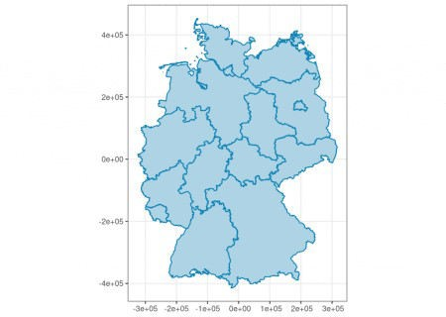

Let’s apply st_simplify with a tolerance of 10km and preserving feature topology:

fedstates_simpl <- st_simplify(fedstates,

preserveTopology = TRUE, dTolerance = 10000)

plot_map(fedstates_simpl, strokecolor = '#097FB3', fillcolor = '#AED3E4')

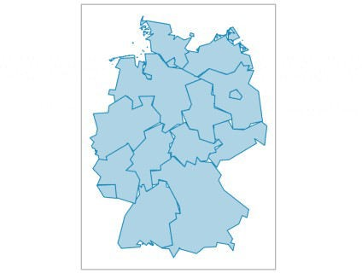

Ups! We can see that st_simplify produced gaps and overlapping features, i.e. shared borders were not handled correctly! The problem is that st_simplify simply doesn’t consider the topological concept of shared borders between features (like federal states in this case).

When setting preserveTopology = TRUE it means that each feature’s topology is preserved, but it doesn’t mean that the topology *between* features is considered.

Luckily, there’s the package rmapshaper that contains a function that does the trick. Before you install the package, please note that it requires a lot of (system-) dependencies to be installed.

Visvalingam’s algorithm, which is used in this function, let’s us specify the portion of vertices that should be kept after simplification. This can be specified with the keep parameter. The parameter keep_shapes controls whether complete features such as islands can be removed in the simplification process.

library(rmapshaper)

fedstates_simpl2 <- ms_simplify(fedstates, keep = 0.001,

keep_shapes = FALSE) plot_map(fedstates_simpl2, strokecolor = '#097FB3',

fillcolor = '#AED3E4')

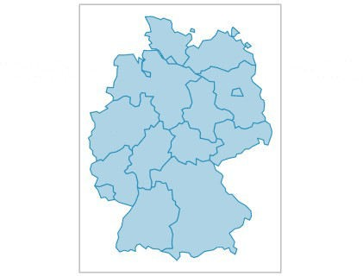

As can be seen, ms_simplify respects the shared borders. The result is also much smaller in terms of memory usage:

round(c(object.size(fedstates), object.size(fedstates_simpl2)) / 1024)

[1] 7757 71

# Expanding and shrinking with st_buffer

st_buffer lets you expand (positive buffer distance) or shrink (negative buffer distance) polygon features. This may not per-se result in a simpler feature form, but it allows you to close holes (by expanding) or remove solitary, small features (by shrinking).

Let’s try a first example. Again, the buffer distance is in the same unit as our CRS, which is meters in our case, and we’ll expand by 1km. When the buffer is generated, new vertices are

added to form the expanded shape with round edges. The parameter nQuadSegs specifies how many segments are generated per quadrant and feature.

mv_buf <- st_buffer(mv, dist = 1000, nQuadSegs = 1 plot_map(mv_buf, graticules = TRUE)

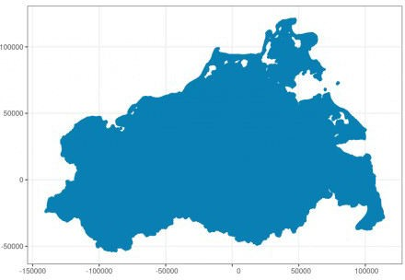

plot_map(mv, mv_buf, graticules = TRUE,

zoom_to = c(13.359, 54.413), zoom_level = 8)

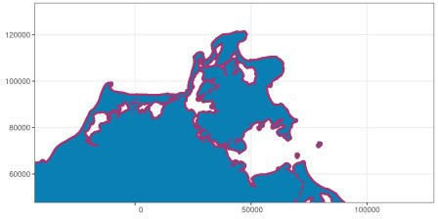

The memory usage is not so much reduced:

round(c(object.size(mv), object.size(mv_buf)) / 1024) [1] 960 265

Now we shrink MV by 1km:

mv_buf <- st_buffer(mv, -1000, nQuadSegs = 1 plot_map(mv_buf)

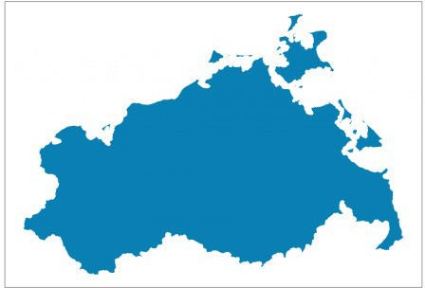

plot_map(mv, mv_buf, zoom_to = c(13.359, 54.413), zoom_level = 8)

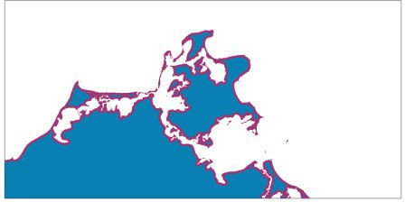

We can also combine both buffering options, by first shrinking in order to remove small isolated features and then expanding again by the same distance so that the result has more or less the same extents as the original:

mv_buf <- st_buffer(mv, -1000, nQuadSegs = 1) %>% st_buffer(1000, nQuadSegs = 1)

plot_map(mv_buf)

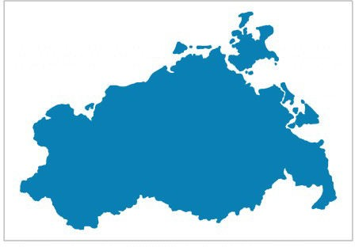

plot_map(mv, mv_buf, zoom_to = c(13.359, 54.413), zoom_level = 8)

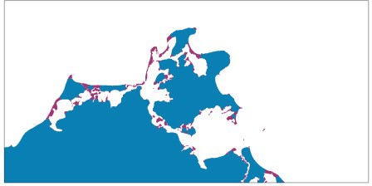

Note how this is more aggressive than st_simplify but the result uses more memory. We could now additionally apply st_simplify to arrive at a very reduced feature.

round(c(object.size(mv), object.size(mv_buf)) / 1024) [1] 960 239

When we apply st_buffer to a dataset with multiple features like the federal states dataset, the buffering will be applied to every feature (i.e. every state’s boundary) separately. This will result in either overlapping features (extending) or gaps between them (shrinking).

# Joining overlapping and adjacent features with st_union

The last function that we will look at is st_union. It can be used to join overlapping and adjacent features. With this, we could for example join all features of the federal state boundaries in Germany and get a single feature that represents the national boundaries. But let’s look at a more interesting example and load a new dataset. It contains a sample with regions with street noise of 50dB or more in Berlin at night.

noise <- read_sf('data/noise_berlin_sample.geojson') %>% st_transform('+proj=aeqd +lat_0=52.51883 +lon_0=13.41537')

plot_map(noise, graticules = TRUE)

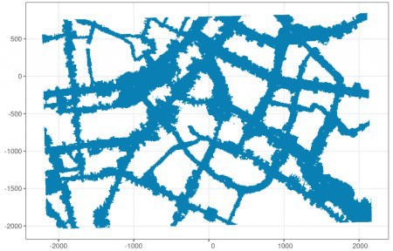

You may notice the ragged edges in the picture above. Furthermore, the dataset is quite large and contains a lot of rows (i.e. features):

nrow(noise) [1] 48795

Why is that so? When we zoom in and also plot each feature’s boundary, we will notice that we actually have some sort of vectorized raster data! The noise regions are tiny raster cells:

plot_map(noise, strokecolor = '#097FB3', fillcolor = '#AED3E4', zoom_level = 15)

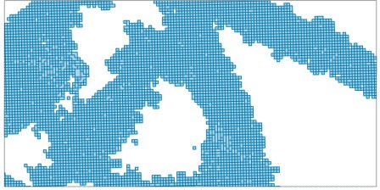

Most cells cover 100m² and come along with the noise level at this spot (L_N column):

summary(noise[c('Shape_Area', 'L_N')])

|  |  |  |  |
| --- | --- | --- | --- |
| Shape_Area | L_N |  | geometry |
| Min. :100.0 | Min. | :50.00 | MULTIPOLYGON :48795 |

|  |  |  |  |
| --- | --- | --- | --- |
| 1st Qu.:100.0 | 1st Qu.:54.10 | epsg:NA : | 0 |
| Median :100.0 | Median :58.50 | +proj=aeqd…: | 0 |
| Mean :105.1 | Mean :59.12 |  |  |
| 3rd Qu.:100.0 | 3rd Qu.:63.80 |  |  |
| Max. :700.0 | Max. :75.40 |  |  |

If we don’t care for the specific noise levels and only want to form a single feature that represents noise levels with 50dB or more, we can apply st_union on the whole dataset:

noise_union <- st_union(noise) noise_union

Geometry set for 1 feature geometry type: MULTIPOLYGON dimension: XY

bbox: xmin: -2218.35 ymin: -2035.134

xmax: 2174.847 ymax: 845.1362

CRS: +proj=aeqd +lat_0=52.51883 +lon_0=13.41537 MULTIPOLYGON (((-1931.274 -2034.915, -1941.274 …

As we can see in the output above, only a single feature is left (and all feature-specific “metadata” such as level of noise is gone!). We can confirm this visually:

plot_map(noise_union, strokecolor = '#097FB3', fillcolor = '#AED3E4', zoom_level = 15)

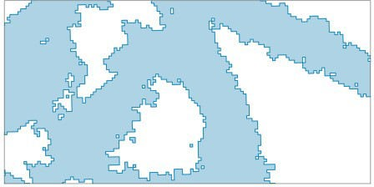

plot_map(noise_union, strokecolor = '#097FB3', fillcolor = '#AED3E4')

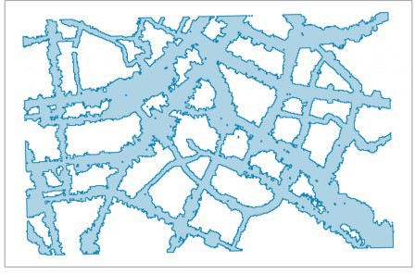

Additionally applying st_simplify removes the ragged edges:

noise_union_simpl <- st_simplify(noise_union,

preserveTopology = FALSE, dTolerance = 50)

plot_map(noise_union_simpl, strokecolor = '#097FB3', fillcolor = '#AED3E4')

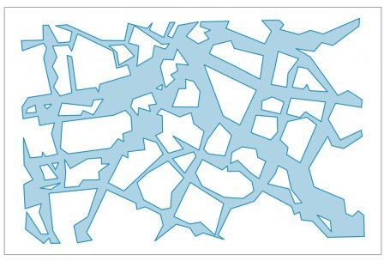

Note how much the memory consumption was reduced from initially 42 *mega*bytes to 282

*kilo*bytes or even 18 kilobytes when further simplified:

round(c(object.size(noise), object.size(noise_union), object.size(noise_union_simpl)) / 1024)

[1] 41959 282 18

Applying simplify without union before would not have had the desired effect since

st_simplify is performed per feature:

st_simplify(noise, preserveTopology = FALSE, dTolerance = 10) %>%

plot_map(strokecolor = '#097FB3', fillcolor = '#AED3E4')

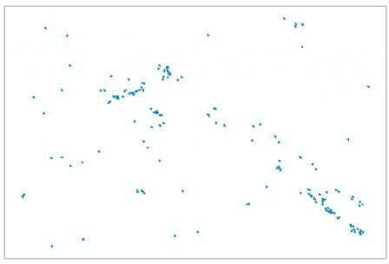

If we want to retain some of the noise level information, we can quantize (“bin”) the noise level data into different ordered categories and apply the union operation per category. I’m used to the dplyr package, so I’ll first create a quantized version of the noise variable L_N with three equally spaced levels between 50dB and 80dB and then use group_by in conjunction with group_modify:

library(dplyr)

noise_per_lvl <- mutate(noise,

level = cut(L_N,

breaks = seq(50, 80, by = 10), right = FALSE,

ordered_result = TRUE)) %>% group_by(level) %>% # ".x" is refers to the current group: group_modify(~ st_union(.x) %>% as_tibble()) %>%

ungroup() %>%

st_as_sf() # convert back to "sf" object since this # information is lost during group_by()

noise_per_lvl

## Simple feature collection with 3 features and 1 field ## geometry type: MULTIPOLYGON

## dimension: XY

## bbox: xmin: -2218.35 ymin: -2035.134…

## CRS: +proj=aeqd +lat_0=52.51883… ## # A tibble: 3 x 2

|  |  |  |  |
| --- | --- | --- | --- |
| ## |  | level | geometry |
| ## | 1 | [50,60) | (((1908.792 -1950.634, 1898.792 -1950.854… |
| ## | 2 | [60,70) | (((1758.789 -1953.926, 1748.789 -1954.146… |
| ## | 3 | [70,80) | (((-527.0325 -373.2836, -537.0327 -373.50… |

Again, the result is much smaller in terms of memory:

round(c(object.size(noise), object.size(noise_per_lvl)) / 1024) [1] 41959 1090

The following gives us a plot with the three noise levels:

ggplot(noise_per_lvl) +

geom_sf(aes(color = level, fill = level)) + coord_sf(datum = NA) +

theme_bw()

