# The INLA Approach to Bayesian models

The Integrated Nested Laplace Approximation, or INLA, approach is a recently developed, computationally simpler method for fitting Bayesian models [(Rue et al., 2009, compared to traditional Markov Chain Monte Carlo (MCMC) approaches. INLA fits models that are classified as latent Gaussian models, which are applicable in many settings (Martino & Rue, 2010. In general, INLA fits a general form of additive models such as:

\(\eta = \alpha + \sum_{j=1}^{nf} f^{(j)}(u_{ij}) + \sum_{k=1}^{n\beta}\beta_k z_{ki} + \epsilon_i\)

where \(\eta\) is the linear predictor for a generalized linear model formula, and is composed of a linear function of some variables u, \(\beta\) are the effects of covariates, z, and \(\epsilon\) is an unstructured residual (Rue et al., 2009). As this model is often parameterized as a Bayesian one, we are interested in the posterior marginal distributions of all the model parameters. Rue and Martino (2007) show that the posterior marginal for the random effects (x) in such models can be approximated as:

\(\tilde{p}(x_i|y) = \sum_k \tilde{p}(x_i|\theta_k, y) \tilde{p}(\theta_k|y) \Delta_k\)

via numerical integration (Rue & Martino, 2007; Schrodle & Held, 2011a, 2011b). The posterior distribution of the hyperparameters (\(\theta\)) of the model can also be approximated as:

\(\tilde{p}(\theta | y)) \propto \frac{p(x, \theta, y)}{\tilde{p}G(x| \theta,y)} \mid _{x} = x^*(\theta)\)

, where G is a Gaussian approximation of the posterior and \(x^*(\theta)\) is the mode of the conditional distribution of \(p(x|\theta,y)\). Thus, instead of using MCMC to find an iterative, sampling-based estimate of the posterior, it is arrived at numerically. This method of fitting the spatial models specified above has been presented by numerous authors (Blangiardo & Cameletti, 2015; Blangiardo et al., 2013; Lindgren & Rue, 2015; Martins et al., 2013; Schrodle & Held, 2011a, 2011b), with comparable results to MCMC.

## Libraries

#library(rgdal) library(spdep) library(RColorBrewer) library(lattice) library(INLA) library(tigris) library(tidycensus) library(ggplot2) library(dplyr)

## Data

The data we will use here are infant mortality rates in US counties between 2000 and 2007.

files<-list.files("~/ExpanDrive/Google Drive/classes/dem7473/data/nhgis0022_csv/nhgis0022_csv/", pattern = "*.csv", full.names = T)

vital<-lapply(files, read.csv, header=T)

library(plyr)

df <- ldply(vital, data.frame)

df$cofips<-paste(substr(df$GISJOIN, 2,3), substr(df$GISJOIN, 5,7), sep="")

df<-df%>%

filter(YEAR %in%2000:2007)%>%

mutate(rate=as.numeric(AGWJ001) )%>% select(YEAR, cofips,rate)

head(df)

|  |  |  |  |
| --- | --- | --- | --- |
| ## | YEAR | cofips | rate |
| ## | 1 2000 | 01001 | 34 |
| ## | 2 2000 | 01003 | 61 |
| ## | 3 2000 | 01005 | 125 |
| ## | 4 2000 | 01007 | 70 |
| ## | 5 2000 | 01009 | 89 |
| ## | 6 2000 | 01011 | 242 |

## Census intercensus population estimates

popurl<-url("<http://www2.census.gov/programs-surveys/popest/datasets/2000-2010/intercensal/county/co-> est00int-tot.csv")

pops<-read.csv(popurl) names(pops)<-tolower(names(pops)) pops<-pops%>%

mutate(cofips = paste(sprintf(fmt = "%02d", state), sprintf(fmt = "%03d",county), sep=""))%>% filter(sumlev==50, !state%in%c(2, 15))

head(pops)

## sumlev region division state county stname ctyname estimatesbase2000

|  |  |  |  |  |  |  |  |  |  |  |
| --- | --- | --- | --- | --- | --- | --- | --- | --- | --- | --- |
| ## 1 | | | 50 | 3 | 6 | 1 | 1 | Alabama | Autauga | County |
| 43751 | | |  |  |  |  |  |  |  |  |
| ## 2 | | | 50 | 3 | 6 | 1 | 3 | Alabama | Baldwin | County |
| 140416 | | |  |  |  |  |  |  |  |  |
| ## 3 | | | 50 | 3 | 6 | 1 | 5 | Alabama | Barbour | County |
| 29042 | | |  |  |  |  |  |  |  |  |
| ## 4 | | | 50 | 3 | 6 | 1 | 7 | Alabama | Bibb | County |
| 19856 | | |  |  |  |  |  |  |  |  |
| ## 5 | | | 50 | 3 | 6 | 1 | 9 | Alabama | Blount | County |
| 50982 | | |  |  |  |  |  |  |  |  |
| ## 6 | | | 50 | 3 | 6 | 1 | 11 | Alabama | Bullock | County |
| 11603 | | |  |  |  |  |  |  |  |  |
| ## |  | popestimate2000 | | | popestimate2001 | | popestimate2002 popestimate2003 | | | |
| ## | 1 | 44021 | | | 44889 | | 45909 46800 | | | |
| ## | 2 | 141342 | | | 144875 | | 147957 151509 | | | |
| ## | 3 | 29015 | | | 28863 | | 28653 28594 | | | |
| ## | 4 | 19913 | | | 21028 | | 21199 21399 | | | |
| ## | 5 | 51107 | | | 51845 | | 52551 53457 | | | |
| ## | 6 | 11581 | | | 11358 | | 11256 11316 | | | |
| ## |  | popestimate2004 | | | popestimate2005 | | popestimate2006 popestimate2007 | | | |
| ## | 1 | 48366 | | | 49676 | | 51328 52405 | | | |
| ## | 2 | 156266 | | | 162183 | | 168121 172404 | | | |
| ## | 3 | 28287 | | | 28027 | | 27861 27757 | | | |
| ## | 4 | 21721 | | | 22042 | | 22099 22438 | | | |
| ## | 5 | 54124 | | | 54624 | | 55485 56240 | | | |
| ## | 6 | 11056 | | | 11011 | | 10776 11011 | | | |
| ## |  | popestimate2008 | | | popestimate2009 | | census2010pop popestimate2010 cofips | | | |
| ## | 1 | 53277 | | | 54135 | | 54571 54632 01001 | | | |

|  |  |  |  |  |  |  |
| --- | --- | --- | --- | --- | --- | --- |
| ## | 2 | 175827 | 179406 | 182265 | 183195 | 01003 |
| ## | 3 | 27808 | 27657 | 27457 | 27411 | 01005 |
| ## | 4 | 22705 | 22941 | 22915 | 22867 | 01007 |
| ## | 5 | 57055 | 57341 | 57322 | 57338 | 01009 |
| ## | 6 | 10953 | 10987 | 10914 | 10890 | 01011 |

### Data prep

pops.long<-reshape(data = pops, idvar = "cofips", varying = list(names(pops)[9:16]), direction="long", drop = names(pops)[c(2,3,4,5,6,8,17,18,19,20)], v.names = "population")

pops.long$year<-pops.long$time+1999 head(pops.long)

|  |  |  |  |  |  |  |
| --- | --- | --- | --- | --- | --- | --- |
| ## | sumlev | ctyname | cofips | time | population | year |
| ## | 01001.1 50 | Autauga County | 01001 | 1 | 44021 | 2000 |
| ## | 01003.1 50 | Baldwin County | 01003 | 1 | 141342 | 2000 |
| ## | 01005.1 50 | Barbour County | 01005 | 1 | 29015 | 2000 |
| ## | 01007.1 50 | Bibb County | 01007 | 1 | 19913 | 2000 |
| ## | 01009.1 50 | Blount County | 01009 | 1 | 51107 | 2000 |
| ## | 01011.1 50 | Bullock County | 01011 | 1 | 11581 | 2000 |

dat.long<-merge(pops.long, df, by.x=c("cofips", "year"), by.y=c("cofips", "YEAR")) head(dat.long)

## cofips year sumlev ctyname time population rate

|  |  |  |  |  |  |
| --- | --- | --- | --- | --- | --- |
| ## | 1 01001 2000 | 50 Autauga County 1 | 44021 | 34 |  |
| ## | 2 01001 2001 | 50 Autauga County | 2 | 44889 | 78 |
| ## | 3 01001 2002 | 50 Autauga County | 3 | 45909 | 83 |
| ## | 4 01001 2003 | 50 Autauga County 4 | 46800 | 79 |  |
| ## | 5 01001 2004 | 50 Autauga County 5 | 48366 | 76 |  |
| ## | 6 01001 2005 | 50 Autauga County 6 | 49676 | 124 |  |

# Get census data using tidycensus

Here I get data from the 2000 decennial census summary file 3 #v00<-load_variables(year=2000, dataset = "sf3", cache = T)

cov_dat<-get_decennial(geography = "county", year = 2000, sumfile = "sf3", summary_var = "P001001",

variables = c("P007003", "P007004","P007010","P053001", "P089001", "P089002" ),

output = "wide")

## Getting data from the 2000 decennial Census

cov_dat<-cov_dat%>%

mutate(cofips=GEOID,pwhite=P007003/summary_value, pblack=P007004/summary_value, phisp=P007010/summary_value,medhhinc=as.numeric(scale(P053001)), ppov=P089002/P089001)

final.dat<-merge(dat.long, cov_dat, by="cofips") head(final.dat)

## cofips year sumlev ctyname time population rate GEOID NAME

|  |  |  |  |  |  |  |  |  |
| --- | --- | --- | --- | --- | --- | --- | --- | --- |
| ## | 1 01001 2006 | 50 Autauga County | 7 | 51328 | 93 | 01001 | Autauga | County |
| ## | 2 01001 2003 | 50 Autauga County | 4 | 46800 | 79 | 01001 | Autauga | County |
| ## | 3 01001 2004 | 50 Autauga County | 5 | 48366 | 76 | 01001 | Autauga | County |
| ## | 4 01001 2005 | 50 Autauga County | | 6 | 49676 | | 124 01001 Autauga County | |
| ## | 5 01001 2000 | 50 Autauga County | | 1 | 44021 | | 34 01001 Autauga County | |

|  |  |  |  |  |  |  |  |  |  |  |  |  |  |
| --- | --- | --- | --- | --- | --- | --- | --- | --- | --- | --- | --- | --- | --- |
| ## | 6 | 01001 2007 | | | 50 Autauga County | | | | 8 | 52405 | | 83 01001 Autauga County | |
| ## |  | P007003 | P007004 | | P007010 | | P053001 | P089001 | | P089002 | summary_value | | pwhite |
| ## | 1 | 34760 | 7450 | | 394 | | 42013 | 43377 | | 4738 | 43671 | | 0.7959515 |
| ## | 2 | 34760 | 7450 | | 394 | | 42013 | 43377 | | 4738 | 43671 | | 0.7959515 |
| ## | 3 | 34760 | 7450 | | 394 | | 42013 | 43377 | | 4738 | 43671 | | 0.7959515 |
| ## | 4 | 34760 | 7450 | | 394 | | 42013 | 43377 | | 4738 | 43671 | | 0.7959515 |
| ## | 5 | 34760 | 7450 | | 394 | | 42013 | 43377 | | 4738 | 43671 | | 0.7959515 |
| ## | 6 | 34760 | 7450 | | 394 | | 42013 | 43377 | | 4738 | 43671 | | 0.7959515 |
| ## |  | pblack | | phisp | | medhhinc | | ppov | | | | | |
| ## | 1 | 0.1705938 | | 0.009022005 | | 0.7593459 | | 0.1092284 | | | | | |
| ## | 2 | 0.1705938 | | 0.009022005 | | 0.7593459 | | 0.1092284 | | | | | |
| ## | 3 | 0.1705938 | | 0.009022005 | | 0.7593459 | | 0.1092284 | | | | | |
| ## | 4 | 0.1705938 | | 0.009022005 | | 0.7593459 | | 0.1092284 | | | | | |
| ## | 5 | 0.1705938 | | 0.009022005 | | 0.7593459 | | 0.1092284 | | | | | |
| ## | 6 | 0.1705938 | | 0.009022005 | | 0.7593459 | | 0.1092284 | | | | | |

## Create expected numbers of cases

In count data models, and spatial epidemiology, we have to express the raw counts of events relative to some expected value, or population offset, see this Rpub for a reminder.

#ratesyr<-aggregate(rate~year, final.dat,mean) #in this case, we will standardize to the average IMR for the period

#ratesyr$E<-ratesyr$rate

#final.dat<-merge(final.dat, ratesyr[,-2], by="year") #rates<-aggregate(rate~1, final.dat, mean) final.dat$E_d<-mean(final.dat$rate)

final.dat<-final.dat[order(final.dat$cofips, final.dat$year),] final.dat$id<-1:dim(final.dat)[1]

head(final.dat)

## cofips year sumlev ctyname time population rate GEOID NAME ## 5 01001 2000 50 Autauga County 1 44021 34 01001 Autauga County

|  |  |  |  |  |  |  |  |  |  |  |  |  |  |  |  |  |
| --- | --- | --- | --- | --- | --- | --- | --- | --- | --- | --- | --- | --- | --- | --- | --- | --- |
| ## | 8 | 01001 2001 | | | 50 Autauga County | | | | | 2 | 44889 | | | 78 01001 Autauga | | County |
| ## | 7 | 01001 2002 | | | 50 Autauga County | | | | | 3 | 45909 | | | 83 01001 Autauga | | County |
| ## | 2 | 01001 2003 | | | 50 Autauga County 4 | | | | | 46800 | 79 01001 Autauga County | | | | |  |
| ## | 3 | 01001 2004 | | | 50 Autauga County 5 | | | | | 48366 | 76 01001 Autauga County | | | | |  |
| ## | 4 | 01001 2005 | | | 50 Autauga County | | | | | 6 | 49676 124 01001 Autauga | | | | | County |
| ## |  | P007003 | P007004 | | | P007010 | | P053001 | P089001 | | P089002 | | summary_value | | pwhite | |
| ## | 5 | 34760 | 7450 | | | 394 | | 42013 | 43377 | | 4738 | | 43671 | | 0.7959515 | |
| ## | 8 | 34760 | 7450 | | | 394 | | 42013 | 43377 | | 4738 | | 43671 | | 0.7959515 | |
| ## | 7 | 34760 | 7450 | | | 394 | | 42013 | 43377 | | 4738 | | 43671 | | 0.7959515 | |
| ## | 2 | 34760 | 7450 | | | 394 | | 42013 | 43377 | | 4738 | | 43671 | | 0.7959515 | |
| ## | 3 | 34760 | 7450 | | | 394 | | 42013 | 43377 | | 4738 | | 43671 | | 0.7959515 | |
| ## | 4 | 34760 | 7450 | | | 394 | | 42013 | 43377 | | 4738 | | 43671 | | 0.7959515 | |
| ## |  | pblack | | phisp | | | medhhinc | | ppov | | | E_d | | id | | |
| ## | 5 | 0.1705938 | | 0.009022005 | | | 0.7593459 | | 0.1092284 | | | 72.33683 | | 1 | | |
| ## | 8 | 0.1705938 | | 0.009022005 | | | 0.7593459 | | 0.1092284 | | | 72.33683 | | 2 | | |
| ## | 7 | 0.1705938 | | 0.009022005 | | | 0.7593459 | | 0.1092284 | | | 72.33683 | | 3 | | |
| ## | 2 | 0.1705938 | | 0.009022005 | | | 0.7593459 | | 0.1092284 | | | 72.33683 | | 4 | | |
| ## | 3 | 0.1705938 | | 0.009022005 | | | 0.7593459 | | 0.1092284 | | | 72.33683 | | 5 | | |
| ## | 4 | 0.1705938 | | 0.009022005 | | | 0.7593459 | | 0.1092284 | | | 72.33683 | | 6 | | |

options(scipen=999)

Next we make the spatial information, we get the polygons from census directly using counties from the

tigris package. We drop counties not in the contiguous 48 US states.

us_co<-counties( cb = T) us_co<-us_co%>%

subset(!STATEFP%in%c("02", "15", "60", "66", "69", "72", "78"))%>%

filter(STATEFP%in%c("01", "05", "12", "13", "21", "22", "28", "37", "45", "47", "48", "51", "40"))

# Construction of spatial relationships:

### Contiguity based neighbors

In a general sense, we can think of a square grid. Cells that share common elements of their geometry are said to be “neighbors”. There are several ways to describe these patterns, and for polygons, we generally use the rules of the chess board.

*Rook adjacency* Neighbors must share a line segment

*Queen adjacency* Neighbors must share a vertex or a line segment

If polygons share these boundaries (based on the specific definition: rook or queen), they are said to be “spatial neighbors” of one another. The figure below illustrates this principle.

For an observation of interest, the pink area, the Rood adjacent areas are those in green in the figure, because they share a line segment. For the second part of the figure on the right, the pink area has different sets of neighbors, compared to the Rook rule neighbors, because the area also shares vertices with other polygons, making them Queen neighbors.

Adjacency using Chessboard Rules Adjacency using Chessboard Rules **Order of adjacency**

The figure above also highlights the order of adjacency among observations. By order of adjacency, we

simply men that observations are either immediate neighbors (the green areas), or they are neighbors of immediate neighbors. These are referred to as first and second order neighbors.

So, we can see, that the yellow polygons are the neighboring areas for this tract, which allows us to think about what the *spatial structure* of the area surrounding this part of campus.

For an example, let’s consider the case of San Antonio again. If our data are polygons, then there is a function in the spdep library in R, poly2nb that will take a polygon layer and find the neighbors of all areas using either a queen or rook rule. First we form the neighbors using the rook rule for all the tracts in Bexar County.

**Distance based association**

The queen and rook rules are useful for polygon features, but distance based contiguity is useful for all feature types (points, polygons, lines). The idea is similar to the polygon adjacency rule from above, but the distance rule is based on the calculated distance between areas. There are a variety of distance metrics that are used in statistics, but the most commonly assumed one is the Euclidean distance. The Euclidean distance between any two points is:

\[D^2 = \sqrt{\left (x_1 – x_2 \right)^2 + \left (y_1 – y_2 \right)^2 } \] Where x and y are the coordinates of each of the two areas. For polygons, these coordinates are typically the centroid of the polygon (you may have noticed this above when we were plotting the neighbor lists), while for point features, these are the two dimensional geometry of the feature. The collection of these distances between all features forms what is known as the distance matrix between observations. This summarizes all distances between all features in the data.

# K nearest neighbors

A useful way to use distances is to construct a k-nearest neighbors set.

This will find the “k” closest observations for each observation, where k is some integer.

For instance if we find the k=3 nearest neighbors, then each observation will have 3 neighbors, which are the closest observations to it, *regardless of the distance between them* which is important.

Using the k nearest neighbor rule, two observations could potentially be very far apart and still be considered neighbors.

#In INLA, we don't need FIPS codes, we need a simple numeric index for our counties us_co$struct<-1:dim(us_co)[1]

nbs<-knearneigh(coordinates(as_Spatial(us_co) ), k = 5, longlat = T) #k=5 nearest neighbors nbs<-knn2nb(nbs, row.names = us_co$struct, sym = T) #force symmetry!!

mat <- nb2mat(nbs, style="B",zero.policy=TRUE) colnames(mat) <- rownames(mat)

mat <- as.matrix(mat[1:dim(mat)[1], 1:dim(mat)[1]])

nb2INLA("cl_graph",nbs)

am_adj <-paste(getwd(),"/cl_graph",sep="") H<-inla.read.graph(filename="cl_graph")

#image(inla.graph2matrix(H), xlab="", ylab="", main="")

## Plot geographies

library(sf)

us_co<-st_as_sf(us_co)

us_co$cofips<-paste(us_co$STATEFP, us_co$COUNTYFP, sep="") us_co%>%

ggplot()+geom_sf()+coord_sf(crs =7603)

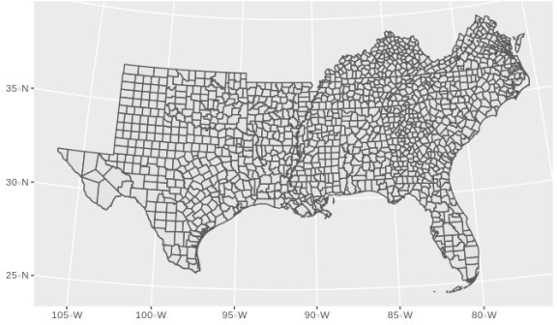

final.dat<-merge( us_co,final.dat, by="cofips", all.y=F) final.dat<-final.dat[order(final.dat$cofips, final.dat$year),] final.dat%>%

filter(year==2000)%>%

ggplot()+geom_sf(aes(fill=rate, col=rate))+coord_sf(crs =7603)+ggtitle("Infant Mortality Rate - 2000")

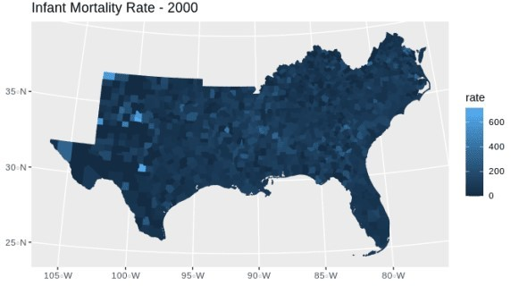

# Model setup

We have a count outcome (deaths and births), in counties over time, and a set of time-constant covariates.

We have several options in the GLM framework with which to model these data, for example:

Binomial – \[y_{ij} \sim Bin(\pi_{ij}) \text{: } logit(\pi_{ij} ) = \beta_{0}+ x'\beta_k \]

Poisson – \[y_{ij} \sim Pois(\lambda_{ij} E_{ij}) \text{: } log(\lambda_{ij} ) = log(E_{ij}) + \beta_{0}+ x'\beta_k \]

Negative Binomial – \[y_{ij} \sim \text{Neg Bin} (\mu_{ij}, \alpha, E_{ij}) \text{: } log(\mu_{ij} ) = log(E_{ij}) + \beta_{0}+ x'\beta_k \]

In addition to various zero-inflated versions of these data.

ggplot(data = final.dat)+geom_histogram(aes(x =log(rate) , y=0.5*..density..))+facet_wrap(~year)+ ggtitle(label = "Distribution of Infant Mortality Rate by Year", subtitle = "US Counties, 2000-2007")

## `stat_bin()` using `bins = 30`. Pick better value with `binwidth`. ## Warning: Removed 1849 rows containing non-finite values (stat_bin).

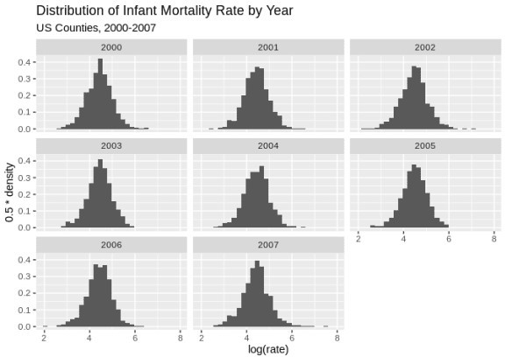

ggplot(data = final.dat)+geom_histogram(aes(x =log(rate/E_d) , y=0.5*..density..))+facet_wrap(~year)+ ggtitle(label = "Distribution of Infant Mortality Relative Risk by Year", subtitle = "US Counties, 2000-2007")

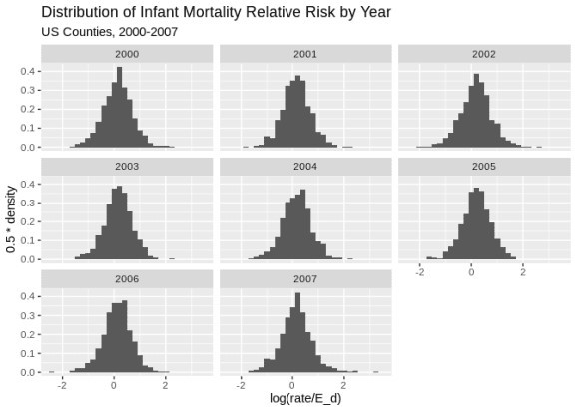## `stat_bin()` using `bins = 30`. Pick better value with `binwidth`. ## Warning: Removed 1849 rows containing non-finite values (stat_bin).

final.dat%>% dplyr::group_by(cofips)%>%

dplyr::summarise(meanrate=mean(rate), meanE=mean(E_d))%>% dplyr::mutate(rate_e=meanrate/meanE)%>%

#ungroup()

# filter(year%in%c(2000))%>% # mutate(rate_e=rate/E_d)%>%

mutate(qrr=cut(rate_e, breaks = quantile(rate_e, p=seq(0,1,length.out = 7)), include.lowest = T))%>% ggplot()+

geom_sf(aes(fill=qrr))+ scale_fill_brewer(type="seq", palette = "RdBu")+

ggtitle(label="Relative Risk Quartile - period average 2000 to 2007")+ coord_sf(crs = 7603)

## `summarise()` ungrouping output (override with `.groups` argument)

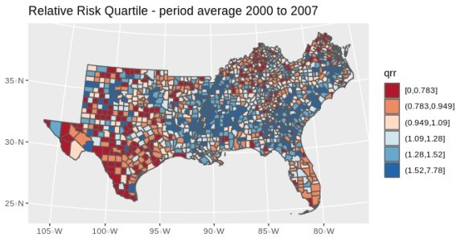

We can fit these model using the Bayesian framework with INLA.

First, we consider the basic GLM for the mortality outcome, with out any hierarchical structure. We can write this model as a Negative Binomial model, for instance as:

\[\text{Deaths}_{ij} \sim NB(\mu_{ij}, \gamma)\] \[\mu_{ij} = \text{log(E_d)}_{ij} + X' \beta\]

INLA will use vague Normal priors for the \(\beta\)’s, and we have other parameters in the model to specify priors for. INLA does not require you to specify all priors, as all parameters have a default prior specification. In this example, I will use a \(Gamma(1, .5)\) prior for all hierarchical variance terms.

#Model specification:

f1<-rate~scale(pblack)+scale(phisp)+scale(ppov)+year

#Model fit

mod1<-inla(formula = f1,data = final.dat, #linear predictor - fixed effects

family = "nbinomial", E = E_d, #marginal distribution for the outcome, expected count control.compute = list(waic=T), # compute DIC or not?

control.predictor = list(link=1), #estimate predicted values & their marginals or not? num.threads = 2,

verbose = F) #model summary summary(mod1)

##

## Call:

## c("inla(formula = f1, family = \"nbinomial\", data = final.dat, E =

## E_d, ", " verbose = F, control.compute = list(waic = T), ## control.predictor = list(link = 1), ", " num.threads = 2)") ## Time used:

## Pre = 0.928, Running = 21.8, Post = 0.722, Total = 23.5 ## Fixed effects:

|  |  |  |  |  |  |  |  |
| --- | --- | --- | --- | --- | --- | --- | --- |
| ## | mean | sd | 0.025quant | 0.5quant | 0.975quant | mode | kld |
| ## | (Intercept) -5.047 | 10.723 | -26.102 | -5.048 | 15.989 | -5.047 | 0 |
| ## | scale(pblack) 0.159 | 0.015 | 0.130 | 0.159 | 0.188 | 0.159 | 0 |
| ## | scale(phisp) -0.025 | 0.013 | -0.050 | -0.025 | 0.001 | -0.025 | 0 |
| ## | scale(ppov) 0.041 | 0.015 | 0.012 | 0.041 | 0.070 | 0.041 | 0 |
| ## | year 0.003 | 0.005 | -0.008 | 0.003 | 0.013 | 0.003 | 0 |
| ## |  |  |  |  |  |  |  |

## Model hyperparameters:

## mean sd 0.025quant

## size for the nbinomial observations (1/overdispersion) 0.624 0.009 0.608

## 0.5quant 0.975quant

## size for the nbinomial observations (1/overdispersion) 0.624 0.641

## mode

## size for the nbinomial observations (1/overdispersion) 0.624 ##

## Expected number of effective parameters(stdev): 5.04(0.001) ## Number of equivalent replicates : 2124.92

##

## Watanabe-Akaike information criterion (WAIC) ...: 114586.38 ## Effective number of parameters .................: 10.27

##

## Marginal log-Likelihood: -57331.80

## Posterior marginals for the linear predictor and ## the fitted values are computed

Plot our observed vs fitted values

plot(x= mod1$summary.fitted.values$mean, y=final.dat$rate/final.dat$E_d , ylab="Observed", xlab="Estimated" )

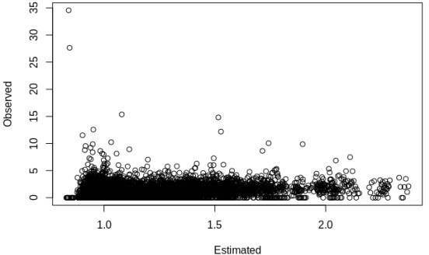

## Basic county level random intercept model

Now we add basic nesting of rates within counties, with a random intercept term for each county. This would allow there to be heterogeneity in the mortality rate for each county, over and above each county’s observed characteristics.

This model would be:

\[\text{Deaths}_{ij} \sim NB(\mu_{ij}, \gamma)\] \[\mu_{ij} = \text{log(E_d)}_{ij} + X' \beta + u_j\] \[u_j \sim

\text{Normal} (0 , \tau_u)\]

where \(\tau_u\) here is the precision, not the variance and **precision = 1/variance.** INLA puts a log-gamma prior on the the precision by default.

f2<-rate~scale(pblack)+scale(phisp)+scale(ppov)+year+ #fixed effects f(struct, model = "iid",param=c(1,.5)) #random effects

mod2<-inla(formula = f2,data = final.dat, family = "nbinomial", E = E_d, control.compute = list(waic=T), control.predictor = list(link=1), num.threads = 2,

verbose = F)

#total model summary summary(mod2)

##

## Call:

## c("inla(formula = f2, family = \"nbinomial\", data = final.dat, E = ## E_d, ", " verbose = F, control.compute = list(waic = T),

## control.predictor = list(link = 1), ", " num.threads = 2)") ## Time used:

## Pre = 0.571, Running = 160, Post = 1.36, Total = 162 ## Fixed effects:

|  |  |  |  |  |  |  |  |
| --- | --- | --- | --- | --- | --- | --- | --- |
| ## | mean | sd | 0.025quant | 0.5quant | 0.975quant | mode | kld |
| ## | (Intercept) -2.824 | 10.758 | -23.945 | -2.824 | 18.279 | -2.824 | 0 |
| ## | scale(pblack) 0.158 | 0.015 | 0.128 | 0.158 | 0.189 | 0.158 | 0 |
| ## | scale(phisp) -0.041 | 0.014 | -0.069 | -0.041 | -0.013 | -0.041 | 0 |
| ## | scale(ppov) 0.044 | 0.015 | 0.014 | 0.044 | 0.074 | 0.044 | 0 |
| ## | year 0.001 | 0.005 | -0.009 | 0.001 | 0.012 | 0.001 | 0 |
| ## |  |  |  |  |  |  |  |
| ## | Random effects: |  |  |  |  |  |  |
| ## | Name Model |  |  |  |  |  |  |

## struct IID model ##

## Model hyperparameters:

## mean sd

0.025quant

## size for the nbinomial observations (1/overdispersion) 0.627 0.009 0.609

## Precision for struct 50.626 7.005

38.292

## 0.5quant 0.975quant

## size for the nbinomial observations (1/overdispersion) 0.627 0.644

## Precision for struct 50.138 65.780

## mode

## size for the nbinomial observations (1/overdispersion) 0.626

## Precision for struct 49.174

##

## Expected number of effective parameters(stdev): 125.34(15.33) ## Number of equivalent replicates : 85.47

##

## Watanabe-Akaike information criterion (WAIC) ...: 114610.09 ## Effective number of parameters .................: 66.26

##

## Marginal log-Likelihood: -57375.58

## Posterior marginals for the linear predictor and ## the fitted values are computed

### Marginal Distributions of hyperparameters

We can plot the posterior marginal of the hyperparameter in this model, in this case \(\sigma_u = 1/\tau_u\) m2<- inla.tmarginal(

function(x) (1/x), #invert the precision to be on variance scale mod2$marginals.hyperpar$`Precision for struct`)

#95% credible interval for the variance inla.hpdmarginal(.95, marginal=m2)

## low high

## level:0.95 0.01491462 0.02565338

plot(m2, type="l", main=c("Posterior distibution for between county variance", "- IID model -"))

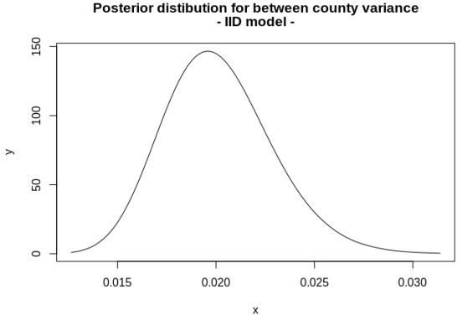

final.dat$fitted_m2<-mod2$summary.fitted.values$mean

p1<-final.dat%>% filter(year%in%c(2000))%>%

mutate(qrr=cut(fitted_m2, breaks = quantile(final.dat$fitted_m2, p=seq(0,1,length.out = 6)), include.lowest = T))%>%

ggplot()+geom_sf(aes(fill=qrr))+scale_colour_brewer(palette = "RdBu" )+scale_fill_brewer(palette = "RdBu" na.value="grey")+guides(fill=guide_legend(title="Relative Risk Quartile"))+ggtitle(label="Relative Risk Quartile - IID Model, 2000")+coord_sf(crs = 7603)

p2<-final.dat%>%

filter(year%in%c(2007))%>%

mutate(qrr=cut(fitted_m2, breaks = quantile(final.dat$fitted_m2, p=seq(0,1,length.out = 6)), include.lowest = T))%>%

ggplot()+geom_sf(aes(fill=qrr))+scale_colour_brewer(palette = "RdBu" )+scale_fill_brewer(palette = "RdBu" na.value="grey")+guides(fill=guide_legend(title="Relative Risk Quartile"))+ggtitle(label="Relative Risk Quartile - IID Model, 2007")+coord_sf(crs = 7603)

library(gridExtra)

##

## Attaching package: 'gridExtra'

## The following object is masked from 'package:dplyr': ##

## combine

pall<-grid.arrange(p1, p2, nrow=2)

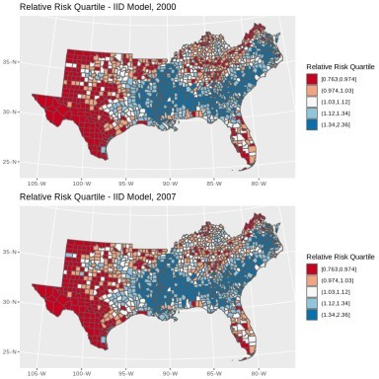

pall

## TableGrob (2 x 1) "arrange": 2 grobs ## z cells name grob ## 1 1 (1-1,1-1) arrange gtable[layout]

## 2 2 (2-2,1-1) arrange gtable[layout]

# library(mapview) #

# map1<-final.dat%>%

# filter(year%in%c(2007))%>%

# mutate(qrr=cut(fitted_m2, breaks = quantile(fitted_m2, p=seq(0,1,length.out = 8)))) # clrs <- colorRampPalette(brewer.pal(8, "RdBu"))

# mapView(as(map1, "Spatial"), zcol="qrr", legend=T, col.regions=clrs)

## BYM Model

Model with spatial correlation – Besag, York, and Mollie (1991) model and temporal heterogeneity

\[\text{Deaths}_{ij} \sim NB(\mu_{ij}, \gamma)\] \[\mu_{ij} = \text{log(E_d)}_{ij} + X' \beta + u_j + v_j +

\gamma_t\]

Which has two random effects, one an IID random effect and the second a spatially correlated random effect, specified as a conditionally auto-regressive prior for the \(v_j\)’s. This is the Besag model:

\[v_j|v_{\neq j},\sim\text{Normal}(\frac{1}{n_i}\sum_{i\sim j}v_j,\frac{1}{n_i\tau})\] and \(u_j\) is an IID normal random effect, \(\gamma_t\) is also given an IID Normal random effect specification, and there are now three hyperparameters, \(\tau_u\) and \(\tau_v\) and \(\tau_{\gamma}\) and each are given log-gamma priors.

For the BYM model we must specify the spatial connectivity matrix in the random effect. #final.dat$year_c<-final.dat$year - 2004

f3<-rate~scale(pblack)+scale(phisp)+scale(ppov)+

f(struct, model = "bym", constr = T, scale.model = T, graph = H,param=c(1,.5))+ f(year, model="iid",param=c(1,.5)) #temporal random effect

mod3<-inla(formula = f3,data = final.dat, family = "nbinomial", E = E_d, control.compute = list(waic=T), num.threads = 2,

verbose = F, control.predictor = list(link=1))

#total model summary summary(mod3)

##

## Call:

## c("inla(formula = f3, family = \"nbinomial\", data = final.dat, E = ## E_d, ", " verbose = F, control.compute = list(waic = T),

## control.predictor = list(link = 1), ", " num.threads = 2)") ## Time used:

## Pre = 0.737, Running = 138, Post = 1.26, Total = 140 ## Fixed effects:

|  |  |  |  |  |  |  |  |  |
| --- | --- | --- | --- | --- | --- | --- | --- | --- |
| ## |  | mean | sd | 0.025quant | 0.5quant | 0.975quant | mode | kld |
| ## | (Intercept) | 0.115 | 0.129 | -0.145 | 0.115 | 0.374 | 0.115 | 0 |
| ## | scale(pblack) | 0.157 | 0.016 | 0.126 | 0.158 | 0.189 | 0.158 | 0 |
| ## | scale(phisp) | -0.039 | 0.016 | -0.069 | -0.039 | -0.007 | -0.040 | 0 |
| ## | scale(ppov) | 0.043 | 0.016 | 0.012 | 0.043 | 0.075 | 0.043 | 0 |
| ## |  |  |  |  |  |  |  |  |
| ## | Random effects: | | | | | |  |  |
| ## | Name Model | | | | | |  |  |
| ## | struct BYM model | | | | | |  |  |
| ## | year IID model | | | | | |  |  |
| ## |  | | | | | |  |  |
| ## | Model hyperparameters: | | | | | |  |  |
| ## |  | | | | | | mean | sd |
| ## | size for the nbinomial observations (1/overdispersion) | | | | | | 0.627 | 0.009 |
| ## | Precision for struct (iid component) | | | | | | 51.094 | 7.099 |

|  |  |  |  |
| --- | --- | --- | --- |
| ## | Precision for struct (spatial component) | 1974.289 1903.577 | |
| ## | Precision for year | 8.760 4.130 | |
| ## |  | 0.025quant 0.5quant | |
| ## | size for the nbinomial observations (1/overdispersion) | 0.609 0.627 | |
| ## | Precision for struct (iid component) | 38.602 50.591 | |
| ## | Precision for struct (spatial component) | 174.447 1425.658 | |
| ## | Precision for year | 2.885 8.075 | |
| ## |  | 0.975quant mode | |
| ## | size for the nbinomial observations (1/overdispersion) | 0.644 0.628 | |
| ## | Precision for struct (iid component) | 66.447 | 49.595 |
| ## | Precision for struct (spatial component) | 7055.730 | 496.592 |

## Precision for year 18.742 6.583

##

## Expected number of effective parameters(stdev): 133.75(15.30) ## Number of equivalent replicates : 80.09

##

## Watanabe-Akaike information criterion (WAIC) ...: 114605.76 ## Effective number of parameters .................: 69.81

##

## Marginal log-Likelihood: -56934.15

## Posterior marginals for the linear predictor and ## the fitted values are computed

plot(y=mod3$summary.random$year$mean,x=unique(final.dat$year), type="l")

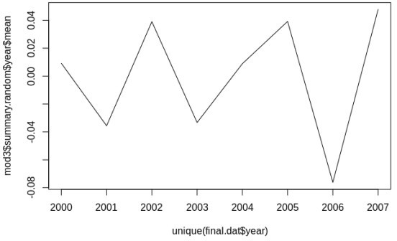

m3a<- inla.tmarginal( function(x) (1/x),

mod3$marginals.hyperpar$`Precision for struct (iid component)`) m3b<- inla.tmarginal(

function(x) (1/x),

mod3$marginals.hyperpar$`Precision for struct (spatial component)`) m3c<- inla.tmarginal(

function(x) (1/x), mod3$marginals.hyperpar$`Precision for year`)

plot(m3a, type="l", main=c("Posterior distibution for between county variance", "- BYM model -"), xlim=c(0,

.2), ylim=c(0, 300))

lines(m3b, col="red") lines(m3c, col="green")

legend("topright", legend=c("BYM IID", "BYM Spatial", "Year"), col=c(1, "red", "green"), lty=c(1,1,1))

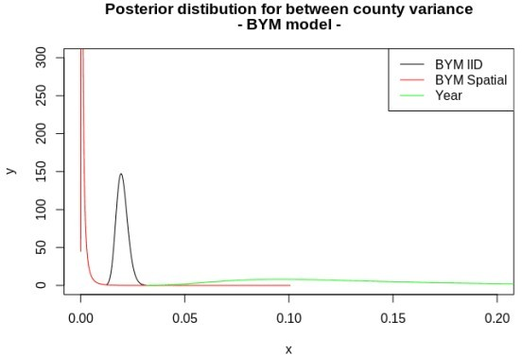

#HPD intervals inla.hpdmarginal(.95,m3a)

## low high

## level:0.95 0.01475866 0.02544088

inla.hpdmarginal(.95,m3b)

## low high

## level:0.95 0.00005416961 0.003970123

inla.hpdmarginal(.95,m3c)

## low high

## level:0.95 0.03927999 0.2945931

This indicates **very** low spatially correlated variance in these data.

# Space-time mapping of the fitted values

final.dat$fitted_m3<-mod3$summary.fitted.values$mean

p3<-final.dat%>% filter(year%in%c(2000))%>%

mutate(qrr=cut(fitted_m3, breaks = quantile(final.dat$fitted_m3, p=seq(0,1,length.out = 6)), include.lowest = T))%>%

ggplot()+geom_sf(aes(fill=qrr))+scale_colour_brewer(palette = "RdBu" )+scale_fill_brewer(palette = "RdBu" na.value="grey")+guides(fill=guide_legend(title="Relative Risk Quartile"))+ggtitle(label="Relative Risk Quartile - IID Model, 2000")+coord_sf(crs = 7603)

p4<-final.dat%>% filter(year%in%c(2007))%>%

mutate(qrr=cut(fitted_m3, breaks = quantile(final.dat$fitted_m3, p=seq(0,1,length.out = 6)), include.lowest = T))%>%

ggplot()+geom_sf(aes(fill=qrr))+scale_colour_brewer(palette = "RdBu" )+scale_fill_brewer(palette = "RdBu" na.value="grey")+guides(fill=guide_legend(title="Relative Risk Quartile"))+ggtitle(label="Relative Risk

Quartile - IID Model, 2007")+coord_sf(crs = 7603)

pall2<-grid.arrange(p3, p4, nrow=2)

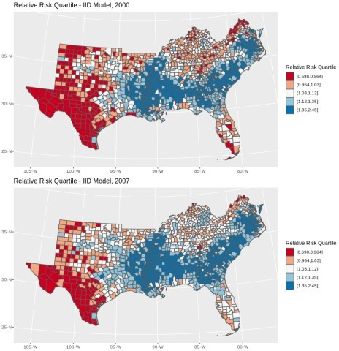

pall2

## TableGrob (2 x 1) "arrange": 2 grobs ## z cells name grob ## 1 1 (1-1,1-1) arrange gtable[layout]

## 2 2 (2-2,1-1) arrange gtable[layout]

#library(mapview)

#map1<-final.dat%>%

# filter(year%in%c(2007))%>%

# mutate(qrr=cut(fitted_m3, breaks = quantile(fitted_m3, p=seq(0,1,length.out = 8)))) #clrs <- colorRampPalette(brewer.pal(8, "RdBu"))

#mapView(as(map1, "Spatial"), zcol="qrr", legend=T, col.regions=clrs)

# Map of spatial random effects

It is common to map the random effects from the BYM model to look for spatial trends, in this case, there are not strong spatial signals:

us_co$sp_re<-mod3$summary.random$struct$mean[1:length(unique(final.dat$cofips))] us_co%>%

mutate(qse=cut(sp_re, breaks = quantile(sp_re, p=seq(0,1,length.out = 6)), include.lowest = T))%>% ggplot()+geom_sf(aes(fill=qse))+scale_colour_brewer(palette = "RdBu" )+scale_fill_brewer(palette = "RdBu", na.value="grey")+guides(fill=guide_legend(title="Spatial Excess Risk"))+ggtitle(label="Spatial Random Effect - BYM Model")+coord_sf(crs = 7603)

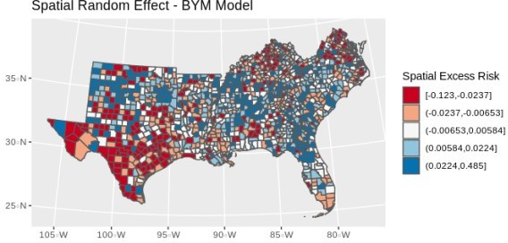

# Exceedence probabilities

In Bayesian spatial models that are centered on an epidemiological type of outcome, it is common to examine the data for spatial clustering. One way to do this is to examine the clustering in the relative risk from one of these GLMM models. For instance if \(\theta\) is the relative risk \[\theta = exp(\beta_0 +

\beta_1*x_1 + u_j)\] from one of our Negative binomial models above. We can use the posterior marginals of the relative risk to ask \(\theta \gt \theta^*\) where \(\theta^*\) is a specific level of excess risk, say 50% extra or \(\theta > 1.25\). If the density, or \(\text{Pr}(\theta \gt \theta^*)\) is high, then there is evidence that the excess risk is not only high, but **significantly** high.

To get the exceedence probabilities from one of our models, we can use the inla.pmarginal() function to ask if \(\text{Pr}(\theta \gt \theta^*)\)

thetastar<-1.25#theta*

inlaprob<- unlist(lapply(mod3$marginals.fitted.values, function(X){ 1-inla.pmarginal(thetastar, X)

}))

hist(inlaprob)

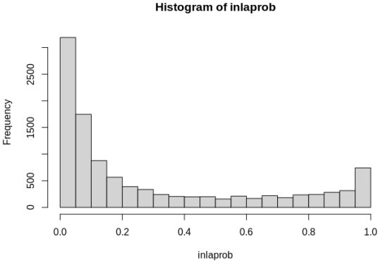

So, we see lots of occasions where the exceedence probability is greater than .9. We can visualize these in a map.

final.dat$exceedprob<-inlaprob

final.dat%>% filter(year%in%c(2007))%>%

mutate(qrr=cut(exceedprob, breaks = c(0, .5, .9, .95, .99, 1), include.lowest = T))%>% ggplot()+geom_sf(aes(fill=qrr))+scale_colour_brewer(palette = "Blues" )+scale_fill_brewer(palette = "Blues" na.value="grey")+guides(fill=guide_legend(title=""))+ggtitle(label=expression(paste("Exceedence Probability Relative Risk ","Pr( ",theta," >1.25"," ) - 2007") ))+coord_sf(crs = 7603)

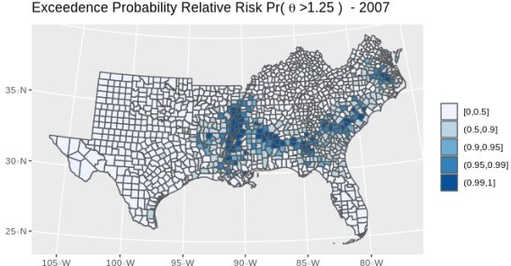

#library(mapview)

#map1<-final.dat%>%

# filter(year%in%c(2007))%>%

# mutate(qrr=cut(exceedprob, breaks = c(0, .5, .9, .95, .99, 1), include.lowest = T))

#clrs <- colorRampPalette(brewer.pal(6, "Blues"))

#mapView(as(map1, "Spatial"), zcol="qrr", legend=T, col.regions=clrs, map.types="OpenStreetMap")

Which shows several areas of the south where risk the infant mortality rate is signficantly higher than the national rate, with high posterior probability.