One of the suggestions is that you need to watch the stocks for at least 3 months closely and make your own conclusions with the help of these predictions.

These prediction ideas you can make use of long-term investment. For intraday, you need to know about some kind of strategies.

Suppose if you are going against the market trend chances higher for losing money. One of the simple strategies

**Load Library**

library(prophet)

library(lubridate)

library(ggplot2)

library(pacman)

pacman::p_load(data.table, fixest, BatchGetSymbols, finreportr, ggplot2, lubridate)

**Set parameters**

first.date <- Sys.Date() - 2500

last.date <- Sys.Date()

freq.data <- "daily"

tickers <- c("BALKRISIND.NS")

We are taking daily data from 2014-07-01 to 2021-05-05.

**Getting Data**

stocks <- BatchGetSymbols(tickers = tickers,

                          first.date = first.date,

                          last.date = last.date,

                          freq.data = freq.data,

                          do.cache = FALSE,

                          thresh.bad.data = 0)

data<-stocks$df.tickers

data<-na.omit(data)

head(data)

Following details will get for analysis.

price.open price.high price.low price.close volume price.adjusted   ref.date

2   367.2603   371.1934  357.9189    364.2366 124870       342.4004 2014-07-02

3   363.8187   367.3586  358.1648    361.9259  30469       340.2281 2014-07-03

4   359.0743   369.2268  359.0743    365.3428  29728       343.4402 2014-07-04

5   362.8600   367.9485  354.9691    358.0419  74821       336.5770 2014-07-07

6   356.7390   360.8688  347.5944    348.8972  79854       327.9806 2014-07-08

7   346.1194   348.5285  330.4850    341.2030 402494       320.7476 2014-07-09

         ticker ret.adjusted.prices ret.closing.prices

2 BALKRISIND.NS         0.004678743        0.004678642

3 BALKRISIND.NS        -0.006344423       -0.006344118

4 BALKRISIND.NS         0.009441102        0.009441052

5 BALKRISIND.NS        -0.019983830       -0.019983871

6 BALKRISIND.NS        -0.025540681       -0.025540653

7 BALKRISIND.NS        -0.022053048       -0.022053126

str(data)

The dataset contains total 1680 observations and 10 variables.

**Q plot**

Let’s plot the dataset for understanding.

qplot(data$ref.date, data$price.close,data=data) 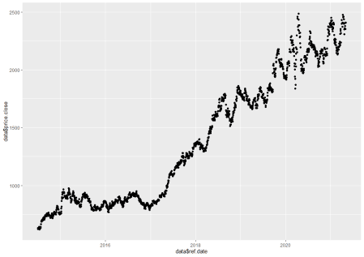

It is clearly evident that the data set is not stationary. Let make use of log transformation and convert it into stationary data.

**Log transformation**

ds <- data$ref.date

y <- data$price.close

df <- data.frame(ds, y)

head(df)

After log transforamtion the data set should like this.

ds        y

1 2014-07-02 364.2366

2 2014-07-03 361.9259

3 2014-07-04 365.3428

4 2014-07-07 358.0419

5 2014-07-08 348.8972

6 2014-07-09 341.2030

Stock forecasting we are using prophet package

m <- prophet(df)

future <- make_future_dataframe(m, periods = 30)

periods indicate the number of days need to forecast.

forecast <- predict(m, future)

**Model performance & Stock Prediction**

pred <- forecast$yhat[1:dim(df)[1]]

actual <- m$history$y

plot(actual, pred)

summary(lm(pred~actual))

Call:

lm(formula = pred ~ actual)

Residuals:

     Min       1Q   Median       3Q      Max

-261.419  -41.156   -4.332   39.322  304.031

Coefficients:

             Estimate Std. Error t value Pr(>|t|)

(Intercept) 27.155044   3.728168   7.284 4.97e-13 ***

actual       0.965945   0.004164 231.989  < 2e-16 ***

---

Signif. codes:  0 ‘***’ 0.001 ‘**’ 0.01 ‘*’ 0.05 ‘.’ 0.1 ‘ ’ 1

Residual standard error: 69.56 on 1678 degrees of freedom

Multiple R-squared:  0.9698,  Adjusted R-squared:  0.9697

F-statistic: 5.382e+04 on 1 and 1678 DF,  p-value: < 2.2e-16

Adjusted R square is 96% quite good model.

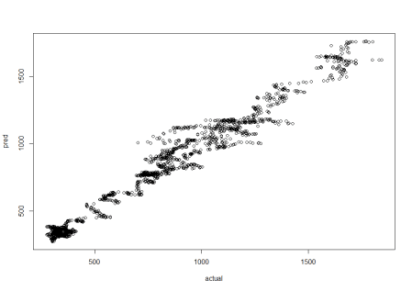

When you are dealing with time series you need to get an idea about some of the trends like weekly and yearly.

**Plot forecast**

prophet_plot_components(m, forecast)

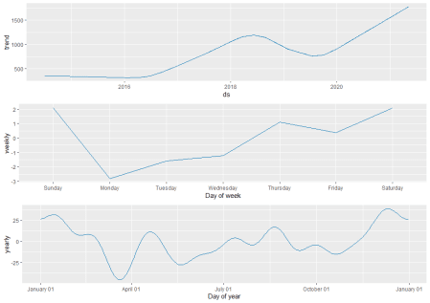

Now you can see some of the trends like weekly Monday price is going down and Thursday and Friday it’s going up and some seasonal trend based on yearly data.

tail(forecast)

You can see predicted values in yhat

ds trend additive_terms additive_terms_lower additive_terms_upper

1705 2021-05-29 1811.291 -20.84209 -20.84209 -20.84209

1706 2021-05-30 1813.041 -20.02460 -20.02460 -20.02460

1707 2021-05-31 1814.791 -24.12734 -24.12734 -24.12734

1708 2021-06-01 1816.542 -22.08570 -22.08570 -22.08570

1709 2021-06-02 1818.292 -20.96707 -20.96707 -20.96707

1710 2021-06-03 1820.042 -17.90472 -17.90472 -17.90472

weekly weekly_lower weekly_upper yearly yearly_lower yearly_upper

1705 2.092700 2.092700 2.092700 -22.93479 -22.93479 -22.93479

1706 2.092701 2.092701 2.092701 -22.11730 -22.11730 -22.11730

1707 -2.826402 -2.826402 -2.826402 -21.30094 -21.30094 -21.30094

1708 -1.585587 -1.585587 -1.585587 -20.50011 -20.50011 -20.50011

1709 -1.239506 -1.239506 -1.239506 -19.72756 -19.72756 -19.72756

1710 1.089445 1.089445 1.089445 -18.99416 -18.99416 -18.99416

multiplicative_terms multiplicative_terms_lower multiplicative_terms_upper

1705 0 0 0

1706 0 0 0

1707 0 0 0

1708 0 0 0

1709 0 0 0

1710 0 0 0

yhat_lower yhat_upper trend_lower trend_upper yhat

1705 1702.054 1876.785 1811.189 1811.291 1790.449

1706 1702.299 1882.703 1812.854 1813.041 1793.017

1707 1699.517 1875.155 1814.448 1814.791 1790.664

1708 1707.877 1885.060 1816.108 1816.543 1794.456

1709 1702.521 1889.921 1817.741 1818.366 1797.325

1710 1708.005 1898.301 1819.334 1820.132 1802.137

plot(m, forecast)

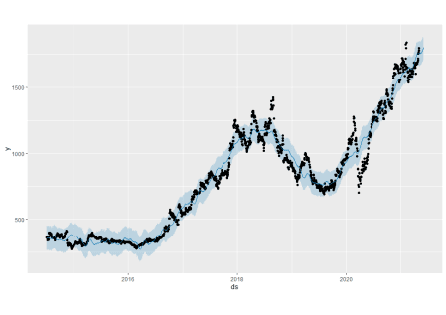

The plot is showing an increasing trend for the next 30 days.

Applying the knowledge of machine learning and algorithms to daily life allows us to make better decisions instead of random guesses.

Disclaimer:- For any kind of investment please consult your financial advisor, we are not recommending any stocks or trading ideas.