SwimmeR version 0.7.2 is now available from CRAN. This new version contains some new features, plus a few changes to make it more user-friendly. Let me show you what I’ve been working on.

library(SwimmeR) library(dplyr) library(stringr) library(flextable) library(rbenchmark)

flextable_style <- function(x) { x %>%

flextable() %>%

bold(part = "header") %>% # bold header

bg(bg = "#D3D3D3", part = "header") %>% # puts gray background behind the header row

align_nottext_col(align = "center", header = TRUE, footer = TRUE)

%>% # center alignment autofit()

}

# New Features

SwimmeR can now parse S.A.M.M.S. style results. S.A.M.M.S., which stands for Swimclub And Meet Management System, was an *ahem* swim club and meet management system that predated Hy-Tek’s Meet and Team Manager. It seems to have been most popular in California, where it’s still used by USA Swimming clubs and high schools into the present day.

S.A.M.M.S. meets look like this:

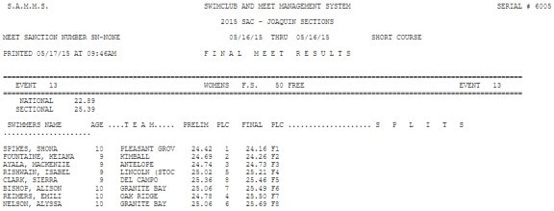

Parsing them is a simple matter for you SwimmeR users – it’s exactly the same as parsing Hy- Tek style results. The only differences come in with respect to relay_swimmers and splits. Same read_results, same swim_parse. S.A.M.M.S. results that I’ve seen don’t include relay swimmers, so of course SwimmeR doesn’t collect them. Splits are also rarely seen in

S.A.M.M.S. results and at this moment are also not collected by SwimmeR, although they may be in a future release.

df <-

swim_parse( read_results(

"<http://www.pacswim.org/userfiles/meets/documents/1629/1119bac.htm>"

)

)

df %>%

head(5) %>% flextable_style()

Place Name Age Team Finals_Time DQ Event

LADOMIRAK,

1

ALEGRIA

PC PALO ALTO

8

STANFORD

16.11 0

EVENT 73 FEMALE 8&UN 25 FREE

1. DIEHN, EVA 8

PC BULL DOG SWIM CLUB

16.36 0

EVENT 73 FEMALE 8&UN 25 FREE

1. HILL, NAOMI 8

PC PALO ALTO STANFORD

16.50 0

EVENT 73 FEMALE 8&UN 25 FREE

1. HOUTZER, AMELIA 8

PC PALO ALTO STANFORD

16.88 0

EVENT 73 FEMALE 8&UN 25 FREE

1. CHANG, KAYLA 8

PC BURLINGAME AQUATIC

17.55 0

EVENT 73 FEMALE 8&UN 25 FREE

On a personal level working with these S.A.M.M.S. results was very encouraging, because they have all kinds of weird bugs and cut corners that make me feel better about SwimmeR. For example some S.A.M.M.S. results list a place order for finals swims, as “F1”, “F2”, etc. But

S.A.M.M.S. can’t handle more than two characters in that field, so if someone comes in 10th they just get “F”.

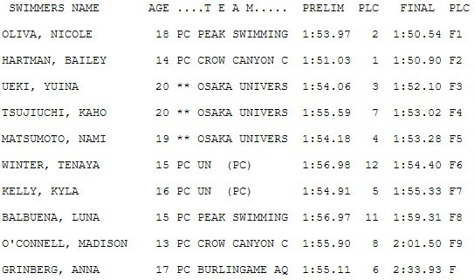

Just “F”

S.A.M.M.S. also doesn’t know what to make of diving, and records diving results like swimming results, so “347.56” is written as “3:47.56” (swim_parse corrects this). S.A.M.M.S. also orders diving results backwards with the lowest (i.e. fastest) score/time listed first.

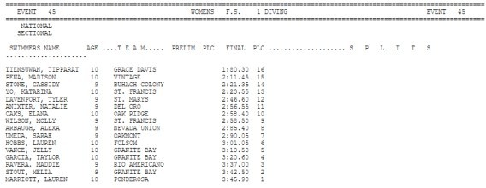

Maybe divers don’t mind being upside down?

S.A.M.M.S. was a commercial product. SwimmeR might have its issues sometimes, but at least it’s free!

Under the hood changes to speed up swim_parse. We can test this with benchmark from the rbenchmark package because I’ve left the old swim_parse function in SwimmeR, renamed swim_parse_old. It’s not exported though so to actually access it you’ll need to call it as SwimmeR:::swim_parse_old.

benchmark("new" = { swim_parse(

read_results( "<http://www.pacswim.org/userfiles/meets/documents/1547/nvst-results.htm>"

)

)

},

"old" = { SwimmeR:::swim_parse_old(

read_results( "<http://www.pacswim.org/userfiles/meets/documents/1547/nvst-results.htm>"

)

)

},

replications = 5) %>% flextable_style()

test replications elapsed relative user.self sys.self

|  |  |  |
| --- | --- | --- |
| new 5 | 33.62 1.000 30.67 | 0.06 |
| old 5 | 76.72 2.282 74.16 | 0.09 |

As you can see, from the relative column above, the new version of swim_parse is a little over twice as fast as the old version (on my computer at least). You’re all very welcome.

Kinder and gentler all around. There have been several changes to make swim_parse more user friendly. First is decreased reliance on the typo and replacement arguments. They’re still present, and still work, but they’re hopefully now much less necessary.

By way of example in this meet there’s a young man named “DU Fayet DE LA Tour, Vin”, as seen here:

swim_parse_old struggles with this, and gets his name wrong.

df_old <- SwimmeR:::swim_parse_old(

read_results( "<http://www.pacswim.org/userfiles/meets/documents/1547/nvst-results.htm>"

)

)

df_old %>%

filter(str_detect(Name, "DU Fayet DE LA Tour") == TRUE) %>% select(-Points,-DQ,-Exhibition) %>%

flextable_style()

Place Name Age Team Prelims_Time Finals_Time Event

|  |  |  |  |
| --- | --- | --- | --- |
| 13 DU Fayet DE LA Tour 14 | NBA-PC 1:02.09 | 1:00.08 | Boys 13-14 100 Yard Freestyle |
| 12 DU Fayet DE LA Tour 14 | NBA-PC 1:20.75 | 1:09.03 | Boys 13-14 100 Yard Backstroke |
| 14 DU Fayet DE LA Tour 14 | NBA-PC 1:16.16 | 1:10.01 | Boys 13-14 100 Yard Butterfly |

Place Name Age Team Prelims_Time Finals_Time Event

16 DU Fayet DE LA Tour 14 NBA-PC 2:50.00 2:35.25 Boys 13-14 200 Yard IM

We can fix the problem in a hacky, and non-intuitive kind of way using typo and replacement, plus some after the parse changes. It works, but it’s not terribly easy.

df_old_tr <- SwimmeR:::swim_parse_old(

read_results( "<http://www.pacswim.org/userfiles/meets/documents/1547/nvst-results.htm>"

),

typo = ", Vin ", replacement = " Vin "

) %>%

mutate(Name = str_replace(Name, " Vin", ", Vin"))

df_old_tr %>%

filter(str_detect(Name, "DU Fayet DE LA Tour") == TRUE) %>% select(-Points, -DQ, -Exhibition) %>%

flextable_style()

Place Name Age Team Prelims_Time Finals_Time Event

DU Fayet DE LA Tour,

13

Vin

NBA-

14

PC

1:02.09 1:00.08 Boys 13-14 100 Yard Freestyle

DU Fayet DE LA Tour,

12

Vin

NBA-

14

PC

1:20.75 1:09.03

Boys 13-14 100 Yard Backstroke

DU Fayet DE LA Tour,

14

Vin

NBA-

14

PC

1:16.16 1:10.01 Boys 13-14 100 Yard Butterfly

DU Fayet DE LA Tour,

16

Vin

NBA-

14

PC

2:50.00 2:35.25 Boys 13-14 200 Yard IM

Compare that to the much simpler approach available in swimmeR version 0.7.2. – no need for

typo & replacement, and no need to after-parse fixes to Vin’s name.

df_new <- swim_parse(

read_results( "<http://www.pacswim.org/userfiles/meets/documents/1547/nvst-results.htm>"

)

)

df_new %>%

filter(str_detect(Name, "DU Fayet DE LA Tour") == TRUE) %>%

select(-Points,-DQ,-Exhibition) %>% flextable_style()

Place Name Age Team Prelims_Time Finals_Time Event

DU Fayet DE LA Tour,

13

Vin

NBA-

14

PC

1:02.09 1:00.08 Boys 13-14 100 Yard Freestyle

DU Fayet DE LA Tour,

12

Vin

NBA-

14

PC

1:20.75 1:09.03

Boys 13-14 100 Yard Backstroke

DU Fayet DE LA Tour,

14

Vin

NBA-

14

PC

1:16.16 1:10.01 Boys 13-14 100 Yard Butterfly

DU Fayet DE LA Tour,

16

Vin

NBA-

14

PC

2:50.00 2:35.25 Boys 13-14 200 Yard IM

This is not a promise that there will be no need for typo and replacement. Sometimes there really are typos that need replacing. Things should be easier now though.

Second – event names were also an issue in older versions of SwimmeR. If swim_parse didn’t find any event names it liked it would throw an error and return nothing. Now, in swimmeR version 0.7.2 the event name definitions are much broader, and failing to find any event names will not result in an error.

df_aus <- swim_parse(

read_results( "https://[www.swimming.org.au/sites/default/files/assets/documents/full%20results_0.pdf](http://www.swimming.org.au/sites/default/files/assets/documents/full%20results_0.pdf)

"

)

)

df_aus %>% head(2) %>%

flextable_style()

Place Name Age Team Prelims_Time Finals_Time Points DQ Exhibition Event

CAMPBELL,

1

CATE

KNOX

27

PYMBLE

24.33 24.05 953 0 0

Women 50 LC Metre Freestyle

CAMPBELL,

2

BRONTE

KNOX

25

PYMBLE

24.60 24.17 939 0 0

Women 50 LC Metre Freestyle

df_2002 <- swim_parse(

read_results(

"https://cdn.swimswam.com/wp-content/uploads/2018/08/2002-Division-I-NCAA- Championships-Men-results1.pdf"

)

)

df_2002 %>%

filter(str_detect(Event, "100 Yard BUTTERFLY")) %>% head(3) %>%

flextable_style()

Place Name Age Team Prelims_Time Finals_Time Points DQ Exhibition Event

CROCKER,

|  |  |  |  |  |  |  |
| --- | --- | --- | --- | --- | --- | --- |
| SO TEXAS | 45.70 | 45.44 | NA | 0 | 0 | Event 9 MEN’s  100 Yard |
|  |  |  |  |  |  | BUTTERFLY |
| SO STANFORD | 46.39 | 46.48 | NA | 0 | 0 | Event 9 MEN’s  100 Yard |
|  |  |  |  |  |  | BUTTERFLY |
| SR ARIZONA | 46.57 | 46.50 | NA | 0 | 0 | Event 9 MEN’s  100 Yard |
|  |  |  |  |  |  | BUTTERFLY |

1

IAN

MARSHALL,

2

PETER

SCHOEMAN,

3

ROLAND

Bug fixes, always bug fixes.

# In Closing

Please do download the newest version of SwimmeR from wherever you get your packages.…