Week two brought us some new Clare drama. We decided to “strip” the data down to its essentials and tr to avoid “dodging” any tough questions.

Since only one man was eliminated this week (for his failure to adequately compliment Clare), this week’ blog post focuses on the suitors’ Instagram accounts. On average, the men have roughly doubled their growth in instagram followers since the show began. They are well on their way to promoting FabFitFun boxes!

The Instagram star, Dale Moss, out of South Dakota has an insane number of followers. Dale began the show with about 180k followers and currently has 267k followers. It really makes one wonder if he’s here for the right reasons!

Due to the fact that his current follower count is so large, we will be excluding his data from the rest of th analysis so that graphs show signs of life for the other contestants.

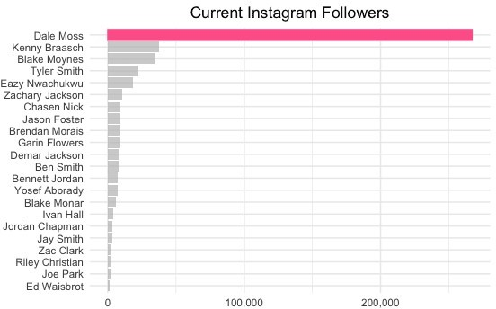

Now that the star from South Dakota has been removed, we can take a look at the increase in followers over time. As one would expect, every contestant gained followers after the show originally aired on October 13, 2020. However, some increased more than others. Initially, Kenny Braasch started out with the most followers but only gained a weak 4% (1.5K followers) since the original air date. On the other hand, Blake Moynes, moved from the bottom 25th percentile to second place due to an increase in followers of almost 800% (30.6K).

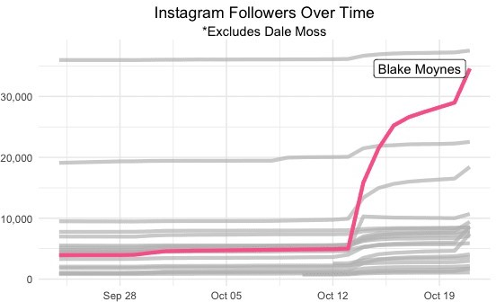

At this point, we can start to see the post-show outcome. In other words, we see the future “influencers” and the “losers”. In the scatterplot, we see that most people had less than 10K followers before the show aired. Which, to be fair, is nothing to sneeze at. The separation between “influencers” and “influencees“ can be seen along the y-axis as those who are gaining continue to rise, most notably, Blake, Ivan, Bennett, and Tyler (recently eliminated).

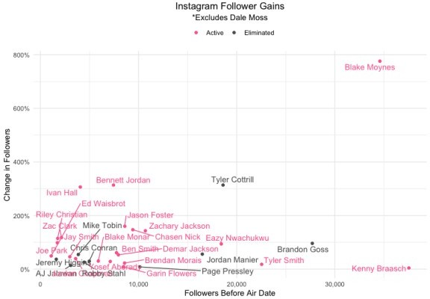

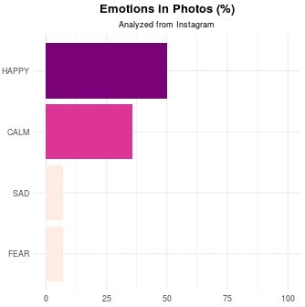

We’ll be doing some analysis after next week’s show, hope to see you then. The code for the plots is below and the data is available upon request by using our contact page.

library(dplyr) library(tidyr) library(ggplot2) library(lubridate)

GLOBAL_DATA = get_database_data() # rds available upon request (contact page)

GLOBAL_DATA$insta_followers_w_losers %>%

filter(!suitor %in% c('chrisbharrison', 'tayshiaaa', 'clarecrawley', 'DaleMoss13')) %>%

group_by(suitor) %>% mutate(min_date = min(datetime),

max_date = max(datetime)) %>%

filter(datetime == min_date | datetime == max_date) %>% arrange(datetime) %>%

mutate(follower_change = follower_count - lag(follower_count), follower_change_pct = follower_change / lag(follower_count)) %>%

drop_na() %>%

left_join(GLOBAL_DATA$contestant_data_raw %>% select(name, end_episode), by

= 'name') %>%

mutate(status = if_else(end_episode <= GLOBAL_DATA$latest_episode, 'Eliminated', 'Active')) %>%

ggplot(aes(x = follower_count, y = follower_change_pct, col = status)) + #geom_abline(slope = 1, intercept = 0, linetype = 'dotted') + geom_point() +

ggrepel::geom_text_repel(aes(label = name), show.legend = FALSE) + #geom_smooth(method = 'lm', se = FALSE) +

theme_minimal() +

labs(x = 'Followers Before Air Date', y = 'Change in Followers', title =

"Instagram Follower Gains", subtitle = "*Excludes Dale Moss") + scale_color_manual("legend", values = c("Active" = "#ff6699", "Eliminated"

"#5a5a5a")) +

scale_fill_manual("legend", values = c("Active" = "#ff6699", "Eliminated" = "#5a5a5a")) +

scale_y_continuous(label = scales::percent) + scale_x_continuous(label = scales::comma) + theme(legend.position = 'top', legend.direction = "horizontal",

legend.title = element_blank(),

plot.title = element_text( hjust = 0.5, vjust = -1), plot.subtitle = element_text( hjust = 0.5, vjust = -1))

GLOBAL_DATA$insta_followers%>%

filter(!suitor %in% c('chrisbharrison', 'tayshiaaa', 'clarecrawley', 'DaleMoss13')) %>%

drop_na() %>%

ggplot(aes(x = datetime, y = follower_count, group = name)) + geom_line(col = '#ff6699', fill = '#ff6699', size = 1.5) + gghighlight::gghighlight(name == 'Blake Moynes', label_key = name,

use_group_by = TRUE) + theme_minimal() +

labs(x = '', y = '', title = "Instagram Followers Over Time", subtitle = "*Excludes Dale Moss") +

scale_y_continuous(label = scales::comma) + theme(legend.position = 'top', legend.direction = "horizontal",

legend.title = element_blank(),

plot.title = element_text( hjust = 0.5, vjust = -1), plot.subtitle = element_text( hjust = 0.5, vjust = -1))

GLOBAL_DATA$insta_followers %>%

filter(!suitor %in% c('chrisbharrison', 'tayshiaaa', 'clarecrawley')) %>% drop_na() %>%

group_by(suitor) %>%

filter(datetime == max(datetime)) %>% ungroup() %>%

ggplot(aes(x = reorder(name, follower_count), y = follower_count)) + geom_col(col = '#ff6699', fill = '#ff6699') +

gghighlight::gghighlight(name == 'Dale Moss', label_key = name, use_group_b

= TRUE) +

coord_flip() + theme_minimal() +

labs(x = '', y = '', title = "Current Instagram Followers") + scale_y_continuous(label = scales::comma) + theme(legend.position = 'top', legend.direction = "horizontal",

legend.title = element_blank(), plot.title = element_text( hjust = 0.5))