**Libraries**

library(tidyverse) library(mlbench) library(ggfortify) library(GGally) library(scagnostics) library(mlr)

**Dataset**

Pima Indians Diabetes dataset from *mlbench* package.

data(PimaIndiansDiabetes) PimaIndiansDiabetes %>%

head()

## pregnant diabetes

|  |  |  |  |  |  |  |
| --- | --- | --- | --- | --- | --- | --- |
| glucose | pressure | triceps | insulin | mass | pedigree | age |
| 148 | 72 | 35 | 0 | 33.6 | 0.627 | 50 |
| 85 | 66 | 29 | 0 | 26.6 | 0.351 | 31 |
| 183 | 64 | 0 | 0 | 23.3 | 0.672 | 32 |
| 89 | 66 | 23 | 94 | 28.1 | 0.167 | 21 |
| 137 | 40 | 35 | 168 | 43.1 | 2.288 | 33 |
| 116 | 74 | 0 | 0 | 25.6 | 0.201 | 30 |

## 1 6

pos

## 2 1

neg

## 3 8

pos

## 4 1

neg

## 5 0

pos

## 6 5

neg

**Colors**

set colorblind-friendly palettes

# The palette with grey:

cbp1 <- c("#999999", "#E69F00", "#56B4E9", "#009E73", "#F0E442", "#0072B2", "#D55E00", "#CC79A7")

ggplot <- function(...) ggplot2::ggplot(...) + scale_color_manual(values = cbp1) +

scale_fill_manual(values = cbp1) + # note: needs to be overridden when using continuous color scales

theme_bw()

**Visualizing Machine Learning models**

Visualizing different steps of the machine learning pipeline can help us

explore the data (EDA),

understand the data (and identify potential problems),

pre-process the data in a suitable way for optimal model performance,

supervise the learning process, optimize modeling,

interpret the model and

compare and evaluate model predictions.

Visualization also greatly simplifies communication of our model and results to decision-makers or the public.

# Exploratory Data Analysis

Exploratory Data Analysis (EDA) is the backbone of data analysis, including those that result in a machine learning model. EDA helps us to understand the data we are working with and put it into context, so that we are able to ask the right questions (or to put our questions into the right frame). It also helps us take appropriate measures for cleaning, normalization/transformation, dealing with missing values, feature preparation and engineering, etc. Particularly if our machine learning model is trained on a limited dataset (but not only then!), appropriate data preparation can vastly improve the machine learning process: models will often train faster and achieve higher accuracy.

An essential part of EDA is data visualization.

Typically, we want to start by exploring potential sources of errors in our data, like

**wrong/useless data types** (sometimes data types are automatically set in a way that is not useful for our analysis, like *factors* versus *strings*, or wrong/strange entries in an otherwise numeric column will make it categorical)

**missing values**,

**outliers** (for example by plotting a box-plot of continuous variables)

Depending on the number of features/variables we have, it makes sense to look at them all individually and in correlation with each other. Depending on whether we have a categorical or continuous variable, we might be interested in properties that are shown by

**histograms** (frequency distribution of binned continuous variables), **density distribution** (normalized distribution of continuous variables) or **bar-plots** (shows counts of categorical variables).

If our target variable is categorical, we will want to look at potential imbalances between the classes. Class imbalance will strongly affect the machine learning modeling process and will require us to consider up-/downsampling or similar techniques before we train a model.

**Correlation analysis** can show us, for example

how our **target/dependent variable correlates with the remaining features** (often, just by looking at the correlation, we can identify one ore more feature that will have a strong impact on predicting the target because they are strongly correlated) or

whether some of the **independent variables/features correlate with each other** (**multicolinearity**; we might want to consider removing strongly correlated features, so that they won’t contribute the “same” information multiple times to the model and thus lead to overfitting).

Additional methods can be used to visualize groups of related features. These methods are often especially useful if we have a large dataset with a large feature set (highly dimensional data). Some of these methods for visualizing groups of related features and/or for comparing multiple variables and visualizing their relationships are:

**Dimensionality reduction**:

*Principal Component Analysis* (PCA, linear, shows as much variation in data as possible)

*Multidimensional scaling* (MDS, non-linear)

*Sammon mapping* (non-linear)

*T-Distributed Stochastic Neighbor Embedding* (t-SNE, non-linear)

*Uniform Manifold Approximation and Projection* (UMAP, non-linear, faster than T-SNE, often captures global variation better than T-SNE and PCA)

*Isometric Feature Mapping Ordination* (Isomap)

Parallel coordinate plots scagnostics

# in our dataset,

# continuous variables are PimaIndiansDiabetes %>%

dplyr::select(where(is.numeric)) %>% head()

|  |  |  |  |  |  |  |  |  |
| --- | --- | --- | --- | --- | --- | --- | --- | --- |
| ## | pregnant | glucose | pressure | triceps | insulin | mass | pedigree | age |
| ## | 1 6 | 148 | 72 | 35 | 0 | 33.6 | 0.627 | 50 |
| ## | 2 1 | 85 | 66 | 29 | 0 | 26.6 | 0.351 | 31 |
| ## | 3 8 | 183 | 64 | 0 | 0 | 23.3 | 0.672 | 32 |
| ## | 4 1 | 89 | 66 | 23 | 94 | 28.1 | 0.167 | 21 |
| ## | 5 0 | 137 | 40 | 35 | 168 | 43.1 | 2.288 | 33 |
| ## | 6 5 | 116 | 74 | 0 | 0 | 25.6 | 0.201 | 30 |

# 'diabetes' is the only categorical variable is also our target or dependent variable

PimaIndiansDiabetes %>% dplyr::select(!where(is.numeric)) %>% head()

|  |  |  |
| --- | --- | --- |
| ## |  | diabetes |
| ## | 1 | pos |
| ## | 2 | neg |
| ## | 3 | pos |
| ## | 4 | neg |
| ## | 5 | pos |
| ## | 6 | neg |

# bar plot of target PimaIndiansDiabetes %>%

ggplot(aes(x = diabetes, fill = diabetes)) + geom_bar(alpha = 0.8) + theme(legend.position = "none") +

labs(x = "Diabetes outcome", y = "count",

title = "Barplot of categorical features",

caption = "Source: Pima Indians Diabetes Database")

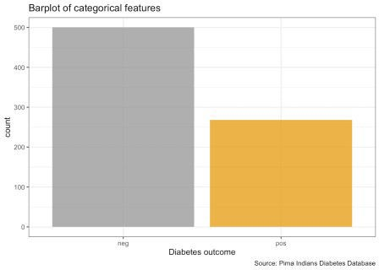

# boxplot of continuous features PimaIndiansDiabetes %>%

gather("key", "value", pregnant:age) %>% ggplot(aes(x = value, fill = diabetes)) +

facet_wrap(vars(key), ncol = 3, scales = "free") + geom_boxplot(alpha = 0.8) +

theme(axis.text.y = element_blank(), axis.ticks.y = element_blank())

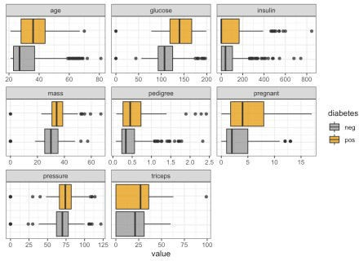

# histogram of features PimaIndiansDiabetes %>%

gather("key", "value", pregnant:age) %>% ggplot(aes(x = value, fill = diabetes)) +

facet_wrap(vars(key), ncol = 3, scales = "free") + geom_histogram(alpha = 0.8) +

labs(x = "value of feature in facet", y = "count",

fill = "Diabetes",

title = "Histogram of features",

caption = "Source: Pima Indians Diabetes Database")

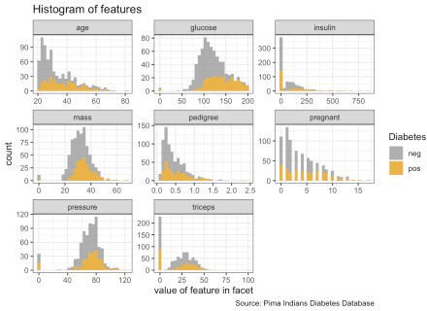

# density plot of of features PimaIndiansDiabetes %>%

gather("key", "value", pregnant:age) %>% ggplot(aes(x = value, fill = diabetes)) +

facet_wrap(vars(key), ncol = 3, scales = "free") + geom_density(alpha = 0.8) +

labs(x = "value of feature in facet", y = "density",

fill = "Diabetes",

title = "Density of continuous features",

caption = "Source: Pima Indians Diabetes Database")

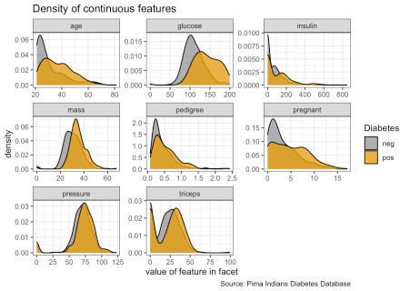

# correlation plot of features mat <- PimaIndiansDiabetes %>

dplyr::select(where(is.numeric))

cormat <- round(cor(mat), 2) cormat <- cormat %>%

as_data_frame() %>%

mutate(x = colnames(mat)) %>%

gather(key = "y", value = "value", pregnant:age)

cormat %>%

remove_missing() %>% arrange(x, y) %>%

ggplot(aes(x = x, y = y, fill = value)) + geom_tile() +

scale_fill_gradient2(low = "blue", high = "red", mid = "white", midpoint = 0, limit = c(-1,1), space = "Lab",

name = "Pearson\nCorrelation") +

theme(axis.text.x = element_text(angle = 45, vjust = 1, hjust = 1))

+

coord_fixed() + labs(x = "feature",

y = "feature",

title = "Correlation between features",

caption = "Source: Pima Indians Diabetes Database")

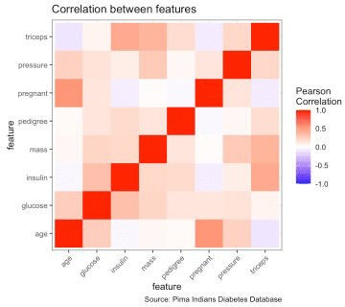

# scatterplot matrix ggpairs(PimaIndiansDiabetes,

columns = c(1:8), alpha = 0.7) +

labs(x = "feature", y = "feature",

title = "Scatterplot matrix",

caption = "Source: Pima Indians Diabetes Database")

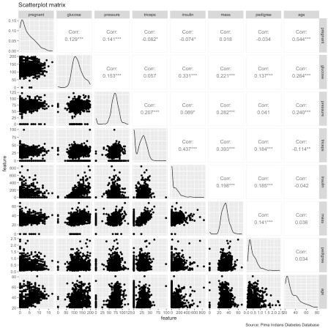

# PCA

prep <- PimaIndiansDiabetes %>% dplyr::select(where(is.numeric))

pca <- prep %>% prcomp(scale. = TRUE)

autoplot(pca,

data = PimaIndiansDiabetes, colour = 'diabetes',

shape = 'diabetes', loadings = TRUE, loadings.colour = 'blue', loadings.label = TRUE, loadings.label.size = 3) +

scale_color_manual(values = cbp1) + scale_fill_manual(values = cbp1) + theme_bw() +

labs(title = "Principal Component Analysis (PCA)", caption = "Source: Pima Indians Diabetes Database")

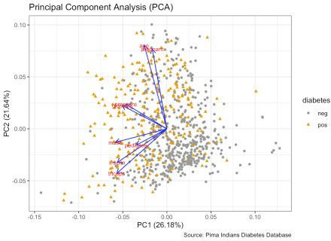

# MDS

d <- dist(prep) # euclidean distances between the rows fit <- cmdscale(d,eig=TRUE, k=2) # k is the number of dim fit$points %>%

head()

|  |  |  |  |
| --- | --- | --- | --- |
| ## |  | [,1] | [,2] |
| ## | 1 | -75.71465 | -35.950783 |
| ## | 2 | -82.35827 | 28.908213 |
| ## | 3 | -74.63064 | -67.906496 |
| ## | 4 | 11.07742 | 34.898486 |
| ## | 5 | 89.74379 | -2.746937 |
| ## | 6 | -80.97792 | -3.946887 |

# Sammon mapping library(MASS)

sam <- sammon(dist(prep))

|  |  |  |
| --- | --- | --- |
| ## Initial stress | : | 0.03033 |
| ## stress after | 0 iters: | 0.03033 |
| sam$points %>% |  |  |
| head() |  |  |

|  |  |  |  |
| --- | --- | --- | --- |
| ## |  | [,1] | [,2] |
| ## | 1 | -75.71465 | -35.950783 |
| ## | 2 | -82.35827 | 28.908213 |
| ## | 3 | -74.63064 | -67.906496 |
| ## | 4 | 11.07742 | 34.898486 |
| ## | 5 | 89.74379 | -2.746937 |
| ## | 6 | -80.97792 | -3.946887 |

# parallel coordinate plots ggparcoord(data = PimaIndiansDiabetes,

columns = c(1:8), groupColumn = 9, scale = "robust", order = "skewness", alpha = 0.7)

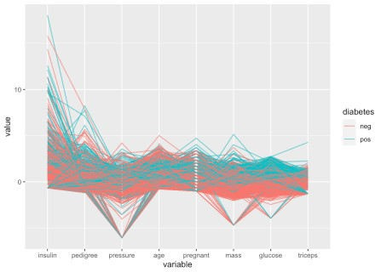

# scagnostics

scagnostics_dataset <- scagnostics(PimaIndiansDiabetes)

# scagnostics grid

scagnostics_grid_dataset <- scagnosticsGrid(scagnostics_dataset)

# outliers

scagnostics_o_dataset <- scagnosticsOutliers(scagnostics_dataset) scagnostics_o_dataset[scagnostics_o_dataset]

## pregnant * age ## TRUE

outlier <- scagnostics_grid_dataset[scagnostics_o_dataset,]

# scagnostics exemplars

scagnostics_ex_dataset <- scagnosticsExemplars(scagnostics_dataset) scagnostics_ex_dataset[scagnostics_ex_dataset]

## pregnant * triceps mass * age triceps * diabetes ## TRUE TRUE TRUE

exemplars <- scagnostics_grid_dataset[scagnostics_ex_dataset,]

# Training a machine learning model

(using mlr package)

create training and test set

set.seed(1000)

train_index <- sample(1:nrow(PimaIndiansDiabetes), 0.8 * nrow(PimaIndiansDiabetes))

test_index <- setdiff(1:nrow(PimaIndiansDiabetes), train_index)

train <- PimaIndiansDiabetes[train_index,] test <- PimaIndiansDiabetes[test_index,]

list( train = summary(train), test = summary(test) ) ## $train

## pregnant glucose pressure triceps

## Min. : 0.000 Min. : 0.0 Min. : 0.00 Min. : 0.00

|  |  |  |  |  |  |  |  |  |
| --- | --- | --- | --- | --- | --- | --- | --- | --- |
| ## | 1st Qu.: | 1.000 | 1st Qu.:100.0 | | 1st Qu.: | 64.00 | 1st Qu.: 0.00 | |
| ## | Median : | 3.000 | Median :119.0 | | Median : | 72.00 | Median :23.00 | |
| ## | Mean : | 3.894 | Mean :123.1 | | Mean : | 68.89 | Mean :20.66 | |
| ## | 3rd Qu.: | 6.000 | 3rd Qu.:143.0 | | 3rd Qu.: | 80.00 | 3rd Qu.:32.75 | |
| ## | Max. :17.000 | | Max. | :199.0 | Max. :114.00 | | Max. | :99.00 |
| ## | insulin | |  | mass | pedigree | |  | age |

diabetes

## Min. : 0.00 Min. : 0.00 Min. :0.0780 Min. :21.00

neg:386

## 1st Qu.: 0.00 1st Qu.:27.10 1st Qu.:0.2442 1st Qu.:24.00

pos:228

|  |  |  |  |  |  |  |
| --- | --- | --- | --- | --- | --- | --- |
| ## | Median : | 36.50 | Median :32.00 | Median :0.3780 | | Median :29.00 |
| ## | Mean : | 81.65 | Mean :31.92 | Mean :0.4742 | | Mean :33.42 |
| ## | 3rd Qu.:131.50 | | 3rd Qu.:36.38 | 3rd Qu.:0.6355 | | 3rd Qu.:41.00 |
| ## | Max. :846.00 | | Max. :59.40 | Max. :2.4200 | | Max. :81.00 |
| ## |  | |  |  | |  |
| ## | $test | |  |  | |  |
| ## | pregnant | | glucose | pressure | | triceps |
| ## | Min. : 0.000 | | Min. : 0.0 | Min. : 0.00 | | Min. : 0.00 |
| ## | 1st Qu.: | 1.000 | 1st Qu.: 93.0 | 1st Qu.: | 62.00 | 1st Qu.: 0.00 |
| ## | Median : | 2.000 | Median :108.0 | Median : | 72.00 | Median :23.00 |
| ## | Mean : | 3.649 | Mean :112.3 | Mean : | 69.96 | Mean :20.03 |
| ## | 3rd Qu.: | 6.000 | 3rd Qu.:133.8 | 3rd Qu.: | 79.50 | 3rd Qu.:32.00 |

## Max. :14.000 Max. :197.0 Max. :122.00 Max. :56.00

## insulin mass pedigree age diabetes

## Min. : 0.0 Min. : 0.00 Min. :0.0850 Min. :21.00

neg:114

## 1st Qu.: 0.0 1st Qu.:27.80 1st Qu.:0.2395 1st Qu.:23.25

pos: 40

|  |  |  |  |  |  |
| --- | --- | --- | --- | --- | --- |
| ## | Median : | 20.5 | Median :32.40 | Median :0.3380 | Median :29.00 |
| ## | Mean : | 72.4 | Mean :32.29 | Mean :0.4627 | Mean :32.54 |
| ## | 3rd Qu.:100.0 | | 3rd Qu.:36.88 | 3rd Qu.:0.6008 | 3rd Qu.:39.75 |
| ## | Max. :744.0 | | Max. :67.10 | Max. :2.3290 | Max. :67.00 |

create classification task and learner

listLearners() %>% head()

|  |  |  |  |
| --- | --- | --- | --- |
| ## | class |  | name short.name |
| ## 1 | classif.ada | ada | Boosting ada |

## 2 classif.adaboostm1 ada Boosting M1 adaboostm1 ## 3 classif.bartMachine Bayesian Additive Regression Trees bartmachine

|  |  |  |  |  |
| --- | --- | --- | --- | --- |
| ## | 4 | classif.binomial | Binomial Regression | binomial |
| ## | 5 | classif.boosting | Adabag Boosting | adabag |
| ## | 6 | classif.bst | Gradient Boosting | bst |
| ## |  | package |  |  |
| ## | 1 | ada,rpart |  |  |

|  |  |  |
| --- | --- | --- |
| ## | 2 | RWeka |
| ## | 3 | bartMachine |
| ## | 4 | stats |
| ## | 5 | adabag,rpart |
| ## | 6 | bst,rpart |
| ## |  |  |

note ## 1

`xval` has been set to `0` by default for speed. ## 2

NAs are directly passed to WEKA with `na.action = na.pass`. ## 3

`use_missing_data` has been set to `TRUE` by default to allow missing data support.

## 4 Delegates to `glm` with freely choosable binomial link function via learner parameter `link`. We set 'model' to FALSE by default to save memory.

## 5

`xval` has been set to `0` by default for speed.

## 6 Renamed parameter `learner` to `Learner` due to nameclash with

`setHyperPars`. Default changes: `Learner = "ls"`, `xval = 0`, and

`maxdepth = 1`.

## type installed numerics factors ordered missings weights prob oneclass

## 1 classif FALSE TRUE TRUE FALSE FALSE FALSE TRUE FALSE

## 2 classif TRUE TRUE TRUE FALSE FALSE FALSE TRUE FALSE

## 3 classif FALSE TRUE TRUE FALSE TRUE FALSE TRUE FALSE

## 4 classif TRUE TRUE TRUE FALSE FALSE TRUE TRUE FALSE

## 5 classif FALSE TRUE TRUE FALSE TRUE FALSE TRUE FALSE

## 6 classif FALSE TRUE FALSE FALSE FALSE FALSE FALSE FALSE

|  |  |  |  |  |  |  |
| --- | --- | --- | --- | --- | --- | --- |
| ## | twoclass | multiclass | class.weights | featimp | oobpreds | functionals |
| ## 1 | TRUE | FALSE | FALSE | FALSE | FALSE | FALSE |
| ## 2 | TRUE | TRUE | FALSE | FALSE | FALSE | FALSE |
| ## 3 | TRUE | FALSE | FALSE | FALSE | FALSE | FALSE |
| ## 4 | TRUE | FALSE | FALSE | FALSE | FALSE | FALSE |
| ## 5 | TRUE | TRUE | FALSE | TRUE | FALSE | FALSE |
| ## 6 | TRUE | FALSE | FALSE | FALSE | FALSE | FALSE |

|  |  |  |  |  |  |
| --- | --- | --- | --- | --- | --- |
| ## | single.functional | se | lcens | rcens | icens |
| ## 1 | FALSE | FALSE | FALSE | FALSE | FALSE |
| ## 2 | FALSE | FALSE | FALSE | FALSE | FALSE |
| ## 3 | FALSE | FALSE | FALSE | FALSE | FALSE |
| ## 4 | FALSE | FALSE | FALSE | FALSE | FALSE |
| ## 5 | FALSE | FALSE | FALSE | FALSE | FALSE |
| ## 6 | FALSE | FALSE | FALSE | FALSE | FALSE |

(dt_task <- makeClassifTask(data = train, target = "diabetes")) ## Supervised task: train

## Type: classif

## Target: diabetes ## Observations: 614 ## Features:

## numerics factors ordered functionals ## 8 0 0 0

## Missings: FALSE

## Has weights: FALSE ## Has blocking: FALSE

## Has coordinates: FALSE ## Classes: 2

## neg pos ## 386 228

## Positive class: neg

(dt_prob <- makeLearner('classif.gbm', predict.type = "prob")) ## Learner classif.gbm from package gbm

## Type: classif

## Name: Gradient Boosting Machine; Short name: gbm ## Class: classif.gbm

## Properties: twoclass,multiclass,missings, numerics,factors,prob,weights,featimp

## Predict-Type: prob

## Hyperparameters: keep.data=FALSE

# Feature Selection

library(FSelector)

listFilterMethods() %>% head()

## id package

desc

## 1 anova.test ANOVA Test for binary and multiclass ..

## 2 auc AUC filter for binary classification ...

## 3 carscore care CAR scores

## 4 FSelector_chi.squared FSelector Chi-squared statistic of independence...

## 5 FSelector_gain.ratio FSelector Chi-squared statistic of independence...

## 6 FSelector_information.gain FSelector Entropy-based information gain betwee...

listFilterEnsembleMethods() %>% head()

|  |  |  |
| --- | --- | --- |
| ## |  | id |
| ## | 1 | E-Borda |
| ## | 2 | E-max |
| ## | 3 | E-mean |
| ## | 4 | E-median |
| ## | 5 | E-min |

##

desc

## 1 Borda ensemble filter. Takes the sum across all base filter methods for each feature.

## 2 Maximum ensemble filter. Takes the best maximum value across all base filter methods for each feature.

## 3 Mean ensemble filter. Takes the mean across all base filter methods for each feature.

## 4 Median ensemble filter. Takes the median across all base filter methods for each feature.

## 5 Minimum ensemble filter. Takes the best minimum value across all base filter methods for each feature. generateFilterValuesData(dt_task, method = "FSelector_information.gain") %>%

plotFilterValues() + theme_bw() +

labs(x = "feature",

y = "information gain",

title = "Information gain of features in GBM", caption = "Source: Pima Indians Diabetes Database")

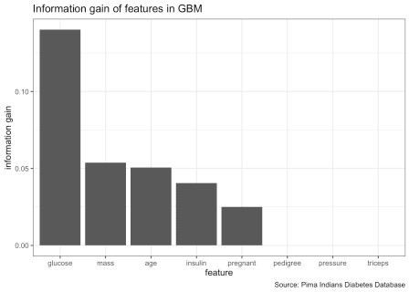

feat_imp_tpr <- generateFeatureImportanceData(task = dt_task,

learner = dt_prob, measure = tpr, interaction = FALSE)

## Distribution not specified, assuming bernoulli ... feat_imp_tpr$res %>%

gather() %>%

ggplot(aes(x = reorder(key, value), y = value)) + geom_bar(stat = "identity") +

labs(x = "feature",

title = "True positive rate of features in GBM", subtitle = "calculated with permutation importance", caption = "Source: Pima Indians Diabetes Database")

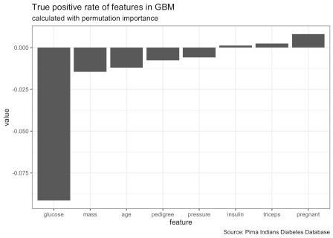

feat_imp_auc <- generateFeatureImportanceData(task = dt_task,

learner = dt_prob, measure = auc, interaction = FALSE)

## Distribution not specified, assuming bernoulli ... feat_imp_auc$res %>%

gather() %>%

ggplot(aes(x = reorder(key, value), y = value)) + geom_bar(stat = "identity") +

labs(x = "feature",

title = "Area under the curve of features in GBM", subtitle = "calculated with permutation importance", caption = "Source: Pima Indians Diabetes Database")

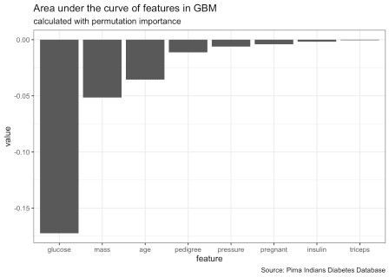

set.seed(1000)

train <- dplyr::select(train, -pedigree, -pressure, -triceps) test <- dplyr::select(test, -pedigree, -pressure, -triceps)

list(train = summary(train), test = summary(test)) ## $train

## pregnant glucose insulin mass

## Min. : 0.000 Min. : 0.0 Min. : 0.00 Min. : 0.00

|  |  |  |  |  |  |  |  |  |  |  |  |
| --- | --- | --- | --- | --- | --- | --- | --- | --- | --- | --- | --- |
| ## | 1st Qu.: | | 1.000 | 1st Qu.:100.0 | | 1st Qu.: | | 0.00 | | 1st Qu.:27.10 | |
| ## | Median : | | 3.000 | Median :119.0 | | Median : | | 36.50 | | Median :32.00 | |
| ## | Mean : | | 3.894 | Mean :123.1 | | Mean : | | 81.65 | | Mean :31.92 | |
| ## | 3rd Qu.: | | 6.000 | 3rd Qu.:143.0 | | 3rd Qu.:131.50 | | | | 3rd Qu.:36.38 | |
| ## | Max. | :17.000 | | Max. | :199.0 | Max. | :846.00 | | | Max. | :59.40 |
| ## |  | age | | diabetes |  |  |  | | |  |  |
| ## | Min. | :21.00 | | neg:386 |  |  |  | | |  |  |
| ## | 1st Qu.:24.00 | | | pos:228 | |  | | |  |  |  |
| ## | Median :29.00 | | |  | |  | | |  |  |  |
| ## | Mean :33.42 | | |  | |  | | |  |  |  |
| ## | 3rd Qu.:41.00 | | |  | |  | | |  |  |  |
| ## | Max. :81.00 | | |  | |  | | |  |  |  |
| ## |  | | |  | |  | | |  |  |  |
| ## | $test | | |  | |  | | |  |  |  |
| ## | pregnant | | | glucose | | insulin | | |  |  | mass |
| ## | Min. : 0.000 | | | Min. : 0.0 | | Min. : | | | 0.0 | Min. | : 0.00 |
| ## | 1st Qu.: | | 1.000 | 1st Qu.: 93.0 | | 1st Qu.: | | 0.0 | | 1st Qu.:27.80 | |
| ## | Median : | | 2.000 | Median :108.0 | | Median : | | 20.5 | | Median :32.40 | |
| ## | Mean : | | 3.649 | Mean :112.3 | | Mean : | | 72.4 | | Mean :32.29 | |
| ## | 3rd Qu.: 6.000 | | | 3rd Qu. | :133.8 | 3rd Qu.:100.0 | | | | 3rd Qu.:36.88 | |
| ## | Max. :14.000 | | | Max. | :197.0 | Max. :744.0 | | | | Max. :67.10 | |
| ## | age | | | diabetes |  |  | | | |  | |
| ## | Min. :21.00 | | | neg:114 |  |  | | | |  | |
| ## | 1st Qu.:23.25 | | | pos: 40 |  |  | | | |  | |
| ## | Median :29.00 | | |  |  |  | | | |  | |
| ## | Mean :32.54 | | |  |  |  | | | |  | |
| ## | 3rd Qu.:39.75 | | |  |  |  | | | |  | |
| ## | Max. :67.00 | | |  |  |  | | | |  | |

(dt_task <- makeClassifTask(data = train, target = "diabetes"))

|  |  |  |
| --- | --- | --- |
| ## | Supervised task: train |  |
| ## | Type: classif |
| ## | Target: diabetes |
| ## | Observations: 614 |
| ## | Features: |
| ## | numerics factors | ordered functionals |
| ## | 5 0 | 0 0 |
| ## | Missings: FALSE |  |
| ## | Has weights: FALSE |  |
| ## | Has blocking: FALSE |  |
| ## | Has coordinates: FALSE |  |
| ## | Classes: 2 |  |
| ## | neg pos |  |
| ## | 386 228 |  |
| ## | Positive class: neg |  |

# Hyperparameter Optimization

getParamSet("classif.gbm")

|  |  |  |  |  |  |  |
| --- | --- | --- | --- | --- | --- | --- |
| ## |  | Type | len | Def |  | |
| ## | distribution | discrete | - | bernoulli |
| ## | n.trees | integer | - | 100 |
| ## | cv.folds | integer | - | 0 |
| ## | interaction.depth | integer | - | 1 |
| ## | n.minobsinnode | integer | - | 10 |
| ## | shrinkage | numeric | - | 0.1 |
| ## | bag.fraction | numeric | - | 0.5 |
| ## | train.fraction | numeric | - | 1 |
| ## | keep.data | logical | - | TRUE |
| ## | verbose | logical | - | FALSE |
| ## | n.cores | integer | - | 1 |
| ## |  |  |  |  | Constr | Req |
| Tunable Trafo | | | | | |  |
| ## distribution gaussian,bernoulli,huberized,adaboost... | | | | | | - |
| TRUE - | | | | | |  |
| ## n.trees 1 to Inf | | | | | | - |
| TRUE - | | | | | |  |
| ## cv.folds -Inf to Inf | | | | | | - |
| TRUE - | | | | | |  |
| ## interaction.depth 1 to Inf | | | | | | - |
| TRUE - | | | | | |  |
| ## n.minobsinnode 1 to Inf | | | | | | - |
| TRUE - | | | | | |  |
| ## shrinkage 0 to Inf | | | | | | - |
| TRUE - | | | | | |  |
| ## bag.fraction 0 to 1 | | | | | | - |
| TRUE - | | | | | |  |
| ## train.fraction 0 to 1 | | | | | | - |
| TRUE - | | | | | |  |
| ## keep.data - | | | | | | - |
| FALSE - | | | | | |  |
| ## verbose - | | | | | | - |
| FALSE - | | | | | |  |
| ## n.cores -Inf to Inf | | | | | | - |
| FALSE - | | | | | |  |
| dt_param <- makeParamSet( | | | | | |  |
| makeIntegerParam("n.trees", lower = 20, upper = 150), | | | | | |  |

makeNumericParam("shrinkage", lower = 0.01, upper = 0.1)) ctrl = makeTuneControlGrid()

rdesc = makeResampleDesc("CV",

iters = 3L, stratify = TRUE)

set.seed(1000)

(dt_tuneparam <- tuneParams(learner = dt_prob,

resampling = rdesc,

measures = list(tpr,auc, fnr, mmce, tnr,

setAggregation(tpr, test.sd)),

par.set = dt_param, control = ctrl,

task = dt_task,

show.info = FALSE))

## Distribution not specified, assuming bernoulli ... ## Distribution not specified, assuming bernoulli ... ## Distribution not specified, assuming bernoulli ... ## Distribution not specified, assuming bernoulli ... ## Distribution not specified, assuming bernoulli ... ## Distribution not specified, assuming bernoulli ... ## Distribution not specified, assuming bernoulli ... ## Distribution not specified, assuming bernoulli ... ## Distribution not specified, assuming bernoulli ... ## Distribution not specified, assuming bernoulli ... ## Distribution not specified, assuming bernoulli ... ## Distribution not specified, assuming bernoulli ... ## Distribution not specified, assuming bernoulli ... ## Distribution not specified, assuming bernoulli ... ## Distribution not specified, assuming bernoulli ... ## Distribution not specified, assuming bernoulli ... ## Distribution not specified, assuming bernoulli ... ## Distribution not specified, assuming bernoulli ... ## Distribution not specified, assuming bernoulli ... ## Distribution not specified, assuming bernoulli ... ## Distribution not specified, assuming bernoulli ... ## Distribution not specified, assuming bernoulli ... ## Distribution not specified, assuming bernoulli ... ## Distribution not specified, assuming bernoulli ... ## Distribution not specified, assuming bernoulli ... ## Distribution not specified, assuming bernoulli ... ## Distribution not specified, assuming bernoulli ... ## Distribution not specified, assuming bernoulli ... ## Distribution not specified, assuming bernoulli ... ## Distribution not specified, assuming bernoulli ... ## Distribution not specified, assuming bernoulli ... ## Distribution not specified, assuming bernoulli ... ## Distribution not specified, assuming bernoulli ... ## Distribution not specified, assuming bernoulli ... ## Distribution not specified, assuming bernoulli ... ## Distribution not specified, assuming bernoulli ... ## Distribution not specified, assuming bernoulli ... ## Distribution not specified, assuming bernoulli ... ## Distribution not specified, assuming bernoulli ... ## Distribution not specified, assuming bernoulli ... ## Distribution not specified, assuming bernoulli ... ## Distribution not specified, assuming bernoulli ... ## Distribution not specified, assuming bernoulli ... ## Distribution not specified, assuming bernoulli ... ## Distribution not specified, assuming bernoulli ... ## Distribution not specified, assuming bernoulli ... ## Distribution not specified, assuming bernoulli ... ## Distribution not specified, assuming bernoulli ... ## Distribution not specified, assuming bernoulli ... ## Distribution not specified, assuming bernoulli ...

## Distribution not specified, assuming bernoulli ... ## Distribution not specified, assuming bernoulli ... ## Distribution not specified, assuming bernoulli ... ## Distribution not specified, assuming bernoulli ... ## Distribution not specified, assuming bernoulli ... ## Distribution not specified, assuming bernoulli ... ## Distribution not specified, assuming bernoulli ... ## Distribution not specified, assuming bernoulli ... ## Distribution not specified, assuming bernoulli ... ## Distribution not specified, assuming bernoulli ... ## Distribution not specified, assuming bernoulli ... ## Distribution not specified, assuming bernoulli ... ## Distribution not specified, assuming bernoulli ... ## Distribution not specified, assuming bernoulli ... ## Distribution not specified, assuming bernoulli ... ## Distribution not specified, assuming bernoulli ... ## Distribution not specified, assuming bernoulli ... ## Distribution not specified, assuming bernoulli ... ## Distribution not specified, assuming bernoulli ... ## Distribution not specified, assuming bernoulli ... ## Distribution not specified, assuming bernoulli ... ## Distribution not specified, assuming bernoulli ... ## Distribution not specified, assuming bernoulli ... ## Distribution not specified, assuming bernoulli ... ## Distribution not specified, assuming bernoulli ... ## Distribution not specified, assuming bernoulli ... ## Distribution not specified, assuming bernoulli ... ## Distribution not specified, assuming bernoulli ... ## Distribution not specified, assuming bernoulli ... ## Distribution not specified, assuming bernoulli ... ## Distribution not specified, assuming bernoulli ... ## Distribution not specified, assuming bernoulli ... ## Distribution not specified, assuming bernoulli ... ## Distribution not specified, assuming bernoulli ... ## Distribution not specified, assuming bernoulli ... ## Distribution not specified, assuming bernoulli ... ## Distribution not specified, assuming bernoulli ... ## Distribution not specified, assuming bernoulli ... ## Distribution not specified, assuming bernoulli ... ## Distribution not specified, assuming bernoulli ... ## Distribution not specified, assuming bernoulli ... ## Distribution not specified, assuming bernoulli ... ## Distribution not specified, assuming bernoulli ... ## Distribution not specified, assuming bernoulli ... ## Distribution not specified, assuming bernoulli ... ## Distribution not specified, assuming bernoulli ... ## Distribution not specified, assuming bernoulli ... ## Distribution not specified, assuming bernoulli ... ## Distribution not specified, assuming bernoulli ... ## Distribution not specified, assuming bernoulli ... ## Distribution not specified, assuming bernoulli ... ## Distribution not specified, assuming bernoulli ...

## Distribution not specified, assuming bernoulli ... ## Distribution not specified, assuming bernoulli ... ## Distribution not specified, assuming bernoulli ... ## Distribution not specified, assuming bernoulli ... ## Distribution not specified, assuming bernoulli ... ## Distribution not specified, assuming bernoulli ... ## Distribution not specified, assuming bernoulli ... ## Distribution not specified, assuming bernoulli ... ## Distribution not specified, assuming bernoulli ... ## Distribution not specified, assuming bernoulli ... ## Distribution not specified, assuming bernoulli ... ## Distribution not specified, assuming bernoulli ... ## Distribution not specified, assuming bernoulli ... ## Distribution not specified, assuming bernoulli ... ## Distribution not specified, assuming bernoulli ... ## Distribution not specified, assuming bernoulli ... ## Distribution not specified, assuming bernoulli ... ## Distribution not specified, assuming bernoulli ... ## Distribution not specified, assuming bernoulli ... ## Distribution not specified, assuming bernoulli ... ## Distribution not specified, assuming bernoulli ... ## Distribution not specified, assuming bernoulli ... ## Distribution not specified, assuming bernoulli ... ## Distribution not specified, assuming bernoulli ... ## Distribution not specified, assuming bernoulli ... ## Distribution not specified, assuming bernoulli ... ## Distribution not specified, assuming bernoulli ... ## Distribution not specified, assuming bernoulli ... ## Distribution not specified, assuming bernoulli ... ## Distribution not specified, assuming bernoulli ... ## Distribution not specified, assuming bernoulli ... ## Distribution not specified, assuming bernoulli ... ## Distribution not specified, assuming bernoulli ... ## Distribution not specified, assuming bernoulli ... ## Distribution not specified, assuming bernoulli ... ## Distribution not specified, assuming bernoulli ... ## Distribution not specified, assuming bernoulli ... ## Distribution not specified, assuming bernoulli ... ## Distribution not specified, assuming bernoulli ... ## Distribution not specified, assuming bernoulli ... ## Distribution not specified, assuming bernoulli ... ## Distribution not specified, assuming bernoulli ... ## Distribution not specified, assuming bernoulli ... ## Distribution not specified, assuming bernoulli ... ## Distribution not specified, assuming bernoulli ... ## Distribution not specified, assuming bernoulli ... ## Distribution not specified, assuming bernoulli ... ## Distribution not specified, assuming bernoulli ... ## Distribution not specified, assuming bernoulli ... ## Distribution not specified, assuming bernoulli ... ## Distribution not specified, assuming bernoulli ... ## Distribution not specified, assuming bernoulli ...

## Distribution not specified, assuming bernoulli ... ## Distribution not specified, assuming bernoulli ... ## Distribution not specified, assuming bernoulli ... ## Distribution not specified, assuming bernoulli ... ## Distribution not specified, assuming bernoulli ... ## Distribution not specified, assuming bernoulli ... ## Distribution not specified, assuming bernoulli ... ## Distribution not specified, assuming bernoulli ... ## Distribution not specified, assuming bernoulli ... ## Distribution not specified, assuming bernoulli ... ## Distribution not specified, assuming bernoulli ... ## Distribution not specified, assuming bernoulli ... ## Distribution not specified, assuming bernoulli ... ## Distribution not specified, assuming bernoulli ... ## Distribution not specified, assuming bernoulli ... ## Distribution not specified, assuming bernoulli ... ## Distribution not specified, assuming bernoulli ... ## Distribution not specified, assuming bernoulli ... ## Distribution not specified, assuming bernoulli ... ## Distribution not specified, assuming bernoulli ... ## Distribution not specified, assuming bernoulli ... ## Distribution not specified, assuming bernoulli ... ## Distribution not specified, assuming bernoulli ... ## Distribution not specified, assuming bernoulli ... ## Distribution not specified, assuming bernoulli ... ## Distribution not specified, assuming bernoulli ... ## Distribution not specified, assuming bernoulli ... ## Distribution not specified, assuming bernoulli ... ## Distribution not specified, assuming bernoulli ... ## Distribution not specified, assuming bernoulli ... ## Distribution not specified, assuming bernoulli ... ## Distribution not specified, assuming bernoulli ... ## Distribution not specified, assuming bernoulli ... ## Distribution not specified, assuming bernoulli ... ## Distribution not specified, assuming bernoulli ... ## Distribution not specified, assuming bernoulli ... ## Distribution not specified, assuming bernoulli ... ## Distribution not specified, assuming bernoulli ... ## Distribution not specified, assuming bernoulli ... ## Distribution not specified, assuming bernoulli ... ## Distribution not specified, assuming bernoulli ... ## Distribution not specified, assuming bernoulli ... ## Distribution not specified, assuming bernoulli ... ## Distribution not specified, assuming bernoulli ... ## Distribution not specified, assuming bernoulli ... ## Distribution not specified, assuming bernoulli ... ## Distribution not specified, assuming bernoulli ... ## Distribution not specified, assuming bernoulli ... ## Distribution not specified, assuming bernoulli ... ## Distribution not specified, assuming bernoulli ... ## Distribution not specified, assuming bernoulli ... ## Distribution not specified, assuming bernoulli ...

## Distribution not specified, assuming bernoulli ... ## Distribution not specified, assuming bernoulli ... ## Distribution not specified, assuming bernoulli ... ## Distribution not specified, assuming bernoulli ... ## Distribution not specified, assuming bernoulli ... ## Distribution not specified, assuming bernoulli ... ## Distribution not specified, assuming bernoulli ... ## Distribution not specified, assuming bernoulli ... ## Distribution not specified, assuming bernoulli ... ## Distribution not specified, assuming bernoulli ... ## Distribution not specified, assuming bernoulli ... ## Distribution not specified, assuming bernoulli ... ## Distribution not specified, assuming bernoulli ... ## Distribution not specified, assuming bernoulli ... ## Distribution not specified, assuming bernoulli ... ## Distribution not specified, assuming bernoulli ... ## Distribution not specified, assuming bernoulli ... ## Distribution not specified, assuming bernoulli ... ## Distribution not specified, assuming bernoulli ... ## Distribution not specified, assuming bernoulli ... ## Distribution not specified, assuming bernoulli ... ## Distribution not specified, assuming bernoulli ... ## Distribution not specified, assuming bernoulli ... ## Distribution not specified, assuming bernoulli ... ## Distribution not specified, assuming bernoulli ... ## Distribution not specified, assuming bernoulli ... ## Distribution not specified, assuming bernoulli ... ## Distribution not specified, assuming bernoulli ... ## Distribution not specified, assuming bernoulli ... ## Distribution not specified, assuming bernoulli ... ## Distribution not specified, assuming bernoulli ... ## Distribution not specified, assuming bernoulli ... ## Distribution not specified, assuming bernoulli ... ## Distribution not specified, assuming bernoulli ... ## Distribution not specified, assuming bernoulli ... ## Distribution not specified, assuming bernoulli ... ## Distribution not specified, assuming bernoulli ... ## Distribution not specified, assuming bernoulli ... ## Distribution not specified, assuming bernoulli ... ## Distribution not specified, assuming bernoulli ... ## Distribution not specified, assuming bernoulli ... ## Distribution not specified, assuming bernoulli ... ## Distribution not specified, assuming bernoulli ... ## Distribution not specified, assuming bernoulli ... ## Distribution not specified, assuming bernoulli ... ## Distribution not specified, assuming bernoulli ... ## Distribution not specified, assuming bernoulli ... ## Distribution not specified, assuming bernoulli ... ## Distribution not specified, assuming bernoulli ... ## Distribution not specified, assuming bernoulli ... ## Distribution not specified, assuming bernoulli ... ## Distribution not specified, assuming bernoulli ...

## Distribution not specified, assuming bernoulli ... ## Distribution not specified, assuming bernoulli ... ## Distribution not specified, assuming bernoulli ... ## Distribution not specified, assuming bernoulli ... ## Distribution not specified, assuming bernoulli ... ## Distribution not specified, assuming bernoulli ... ## Distribution not specified, assuming bernoulli ... ## Distribution not specified, assuming bernoulli ... ## Distribution not specified, assuming bernoulli ... ## Distribution not specified, assuming bernoulli ... ## Distribution not specified, assuming bernoulli ... ## Distribution not specified, assuming bernoulli ... ## Distribution not specified, assuming bernoulli ... ## Distribution not specified, assuming bernoulli ... ## Distribution not specified, assuming bernoulli ... ## Distribution not specified, assuming bernoulli ... ## Distribution not specified, assuming bernoulli ... ## Distribution not specified, assuming bernoulli ... ## Distribution not specified, assuming bernoulli ... ## Distribution not specified, assuming bernoulli ... ## Distribution not specified, assuming bernoulli ... ## Distribution not specified, assuming bernoulli ... ## Distribution not specified, assuming bernoulli ... ## Distribution not specified, assuming bernoulli ... ## Distribution not specified, assuming bernoulli ... ## Distribution not specified, assuming bernoulli ... ## Distribution not specified, assuming bernoulli ... ## Distribution not specified, assuming bernoulli ... ## Distribution not specified, assuming bernoulli ... ## Distribution not specified, assuming bernoulli ... ## Distribution not specified, assuming bernoulli ... ## Distribution not specified, assuming bernoulli ... ## Distribution not specified, assuming bernoulli ... ## Distribution not specified, assuming bernoulli ... ## Distribution not specified, assuming bernoulli ... ## Distribution not specified, assuming bernoulli ... ## Distribution not specified, assuming bernoulli ... ## Distribution not specified, assuming bernoulli ... ## Distribution not specified, assuming bernoulli ... ## Distribution not specified, assuming bernoulli ... ## Distribution not specified, assuming bernoulli ... ## Distribution not specified, assuming bernoulli ... ## Tune result:

## Op. pars: n.trees=20; shrinkage=0.02

## tpr.test.mean=1.0000000,auc.test.mean=0.7878691,fnr.test. mean=0.0000000,mmce.test.mean=0.3713375,tnr.test.mean=0.

0000000,tpr.test.sd=0.0000000

data = generateHyperParsEffectData(dt_tuneparam,

partial.dep = TRUE)

plotHyperParsEffect(data, x = "n.trees", y = "tpr.test.mean", partial.dep.learn = makeLearner("regr.gbm"))

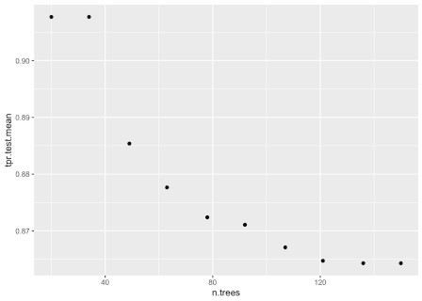

plotHyperParsEffect(data, x = "shrinkage", y = "tpr.test.mean", partial.dep.learn = makeLearner("regr.gbm"))

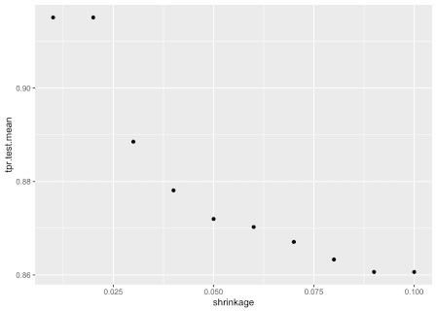

plotHyperParsEffect(data,

x = "n.trees",

y = "shrinkage",

z = "tpr.test.mean", plot.type = "heatmap",

partial.dep.learn = makeLearner("regr.gbm")) +

theme_bw() +

labs(title = "Hyperparameter effects data",

subtitle = "of GBM model with reduced feature set", caption = "Source: Pima Indians Diabetes Database")

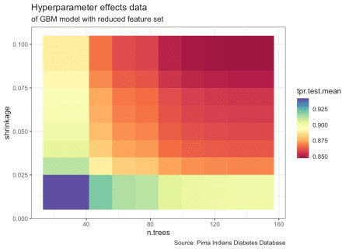

list( `Optimal HyperParameters` = dt_tuneparam$x,

`Optimal Metrics` = dt_tuneparam$y ) ## $`Optimal HyperParameters`

## $`Optimal HyperParameters`$n.trees ## [1] 20

##

## $`Optimal HyperParameters`$shrinkage ## [1] 0.02

## ##

## $`Optimal Metrics`

## tpr.test.mean auc.test.mean fnr.test.mean mmce.test.mean tnr.test.mean

## 1.0000000 0.7878691 0.0000000 0.3713375

0.0000000

## tpr.test.sd

## 0.0000000

gbm_final <- setHyperPars(dt_prob, par.vals = dt_tuneparam$x)

set.seed(1000)

gbm_final_train <- train(learner = gbm_final, task = dt_task) ## Distribution not specified, assuming bernoulli ... getLearnerModel(gbm_final_train)

## gbm::gbm(formula = f, data = d, n.trees = 20L, shrinkage = 0.02, ## keep.data = FALSE)

## A gradient boosted model with bernoulli loss function. ## 20 iterations were performed.

## There were 5 predictors of which 3 had non-zero influence.

# Decision Trees

Recursive Partitioning (rpart & rpart.plot)

library(rpart) library(rpart.plot)

rpart_tree <- rpart(diabetes ~ .,

data = train, method = "class")

rpart.plot(rpart_tree,

roundint=FALSE, type = 3,

clip.right.labs = FALSE)

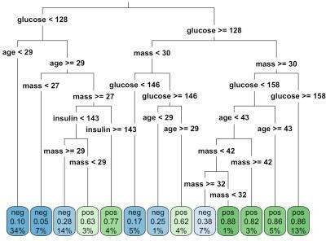

rpart.rules(rpart_tree, roundint = FALSE)

|  |  |  |  |  |  |  |  |  |  |  |  |  |  |  |  |  |  |
| --- | --- | --- | --- | --- | --- | --- | --- | --- | --- | --- | --- | --- | --- | --- | --- | --- | --- |
| ## | diabetes |  | | | | | | | | | | | | | | | |
| ## | 0.05 | when | glucose | < | 128 |  |  | & | mass | < | 27 |  | | & | age | >= | 29 |
| ## | 0.10 | when | glucose | < | 128 |  |  |  |  |  |  |  | | & | age | < | 29 |
| ## | 0.17 | when | glucose | is | 128 | to | 146 | & | mass | < | 30 |  | |  |  |  |  |
| ## | 0.25 | when | glucose | >= |  |  | 146 | & | mass | < | 30 |  | | & | age | < | 29 |
| ## | 0.28 | when | glucose | < | 128 |  |  | & | mass | >= |  | 29 | | & | age | >= | 29 |
| & insulin < | | 143 |  |  |  |  |  |  |  |  |  |  |  |  |  |  |  |
| ## 0.38 | | when | glucose | is | 128 | to | 158 | & | mass | is | 32 | to | 42 | & | age | < | 43 |
| ## 0.62 | | when | glucose | >= |  |  | 146 | & | mass | < | 30 |  |  | & | age | >= | 29 |
| ## 0.63 | | when | glucose | < | 128 |  |  | & | mass | is | 27 | to | 29 | & | age | >= | 29 |
| & insulin < | | 143 |  |  |  |  |  |  |  |  |  |  |  |  |  |  |  |
| ## 0.77 | | when | glucose | < | 128 |  |  | & | mass | >= |  |  | 27 | & | age | >= | 29 |
| & insulin >= | | 143 |  |  |  |  |  |  |  |  |  |  |  |  |  |  |  |
| ## 0.82 | | when | glucose | is | 128 | to | 158 | & | mass | >= |  |  | 42 | & | age | < | 43 |
| ## 0.86 | | when | glucose | is | 128 | to | 158 | & | mass | >= |  |  | 30 | & | age | >= | 43 |
| ## 0.86 | | when | glucose | >= |  |  | 158 | & | mass | >= |  |  | 30 |  |  |  |  |
| ## 0.88 | | when | glucose | is | 128 | to | 158 | & | mass | is | 30 | to | 32 | & | age | < | 43 |

# Prediction

set.seed(1000)

(gbm_final_predict <- predict(gbm_final_train, newdata = test)) ## Prediction: 154 observations

## predict.type: prob

## threshold: neg=0.50,pos=0.50

## time: 0.00

|  |  |  |  |  |
| --- | --- | --- | --- | --- |
| ## | truth | prob.pos | prob.neg | response |
| ## 12 | pos | 0.4807717 | 0.5192283 | neg |
| ## 18 | pos | 0.3229851 | 0.6770149 | neg |
| ## 19 | neg | 0.3229851 | 0.6770149 | neg |
| ## 20 | pos | 0.3300235 | 0.6699765 | neg |
| ## 34 | neg | 0.3091184 | 0.6908816 | neg |
| ## 38 | pos | 0.3229851 | 0.6770149 | neg |

## ... (#rows: 154, #cols: 4) gbm_final_predict %>% calculateROCMeasures() ## predicted

## true neg pos

## neg 114 0 tpr: 1 fnr: 0

## pos 40 0 fpr: 1 tnr: 0

## ppv: 0.74 for: NaN lrp: 1 acc: 0.74 ## fdr: 0.26 npv: NaN lrm: NaN dor: NaN ##

##

## Abbreviations:

## tpr - True positive rate (Sensitivity, Recall) ## fpr - False positive rate (Fall-out)

## fnr - False negative rate (Miss rate) ## tnr - True negative rate (Specificity)

## ppv - Positive predictive value (Precision) ## for - False omission rate

## lrp - Positive likelihood ratio (LR+) ## fdr - False discovery rate

## npv - Negative predictive value ## acc - Accuracy

## lrm - Negative likelihood ratio (LR-) ## dor - Diagnostic odds ratio

model_performance <- performance(gbm_final_predict,

measures = list(tpr, auc, mmce, acc,

tnr)) %>%

as.data.frame(row.names = c("True Positive Rate","Area Under Curve", "Mean Misclassification Error","Accuracy","True Negative Rate"))

model_performance

## .

## True Positive Rate 1.0000000

## Area Under Curve 0.7695175

## Mean Misclassification Error 0.2597403

|  |  |  |
| --- | --- | --- |
| ## | Accuracy | 0.7402597 |
| ## | True Negative Rate | 0.0000000 |

gbm_final_threshold <- generateThreshVsPerfData(gbm_final_predict,

measures = list(tpr,

auc, mmce, tnr)) gbm_final_threshold %>%

plotROCCurves() + geom_point() +

theme_bw() +

labs(title = "ROC curve from predictions",

subtitle = "of GBM model with reduced feature set", caption = "Source: Pima Indians Diabetes Database")

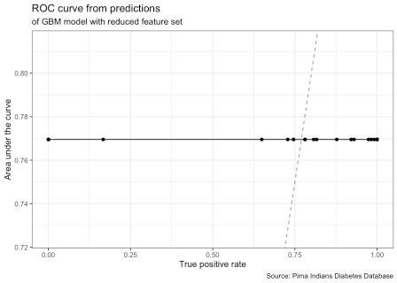

gbm_final_threshold %>% plotThreshVsPerf() + geom_point() +

theme_bw() +

labs(title = "Threshold vs. performance",

subtitle = "for 2-class classification of GBM model with reduced feature set",

caption = "Source: Pima Indians Diabetes Database")

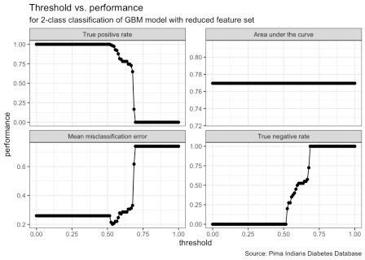

gbm_final_threshold$data %>% head()

|  |  |  |  |  |  |
| --- | --- | --- | --- | --- | --- |
| ## | tpr | auc | mmce | tnr | threshold |
| ## | 1 1 | 0.7695175 | 0.2597403 | 0 | 0.00000000 |
| ## | 2 1 | 0.7695175 | 0.2597403 | 0 | 0.01010101 |
| ## | 3 1 | 0.7695175 | 0.2597403 | 0 | 0.02020202 |

|  |  |  |  |  |  |  |
| --- | --- | --- | --- | --- | --- | --- |
| ## | 4 | 1 | 0.7695175 | 0.2597403 | 0 | 0.03030303 |
| ## | 5 | 1 | 0.7695175 | 0.2597403 | 0 | 0.04040404 |
| ## | 6 | 1 | 0.7695175 | 0.2597403 | 0 | 0.05050505 |

gbm_final_thr <- gbm_final_predict %>% setThreshold(0.59595960)

(dt_performance <- gbm_final_thr %>% performance(measures = list(tpr, auc, mmce, tnr)) )

## tpr auc mmce tnr ## 0.8070175 0.7695175 0.2727273 0.5000000

(dt_cm <- gbm_final_thr %>% calculateROCMeasures() ) ## predicted

## true neg pos

## neg 92 22 tpr: 0.81 fnr: 0.19

## pos 20 20 fpr: 0.5 tnr: 0.5

## ppv: 0.82 for: 0.52 lrp: 1.61 acc: 0.73

## fdr: 0.18 npv: 0.48 lrm: 0.39 dor: 4.18 ##

##

## Abbreviations:

## tpr - True positive rate (Sensitivity, Recall) ## fpr - False positive rate (Fall-out)

## fnr - False negative rate (Miss rate) ## tnr - True negative rate (Specificity)

## ppv - Positive predictive value (Precision) ## for - False omission rate

## lrp - Positive likelihood ratio (LR+) ## fdr - False discovery rate

## npv - Negative predictive value ## acc - Accuracy

## lrm - Negative likelihood ratio (LR-) ## dor - Diagnostic odds ratio

performance_threshold <- performance(gbm_final_thr, measures = list(tpr, auc, mmce, acc, tnr)) %>%

as.data.frame(row.names = c("True Positive Rate", "Area Under Curve",

|  |  |
| --- | --- |
| "Mean Misclassification Error",  performance_threshold | "Accuracy", "True Negative Rate")) |
| ## | . |
| ## True Positive Rate | 0.8070175 |
| ## Area Under Curve | 0.7695175 |
| ## Mean Misclassification Error | 0.2727273 |
| ## Accuracy | 0.7272727 |
| ## True Negative Rate | 0.5000000 |

# Decision Boundaries

#remotes::install_github("grantmcdermott/parttree") library(parsnip)

library(parttree)

set.seed(123) ## For consistent jitter

## Build our tree using parsnip (but with rpart as the model engine) ti_tree =

decision_tree() %>% set_engine("rpart") %>% set_mode("classification") %>%

fit(diabetes ~ glucose + mass, data = PimaIndiansDiabetes)

## Plot the data and model partitions PimaIndiansDiabetes %>%

ggplot(aes(x = glucose, y = mass)) + geom_jitter(aes(col = diabetes), alpha = 0.7) +

geom_parttree(data = ti_tree, aes(fill = diabetes), alpha = 0.1) + theme_bw() +

labs(title = "Decision boundaries",

subtitle = "for 2-class classification of RPART model (glucose

+ mass)",

caption = "Source: Pima Indians Diabetes Database")

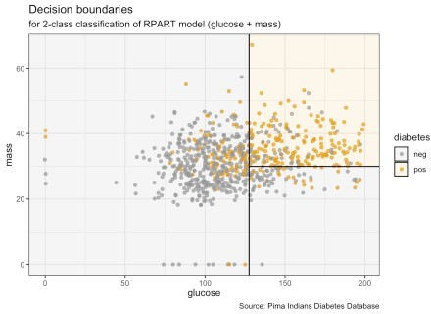

# Time-series

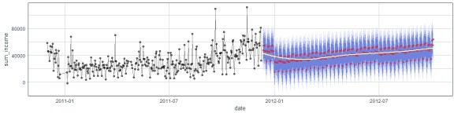

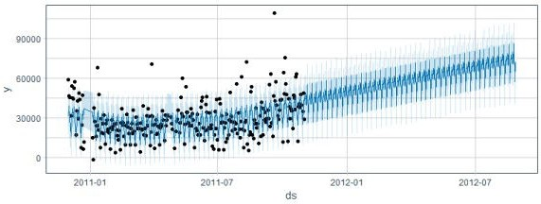

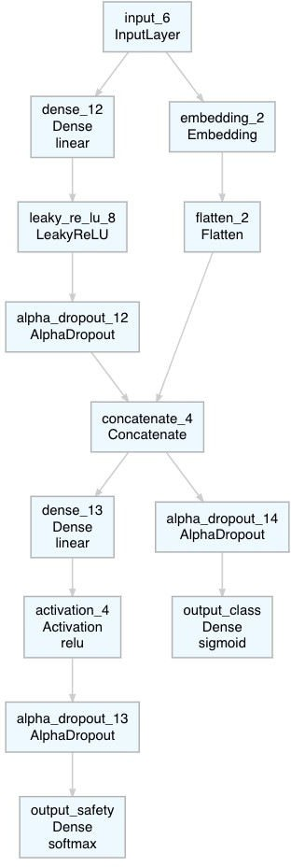

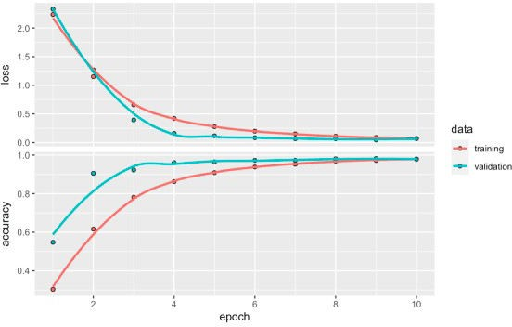

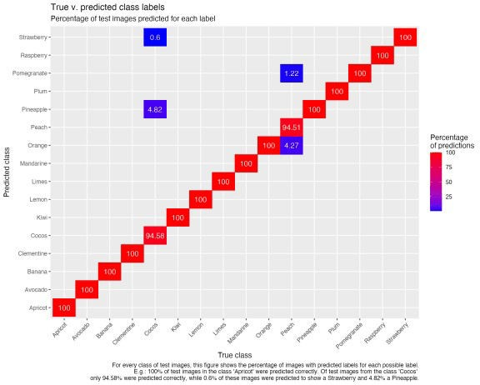

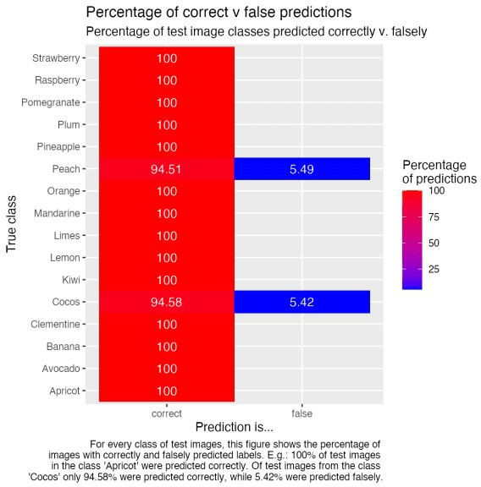

# Explainable AI

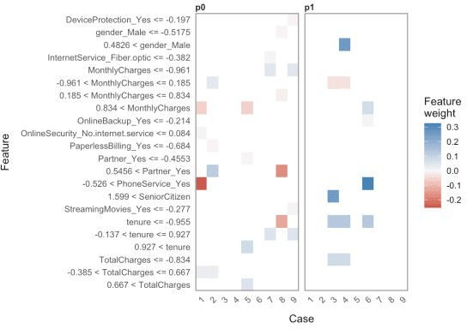

# session info devtools::session_info()

## ─ Session info ──────────────────────────────

───

|  |  |  |
| --- | --- | --- |
| ## | setting | value |
| ## | version | R version 4.0.4 (2021-02-15) |
| ## | os | macOS Big Sur 10.16 |
| ## | system | x86_64, darwin17.0 |
| ## | ui | X11 |
| ## | language | (EN) |
| ## | collate | en_US.UTF-8 |
| ## | ctype | en_US.UTF-8 |
| ## | tz | Europe/Berlin |
| ## | date | 2021-04-27 |
| ## |  |  |

## ─ Packages ──────────────────────────────

───────

|  |  |  |  |  |
| --- | --- | --- | --- | --- |
| ## | package | * version | date | lib |
| ## | assertthat | 0.2.1 | 2019-03-21 | [2] |
| ## | backports | 1.2.1 | 2020-12-09 | [2] |
| ## | BBmisc | 1.11 | 2017-03-10 | [2] |
| ## | blogdown | 1.2 | 2021-03-04 | [2] |
| ## | bookdown | 0.21 | 2020-10-13 | [2] |

|  |  |  |  |  |  |
| --- | --- | --- | --- | --- | --- |
| ## | broom |  | 0.7.5 | 2021-02-19 | [2] |
| ## | bslib |  | 0.2.4 | 2021-01-25 | [2] |
| ## | cachem |  | 1.0.4 | 2021-02-13 | [2] |
| ## | callr |  | 3.5.1 | 2020-10-13 | [2] |
| ## | cellranger |  | 1.1.0 | 2016-07-27 | [2] |
| ## | checkmate |  | 2.0.0 | 2020-02-06 | [2] |
| ## | cli |  | 2.3.1 | 2021-02-23 | [2] |
| ## | colorspace |  | 2.0-0 | 2020-11-11 | [2] |
| ## | crayon |  | 1.4.1 | 2021-02-08 | [2] |
| ## | data.table |  | 1.14.0 | 2021-02-21 | [2] |
| ## | DBI |  | 1.1.1 | 2021-01-15 | [2] |
| ## | dbplyr |  | 2.1.0 | 2021-02-03 | [2] |
| ## | desc |  | 1.3.0 | 2021-03-05 | [2] |
| ## | devtools |  | 2.3.2 | 2020-09-18 | [2] |
| ## | digest |  | 0.6.27 | 2020-10-24 | [2] |
| ## | dplyr | * | 1.0.5 | 2021-03-05 | [2] |
| ## | ellipsis |  | 0.3.1 | 2020-05-15 | [2] |
| ## | entropy |  | 1.2.1 | 2014-11-14 | [1] |
| ## | evaluate |  | 0.14 | 2019-05-28 | [2] |
| ## | fansi |  | 0.4.2 | 2021-01-15 | [2] |
| ## | farver |  | 2.1.0 | 2021-02-28 | [2] |
| ## | fastmap |  | 1.1.0 | 2021-01-25 | [2] |
| ## | fastmatch |  | 1.1-0 | 2017-01-28 | [2] |
| ## | forcats | * | 0.5.1 | 2021-01-27 | [2] |
| ## | fs |  | 1.5.0 | 2020-07-31 | [2] |
| ## | FSelector | * | 0.33 | 2021-02-16 | [1] |
| ## | gbm |  | 2.1.8 | 2020-07-15 | [2] |
| ## | generics |  | 0.1.0 | 2020-10-31 | [2] |
| ## | GGally | * | 2.1.1 | 2021-03-08 | [1] |
| ## | ggfortify | * | 0.4.11 | 2020-10-02 | [2] |
| ## | ggplot2 | * | 3.3.3 | 2020-12-30 | [2] |
| ## | glue |  | 1.4.2 | 2020-08-27 | [2] |
| ## | gridExtra |  | 2.3 | 2017-09-09 | [2] |
| ## | gtable |  | 0.3.0 | 2019-03-25 | [2] |
| ## | haven |  | 2.3.1 | 2020-06-01 | [2] |
| ## | highr |  | 0.8 | 2019-03-20 | [2] |
| ## | hms |  | 1.0.0 | 2021-01-13 | [2] |
| ## | htmltools |  | 0.5.1.1 | 2021-01-22 | [2] |
| ## | httr |  | 1.4.2 | 2020-07-20 | [2] |
| ## | jquerylib |  | 0.1.3 | 2020-12-17 | [2] |
| ## | jsonlite |  | 1.7.2 | 2020-12-09 | [2] |
| ## | knitr |  | 1.31 | 2021-01-27 | [2] |
| ## | labeling |  | 0.4.2 | 2020-10-20 | [2] |
| ## | lattice |  | 0.20-41 | 2020-04-02 | [2] |
| ## | lifecycle |  | 1.0.0 | 2021-02-15 | [2] |
| ## | lubridate |  | 1.7.10 | 2021-02-26 | [2] |
| ## | magrittr |  | 2.0.1 | 2020-11-17 | [2] |
| ## | MASS | * | 7.3-53.1 | 2021-02-12 | [2] |
| ## | Matrix |  | 1.3-2 | 2021-01-06 | [2] |
| ## | memoise |  | 2.0.0 | 2021-01-26 | [2] |
| ## | mlbench | * | 2.1-3 | 2021-01-29 | [1] |
| ## | mlr | * | 2.19.0 | 2021-02-22 | [2] |

|  |  |  |  |  |  |
| --- | --- | --- | --- | --- | --- |
| ## | mmpf | * | 0.0.5 | 2018-10-24 | [2] |
| ## | modelr |  | 0.1.8 | 2020-05-19 | [2] |
| ## | munsell |  | 0.5.0 | 2018-06-12 | [2] |
| ## | parallelMap |  | 1.5.0 | 2020-03-26 | [2] |
| ## | ParamHelpers | * | 1.14 | 2020-03-24 | [2] |
| ## | parsnip | * | 0.1.5 | 2021-01-19 | [2] |
| ## | parttree | * | 0.0.1.9000 | 2021-03-14 | [1] |
| ## | pillar |  | 1.5.1 | 2021-03-05 | [2] |
| ## | pkgbuild |  | 1.2.0 | 2020-12-15 | [2] |
| ## | pkgconfig |  | 2.0.3 | 2019-09-22 | [2] |
| ## | pkgload |  | 1.2.0 | 2021-02-23 | [2] |
| ## | plyr |  | 1.8.6 | 2020-03-03 | [2] |
| ## | prettyunits |  | 1.1.1 | 2020-01-24 | [2] |
| ## | processx |  | 3.4.5 | 2020-11-30 | [2] |
| ## | ps |  | 1.6.0 | 2021-02-28 | [2] |
| ## | purrr | * | 0.3.4 | 2020-04-17 | [2] |
| ## | R6 |  | 2.5.0 | 2020-10-28 | [2] |
| ## | randomForest |  | 4.6-14 | 2018-03-25 | [2] |
| ## | RColorBrewer |  | 1.1-2 | 2014-12-07 | [2] |
| ## | Rcpp |  | 1.0.6 | 2021-01-15 | [2] |
| ## | readr | * | 1.4.0 | 2020-10-05 | [2] |
| ## | readxl |  | 1.3.1 | 2019-03-13 | [1] |
| ## | remotes |  | 2.2.0 | 2020-07-21 | [2] |
| ## | reprex |  | 1.0.0 | 2021-01-27 | [2] |
| ## | reshape |  | 0.8.8 | 2018-10-23 | [1] |
| ## | rJava | * | 0.9-13 | 2020-07-06 | [2] |
| ## | rlang |  | 0.4.10 | 2020-12-30 | [2] |
| ## | rmarkdown |  | 2.7 | 2021-02-19 | [2] |
| ## | rpart | * | 4.1-15 | 2019-04-12 | [2] |
| ## | rpart.plot | * | 3.0.9 | 2020-09-17 | [1] |
| ## | rprojroot |  | 2.0.2 | 2020-11-15 | [2] |
| ## | rstudioapi |  | 0.13 | 2020-11-12 | [2] |
| ## | rvest |  | 1.0.0 | 2021-03-09 | [2] |
| ## | RWeka |  | 0.4-43 | 2020-08-23 | [1] |
| ## | RWekajars |  | 3.9.3-2 | 2019-10-19 | [1] |
| ## | sass |  | 0.3.1 | 2021-01-24 | [2] |
| ## | scagnostics | * | 0.2-4.1 | 2018-04-04 | [1] |
| ## | scales |  | 1.1.1 | 2020-05-11 | [2] |
| ## | sessioninfo |  | 1.1.1 | 2018-11-05 | [2] |
| ## | stringi |  | 1.5.3 | 2020-09-09 | [2] |
| ## | stringr | * | 1.4.0 | 2019-02-10 | [2] |
| ## | survival |  | 3.2-7 | 2020-09-28 | [2] |
| ## | testthat |  | 3.0.2 | 2021-02-14 | [2] |
| ## | tibble | * | 3.1.0 | 2021-02-25 | [2] |
| ## | tidyr | * | 1.1.3 | 2021-03-03 | [2] |
| ## | tidyselect |  | 1.1.0 | 2020-05-11 | [2] |
| ## | tidyverse | * | 1.3.0 | 2019-11-21 | [2] |
| ## | usethis |  | 2.0.1 | 2021-02-10 | [2] |
| ## | utf8 |  | 1.2.1 | 2021-03-12 | [2] |
| ## | vctrs |  | 0.3.6 | 2020-12-17 | [2] |
| ## | withr |  | 2.4.1 | 2021-01-26 | [2] |
| ## | xfun |  | 0.22 | 2021-03-11 | [2] |

|  |  |  |  |  |  |
| --- | --- | --- | --- | --- | --- |
| ## | XML |  | 3.99-0.5 | 2020-07-23 | [2] |
| ## | xml2 |  | 1.3.2 | 2020-04-23 | [2] |
| ## | yaml |  | 2.2.1 | 2020-02-01 | [2] |
| ## | source |  |  | | |
| ## | CRAN (R | 4.0.0) |
| ## | CRAN (R | 4.0.2) |
| ## | CRAN (R | 4.0.2) |
| ## | CRAN (R | 4.0.2) |
| ## | CRAN (R | 4.0.2) |
| ## | CRAN (R | 4.0.4) |
| ## | CRAN (R | 4.0.2) |
| ## | CRAN (R | 4.0.2) |
| ## | CRAN (R | 4.0.2) |
| ## | CRAN (R | 4.0.0) |
| ## | CRAN (R | 4.0.2) |
| ## | CRAN (R | 4.0.4) |
| ## | CRAN (R | 4.0.2) |
| ## | CRAN (R | 4.0.2) |
| ## | CRAN (R | 4.0.4) |
| ## | CRAN (R | 4.0.2) |
| ## | CRAN (R | 4.0.2) |
| ## | CRAN (R | 4.0.2) |
| ## | CRAN (R | 4.0.2) |
| ## | CRAN (R | 4.0.2) |
| ## | CRAN (R | 4.0.2) |
| ## | CRAN (R | 4.0.0) |
| ## | CRAN (R | 4.0.2) |
| ## | CRAN (R | 4.0.1) |
| ## | CRAN (R | 4.0.2) |
| ## | CRAN (R | 4.0.2) |
| ## | CRAN (R | 4.0.2) |
| ## | CRAN (R | 4.0.2) |
| ## | CRAN (R | 4.0.2) |
| ## | CRAN (R | 4.0.2) |
| ## | CRAN (R | 4.0.2) |
| ## | CRAN (R | 4.0.2) |
| ## | CRAN (R | 4.0.2) |
| ## | CRAN (R | 4.0.2) |
| ## | CRAN (R | 4.0.2) |
| ## | CRAN (R | 4.0.2) |
| ## | CRAN (R | 4.0.2) |
| ## | CRAN (R | 4.0.2) |
| ## | CRAN (R | 4.0.0) |
| ## | CRAN (R | 4.0.2) |
| ## | CRAN (R | 4.0.0) |
| ## | CRAN (R | 4.0.2) |
| ## | CRAN (R | 4.0.2) |
| ## | CRAN (R | 4.0.2) |
| ## | CRAN (R | 4.0.2) |
| ## | CRAN (R | 4.0.2) |
| ## | CRAN (R | 4.0.2) |
| ## | CRAN (R | 4.0.2) |

|  |  |  |  |
| --- | --- | --- | --- |
| ## | CRAN | (R | 4.0.2) |
| ## | CRAN | (R | 4.0.2) |
| ## | CRAN | (R | 4.0.2) |
| ## | CRAN | (R | 4.0.2) |
| ## | CRAN | (R | 4.0.4) |
| ## | CRAN | (R | 4.0.2) |
| ## | CRAN | (R | 4.0.2) |
| ## | CRAN | (R | 4.0.4) |
| ## | CRAN | (R | 4.0.2) |
| ## | CRAN | (R | 4.0.2) |
| ## | CRAN | (R | 4.0.0) |
| ## | CRAN | (R | 4.0.2) |
| ## | CRAN | (R | 4.0.2) |
| ## | CRAN | (R | 4.0.2) |

## Github (grantmcdermott/parttree@9d25d2c) ## CRAN (R 4.0.2)

## CRAN (R 4.0.2) ## CRAN (R 4.0.0) ## CRAN (R 4.0.4) ## CRAN (R 4.0.0) ## CRAN (R 4.0.0) ## CRAN (R 4.0.2) ## CRAN (R 4.0.2) ## CRAN (R 4.0.0) ## CRAN (R 4.0.2) ## CRAN (R 4.0.2) ## CRAN (R 4.0.0) ## CRAN (R 4.0.2) ## CRAN (R 4.0.2) ## CRAN (R 4.0.2) ## CRAN (R 4.0.2) ## CRAN (R 4.0.2) ## CRAN (R 4.0.2) ## CRAN (R 4.0.2) ## CRAN (R 4.0.2) ## CRAN (R 4.0.4) ## CRAN (R 4.0.4) ## CRAN (R 4.0.2) ## CRAN (R 4.0.2) ## CRAN (R 4.0.2) ## CRAN (R 4.0.2) ## CRAN (R 4.0.2) ## CRAN (R 4.0.2) ## CRAN (R 4.0.2) ## CRAN (R 4.0.2) ## CRAN (R 4.0.0) ## CRAN (R 4.0.0) ## CRAN (R 4.0.2)

|  |  |  |  |
| --- | --- | --- | --- |
| ## | CRAN | (R | 4.0.2) |
| ## | CRAN | (R | 4.0.0) |
| ## | CRAN | (R | 4.0.0) |
| ## | CRAN | (R | 4.0.2) |
| ## | CRAN | (R | 4.0.4) |
| ## | CRAN | (R | 4.0.2) |
| ## | CRAN | (R | 4.0.2) |
| ## | CRAN | (R | 4.0.2) |
| ## | CRAN | (R | 4.0.2) |
| ## | CRAN | (R | 4.0.0) |
| ## | CRAN | (R | 4.0.0) |
| ## |  |  |  |

## [1] /Users/shiringlander/Library/R/4.0/library

## [2] /Library/Frameworks/R.framework/Versions/4.0/Resources/library