This tutorial focuses on, plot_time_series(), a workhorse time-series plotting function that:

Generates interactive plotly plots (great for exploring & shiny apps) Consolidates 20+ lines of ggplot2 & plotly code

Scales well to many time series

Can be converted from interactive plotly to static ggplot2 plots

Load the following libraries. For the purposes of this tutorial, I’m setting all plots to static ggplot2 using interactive <- FALSE, but I encourage you to switch this to TRUE to see how easy it is to make interactive plotly plots.

library(tidyverse) library(lubridate) library(timetk)

# Setup for the plotly charts (# FALSE returns ggplots) interactive <- FALSE

# Plotting a Single Time Series

Let’s start with a popular time series, taylor_30_min, which includes energy demand in megawatts at a sampling interval of 30-minutes. This is a single time series.

taylor_30_min

## # A tibble: 4,032 x 2

## date value

##

|  |  |  |  |  |
| --- | --- | --- | --- | --- |
| ## | 1 | 2000-06-05 | 00:00:00 | 22262 |
| ## | 2 | 2000-06-05 | 00:30:00 | 21756 |
| ## | 3 | 2000-06-05 | 01:00:00 | 22247 |
| ## | 4 | 2000-06-05 | 01:30:00 | 22759 |
| ## | 5 | 2000-06-05 | 02:00:00 | 22549 |
| ## | 6 | 2000-06-05 | 02:30:00 | 22313 |
| ## | 7 | 2000-06-05 | 03:00:00 | 22128 |
| ## | 8 | 2000-06-05 | 03:30:00 | 21860 |
| ## | 9 | 2000-06-05 | 04:00:00 | 21751 |
| ## | 10 | 2000-06-05 | 04:30:00 | 21336 |

## # … with 4,022 more rows

The plot_time_series() function generates an interactive plotly chart by default.

Simply provide the date variable (time-based column, .date_var) and the numeric variable (.value) that changes over time as the first 2 arguments

When .interactive = TRUE, the .plotly_slider = TRUE adds a date slider to the bottom of the chart.

taylor_30_min %>% plot_time_series(date, value,

.interactive = interactive, # <- Toggle

this TRUE/FALSE

.plotly_slider = TRUE)

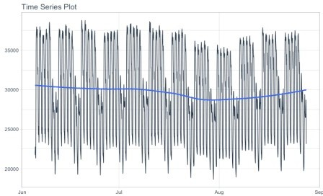

# Plotting Groups

Next, let’s move on to a dataset with time series groups, m4_daily, which is a sample of 4 time series from the M4 competition that are sampled at a daily frequency.

**Visualizing grouped data** is as simple as grouping the data set with group_by() prior to piping into the plot_time_series() function. Key points:

Groups can be added in 2 ways: by group_by() or by using the ... to add groups. Groups are then converted to facets.

.facet_ncol = 2 returns a 2-column faceted plot

.facet_scales = "free" allows the x and y-axis of each plot to scale independently of the other plots

m4_daily %>% group_by(id) %>%

plot_time_series(date, value,

.facet_ncol = 2, .facet_scales = "free",

.interactive = interactive)

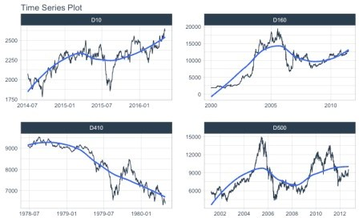

# Visualizing Trend with the Smoother

You may be wondering, what is that ***blue line*** that keeps showing up on all of our plots. It’s called a **smoother**, and it’s a really awesome way to visualize trend through the noise in a time series.

We can adjust the smoother using:

**Toggle on/off:** .smooth = TRUE/FALSE

**Change the flexibility of the line:** Try .smooth_period = "52 weeks" (30-days of data) or .smooth_span = 0.25 (25% of data). By default, .smooth_span gets priority.

Here I’m changing the smooth_span = 0.25 to increase the flexibility by using 25% of the data in the smoother. Not that the time series I’m using is a weekly series, m4_weekly.

m4_weekly %>% group_by(id) %>%

plot_time_series(date, value,

of data

windows of data

# Smoother

.smooth = TRUE,

.smooth_span = 0.25, # <- Uses % # .smooth_period = "52 weeks", # <- Uses

.facet_ncol = 2, .facet_scales = "free",

.interactive = interactive)

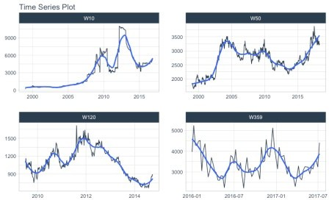

# Visualizing Transformations & Sub-Groups

Let’s switch to an hourly dataset with multiple groups. We can showcase:

1. **Log transformation** to the .value
2. Use of .color_var to highlight **sub-groups.**

The intent is to showcase the groups in faceted plots, but to highlight weekly windows (weekly sub-groups, using week()) within the data while simultaneously doing a log() transformation to the value. This is simple to do:

1. .value = log(value) Applies the Log Transformation
2. The data is ungrouped, so we can add facets internally using the ... to supply one or more facet columns.
3. .color_var = week(date) The date column is transformed to a

lubridate::week() number. The color is applied to each of the week numbers.

m4_hourly %>% group_by(id) %>%

plot_time_series(date, log(value), # Apply a Log Transformation

.color_var = week(date), # Color applied to Week transformation

# Facet formatting

.facet_ncol = 2,

.facet_scales = "free",

.interactive = interactive)

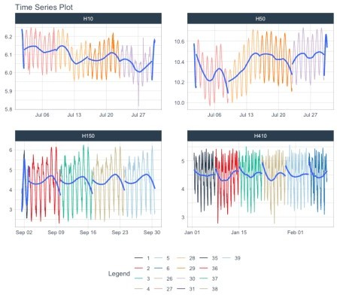

# Static ggplot2 Visualizations & Customizations

All of the visualizations can be converted from interactive plotly (great for exploring and shiny apps) to static ggplot2 visualizations (great for reports).

Toggle Interactive/Static: .interactive = TRUE/FALSE

Add title, legend, x & y-axis labels: .title, .color_lab, .x_lab and .y_lab

taylor_30_min %>% plot_time_series(date, value,

.color_var = month(date, label = TRUE),

.interactive = FALSE, # <- Returns

static ggplot

# Customization

.title = "Taylor's MegaWatt Data",

.x_lab = "Date (30-min intervals)",

.y_lab = "Energy Demand (MW)",

.color_lab = "Month") + scale_y_continuous(labels = scales::comma_format())

