Trail running can be hard. During one, I was wondering if we can avoid the race completely and predict the race time according to distance, elevation change, sex and performance index (so yes, we have to run sometimes to measure it).

We need a dataset to play with. ITRA maintain a quite comprehensive database, but no current dataset is openly available. However we can use the hidden JSON API to scrape a sample

library(itra)

library(tidyverse) library(glue) library(hms) library(lubridate) library(gghighlight) library(progress)

A test:

itra_runners("jornet") #> # A tibble: 5 x 15

|  |  |  |  |  |  |  |  |  |  |  |  |
| --- | --- | --- | --- | --- | --- | --- | --- | --- | --- | --- | --- |
| #>  #> | id_coureur | id | cote | nom | prenom | quartz | team | M | L | XL | XXL |
| #> | 1 2704 | 2.70e3 | 950 | JORN… | Kilian | 20 | "" | 898 | NA | NA | 896 |
| #> | 2 707322 | 7.07e5 | 538 | RENU… | Arturo | 0 | "" | NA | NA | NA | NA |
| #> | 3 2667939 | 2.67e6 | 520 | PARE… | Samuel | 0 | "" | NA | NA | NA | NA |
| #> | 4 2673933 | 2.67e6 | 468 | PÉRE… | Anna | 0 | "" | NA | NA | NA | NA |
| #> | 5 2673935 | 2.67e6 | 468 | RIUS… | Sergi | 0 | "" | NA | NA | NA | NA |

#> # … with 4 more variables: S , XS , XXS , palmares

It works…

So, we’re going to build a daframe of single letters and random page index to create our dataset of runners. I’ll manually add some low index to oversample the elite athletes otherwise we will probably miss them entirely.

# helpers

# compute the mode (to find the runner sex from its details ; see below) stat_mode <- function(x, na.rm = FALSE) {

if(na.rm) {

x <- x[!is.na(x)]

}

ux <- unique(x) ux[which.max(tabulate(match(x, ux)))]

}

# sample

# progress bar versions of ITRA functions (scraping will be slow, we want to know if it works)

pb_itra_runners <- function(...) { pb$tick()

itra_runners(...)

}

pb_itra_runner_results <- function(...) { pb$tick()

itra_runner_results(...)

}

pb_itra_runner_details <- function(...) { pb$tick()

itra_runner_details(...)

}

# dataset generation from a "random" set of index #

oversample_high_score <- c(0, 50, 100, 250, 500) my_sample <- tibble(l = letters

n = c(oversample_high_score, sample(0:100000,

length(letters) - length(oversample_high_score))))

%>%

expand(l, n) %>% distinct(l, n)

We have 676 tuples of (letter, index). We can now start querying the website, we should get 5 runners for each tuple. But we will have some duplicates because for example at index 0 we will get « Kilian Jornet » for

« k », « i », « l »…

I use purr::map2 to iterate along our sample, using slowly to avoid overloading the website and

possibly to get NA instead of stopping errors.

You’ll see that the JSON variables have french or english names!

# querying runners --------

pb <- progress_bar$new(format = "[:bar] :current/:total remaining: :eta", total = nrow(echant))

my_dataset <- my_sample %>%

mutate(runners = map2(l, n, possibly(slowly(pb_itra_runners, rate_delay(.5)), NA)))

# runners list

runners <- my_dataset %>% drop_na(runners) %>% unnest(runners) %>%

distinct(id_coureur, .keep_all = TRUE) %>% select(-l, -n)

Here instead of 3380 runners I get only 2796…

Then we can query for their race results and their sex.

# runners results

pb <- progress_bar$new(format = "[:bar] :current/:total remaining: :eta", total = nrow(runners))

results <- runners %>%

select(id, first_name = prenom, last_name = nom) %>% mutate(resultats = pmap(., possibly(slowly(pb_itra_runner_results,

rate_delay(.5)), NA))) %>% unnest(results)

# performance index by trail category and sex

pb <- progress_bar$new(format = "[:bar] :current/:total remaining: :eta", total = nrow(runners))

runners_details <- runners %>% select(id) %>%

mutate(details = map(id, possibly(slowly(pb_itra_runner_details, rate_delay(.5)), NA))) %>%

unnest(details)

Some preprocessing is necessary. Sex is not a direct property of the runners, we must get it from runners_details. We then join our 3 dataframes and compute some new variables.

Levels come from:

# preprocessing ----

runners_sex <- runners_details %>% group_by(id) %>%

summarise(sex = stat_mode(sexe, na.rm = TRUE))

results_clean <- results %>% rename(cote_course = cote) %>%

left_join(select(runners, -nom, -prenom), by = "id") %>% left_join(runners_sex, by = "id") %>%

mutate(dist_tot = as.numeric(dist_tot), dt = ymd(dt),

time = lubridate::hms(temps), hours = as.numeric(time, "hours"), kme = dist_tot + deniv_tot / 100, level = factor(

case_when(

|  |  |  |  |  |  |  |  |  |  |  |  |  |  |  |  |  |
| --- | --- | --- | --- | --- | --- | --- | --- | --- | --- | --- | --- | --- | --- | --- | --- | --- |
|  | (cote | > | 825 | & | sex | == | "H") | | | (cote | > | 700 | & | sex | == | "F") | ~ |
| "elite", |  |  |  |  |  |  |  |  |  |  |  |  |  |  |  |  |
|  | (cote | > | 750 | & | sex | == | "H") | | | (cote | > | 625 | & | sex | == | "F") | ~ |
| "expert", |  |  |  |  |  |  |  |  |  |  |  |  |  |  |  |  |
|  | (cote | > | 650 | & | sex | == | "H") | | | (cote | > | 550 | & | sex | == | "F") | ~ |
| "advanced", |  |  |  |  |  |  |  |  |  |  |  |  |  |  |  |  |
|  | (cote | > | 500 | & | sex | == | "H") | | | (cote | > | 475 | & | sex | == | "F") | ~ |
| "strong", |  |  |  |  |  |  |  |  |  |  |  |  |  |  |  |  |
|  | (cote | > | 350 | & | sex | == | "H") | | | (cote | > | 350 | & | sex | == | "F") | ~ |
| "intermediate", |  |  |  |  |  |  |  |  |  |  |  |  |  |  |  |  |

is.na(sex) ~ NA_character_, TRUE ~ "novice"),

levels = c("novice", "intermediate", "strong", "advanced", "expert", "elite")))

Now some exploratory analysis :

# analysis

# runners' ITRA performance index runners %>%

left_join(runners_sex) %>% ggplot(aes(cote, fill = sex)) +

geom_histogram(binwidth = 10)

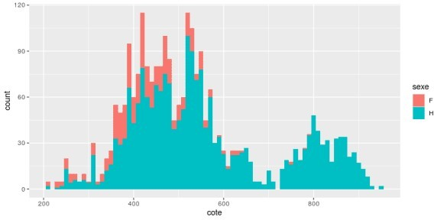

Most athletes have an ITRA score between 300 and 700. We can also see the results of our oversampling with many athletes added above 700

# distance ran results_clean %>%

ggplot(aes(dist_tot)) + geom_histogram(binwidth = 2)

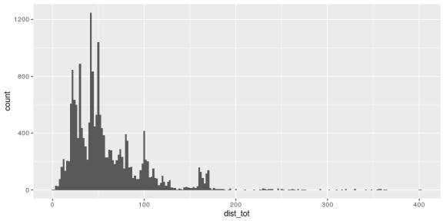

We can see the common distances at 25, 50, 100 km and 160 km (100 miles)

# times ran results_clean %>%

ggplot(aes(hours)) + geom_histogram(binwidth = 1 / 6)

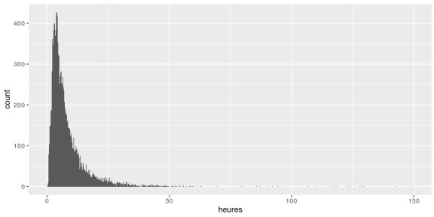

Most athletes run about 4 hours

# by level results_clean %>%

drop_na(level) %>% filter(hours != 0) %>%

ggplot(aes(kme, hours, color = level)) + geom_point(alpha = .3) + gghighlight() +

coord_cartesian(xlim = c(0, 320), ylim = c(0, 65)) + facet_wrap(~ level)

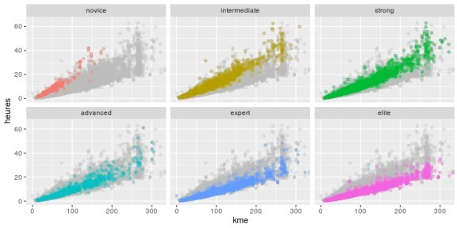

Novices are slow and don’t run long races. Elites are fast from short races to ultra-trail

Now, back to my initial question. Can I just predict my race time and avoid a long pain by not running?

I will use a random forest. Since the rows are not independent (we have several results per runner), I use a group kfold on the runner id.

library(caret) library(ranger)

results_rf <- results_clean %>% drop_na(hours, cote)

# grouped CV folds group_fit_control <- trainControl(

index = groupKFold(resultats_rf$id, k = 10), method = "cv")

rf_fit <- train(houres ~ dist_tot + deniv_tot + deniv_neg_tot + cote + sex,

data = results_rf, method = "rf",

trControl = group_fit_control)

rf_fit Random Forest

18339 samples

5 predictors

No pre-processing

Resampling: Cross-Validated (10 fold)

Summary of sample sizes: 16649, 16704, 16338, 16524, 16407, 16223, ... Resampling results across tuning parameters:

|  |  |  |  |  |
| --- | --- | --- | --- | --- |
| mtry | splitrule | RMSE | Rsquared | MAE |
| 2 | variance | 1.822388 | 0.9472348 | 0.8747978 |
| 2 | extratrees | 1.844228 | 0.9463288 | 0.8810525 |
| 3 | variance | 1.827556 | 0.9469227 | 0.8801065 |
| 3 | extratrees | 1.847274 | 0.9459055 | 0.8800262 |
| 5 | variance | 1.873645 | 0.9440697 | 0.9021319 |
| 5 | extratrees | 1.853316 | 0.9455854 | 0.8882530 |

Tuning parameter 'min.node.size' was held constant at a value of 5 RMSE was used to select the optimal model using the smallest value.

The final values used for the model were mtry = 2, splitrule = variance and min.node.size = 5.

So with a root mean square error of 1.82 hours, I can’t say that my model is super precise ; I’ll leave the tuning to the specialists.

However in my case, my last 16 km (01:40:00) is pretty well predicted!

predict(rf_fit, newdata = tibble(dist_tot = 16, 600,

600,

magrittr::multiply_by(3600) %>% floor() %>%

seconds_to_period() %>% hms::hms()

# 01:37:42

So next time I’ll just run the model instead of running the race.

deniv_tot =

deniv_neg_tot =

cote = 518, sex = "H")) %>%