# Sample Engagement

I’ll start with the caveat: as for now (afaik), the Twitter API does not provide information about who likes a tweet (which may be where most of the gloating happens). However, it does support retweeters, so we can see what accounts retweeted Trump’s covid tweet.

There are several packages to pull info from Twitter, yet my favorite one by far is rtweet

(Kearney, 2020).

Once you set your API tokens, getting retweeters is a piece of cake:

retweeters <- rtweet::get_retweeters(status_id = "1311892190680014849")

This function is limited to 100 users for a given status, so I wrapped it in a loop until it returned a couple of thousands of retweeters. This will be our sample for ideological estimation. We can then look them up to get their screen name and all the info we need further down the road.

users <- rtweet::lookup_users(retweeters$user_id)

# Ideological Estimation

How does one estimate ideology on Twitter? There are several ways, however, the most popular one I know of (perhaps due to my own psych bias) is the Barberá method (Barberá et al., 2015). I won’t get much into the technical stuff, but in broad terms, it uses your Twitter network.

There are accounts of individuals (e.g., politicians, public figures) and institutions (e.g., newspapers) that we pretty much know their political orientation. Given a certain user follows some of these high profile accounts, the algorithm can infer the user’s political orientation (interesting, right? read the paper!). This means that for every user in our sample of Trump retweeters, we need to get their entire (or actually max 5000) network of people they follow (aka “friends” in the Twitter API jargon) to estimate their ideology.

I don’t think Twitter particularly likes that because it allows for 15 network calls every 15 minutes, which really backlogs the estimation process.

library(tweetscores)

#pre allocate ideology vector users$ideology <- NA

#loop

for (i in 1:dim(users)[1]) {

user <- users$screen_name[i] #assign screen name to 'user' if (!is.na(user)){

friends <- getFriends(screen_name=user, oauth="~my_oauth") #sometimes the loop breaks because there are no known friends, #this is why I wrapped it in a tryCatch

tryCatch({

users_name$ideology[i] <- estimateIdeology2(user, friends)

}, error=function(e){})

}

}

# Plot it like it’s hot

It looks like we got 753 accounts with known ideology. Not bad! What is their ideological distribution?

I wanted to make a density plot and fill it with ranging colors from blue to red.

:

library(tidyverse)

1. <- na.omit(users$ideology)
2. <- density(na.omit(x), n = 2^12)

ggplot(data.frame(x = y$x, y = y$y), aes(x, y)) + geom_line() + geom_segment(aes(xend = x, yend = 0, color = x)) + scale_color_gradient(low = 'dodgerblue2', high = 'firebrick2') + labs(x = "Ideology Estimate", y = "Density") + cowplot::theme_cowplot() + guides(color=FALSE)

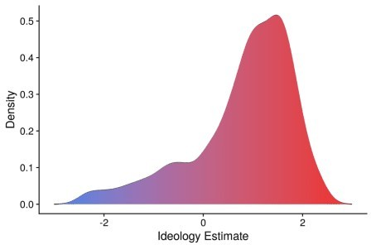

I  pretty plots.

The X-axis corresponds to ideology, wherein negative values stand for liberal views and positive values for conservative views. The Y-axis corresponds to the probability density function.