I just learned that in sheep, lambs from the same litter pretty often have different fathers, if the ewe has mated with different males. Berry et al. (2020) looked at sheep flocks on Irland that used more than one ram, and:

Of the 539 pairs of twins included in the analysis, 160 (i.e. 30%) were sired by two different rams. Of the 137 sets of triplets included in the analysis, 73 (i.e. 53%) were sired by more than one ram. Of the nine sets of quadruplets, eight were sired by two rams with the remaining litter being mono-paternal. The overall incidence of heteropaternal superfecundation among litters was therefore 35%. Given that the incidence of multiple births in these flocks was 65%, heteropaternal superfecundation is expected to be relatively common in sheep; this is especially true as all but two of the litter-mates were polyzygotic.

# Time for some Mendelian inheritance

Let’s simulate a situation like this: We set up a population and a marker panel for genotyping, split them into ewes and rams, and make some lambs.

library(AlphaSimR)

founderpop <- runMacs(nInd = 105,

nChr = 10,

segSites = 100)

simparam <- SimParam$new(founderpop) simparam$setGender("no")

simparam$addSnpChip(nSnpPerChr = 100) parents <- newPop(founderpop,

simParam = simparam)

ewes <- parents[1:100] rams <- parents[101:105]

lambs <- randCross2(females = ewes,

males = rams, nCrosses = 100,

nProgeny = 2, simParam = simparam)

Now, if we have the genotypes of a lamb and its mother, how do we know the father? In this paper, they use exclusion methods: They compared the genotypes from the offspring with the parents and used inheritance rules to exclude rams that can't be the father because if they were, the offspring couldn't have the genotypes it had. Such breaking of regular inheritance patterns would be a "Mendelian inconsistency". This is the simplest kind of parentage assignment; fancier methods will calculate the probabilities of different genotypes, and allow you to reconstruct unknown relationships.

We can do this in two ways:

ignore the ewe’s genotypes and look for opposite homozygotes between lamb and ram, which are impossible regardless of the mother’s genotype

use both the ewe’s and ram’s genotypes to look what lamb genotypes are possible from a cross

between them; this adds a few more cases where we can exclude a ram even if the lamb is heterozygous

To do the first, we count the number of opposite homozygous markers. In this genotype coding, 0 and 2 are homozygotes, and 1 is a heterozygous marker.

opposite_homozygotes <- function(ram,

lamb) {

sum(lamb == 0 & ram == 2) + sum(lamb == 2 & ram == 0)

}

When we include the ewe's genotype, there are a few more possible cases. We could enumerate all of them, but here is some R code to generate them. We first get all possible gametes from each parent, we combine the gametes in all possible combinations, and that gives us the possible lamb genotypes at that marker. If the lamb does, in fact, not have any of those genotypes, we declare the marker inconsistent. Repeat for all markers.

## Generate the possible gametes from a genotype possible_gametes <- function(genotype) {

if (genotype == 0) { gametes <- 0

} else if (genotype == 1) { gametes <- c(0, 1)

} else if (genotype == 2) { gametes <- 1

}

gametes

}

## Generate the possible genotypes for an offspring from ## parent possible gametes

possible_genotypes <- function(father_gametes,

mother_gametes) {

possible_combinations <- expand.grid(father_gametes, mother_gametes) resulting_genotypes <- rowSums(possible_combinations) unique(resulting_genotypes)

}

## Check offspring genotypes for consistency with parent genotypes

mendelian_inconsistency <- function(ewe

ram, lamb) {

n_markers <- length(ewe) inconsistent <- logical(n_markers)

for (marker_ix in 1:n_markers) { possible_lamb_genotypes <-

possible_genotypes(possible_gametes(ewe[marker_ix]),

possible_gametes(ram[marker_ix]))

inconsistent[marker_ix] <-

!lamb[marker_ix] %in% possible_lamb_genotypes

}

sum(inconsistent)

}

Here is the outcome for a set of random lambs. The red dots point out the true fathers: because we have perfect genotype data simulated without errors, the true father always has 100% consistent markers.

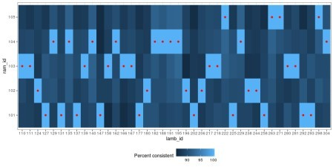

If we compare how many markers are found inconsistent with the two methods, we get a pattern like this graph. Including the ewe’s genotypes lets us discover a lot more inconsistent markers, but in this case, with plentiful and error-free markers, it doesn’t make a difference.

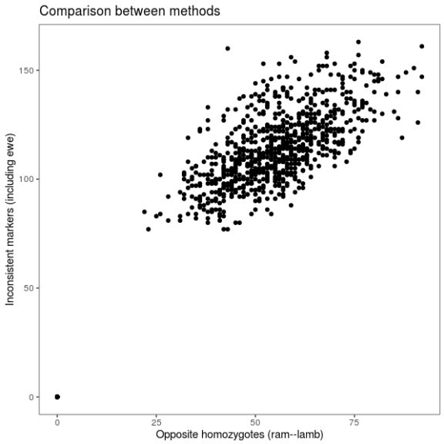

# Thresholds and errors

If I have any complaint with the paper, it’s that the parentage analysis isn’t really described in the methods. This is what it says:

Parentage testing using simple exclusion-based approaches is determined by the proportion of opposing homozygotes in putative sire–offspring pairs.

/…/

Maternal verification was undertaken using the exclusion method (Double et al . 1997) comparing the genotype of the dam with that of her putative progeny and only validated dam– offspring pairs were retained. Genotypes of the mature rams in the flock were compared with all lambs born in that flock using the exclusion method.

(The reference is related to exclusion methods, but it’s describing how to calculate exclusion probabilities in a certain circumstance. That is, it’s part of a methodological conversation about exclusion methods, but doesn’t actually describe what they did.)

I don’t doubt that they did it well. Still, it would be interesting to know the details, because in the absence of perfect genotype data, they must have had some thresholds for error and some criterion for deciding which ram was right, even if it seemed obvious.

The Full Code in R Language

|  |
| --- |
|  |
| library(AlphaSimR) |
|  | library(dplyr) |
|  | library(ggplot2) |
|  |  |
|  |  |
|  | founderpop <- runMacs(nInd = 105, |
|  | nChr = 10, |
|  | segSites = 100) |
|  |  |
|  | simparam <- SimParam$new(founderpop) |
|  | simparam$setGender("no") |
|  |  |
|  | simparam$addSnpChip(nSnpPerChr = 100) |
|  |  |
|  | parents <- newPop(founderpop, |
|  | simParam = simparam) |
|  |  |
|  | ewes <- parents[1:100] |
|  | rams <- parents[101:105] |
|  |  |
|  | lambs <- randCross2(females = ewes, |
|  | males = rams, |
|  | nCrosses = 100, |
|  | nProgeny = 2, |
|  | simParam = simparam) |
|  |  |
|  |  |
|  |  |
|  | ## Generate the possible gametes from a genotype |
|  |  |
|  | possible_gametes <- function(genotype) { |
|  |  |
|  | if (genotype == 0) { |
|  | gametes <- 0 |
|  | } else if (genotype == 1) { |
|  | gametes <- c(0, 1) |
|  | } else if (genotype == 2) { |
|  | gametes <- 1 |
|  | } |
|  |  |
|  | gametes |
|  | } |
|  |  |
|  | ## Generate the possible genotypes for an offspring from parent possible gametes |
|  |  |
|  | possible_genotypes <- function(father_gametes, |
|  | mother_gametes) { |
|  |  |
|  | possible_combinations <- expand.grid(father_gametes, mother_gametes) |
|  | resulting_genotypes <- rowSums(possible_combinations) |
|  | unique(resulting_genotypes) |
|  | } |
|  |  |
|  |  |
|  | ## Check offspring genotypes for consistency with parent gentotypes |
|  |  |
|  | mendelian_inconsistency <- function(ewe, |
|  | ram, |
|  | lamb) { |
|  |  |
|  | n_markers <- length(ewe) |
|  | inconsistent <- logical(n_markers) |
|  |  |
|  | for (marker_ix in 1:n_markers) { |
|  |  |
|  | possible_lamb_genotypes <- |
|  | possible_genotypes(possible_gametes(ewe[marker_ix]), |
|  | possible_gametes(ram[marker_ix])) |
|  |  |
|  | inconsistent[marker_ix] <- |
|  | !lamb[marker_ix] %in% possible_lamb_genotypes |
|  | } |
|  |  |
|  | sum(inconsistent) |
|  | } |
|  |  |
|  | opposite_homozygotes <- function(ram, |
|  | lamb) { |
|  | sum(lamb == 0 & ram == 2) + |
|  | sum(lamb == 2 & ram == 0) |
|  |  |
|  | } |
|  |  |
|  |  |
|  | ## Now, we go through all the lambs, we take the mother as given, |
|  | ## and check their consistency with all the potential rams |
|  |  |
|  | check_lambs <- function(ewes, |
|  | rams, |
|  | lambs) { |
|  |  |
|  | rams_geno <- pullSnpGeno(rams, |
|  | simParam = simparam) |
|  |  |
|  | ewes_geno <- pullSnpGeno(ewes, |
|  | simParam = simparam) |
|  |  |
|  | lambs_geno <- pullSnpGeno(lambs, |
|  | simParam = simparam) |
|  |  |
|  |  |
|  | inconsistent_with_rams <- vector(length = lambs@nInd, |
|  | mode = "list") |
|  |  |
|  | for (lamb_ix in 1:lambs@nInd) { |
|  |  |
|  | lamb_geno <- lambs_geno[lamb_ix,] |
|  | ewe_geno <- ewes_geno[which(ewes@id == lambs@mother[lamb_ix]),] |
|  |  |
|  | inconsistent_with_rams[[lamb_ix]] <- |
|  | data.frame(lamb_id = lambs@id[lamb_ix], |
|  | ram_id = numeric(rams@nInd), |
|  | inconsistent_markers = numeric(rams@nInd), |
|  | opposite_homozygotes = numeric(rams@nInd)) |
|  |  |
|  | for (ram_ix in 1:rams@nInd) { |
|  | ram_geno <- rams_geno[ram_ix,] |
|  | inconsistent_with_rams[[lamb_ix]]$inconsistent_markers[ram_ix] <- |
|  | mendelian_inconsistency(ewe_geno, |
|  | ram_geno, |
|  | lamb_geno) |
|  | inconsistent_with_rams[[lamb_ix]]$opposite_homozygotes[ram_ix] <- |
|  | opposite_homozygotes(ram_geno, |
|  | lamb_geno) |
|  | inconsistent_with_rams[[lamb_ix]]$ram_id[ram_ix] <- rams@id[ram_ix] |
|  | } |
|  | } |
|  |  |
|  | Reduce(rbind, inconsistent_with_rams) |
|  | } |
|  |  |
|  |  |
|  | lambs_inconsistency <- check_lambs(ewes, rams, lambs) |
|  |  |
|  |  |
|  |  |
|  | ## Plot of consistency |
|  |  |
|  | random_lambs <- sample(lambs@id, 40) |
|  |  |
|  | true_father <- data.frame(lamb_id = lambs@id, |
|  | ram_id = lambs@father) |
|  |  |
|  | plot_tile <- ggplot() + |
|  | geom_tile(aes(x = lamb_id, |
|  | y = ram_id, |
|  | fill = (1000 - inconsistent_markers)/10), |
|  | data = filter(lambs_inconsistency, lamb_id %in% random_lambs)) + |
|  | geom_point(aes(x = lamb_id, |
|  | y = ram_id), |
|  | colour = "red", |
|  | data = filter(true_father, lamb_id %in% random_lambs)) + |
|  | theme_bw() + |
|  | scale_fill_gradient(name = "Percent consistent") + |
|  | theme(legend.position = "bottom") |
|  |  |
|  |  |
|  | plot_methods <- qplot(x = opposite_homozygotes, |
|  | y = inconsistnt_markers, |
|  | data = lambs_inconsistency) + |
|  | theme_bw() + |
|  | theme(panel.grid = element_blank()) + |
|  | ggtitle("Comparison between methods") + |
|  | xlab("Opposite homozygotes (ram--lamb)") + |
|  | ylab("Inconsistent markers (including ewe)") |
|  |  |