My challenge was that in Connecticut counties aren’t really an especially useful geographic entity (no offense to any county officials). It’s just not

how many of us think of the state and apart from that many decisions for things

like school openings, and voting are based at the town level. In our quaint New England way (and

I should confess I was born elsewhere) we think about about things at a level called “town” (notwithstanding the cliche “quaint New England village”). That’s where the title comes from – a play on “it takes a village”.

This post chronicles the journey of taking Nathan’s great work and modifying it to fit Connecticut as well as making a few other tweaks that I think help

the overall presentation.

I know **tl;dr** get to the code Chuck that’s why we’re here.

# Setup and libraries

I won’t apologize but yes there are a lot of libraries invloved and yes I am going to suppress all the various start-up messages.

#######

library(dplyr) library(tidyr) library(forcats) library(purrr)

library(lubridate) # Date wrangling library(ggplot2) theme_set(theme_bw()) library(scales) # Pretty axis labels library(tigris) options(tigris_use_cache = TRUE) library(gganimate) # GIF production

library(tidycensus) # Population estimates library(transformr) # used by gganimate library(ggthemes) # map themes library(viridis) # Heatmap color palette library(zoo) # rollapply

# Initial data and wrangling

Because I may choose to do some further analyses I’m going to grab the data from Connecticut Open Data which has a wealth of

information about the state, including a daily set of information about Covid19 which is located at

https://data.ct.gov/Health-and-Human-Services/COVID-19-Tests-Cases-and-Deaths-By- Town-/28fr-iqnx.

The Connecticut COVID data starts on March 24th which is of course not

when this all started but will work for our purposes.

To make my life easier I’ve saved the file locally and renamed it to include a date stamp.

As noted by comments in the code the first step is to convert Last.update.date

to a true date format and convert Town into a factor. Once that’s

done it’s easy to plot the obvious charts – raw cumulative cases for the state over time as well as the same information by Town for all 169 towns.

Applying scales::breaks_pretty to our date axis makes easy work of how granular we want the axis to be (monthly for now).

##### Get the data here

## https://data.ct.gov/Health-and-Human-Services/COVID-19-Tests-Cases-and-Deaths-By-

Town-/28fr-iqnx

## change name to COVID19_CT_By_Town_Oct15.csv

ct_covid <- read.csv("COVID19_CT_By_Town_Oct16.csv") ## Convert to date and factor

ct_covid <- ct_covid %>%

mutate(Last.update.date = lubridate::as_date(Last.update.date,

format = "%m/%d/%y"))

%>%

mutate(Town = factor(Town))

# raw cases over time ct_covid %>%

group_by(Last.update.date) %>% summarise(cases = sum(Total.cases)) %>%

ggplot(aes(x = Last.update.date, y = cases, group = 1)) + geom_line() +

scale_x_date(breaks = scales::breaks_pretty(n = 10)) + scale_y_continuous(labels = scales::label_number(big.mark = ",")) + labs(

title = "COVID-19 cases in Connecticut", x = "Month",

y = "Cases",

caption = paste0("Image generated: ",

Sys.time(), "\n",

"Data source: https://data.ct.gov/Health-and-Human- Services/COVID-19-Tests-Cases-and-Deaths-By-Town-/28fr-iqnx")

)

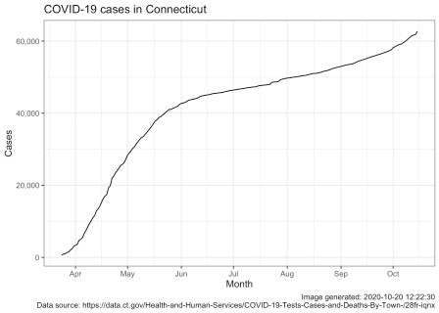

# raw cases by town over time ct_covid %>%

group_by(Town, Last.update.date) %>%

ggplot(aes(x = Last.update.date, y = Total.cases, group = Town, color = Town)) +

geom_line(show.legend = FALSE) +

scale_x_date(breaks = scales::breaks_pretty(n = 10)) + scale_y_continuous(labels = scales::label_number(big.mark = ",")) + labs(

title = "COVID-19 cases in Connecticut by town", x = "Month",

y = "Cases",

caption = paste0("Image generated: ",

Sys.time(), "\n",

"Data source: https://data.ct.gov/Health-and-Human- Services/COVID-19-Tests-Cases-and-Deaths-By-Town-/28fr-iqnx")

)

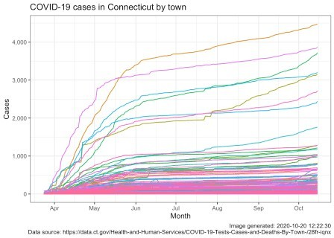

# Onward and upward

That was easy, but pretty uninformative. I guess there’s solace in knowing that our 60,000+ cases are but a fraction of the US 8 million but it doesn’t tell us much about the trend other than seeing the “bend” starting in June and what appears to be an increasing trend starting in September. The by town plot is rendered rather useless by having 169 lines and the fact that towns have very disparate populations. That’s why many many towns are clustered under 500, they don’t have large populations to begin with

We need to address both of these issues in our final product.

To address the issue of different population levels by town we’ll grab the 2010 Census data on a by town basis. CT data provides those numbers as well

but by using tidycensus we’ll get information about town by county as well as the all important GEOID which will enable us to put the data about population on a map.

tidycensus::get_decennial gets us the raw data we need (I checked and the population numbers match those the state provides – no surprise). The second step uses some tidyverse magic to clean and filter the data. The grepl removes some rows that acknowledge the county boundaries but have zero population. The census data has Town, County and State in one column we use tidyr::separate to break them apart. States vary but for CT the towns are known as **“county subdivision”** in census parlance

and variables = "P001001" gets us the total population for the town in 2010 according to the census.

ct_town_pops <-

tidycensus::get_decennial(geography = "county subdivision",

variables = "P001001", state = "Connecticut")

ct_town_pops <- ct_town_pops %>%

filter(!grepl("not defined", NAME)) %>% rename(population = value, name_cty_st = NAME) %>% select (-variable) %>%

tidyr::separate(col = name_cty_st,

into = c("Town", "County", "State"), sep = ",") %>%

mutate(Town = gsub(" town$", "\\1", Town),

County = trimws(County, which = "both")) %>% select(-State)

ct_town_pops

## # A tibble: 169 x 4

|  |  |  |  |  |  |  |
| --- | --- | --- | --- | --- | --- | --- |
| ##  ## |  | GEOID | Town | County |  | population |
| ## | 1 | 0900118500 | Danbury | Fairfield | County | 80893 |
| ## | 2 | 0900104720 | Bethel | Fairfield | County | 18584 |
| ## | 3 | 0900108070 | Bridgeport | Fairfield | County | 144229 |
| ## | 4 | 0900108980 | Brookfield | Fairfield | County | 16452 |
| ## | 5 | 0900118850 | Darien | Fairfield | County | 20732 |

|  |  |  |  |  |  |  |
| --- | --- | --- | --- | --- | --- | --- |
| ## | 6 | 0900123890 | Easton | Fairfield | County | 7490 |
| ## | 7 | 0900126620 | Fairfield | Fairfield | County | 59404 |
| ## | 8 | 0900133620 | Greenwich | Fairfield | County | 61171 |
| ## | 9 | 0900148620 | Monroe | Fairfield | County | 19479 |
| ## | 10 | 0900150580 | New Canaan | Fairfield | County | 19738 |

## # … with 159 more rows range(ct_town_pops$population) ## [1] 854 144229

Finally we use good

old range to show the smallest town population is 854 and the largest is

1.4422910^{5}.

Next we use tigris::county_subdivisions to get the geographic information about the shape of each town so we can map it. The package accesses the geographic shapefiles the

census bureau provides.

Once again grepl

helps us remove rows we don’t want. A call to base plot confirms we’re on track. A right_join allows us to marry the town shapes with the town populations into one object called ct_town_data.

ct_town_shapes <-

tigris::county_subdivisions(state = "Connecticut",

county = NULL, cb = FALSE)

ct_town_shapes <- ct_town_shapes %>%

filter(!grepl("not defined", NAME)) # ct_town_shapes

plot(ct_town_shapes$geometry)

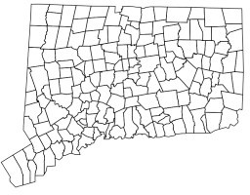

ct_town_data <- right_join(ct_town_pops, ct_town_shapes)

# Let’s roll

The plot looks good even with no special directives and renders both the shoreline and “the notch” well.

We now have two important objects ct_covid and ct_town_data, we still need to move from cumulative cases to rolling averages over time while adjusting for population size by making it **per capita**. For those of you that just live for long dplyr pipelines that do major transformations of the data here we go.

We will

1. Group by town (so we do all the math by Town)
2. Put yesterdays total case count into prev_count with a lag
3. Therefore the increase in cases from day to day is Total.cases - prev_count

which we’ll call new_cases

1. Use zoo::rollapply to compute the mean (average) new cases over the last 7 days all call it roll_cases.
2. After we ungroup we can join the population data to the case count data with a left_join.
3. Now that evey row of our tibble has Total.cases, new_cases, and

roll_cases we can create a column for each of those *“per capita”*

The most common per capita method used in public health is per 100,000 residents so the math is cases divided by population * 100,000 and voila. A tail

gives you a glimpse of what selected columns look like.

roll_ct_covid <- ct_covid %>% arrange(Last.update.date) %>% group_by(Town) %>%

mutate(prev_count = lag(Total.cases, default = 0)) %>% mutate(new_cases = Total.cases - prev_count) %>% mutate(roll_cases = zoo::rollapply(new_cases,

7,

mean, fill = 0,

align = "right", na.rm = TRUE)) %>%

ungroup() %>% left_join(

ct_town_pops

) %>%

mutate(

cases_capita = Total.cases / population * 100000, # cases per_capita residents

new_capita = new_cases / population * 100000, # cases per_capita residents

roll_capita = roll_cases / population * 100000 # rolling new cases per_capita residents

)

tail(roll_ct_covid %>%

select(Last.update.date, Town, population, Total.cases, new_cases, roll_cases, roll_capita))

## # A tibble: 6 x 7

## Last.update.date Town population Total.cases new_cases roll_cases roll_capita

##

|  |  |  |  |  |  |  |
| --- | --- | --- | --- | --- | --- | --- |
| ## 1 | 2020-10-15 | Wind… | 29044 | 692 | 5 | 3.14 |
| 10.8 |  |  |  |  |  |  |
| ## 2 | 2020-10-15 | Wind… | 12498 | 163 | 1 | 1 |
| 8.00 |  |  |  |  |  |  |
| ## 3 | 2020-10-15 | Wolc… | 16680 | 159 | 2 | 1.71 |
| 10.3 |  |  |  |  |  |  |
| ## 4 | 2020-10-15 | Wood… | 8990 | 155 | 0 | 0.286 |
| 3.18 |  |  |  |  |  |  |
| ## 5 | 2020-10-15 | Wood… | 9975 | 71 | 2 | 0.571 |
| 5.73 |  |  |  |  |  |  |
| ## 6 | 2020-10-15 | Wood… | 7964 | 40 | 0 | 0.429 |
| 5.38 |  |  |  |  |  |  |

Before we go too much farther let’s see what the trend is when we use the 7 day rolling average for new cases across the entire state.

roll_agg_ct_cases <- roll_ct_covid %>% group_by(Last.update.date) %>%

summarize(roll_cases = sum(roll_cases))

roll_agg_ct_cases %>% ggplot(aes(Last.update.date, roll_cases)) + geom_line() +

geom_smooth(span = .15) + labs(

title = "7-Day Rolling Average of New COVID-19 Cases in Connecticut",

y = "Cases",

caption = paste0("Image generated: ",

Sys.time(), "\n",

"Data source: https://data.ct.gov/Health-and-Human- Services/COVID-19-Tests-Cases-and-Deaths-By-Town-/28fr-iqnx")

) +

theme_bw() + theme(

title = element_text(size = 10), axis.title.x = element_blank()

)

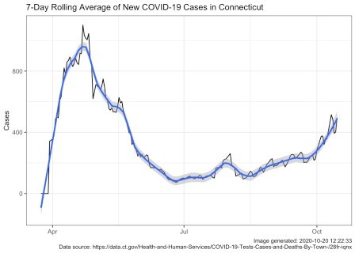

Ah, now there’s a much more informative plot. The black line shows the actual

data with all its jags and sub peaks. The blue line applies geom_smooth(span = .15)

which gives us a smoothing algorithm. Either line tells the same story. April 20-26

was the high point and by late June we were in much better shape. Summer was pretty flat but by September we were climbing and in October we’re climbing faster. Unless you ignore the news completely you probably knew this but the state level picture

can be very useful.

# Show me the map

I know, I know I promised you a map by Town. First a little more clean-up.

A rolling average of 7 days requires seven days of data so the first day we can plot is six days from the first date in our data. The state doesn’t

publish data on the weekends or holidays so lets add some rows that basically

just fill in the weekends and holidays from the day before. The tidyr::complete

and tidyr::fill handle that for us.

There are rare cases where the total.cases go down by say one. Probably correcting a small error. In the unlikely event things turn negative let’s

just call it zero. We’ll do that with a couple of ifelse.

### first date in dataset +6 is when rolling can go above zero first_date <-

ct_covid %>% pull(Last.update.date) %>% min() + 6

roll_ct_covid <- roll_ct_covid %>% group_by(Town) %>%

tidyr::complete(Last.update.date = seq.Date(from = min(Last.update.date),

to =

max(Last.update.date),

tidyr::fill(Town.number,

Total.cases:roll_capita,

.direction = "down")

by="day")) %>%

temp <- roll_ct_covid %>% filter(Last.update.date >= first_date) %>% mutate(roll_capita = ifelse(roll_capita < 0,

0,

roll_capita)) %>% mutate(roll_cases = ifelse(roll_cases < 0,

0,

roll_cases))

Okay now we need to do two more big things and one small thing. First we need to join the town “shapes” to the town COVID data before we can make a map. We’ll take our temp object and our ct_town_shapes and inner_join them.

Unlike Nathan’s map I want to take the rolling average of new cases

per capita roll_capita and put them in discrete “buckets” instead of a continuous variable. We’ll make 11 buckets evenly spaced from 0 to 49.99999 by increments of 5 plus a final bucket with everything over

50. We’ll do that with cut then forcats::fct_lump_n and lastly some gsub magic to make the factor levels pretty.

temp_sf <- inner_join(temp, ct_town_shapes) %>% select(GEOID, Town, Last.update.date, roll_cases,

County:roll_capita, geometry)

temp_sf$roll_cap_levels <- temp_sf$roll_capita %>% cut_width(width = 5,

center = 2.5) %>%

factor()

temp_sf$roll_cap_levels <- forcats::fct_lump_n(temp_sf$roll_cap_levels,

n = 10,

other_level = "> 50")

temp_sf$roll_cap_levels <- temp_sf$roll_cap_levels %>% fct_relabel(~ gsub(",[0-9]{1,2}",

" to ",

.x)) %>%

fct_relabel(~ gsub("\\[|\\]|\\(",

"",

.x))

A tiny bit of chicanery will allow us to center Town names on our map. sf::st_centroid and sf::st_coordinates will get us x and y coordinates to use to place the names near the geographic center of the town. Then we can make a pretty

map of population by town labeled and with a nice scale. Because 169 towns is a lot of labels and because town boundaries are irregular we’ll use ggrepel::geom_text_repel to declutter.

We’ll use viridis to ensure that our colors are viewable for those with challenges seeing certain colors (colorblindness) and print well in gray scale. We’ll shade the map so that more heavily populated

areas show darkest and with an oversize scale under the map to show population numbers.

temp_sf <- temp_sf %>% mutate(

CENTROID = purrr::map(geometry, sf::st_centroid), COORDS = map(CENTROID, sf::st_coordinates), COORDS_X = map_dbl(COORDS, 1),

COORDS_Y = map_dbl(COORDS, 2)

)

temp_sf %>%

filter(Last.update.date == "2020-03-30") %>% ggplot() +

geom_sf(aes(geometry = geometry, fill = population), size = 0.25) + ggrepel::geom_text_repel(

mapping = aes(

x = COORDS_X, y = COORDS_Y,

label = Town), size = 2,

min.segment.length = .5, point.padding = NA, segment.color = "grey50", force = .5,

box.padding = .15, fontface = "bold") +

scale_fill_viridis(alpha = .7,

direction = -1, discrete = FALSE, labels = comma,

breaks = seq.int(10000, 150000, 40000)) + ggthemes::theme_map() +

theme(legend.position = "bottom", legend.justification = "center", legend.key.size = unit(3, "lines"), legend.text = element_text(size = 6)) +

labs(

title = "Connecticut town populations", subtitle = "Census 2010 data",

caption = paste0("Image generated: ", Sys.time())

)

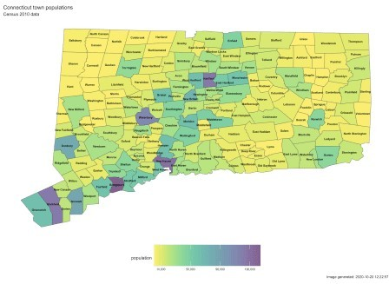

# Put it all together

The final step is to make the animation. This essentially means making a ggplot object in more or less the usual way. The initial lines

should look quite familiar to the previous plot if you have been following along. Then comes:

gganimate::transition_time(Last.update.date) + enter_fade() + exit_fade()

which warns gganimate that our frames, our transitions, will be based

on Last.update.date. gganimate does **not** support parallel processing unfortunately so it does take quite some time to run if we attempt to process a lot of dates. We’ll create two animations

one with the full span of data,

all 200 days (all_data), and another quicker one with just the last month (last_30_days).

In both cases the darker colors indicates low numbers (good for us) and “hot spots” are readily apparent as bright spots.

days <-

temp_sf %>% pull(Last.update.date) %>% n_distinct()

days

## [1] 200

days2 <-

temp_sf %>%

filter(Last.update.date >= "2020-09-17") %>% pull(Last.update.date) %>%

n_distinct()

days2

## [1] 29

all_data <- ggplot(temp_sf) +

geom_sf(aes(fill = roll_cap_levels, geometry = geometry), size =

0.25) +

viridis::scale_fill_viridis(name = "New cases 7 day average: ",

discrete = TRUE) +

ggthemes::theme_map() + theme(legend.position = "bottom",

legend.justification = "center", legend.text = element_text(size = 6)) +

guides(fill = guide_legend(nrow = 1,

title.position = "top", label.position = "bottom", label.hjust = 0,

title.hjust = 0.5, byrow = TRUE)) +

labs(

title = paste0("Connecticut 7-day rolling average of new COVID cases per ",

scales::comma(100000), " residents by town"),

subtitle = "Date: {frame_time}",

caption = paste0("Image generated: ", Sys.time(),

" Data updated ", max(ct_covid$Last.update.date)

, "\n",

Data")

) +

"Data source: https://data.ct.gov/ -- Connecticut Open

gganimate::transition_time(Last.update.date) + enter_fade() +

exit_fade()

last_30_days <-

temp_sf %>% filter(Last.update.date >= "2020-09-17") %>% ggplot() +

geom_sf(aes(fill = roll_cap_levels, geometry = geometry), size =

0.25) +

viridis::scale_fill_viridis(name = "New cases 7 day average: ",

discrete = TRUE) +

ggthemes::theme_map() + theme(legend.position = "bottom",

legend.justification = "center", legend.text = element_text(size = 6)) +

guides(fill = guide_legend(nrow = 1,

title.position = "top", label.position = "bottom", label.hjust = 0,

title.hjust = 0.5, byrow = TRUE)) +

labs(

title = paste0("Connecticut 7-day rolling average of new COVID cases per ",

scales::comma(100000), " residents by town"),

subtitle = "Date: {frame_time}",

caption = paste0("Image generated: ", Sys.time(),

" Data updated ", max(ct_covid$Last.update.date)

, "\n",

Data")

) +

"Data source: https://data.ct.gov/ -- Connecticut Open

gganimate::transition_time(Last.update.date) + enter_fade() +

exit_fade()

# Animate it

The call to gganimate::animate is relatively straight-forward, we feed

it the name of the ggplot object we created above all_data or last_30_days how many frames to create (one per day plus the fade in and fade out) and optionally information about size and resolution. On my older Mac it takes approximately 14 minutes for the 200 days, and under 2 minutes for the month.

There is a function to save the animation as a **gif** which is what I have done for the larger file.

Sys.time()

## [1] "2020-10-20 12:23:02 EDT"

anim <- gganimate::animate( all_data,

nframes = days + 20, fps = 2,

start_pause = 5,

end_pause = 15,

res = 96,

width = 800,

height = 600, units = "px"

)

gganimate::anim_save("ct_covid_rolling_Oct16.gif", animation = anim) Sys.time()

## [1] "2020-10-20 12:35:47 EDT"

# anim

The smaller one I’ll include directly in this blog post

Sys.time()

## [1] "2020-10-20 12:35:47 EDT"

anim2 <- gganimate::animate( last_30_days,

nframes = days2 + 20,

fps = 1,

start_pause = 5,

end_pause = 15,

res = 96,

width = 800,

height = 600, units = "px"

)

gganimate::anim_save("last_30_days.gif", animation = anim2) Sys.time()

## [1] "2020-10-20 12:37:00 EDT"

anim2

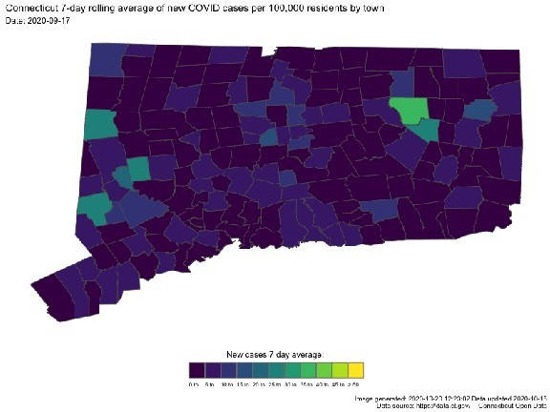

# Done