We’ll start with a simple synthetic example, where score is the score produced by a trained model, and y is the actual outcome in the evaluation data set (TRUE or FALSE). We’ll assume for this discussion that the model score is a number in the unit interval, as would be true for a probability model.

set.seed(1452225)

# sigmoid maps the real line to the unit interval sigmoid = function(x) {

1/(1 + exp(-x))

}

# data with two different regimes of behavior d <- rbind(

data.frame(

score = sigmoid(0.4*(rnorm(1000) - 2.5) ),

y = sample(c(TRUE, FALSE), prob = c(0.02, 0.98), size = 1000, replace = TRUE)),

data.frame(

score = sigmoid( 0.4*(rnorm(200) + 2.5) ),

y = sample(c(TRUE, FALSE), size = 200, replace = TRUE))

)

Here’s the ROC, and its associated AUC:

library(ggplot2) library(WVPlots)

ROCPlot(d, "score", "y", truthTarget=TRUE, title="Model ROC")

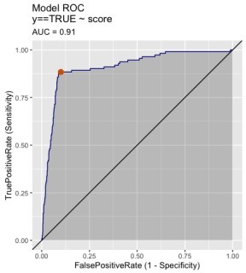

Every point of the ROC corresponds to a given *threshold*; datums that score at least the threshold value are classified as positive (or TRUE, in this case), and datums that score below the threshold are classified as negative, or FALSE. **So the ROC represents the false positive and true positive rates of *all possible* classification rules that can be defined from this model by varying the threshold**. I’ve marked the point that corresponds to the threshold 0.5, which is the most commonly used threshold.

# The ROC Unrolled

To make the information in the ROC more explicit, let’s plot the true positive rates and false positive rates off

all possible classification rules as a function of threshold. We can do this with the ThresholdPlot()

function from the WVPlots package.

ThresholdPlot(d, "score", "y", title="ROC 'unrolled'", truth_target = TRUE,

metrics = c("true_positive_rate", "false_positive_rate")) + geom_vline(xintercept = 0.5, color = "#d95f02")

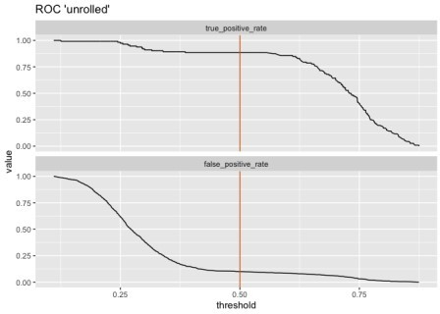

I’ve added a horizontal line at threshold = 0.5.

The threshold plot and the ROC give us the exact same tradeoff information. While the ROC and the AUC are more convenient for comparing multiple scoring models, the threshold plot makes the relationship of performance to threshold value explicit. This can be useful if you are willing to tweak the threshold to make a tradeoff. For example, if avoiding false positives is more important to you than catching all the positive instances, you could try a stricter threshold like 0.75. In this case, the classifier would make fewer false positive errors, but it would also detect far fewer positive examples, as well.

**Some Strawman Models for Intuition**

The threshold plot can also give us further intuition about the ROC. We can see that as the threshold goes to zero, both the true and false positive rates go to one (the upper right hand corner of the ROC). As the threshold goes to one, both the rates go to zero (the lower left hand corner of the ROC). As the threshold increases from zero to one, it traces out the rest of the ROC from upper right to bottom left, representing all the tradeoffs between true positive rate and false positive rate that are possible with a given model.

## The Ideal Model

The ideal model would predict every instance perfectly; positives would score one, negatives would score zero. Let’s see what that would look like.

ideal <- data.frame(score = c(rep(1, 50), rep(0, 50)), y = c(rep(TRUE, 50), rep(FALSE, 50)) )

ThresholdPlot(ideal, "score", "y", title="Ideal model", truth_target = TRUE,

metrics = c("true_positive_rate", "false_positive_rate"))

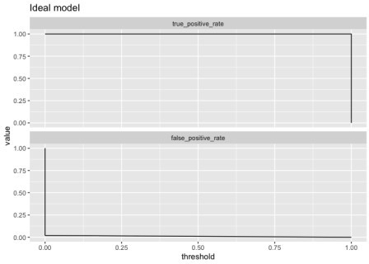

(The endpoints are convention). With an ideal model, any threshold except exactly zero or one produces a classification rule with a true positive rate of one and and a false positive rate of zero. This traces out an ROC that’s exactly the unit square:

ROCPlot(ideal, "score", "y",

truthTarget = TRUE, title = "Ideal model")

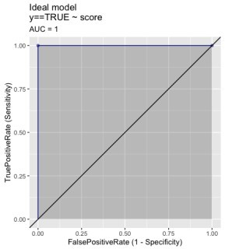

So now we know ***the ideal model has an AUC of 1***. We want our actual model to trace out a curve as close to the ideal model as possible; such a model should have an AUC close to 1.

## The Random Model

What about a model that doesn’t predict anything at all, but just returns random answers? random <- data.frame(score = runif(1000),

y = c(rep(TRUE, 500), rep(FALSE, 500)) )

ThresholdPlot(random, "score", "y", title="Random model", truth_target = TRUE,

metrics = c("true_positive_rate", "false_positive_rate"))

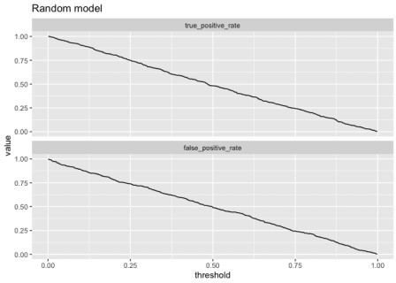

Both the true and false positive rates are proportional to the threshold, and the ROC will be close to the line

x = y.

ROCPlot(random, "score", "y",

truthTarget = TRUE, title = "Random model")

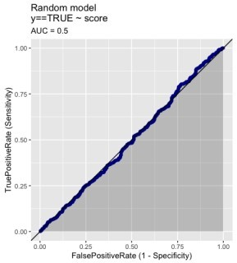

***A random model has an AUC near 0.5***. And a model that has an ROC that dips below the line x = y (and has an AUC less than 0.5) is actually anticorrelated with the true class labels.

# The ROC and Class Prevalence

It’s worth noting that the ROC depends on the false positive rate (the rate at which negatives are misclassified as positives) and true positive rate (the rate at which positives are correctly classified), *neither of which depends on class prevalence*. That means that ***the ROC is independent of class prevalence***. In other words, it can look overly optimistic when the target class is rare.

To demonstrate, let’s look at two situations that have been designed to produce the same ROC. The first situation is a model applied to a balanced-class population; the second is a model applied where the positive class is relatively rare (about 20%).

# Look at class balances table(balanced$y)

## FALSE TRUE ## 1000 1000

table(unbalanced$y)

## FALSE TRUE ## 1600 400

ROCPlotPair2(nm1 = "Balanced classes", # model 1 frame1 = balanced,

xvar1 = "score", truthVar1 = "y", truthTarget1 = TRUE, nm2 ="Unbalanced classes", # model 2

frame2 = unbalanced,

xvar2 = "score", truthVar2 = "y", truthTarget2 = TRUE, title = "Comparing different class prevalences", estimate_sig = FALSE)

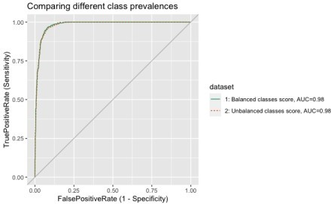

As designed, the ROC is nearly identical in both situations, with a high AUC. These both look like good models.

But suppose instead of false positive rate, you are worried about *precision* (the probability that a instance predicted to be positive is actually positive). With respect to precision, the two models behave quite differently.

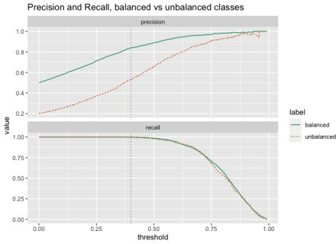

Both models have identical recall (which is the same as true positive rate, and is independent of class prevalence), but the model that is applied to a population where the positive class is rare will have much lower precision for any useful setting of the classifier threshold.

Incidentally, this is why when evaluating what a positive result of a medical screening test means, it’s important to know the prevalence of the disease (or other medical condition) in the population. Medical screening tests are generally designed to meet certain levels of sensitivity (true positive rate) and specificity (1 – false positive rate); these measures are independent of the disease prevalence.

Suppose that the example in the graph above showed a screening test applied to two different populations. We want to make sure that we identify everyone who has the disease, so we set the threshold at 0.4 (the vertical line on the graph), so the recall is close to one. If 50% of the population has the disease, then 8 out of 10 people who test positive will actually be positive. But if only 20% of the population has the disease, then nearly half the people who test positive are actually negative.

These sort of details are easier to work through with tools that expose tradeoff management, like

ThresholdPlot, rather than only examining the ROC.

# Let’s Sum It All Up

What have we established in this article?

The ROC and AUC are useful for quickly comparing multiple models. In a comparison, higher AUCs generally mean better models.