# How it works (briefly)

This diagram in Figure 1 outlines the pieces of the setup.

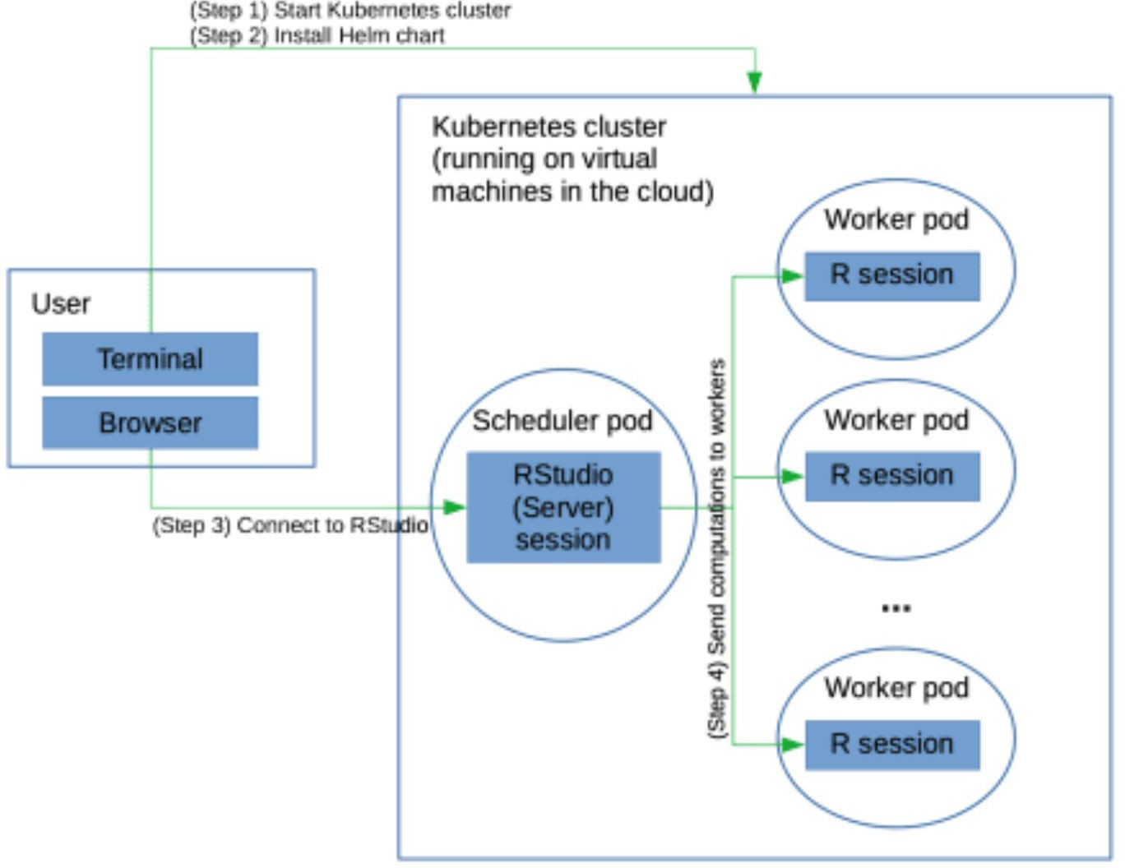

*Figure 1. Overview of using future on a Kubernetes cluster*

Work on a Kubernetes cluster is divided amongst *pods*, which carry out the components of your work and can communicate with each other. A pod is basically a Linux container. (Strictly speaking a pod can contain multiple containers and shared resources for those containers, but for our purposes, it’s simplest just to think of a pod as being a Linux container.) The pods run on the nodes in the Kubernetes cluster, where each Kubernetes node runs on a compute instance of the cloud provider. These instances are themselves virtual machines running on the cloud provider’s actual hardware. (I.e., somewhere out there, behind all the layers of abstraction, there are actual real computers running on endless aisles of computer racks in some windowless warehouse!) One of the nice things about Kubernetes is that if a pod dies, Kubernetes will automatically restart it.

The basic steps are:

1. Start your Kubernetes cluster on the cloud provider’s Kubernetes service
2. Start the pods using Helm, the Kubernetes package manager
3. Connect to the RStudio Server session running on the cluster from your browser
4. Run your future-based computation
5. Terminate the Kubernetes cluster

We use the Kubernetes package manager, Helm, to run the pods of interest:

one (scheduler) pod for a main process that runs RStudio Server and communicates with the workers

multiple (worker) pods, each with one R worker process to act as the workers managed by the **future** package

Helm manages the pods and related *services*. An example of a service is to open a port on the scheduler pod so the R worker processes can connect to that port, allowing the scheduler pod

RStudio Server process to communicate with the worker R processes. I have a Helm chart that does this; it borrows heavily from the Dask Helm chart for the Dask package for Python.

Each pod runs a Docker container. I use my own Docker container that layers a bit on top of the Rocker container that contains R and RStudio Server.

# Step 1: Start the Kubernetes cluster

Here I assume you have already installed:

the command line interface to Google Cloud,

the kubectl interface for interacting with Kubernetes, and

helm for installing Helm charts (i.e., Kubernetes packages). Installation details can be found in the future-kubernetes repository. First we’ll start our cluster (the first part of Step 1 in Figure 1):

gcloud container clusters create \

--machine-type n1-standard-1 \

--num-nodes 4 \

--zone us-west1-a \

--cluster-version latest \ my-cluster

I’ve asked for four virtual machines (nodes), using the basic (and cheap) n1-standard-1

instance type (which has a single CPU per virtual machine) from Google Cloud Platform.

You’ll want to specify the total number of cores on the virtual machines to be equal to the number of R workers that you want to start and that you specify in the Helm chart (as discussed below). Here we ask for four one-cpu nodes, and our Helm chart starts four workers, so all is well. See the Modifications section below on how to start up a different number of workers.

Since the RStudio Server process that you interact with wouldn’t generally be doing heavy computation at the same time as the workers, it’s OK that the RStudio scheduler pod and a worker pod would end up using the same virtual machine.

# Step 2: Install the Helm chart to set up your pods

Next we need to get our pods going by installing the Helm chart (i.e., package) on the cluster; the installed chart is called a *release*. As discussed above, the Helm chart tells Kubernetes what pods to start and how they are configured.

First we need to give our account permissions to perform administrative actions:

kubectl create clusterrolebinding cluster-admin-binding \

--clusterrole=cluster-admin

Now let’s install the release. This code assumes the use of Helm version 3 or greater

git clone https://github.com/paciorek/future-helm-chart # download the materials tar -czf future-helm.tgz -C future-helm-chart . # create a zipped archive (tarball) that `helm install` needs

helm install --wait test ./future-helm.tgz # install

(start the pods)

You’ll need to name your release; I’ve used ‘test’ above.

The --wait flag tells helm to wait until all the pods have started. Once that happens, you’ll see a message about the release and how to connect to the RStudio interface, which we’ll discuss further in the next section.

We can check the pods are running:

kubectl get pods

You should see something like this (the alphanumeric characters at the ends of the names will differ in your case):

|  |  |  |  |  |
| --- | --- | --- | --- | --- |
| NAME | READY | STATUS | RESTARTS | AGE |
| future-scheduler-6476fd9c44-mvmz6 | 1/1 | Running | 0 | 116s |
| future-worker-54db85cb7b-47qsd | 1/1 | Running | 0 | 115s |
| future-worker-54db85cb7b-4xf4x | 1/1 | Running | 0 | 115s |
| future-worker-54db85cb7b-rj6bj | 1/1 | Running | 0 | 116s |
| future-worker-54db85cb7b-wvp4n | 1/1 | Running | 0 | 115s |

As expected, we have one scheduler and four workers.

# Step 3: Connect to RStudio Server running in the cluster

Next we’ll connect to the RStudio instance running via RStudio Server on our main (scheduler) pod, using the browser on our laptop (Step 3 in Figure 1).

After installing the Helm chart, you should have seen a printout with some instructions on how to do this. First you need to connect a port on your laptop to the RStudio port on the main pod (running of course in the cloud):

export RSTUDIO_SERVER_IP="127.0.0.1" export RSTUDIO_SERVER_PORT=8787

kubectl port-forward --namespace default svc/future-scheduler

$RSTUDIO_SERVER_PORT:8787 &

You can now connect from your browser to the RStudio Server instance by going to the URL: https://127.0.0.1:8787.

Enter rstudio as the username and future as the password to login to RStudio.

What’s happening is that port 8787 on your laptop is forwarding to the port on the main pod on which RStudio Server is listening (which is also port 8787). So you can just act as if RStudio Server is accessible directly on your laptop.

One nice thing about this is that there is no public IP address for someone to maliciously use to connect to your cluster. Instead the access is handled securely entirely through kubectl running on your laptop. However, it also means that you couldn’t easily share your cluster with a collaborator. For details on configuring things so there is a public IP,

Note that there is nothing magical about running your computation via RStudio. You could connect to the main pod and simply run R in it and then use the **future** package.

# Step 4: Run your future-based parallel R code

Now we’ll start up our future cluster and run our computation (Step 4 in Figure 1):

library(future)

plan(cluster, manual = TRUE, quiet = TRUE)

The key thing is that we set manual = TRUE above. This ensures that the functions from the **future** package don’t try to start R processes on the workers, as those R processes have already been started by Kubernetes and are waiting to connect to the main (RStudio Server) process.

Note that we don’t need to say how many future workers we want. This is because the Helm chart sets an environment variable in the scheduler pod’s Renviron file based on the number of worker pod replicas. Since that variable is used by the **future** package (via parallelly::availableCores()) as the default number of future workers, this ensures that there are only as many future workers as you have worker pods. However, if you modify the number of worker pods after installing the Helm chart, you may need to set the workers argument to plan() manually. (And note that if you were to specify more future workers than R worker processes (i.e., pods) you would get an error and if you were to specify fewer, you wouldn’t be using all the resources that you are paying for.)

Now we can use the various tools in the **future** package as we would if on our own machine or working on a Linux cluster.

Let’s run our parallelized operations. I’m going to do the world’s least interesting calculation of calculating the mean of many (10 million) random numbers forty separate times in parallel. Not interesting, but presumably if you’re reading this you have your own interesting computation in mind and hopefully know how to do it using future’s tools such as **future.apply** and **foreach** with **doFuture**.

library(future.apply)

output <- future_sapply(1:40, function(i) mean(rnorm(1e7)), future.seed

= TRUE)

Note that all of this assumes you’re working interactively, but you can always reconnect to the RStudio Server instance after closing the browser, and any long-running code should continue running even if you close the browser.

Figure 2 shows a screenshot of the RStudio interface.

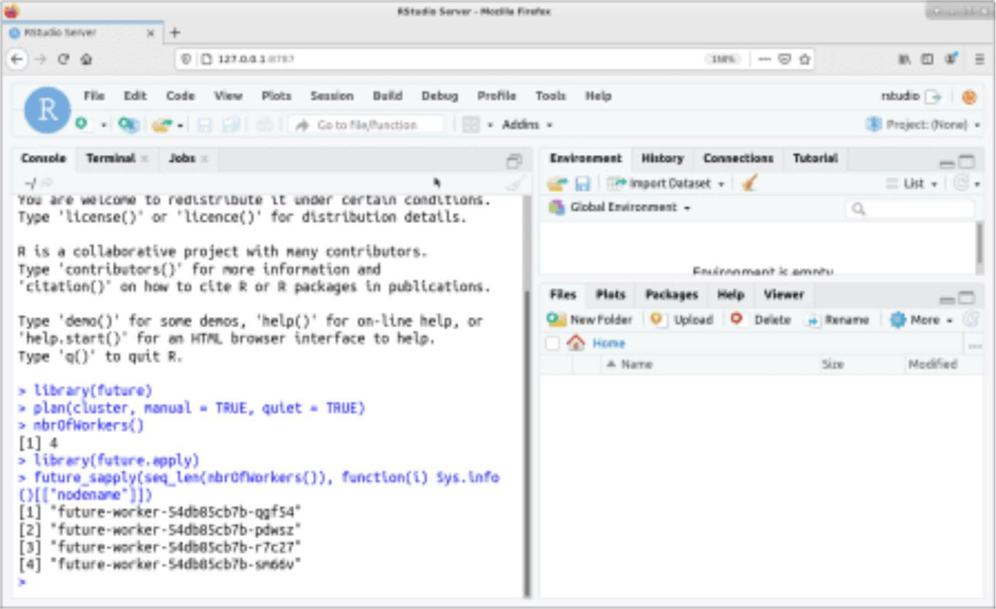

*Figure 2. Screenshot of the RStudio interface*

## Working with files

Note that /home/rstudio will be your default working directory in RStudio and the RStudio Server process will be running as the user rstudio.

You can use /tmp and /home/rstudio for files, both within RStudio and within code running on the workers, but note that files (even in /home/rstudio) are not shared between workers nor between the workers and the RStudio Server pod.

To make data available to your RStudio process or get output data back to your laptop, you can use kubectl cp to copy files between your laptop and the RStudio Server pod. Here’s an example of copying to/from /home/rstudio:

## create a variable with the name of the scheduler pod export SCHEDULER=$(kubectl get pod --namespace default -o jsonpath='{.items[?(@.metadata.labels.component==" scheduler")].metadata.name}')

## copy a file to the scheduler pod

kubectl cp my_laptop_file ${SCHEDULER}:home/rstudio/

## copy a file from the scheduler pod

kubectl cp ${SCHEDULER}:home/rstudio/my_output_file .

Of course you can also interact with the web from your RStudio process, so you could download data to the RStudio process from the internet.

# Step 5: Cleaning up

Make sure to shut down your Kubernetes cluster, so you don’t keep getting charged.

gcloud container clusters delete my-cluster --zone=us-west1-a

# Modifications

You can modify the Helm chart in advance, before installing it. For example you might want to install other R packages for use in your parallel code or change the number of workers.

To add additional R packages, go into the future-helm-chart directory (which you created using the directions above in Step 2) and edit the values.yaml file. Simply modify the lines that look like this:

env:

# - name: EXTRA_R_PACKAGES

# value: data.table

by removing the “#” comment characters and putting the R packages you want installed in place of data.table, with the names of the packages separated by spaces, e.g.,

env:

- name: EXTRA_R_PACKAGES

value: foreach doFuture

In many cases you may want these packages installed on both the scheduler pod (where RStudio Server runs) and on the workers. If so, make sure to modify the lines above in both the

scheduler and worker stanzas.

To modify the number of workers, modify the replicas line in the worker stanza of the values.yaml file.

Then rebuild the Helm chart:

cd future-helm-chart ## ensure you are in the directory containing

`values.yaml`

tar -czf ../future-helm.tgz .

and install as done previously.

Note that doing the above to increase the number of workers would probably only make sense if you also modify the number of virtual machines you start your Kubernetes cluster with such that the total number of cores across the cloud provider compute instances matches the number of worker replicas.

You may also be able to modify a running cluster. For example you could use gcloud container clusters resize. I haven’t experimented with this.

To modify if your Helm chart is already installed (i.e., your release is running), one simple option is to reinstall the Helm chart as discussed below. You may also need to kill the port-forward process discussed in Step 3.

For some changes, you can also also update a running release without uninstalling it by “patching” the running release or scaling resources. I won’t go into details here.

# Troubleshooting

Things can definitely go wrong in getting all the pods to start up and communicate with each other. Here are some suggestions for monitoring what is going on and troubleshooting.

First, you can use kubectl to check the pods are running:

kubectl get pods

## Connect to a pod

To connect to a pod, which allows you to check on installed software, check on what the pod is doing, and other troubleshooting, you can do the following

export SCHEDULER=$(kubectl get pod --namespace default -o jsonpath='{.items[?(@.metadata.labels.component==" scheduler")].metadata.name}')

export WORKERS=$(kubectl get pod --namespace default -o jsonpath='{.items[?(@.metadata.labels.component==" worker")].metadata.name}')

## access the scheduler pod:

kubectl exec -it ${SCHEDULER} -- /bin/bash ## access a worker pod:

echo $WORKERS

kubectl exec -it -- /bin/bash

Alternatively just determine the name of the pod with kubectl get pods and then run the

kubectl exec -it ... invocation above.

Note that once you are in a pod, you can install software in the usual fashion of a Linux machine (in this case using apt commands such as apt-get install).

## Connect to a virtual machine

Or to connect directly to an underlying VM, you can first determine the name of the VM and then use the gcloud tools to connect to it.

kubectl get nodes

## now, connect to one of the nodes, 'gke-my-cluster-default-pool- 8b490768-2q9v' in this case:

gcloud compute ssh gke-my-cluster-default-pool-8b490768-2q9v --zone us- west1-a

## Check your running code

To check that your code is actually running in parallel, one can run the following test and see that the result returns the names of distinct worker pods.

library(future.apply)

future_sapply(seq_len(nbrOfWorkers()), function(i) Sys.info() [["nodename"]])

You should see something like this:

[1] future-worker-54db85cb7b-47qsd future-worker-54db85cb7b-4xf4x

[3] future-worker-54db85cb7b-rj6bj future-worker-54db85cb7b-wvp4n

One can also connect to the pods or to the underlying virtual nodes (as discussed above) and run Unix commands such as top and free to understand CPU and memory usage.

## Reinstall the Helm release

You can restart your release (i.e., restarting the pods, without restarting the whole Kubernetes cluster):

helm uninstall test

helm install --wait test ./future-helm.tgz

Note that you may need to restart the entire Kubernetes cluster if you’re having difficulties that reinstalling the release doesn’t fix.