Let’s make a basic plot and see its default look (I am generating this on a Mac with the Quartz device):

library(ggplot2)

base_fig <- ggplot(data = economics, aes(date, pop)) +

geom_line() +

labs(title = "Total US population over time",

subtitle = "Population in thousands",

x = "Date",

y = "Total population (in thousands)")

base_fig

To change all text in the figure to Times New Roman, we just need to update the text option of the theme as follows:

base_fig +

theme(text = element_text(family = "Times New Roman"))

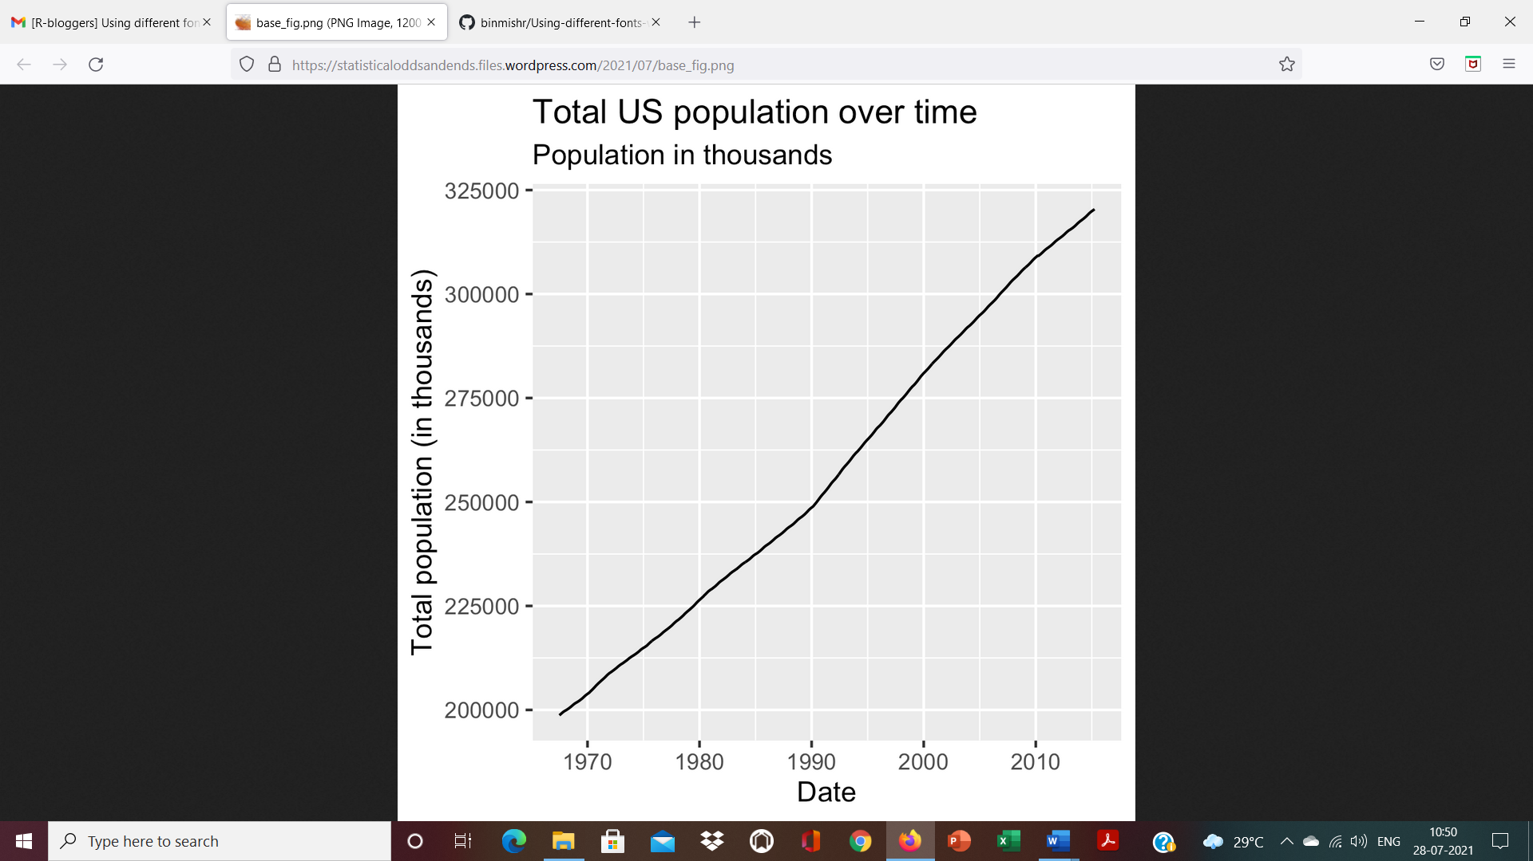

ggplot allows you to change the font of each part of the figure: you just need to know the correct option to modify in the theme. (For a full list of customizable components of the theme, see [this documentation](https://ggplot2.tidyverse.org/reference/theme.html).)

base_fig +

theme(plot.title = element_text(family = "mono"),

plot.subtitle = element_text(family = "sans"),

axis.title.x = element_text(family = "Comic Sans MS"),

axis.title.y = element_text(family = "AppleGothic"),

axis.text.x = element_text(family = "Optima"),

axis.text.y = element_text(family = "Luminari"))

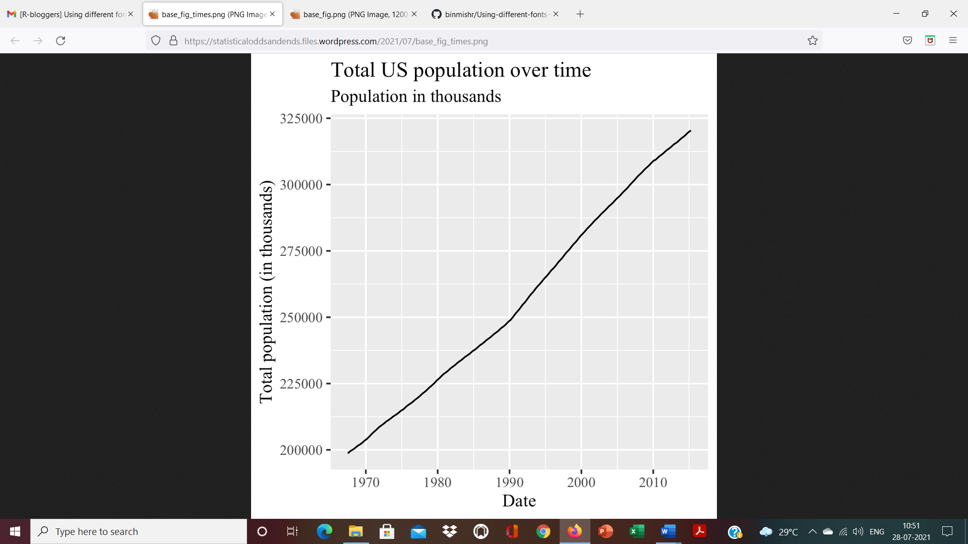

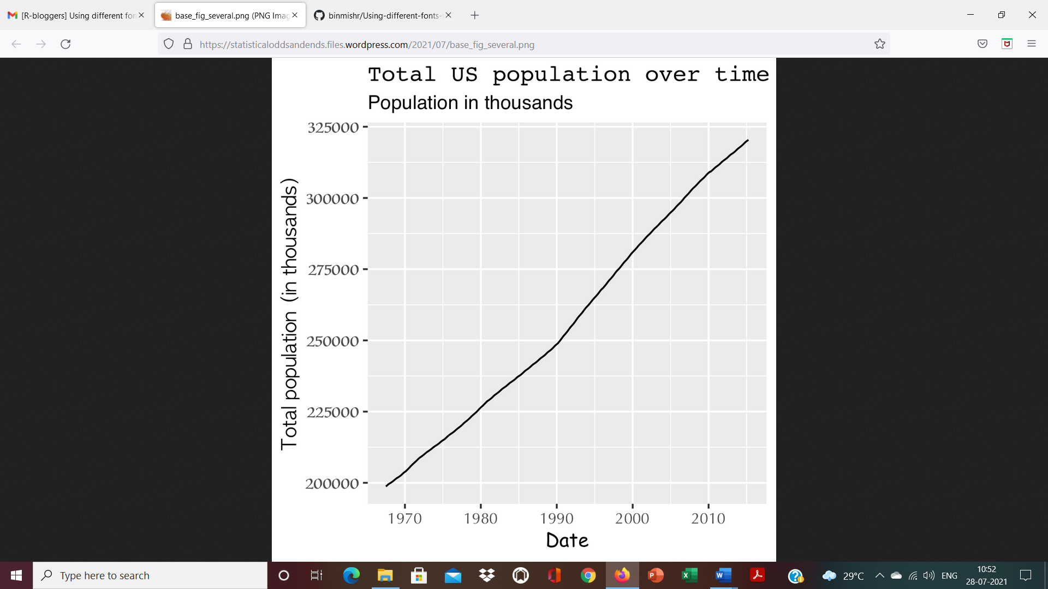

For standard fonts (i.e. widely-used fonts used in large parts of academia and industry) the code above will suffice.

***What fonts can I pass to element_text()?*** I couldn’t find an easy answer on this. This will depend on the OS you are using and the graphics device used to render the figure.

On a Mac, you can go to the “Font Book” application and have a look at the list of fonts there. Most fonts there should work. One exception I noticed is when using fonts having a different alphabet. (For example, using family = "Klee" in the code above did not work for me.)

***What’s a graphic device?*** It’s the engine that renders your plot. Common graphics devices are Quartz and X11. This is something the user typically does not need to care about.

***What are “mono”, “sans” and “serif”?*** These are categories of “types of fonts”. When the user specifies one of these 3 keywords instead of a full font name (e.g. “Times New Roman”), the graphics engine uses its default font associated for that keyword.

For the Quartz device, you can use quartzFonts() to see what the default font for each of these keywords is:

quartzFonts()

# $serif

# [1] "Times-Roman" "Times-Bold" "Times-Italic" "Times-BoldItalic"

#

# $sans

# [1] "Helvetica" "Helvetica-Bold" "Helvetica-Oblique" "Helvetica-BoldOblique"

#

# $mono

# [1] "Courier" "Courier-Bold" "Courier-Oblique" "Courier-BoldOblique"