Visualization graphs, Huge information is being collected through data in the business world, we must need a tool to picture of that data so we can interpret it and make decisions on time.

Data visualization provides a clear idea of what the information means by giving it visual context through maps or graphs.

Visualization allows humans to identify trends, patterns, and anomalies from large datasets.

**ggside**

In this tutorial we are going to explain one of the new packages ggside with ggplot.

ggside mainly used for creating customizable side plots with the help of ggplot.

If you want to install the package you can directly install from gitgub.

library(devtools)

devtools::install_github("jtlandis/ggside")

**Load packages**

library(ggside)

library(tidyverse)

library(tidyquant)

 geom_xside* allows you to place geometries along the x-axis and geom_yside* allows placement along the y-axis.

All of the geom_*side* functions provide a variation on the color aesthetics color/fill.

The variants are named xcolour and xfill or ycolour and yfill for their respective xside or yside geoms.

The following geoms are currently available to use right away from the ggside package.

* GeomBar
* GeomBoxplot
* GeomDensity
* GeomFreqpoly
* GeomHistogram
* GeomLine
* GeomPath
* GeomPoint
* GeomText
* GeomTile
* GeomViolin

In this tutorial, we are exploring only GeomDensity and GeomBoxplot.

**Side Density Plot**

geom_xsidedensity() function will create a density plot in top parallel to x-axis of the ggplot. In the same way, geom_ysidedensity () function will create a density plot parallel to the y-axis.

p2<-mpg %>%

  ggplot(aes(hwy, cty, color = class)) +

  geom_point(size = 2, alpha = 0.3) +

  geom_smooth(aes(color = NULL), se=TRUE) +

  geom_xsidedensity(

    aes(

      y    = after_stat(density),

      fill = class

    ),

    alpha    = 0.5,

    size     = 1,

    position = "stack"

  ) +

  geom_ysidedensity(

    aes(

      x    = after_stat(density),

      fill = class

    ),

    alpha    = 0.5,

    size     = 1,

    position = "stack"

  ) +

  scale_color_tq() +

  scale_fill_tq() +

  theme_tq() +

  labs(title = "Fuel Economy by Vehicle Type" ,

       subtitle = "Density Plot",

       x = "Highway", y = "City") +  theme(

    ggside.panel.scale.x = 0.4,

    ggside.panel.scale.y = 0.4

  )

plot(p2)

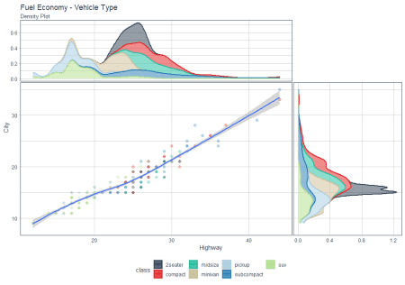

**Xside placed bottom, Yside placed left**

p2 + ggside(x.pos = "bottom", y.pos = "left") +

  labs(title = "FacetNull", subtitle = "Xside placed bottom, Yside placed left")

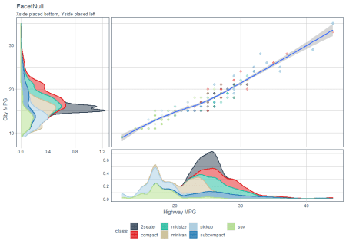

**Collapsing X side Panels**

p2 + facet_wrap(drv~fl) +

  labs(title = "FacetWrap", subtitle = "Collapsing X side Panels") +

  ggside(collapse = "x")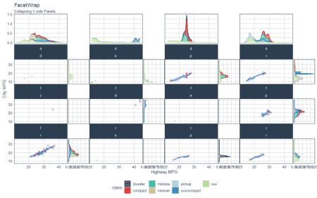

**Collapsing All Side Panels**

p2 + facet_grid(drv~fl, space = "free", scales = "free") +

  labs(title = "FacetGrid", subtitle = "Collapsing All Side Panels") +

ggside(collapse = "all")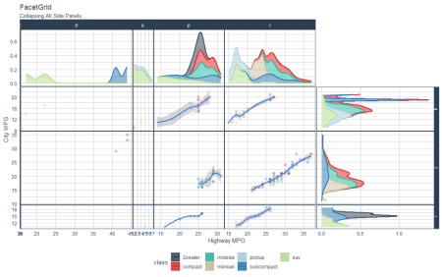

**Side Boxplot**

mpg %>%

  ggplot(aes(x = cty, y = hwy, color = class)) +

  geom_point() +

  geom_smooth(aes(color = NULL)) +

  geom_xsideboxplot(

    alpha    = 0.5,

    size     = 1  ) +

  scale_color_tq() +

  scale_fill_tq() +

  theme_tq() +

  facet_grid(cols = vars(cyl), scales = "free_x") +

  labs( title = "Fuel Economy by Engine Size")

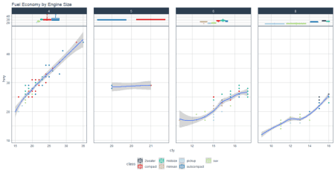

Data visualization can help by delivering data in the most efficient way possible. Better visualization provides to make better decisions and predictions.