# Before we get started, get the Cheat Sheet

Datapasta is great for importing raw data from HTML tables on the web. But, you’ll still need to learn how to transform / wrangle the data and produce visualizations.

**Quick example – Clicking the “CS” next to “dplyr”** opens the Data Transformation with Dplyr Cheat Sheet.

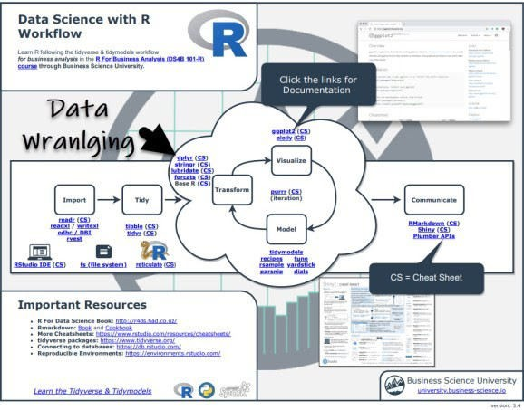

Now you’re ready to quickly reference dplyr functions. Ok, onto the tutorial.

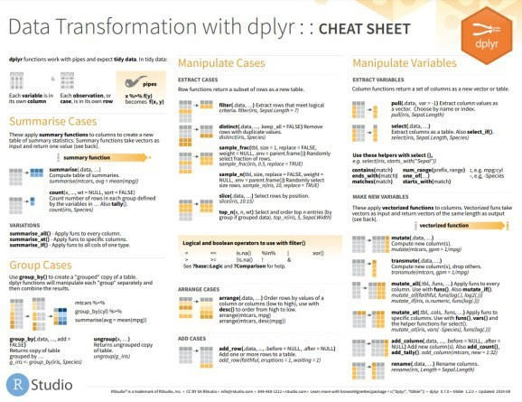

# Datapasta RStudio Addin

Datapasta contains an RStudio Add-In for Pasting web-tables stored in your “clipboard” (what happens when you “copy” something).

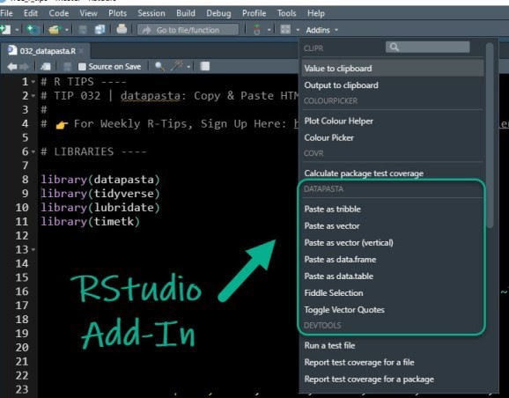

# Example 1: Copying Stock Data from Yahoo! Finance

Let’s go through a quick example. We can navigate to Yahoo! Finance and search for a ticker symbol like AAPL.

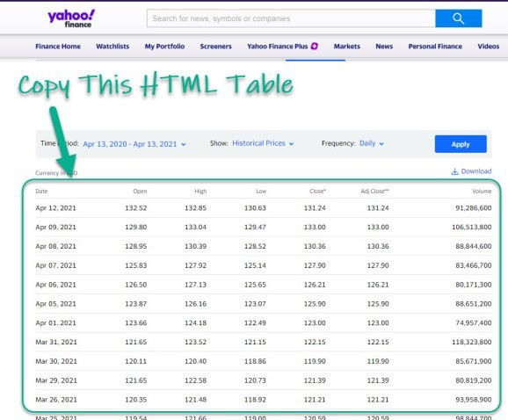

Source: Yahoo! Finance

Next, use the Datapasta Addin to **“paste as tribble”**. This pastes our data into our R script file.

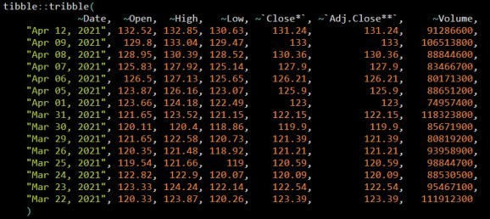

Next, use dplyr and timetk to wrangle and visualize the data. We can see a spike in volume on last day of the month.

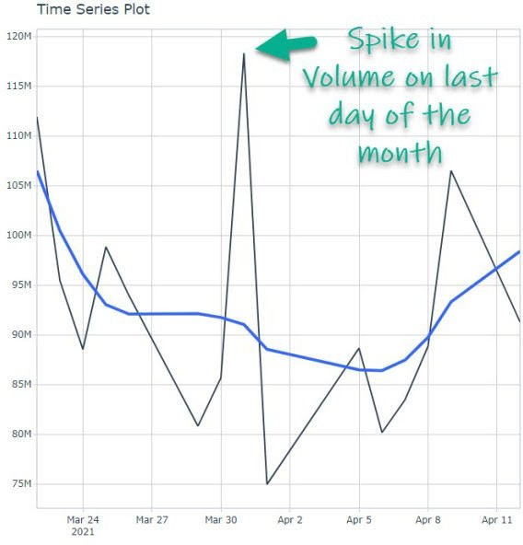

# Example 2: Getting Revenue Data for World Largest Companies

**From Wikipedia**

First, head over to Wikipedia and search for the “list of largest companies”.

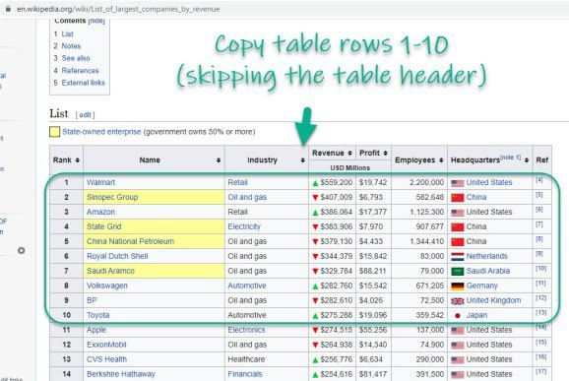

Source: Wikipedia

Use **datapasta** to “paste as data.table”. Then do some data wrangling with **dplyr**. Then visualize with **ggplot2**. And in a few lines of code you can create this chart showing that Walmart is dominating in Revenue.

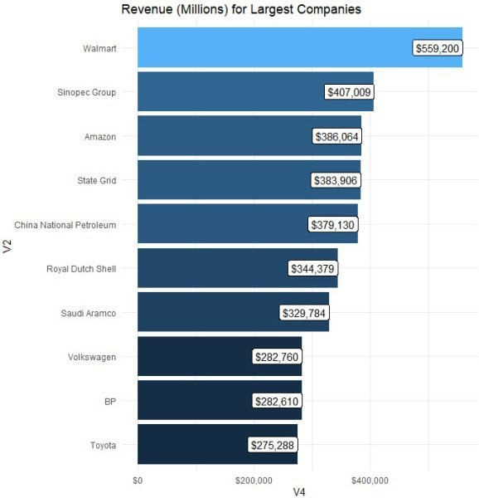

# In Summary

You just quickly scraped HTML tables using the copy-and-paster Rstudio Add-In known as

**datapasta** . This is an amazing productivity boost!!