The code below pulls data on cumulative COVID cases per 100k people on 2020-12-31 at the county level. covidcast_signal is the function to use for pulling data, and it returns an object of class c("covidcast_signal", "data.frame").

library(covidcast)

# Cumulative COVID cases per 100k people on 2020-12-31 df <- covidcast_signal(data_source = "usa-facts",

signal = "confirmed_cumulative_prop",

start_day = "2020-12-31", end_day = "2020-12-31")

summary(df)

# A `covidcast_signal` data frame with 3142 rows and 9 columns. #

# data_source : usa-facts

# signal : confirmed_cumulative_prop # geo_type : county

#

# first date : 2020-12-31

# last date : 2020-12-31

# median number of geo_values per day : 3142

There is a plot method for calss covidcast_signal objects:

plot(df)

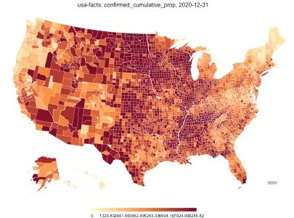

The automatic plot is usually not bad. The plot method comes with some arguments that the user can use to customize the plot :

breaks <- c(0, 500, 1000, 5000, 10000)

colors <- c("#D3D3D3", "#FEDDA2", "#FD9950", "#C74E32", "#800026")

plot(df, choro_col = colors, choro_params = list(breaks = breaks), title = "Cumulative COVID cases per 100k people on 2020-12-31")

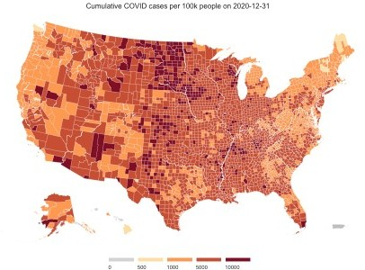

The plot returned is actually created using the ggplot2 package, so it is possible to add your own ggplot2 code on top of it:

library(ggplot2)

plot(df, choro_col = colors, choro_params = list(breaks = breaks), title = "Cumulative COVID cases per 100k people on 2020-12-31") +

theme(title = element_text(face = "bold"))

