# Make correlation plots in 1 line of code

Productivity is essential in data science. Businesses need value quickly so they can make decisions. So, naturally I’m a big fan of the 1-line of code to do something great. Corrmorrant gets this.

Using the corrmorrant::corrmorrant() function, we generate a correlation plot in 1 line of code.

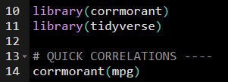

The correlation plot includes:

**Lower Triangle**: Scatter plot, ggplot2::geom_scatter()

**Upper Triangle**: Correlation strength as text labels, ggplot2::geom_text()

**Diagonal**: Density plot, ggplot2::geom_density()

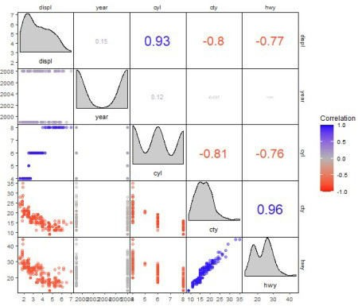

# Correlation Plot Customization

It gets better – corrmorrant has a ggplot2 API that provides a grammar for correlation graphics.

ggcorrm()– Creates a correlation ggplot.

lotri()– Applies a ggplot2 geometry to the lower triangle.

utri()– Applies a ggplot2 geometry to the lower triangle.

And there are special **Ggplot Helpers** like utri_heatmap(), dia_historgram(),

and scale_fill_corr() that apply quick geoms to parts of the plot.

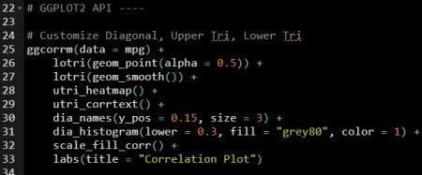

The correlation plot has now been customized with a smoother in the lower triangle, histogram on the diagonal, and heatmap on the upper triangle. This is why it pays dividends to **learn ggplot2**.

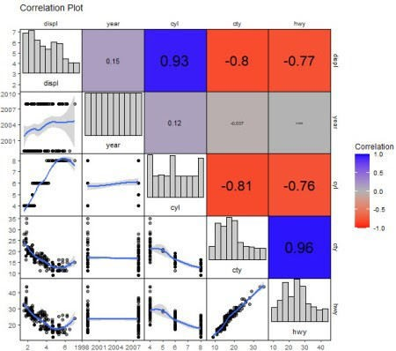

# Challenge: Grouped Correlations and Dark Theme

**This is really cool.**

Here’s a test if you’ve been following along and want to test your ggplot2 skills. Make this plot that applies “cyl” column as groups to the geoms. Note that you’ll need to do a trick to get the grouped correlations in the upper triangle.

