# patchwork

**Combine multiple ggplots into one.**

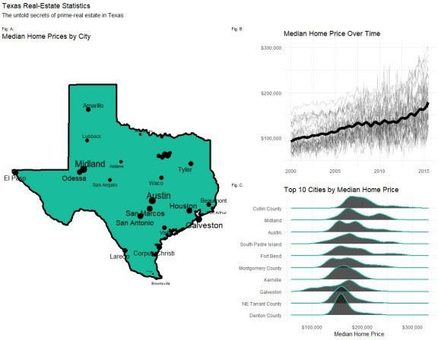

A Texas Real Estate Storyboard

What we’re making today combines 3 plots into 1 illustrative storyboard.

1. Map Plot
2. Time Series Plot
3. Ridgeline Plot

The **ggplot2 package** is great for single plots, but what about creating a storyboard for illustrating ideas, making persuasive arguments, and storytelling?

Now you can **make publication-ready storyboards using patchwork**, the composer of ggplot2. Patchwork makes it ridiculously simple to combine separate ggplots into the same graphic, arranging plots into a grid and adding figures, labels, and annotations.

The patchwork package aims to make it easy to combine ggplots by:

Using a ggplot2 syntax for using a grammar of plot-layout operations. Extends the amazing ggplot2 package.

# How patchwork works

Here’s the simplified patchwork syntax. That’s all we need to create a two-column layout with the right-column containing two rows is in the simple syntax. Let’s break it down.

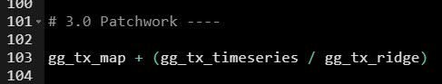

**Patchwork has a very simple syntax** where we can create layouts super easily. Here’s the general syntax that combines:

1. Two-Column Layout using the **Plus Sign `+`**
2. **Parenthesis `()`** to create a subplot group.
3. Two-Row Layout using the **Division Sign `\`**

This is the basic layout for the Texas Real-Estate Storyboard shown in the chart above.  The most important component to patchwork is that **you need to be good at developing**

**ggplot2 plots** if you want to make your storyboard look great.

# Before we get started, get the Cheat Sheet

patchwork is great for combining plots. But, you’ll still need to learn how to wrangle data with dplyr and visualize data with ggplot2. For those topics.

## Quick Example:

Download the Ultimate R Cheat Sheet. **Then Click the “CS” next to “ggplot2”** opens the Data Visualization with Dplyr Cheat Sheet.

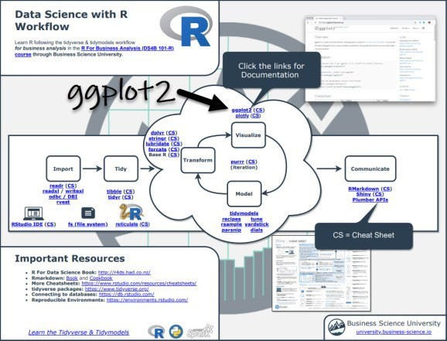

Now you’re ready to quickly reference ggplot2 functions. Onto the tutorial.

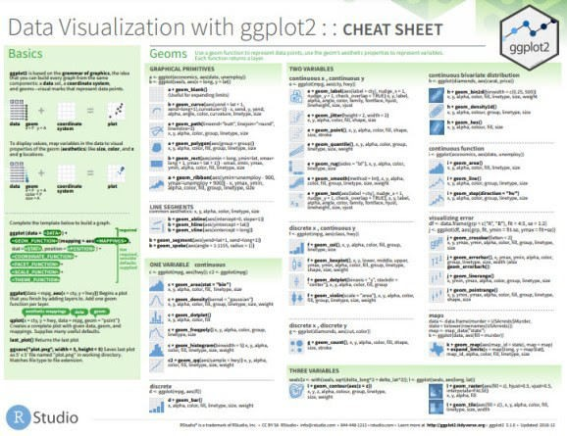

# Step 1: Load Libraries & Data

The libraries we’ll need today are patchwork, ggridges, ggrepel, maps, tidyverse, and lubridate. All packages are available on CRAN and can be installed with install.packages().

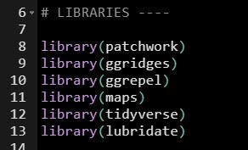

The dataset is the txhousing data that comes with ggplot2.

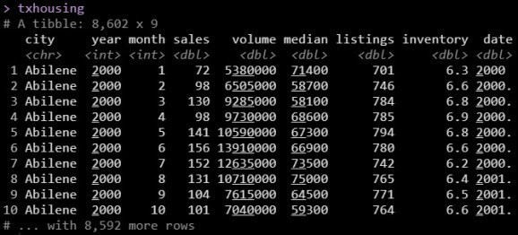

# Step 2: Make our Sub-Plots

We’ll start by making individual plots that are components of our final patchwork storyboard.

## Plot 1. Time Series Plot

First, we make a time series plot that shows the smoothed trend in median home prices of all the Texas cities along with their individual trends in median price.

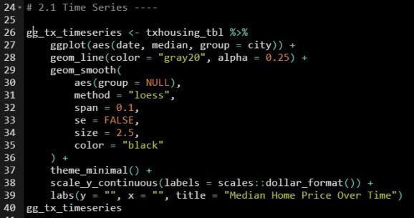

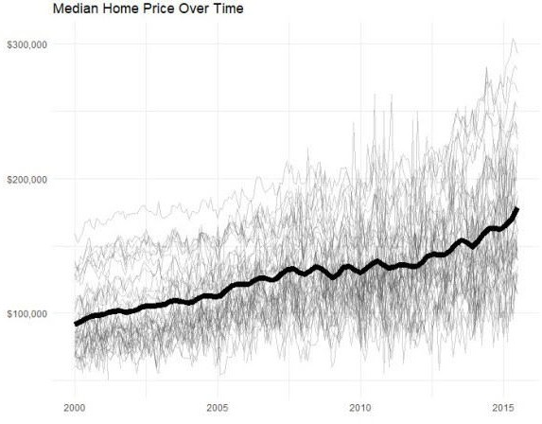

## Plot 2. Ridgeline Plot

Next is creating a ridgeline plot, a special plot that shows distribution of median home prices by top-10 cities in an aesthetically pleasing visual. PS.

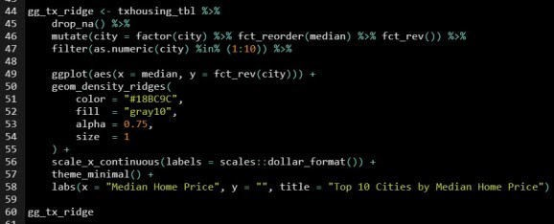

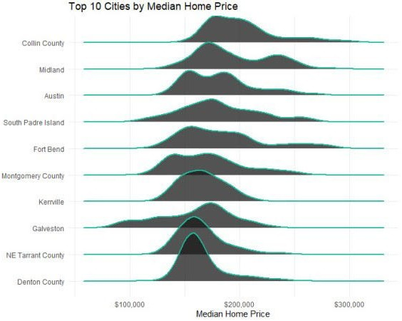

## Plot 3. The Map Plot

The final plot is a geographic map that showcases the summary of which cities have the highest median home prices in Texas.

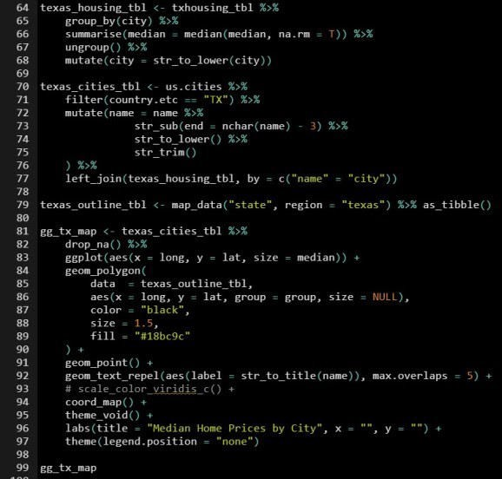

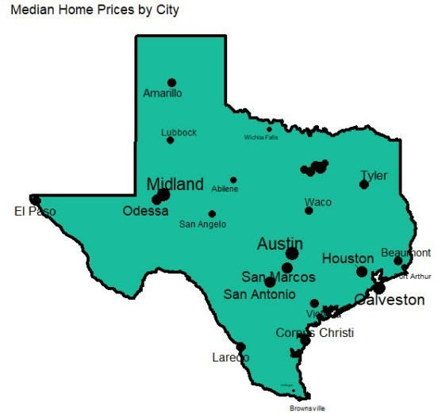

# Step 3: Compose with patchwork

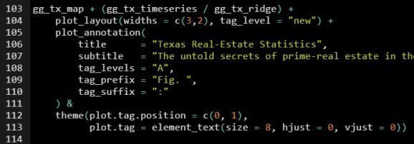



# In Summary

**You just quickly made a professional storyboard using the ggplot2 and patchwork**. Fantastic!

You should be proud.