I am pleased to announce **survivoR 0.9.2** is now on CRAN. The **survivoR** data package is a collection of datasets detailing events and the cast across all 40 seasons of the US Survivor, including castaway information, vote history, immunity and reward challenge winners, jury votes, and viewers. It also includes season and tribe colour palettes, and ggplot2 scale functions.

To install, simply enter

install.packages("survivoR")

I intend to update the data after each episode airs (by that I mean within a few days after the episode airs and probably on the weekend – just to manage expectations). There is plenty of data here, but there is also plenty of room for expansion. I will be adding new features, such as details on exiled castaways across the seasons, challenge details, and when hidden immunity idols were found, played, and for who over time. If you have a request for specific data let me know in the comments and I’ll see what I can do. Also, if you’d like to contribute by adding to existing datasets or contribute a new dataset.

Showcase

Just to jazz up the post a little, here are a few plots I’ve produced recently using the data.

# Sole Survivors

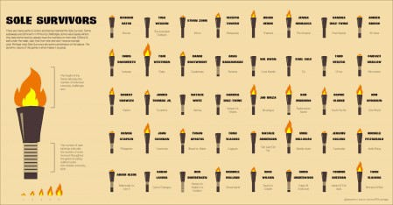

Sole Survivors: Height of the flame indicates the number of immunity challenges one. Number of rope bindings indicates the number of votes received.

# Fire represents your life

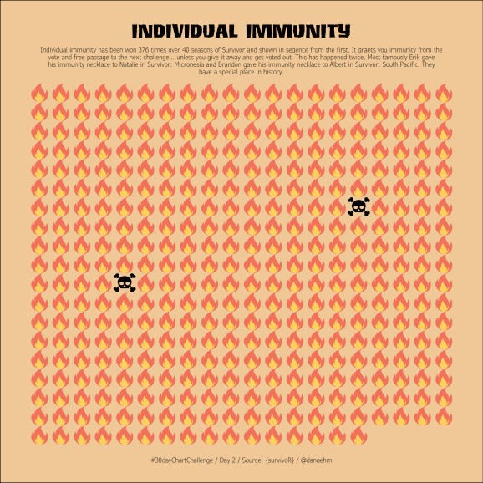

Each flame represents someone being safe at tribal council. The skulls represent those silly enough to give it away and get voted out.

# The Survivor base

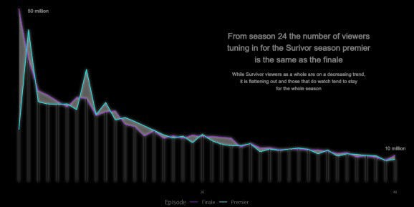

Survivor viewers over time.