Trifolia Workbench

**Table of contents**

Introduction 5

What's New 5

System Requirements 6

Language 6

Building a FHIR IG 6

Logging In 8

Navigation 10

Terminology 10

User Profiles 11

Security 11

Roles 12

Permissions 12

Groups 12

Implementation Guides 13

Templates/Profiles 14

Terminology 15

Authoring 15

Implementation Guides 15

Permissions 17

Cardinality 18

Template Types 18

Custom Schematron 18

Categories 18

Bookmarks 18

Files 19

Versioning 19

Editor 20

Meta-Data 20

Constraints 21

Numbers 22

Cardinality and Conformance 22

Bindings 23

Categories 24

Choice Elements 24

Preview 25

Validation 25

Versioning 25

Copying 25

Design Patterns 25

CDA Best Practices 26

FHIR Best Practices 27

Publish Settings 27

Terminology 28

MS Word 29

Schematron 31

Web-Based IG 31

Terminology 31

XML/JSON 33

Importing 33

Reports 34

Formatting Text 34

Inferred Templates 36

Importing 36

FHIR 36

API 38

Extensions 39

Developer Docs 40

Version 4.3.1 40

Version 4.3.0 40

Version 4.2.x 41

Version 4.2.0 42

Version 4.1.0 43

Version 4.0.0 44

Version 3.0.0 45

Version 2.19.0 48

Version 2.17.0 51

Version 2.16.0 54

Version 2.15.0 55

Version 2.14.0 58

Version 2.12.0 61

Version 2.10.0 62

**Introduction**

Trifolia Workbench is a web-based application connected to a SQL Server database. Use it to browse, edit and create templates/profiles, value sets, and implementation guides. You can export the information created in a variety of formats, and can generate Schematron code for use in validating the implementation in applications.

Trifolia supports the following core standards:

* Clinical Document Architecture (CDA)
* E-Measure
* FHIR DSTU1
* FHIR DSTU2
* FHIR STU3

**What's New**

## Version 4.4.0

Released on ????, 2017

### Schematron Export Improvements

A number of improvements have been made to Schematron exports including:

* Minor performance improvements
* Bug fix to generated Schematron when dealing with single-value bindings within branches
* Bug fix to Schematron rule context's for templates whose schema doesn't have the typical element used by the template predicate (ex: templateId)

### Default field selection for exports

The "Save As Default" functionality for "Export templates/profiles to MS Word" was not saving all fields. This is now fixed so that when you indicate to save your preferences as default, the selected templates/profiles *and* the sort order are persisted.

### Implementation Guide Editing

Permissions management on the "Edit Implementation Guide" screen has been improved so that multiple users can be added with less effort. The "General" tab has been re-organized into two separate columns so that more fields can fit on a single screen, reducing the need to scroll to edit the fields.

### Developer Improvements

A number of improvements have been made to make it easier for developers to work on Trifolia, including:

* Using the latest version of Entity Framework, with code-first approach. This will make it easier to modify the database, and apply those modifications during installation. It will also be easier to setup new installations of Trifolia.
* Installation script improvements. Re-designing the installation script to automatically apply the database migrations, and to remove files that are no longer used by the application.

### Development Log

|  |  |
| --- | --- |
| **Issue Type** | **Summary** |
| Defect | Branch within a branch produces incorrect schematron rule context |
| Defect | Export to MS. Word - "Save As Default" not working |
| Defect | Display errors in user-friendy way |
| Defect | Export Templates to MS Word - Save as Default not saving unchecked templates |
| Defect | Binding does not delete once set |
| Improvement | Element with single-value binding within a branch does not test single-value |
| Improvement | Allow a template/profile's author to be changed |
| New Feature | Schematron US Realm Addr/name etc templates need manual search and replace contexts in the Schematron file |

**System Requirements**

* Chrome
* Safari
* Firefox
* Internet Explorer 9+

**Language**

|  |  |
| --- | --- |
| **CDA Term** | **FHIR Term** |
| Template | Profile |
| Branch | Slice |
| Branch Identifier | Discriminator |

**Building a FHIR IG**

This tutorial will provide an overview of the workflow/process used to design/develop a FHIR implementation guide using Trifolia.

The basic steps are as follows, with details below:

1. FHIR and IG Publisher Overview
2. Create an implementation guide.
3. Create profiles for the implementation guide.
4. Upload "FHIR resource instances" to the implementation guide.
5. Export the implementation guide as a FHIR build package.

## FHIR and IG Publisher Overview

See the [FHIR current build](http://build.fhir.org/overview-dev.html) for more information.

FHIR (*Fast Health Interoperability Resources*) is designed to enable information exchange to support the provision of healthcare in a wide variety of settings. The specification builds on and adapts modern, widely used RESTful practices to enable the provision of integrated healthcare across a wide range of teams and organizations.

* Implementation guides are a collection of FHIR resources(profiles, value sets, examples and human readable documentation) tied together by the Implementation Guide resource
* Acronym FHIR = F – Fast (to design & to implement) H – Health, I – Interoperable and R – Resources(building blocks)
* Resources are discrete chunks of clinical information, can be assembled into larger constructs and resources are operated on via FHIR’s REST APIs
* FHIR documents are a collection of resources bound together, and are transferred between systems as a Bundle resource
* The root of a FHIR document is a Composition resource that can be signed, authenticated, etc, and has the same basic obligations as a CDA document.

### IG Publisher

See the [IG Publisher Documentation](http://wiki.hl7.org/index.php?title=IG_Publisher_Documentation) for more information.

* The FHIR team provides an IG Publishing tool that takes the implementation guide resources and converts them to a set of 3 different types of files (generated resources in xml, json, ttl formats, a set of fragments ready to include in generated html files and Several different zip files: which are used by implementers for various purposes).
* The outcome of the publishing process is a set of HTML files that represent the implementation guide. These files can be posted to a web server.
* Alternatively, you may use the IG publisher to validate and render a set of Profiles, value sets etc without building a formal IG

## Create an implementation guide

See Authoring > Implementation Guides for details.

* The "type" of implementation guide is set to a FHIR implementation guide type.
* Create a base identifier for the implementation guide that is a URL (ex: https://trifolia.lantanagroup.com/my_base_id"). This base url will be used by the FHIR IG publisher, and requires that all profiles within the implementation guide have a matching base identifier.
* Provide a description for the implementation guide. This description (if specified in the Implementation Guide Editor) is on the front page of the implementation guide after the IG publisher has been run on the artifacts produced by Trifolia.
* Include additional guidance that will not be inferred by the profiles of the implementation guide in the "Volume 1" tab, by adding sections to "Volume 1". Each of the sections defined in the implementation guide's "Volume 1" tab will be displayed on the "Overview" tab of the implementation guide's front-page.

## Create FHIR profiles for the implementation guide

See Authoring > Templates/Profiles > Editor for details.

* Each FHIR profile must have the same base url as the implementation guide in the "long id" field. The identifier for FHIR profiles is defaulted to a combination of the bookmark/name of the FHIR profile and the associated implementation guide's base url.
* Each profile must have a "short id" that matches the outer-most leaf level of the long id (everything to the right of the last / in the long id).
* Define constraints for each profile in the "Constraints" tab of the editor, modifying the cardinality, value set bindings, etc. as appropriate.

### Defining and using extensions

In the event that an extension is necessary, you must produce a profile that describes how the extension is intended to be used, and reference that extension as a "Contained template/profile" on the "extension" element of another profile.

## Upload "FHIR resource instances" to the implementation guide

See Authoring > ImplementationGuides > Files for details.

In certain cases, (such as "Conformance", "SearchParameter" and "Questionnaire") instances of resources need to be uploaded to Trifolia, then associated with the implementation guide rather than defining profiles. Add these "FHIR resource instances" to the implementation guide's files (as type "FHIR Resource Instance") so that they are included in the FHIR build package when exported from Trifolia.

## Export the implementation guide as a FHIR build package

See Exporting > XML/JSON for details.

Export the implementation guide as a FHIR build package. The zip package that will be run against the FHIR ig publisher.

Run the FHIR IG publisher by following these steps:

1. Extract the FHIR IG Package to a directory on your machine.
2. Download the FHIR IG Publisher jar file from the FHIR's [Downloads](http://build.fhir.org/downloads.html) page or click [here](http://build.fhir.org/org.hl7.fhir.igpublisher.jar) to directly download the .jar file. Store the .jar file in the same directory that the FHIR IG Package was extracted to.
3. Execute the "RunIGPublisher.bat" batch script.
4. If using the GUI interface, select the XXXX.json file exported from the ZIP.
5. Press "execute".

Note: The FHIR IG publisher is new functionality, being actively developed. If the latest version of the FHIR IG publisher produces errors, you should seek guidance from <http://chat.fhir.org> in the #Implementers channel.

**Logging In**

### Open-Source Authentication

The existing Active Directory and custom HL7 authentication has been replaced with a generic authentication method (OAuth 2.0). **OAuth** is an open standard for authorization, commonly used as a way for Internet users to log in to third party websites using their Google, Facebook, Microsoft, GitHub, etc. accounts without exposing their password.

As part of this migration, all existing Trifolia user accounts have been added/imported to the new OAuth Trifolia directory. Existing Trifolia users will receive a Password Reset link via e-mail that will allow them to use their Trifolia credentials when logging in using the Auth0. Clicking on the link in the email will direct the user to auth0.com and prompt the user to create a new password for your Trifolia account.

Existing users can use their Trifolia credentials to login, and pre-existing permissions to resources (implementation guides, templates, value sets, code systems, etc.), will persist. Each authentication method (Facebook, Microsoft Account, Username/Password, etc.) represents a separate user in Trifolia, with a separate username/password and permissions.

Please refer to the Security section for more information on access and permissions.

## Log In to Trifolia

1. In the upper-right corner, select Log In and choose Login from the drop-down menu. When users click the "Login" option. The Auth0 Log In page appears, as shown below

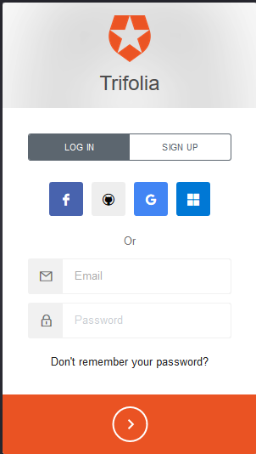

1. Once you log in to Trifolia Workbench, the functions available depend on the access permissions granted to your login credentials.
2. If it is the first time logging in, you will be prompted to enter "My Profile" information. See My Profile for more information. If are an existing user,   
   you can modify your My Profile information from the menu in the top-right corner.

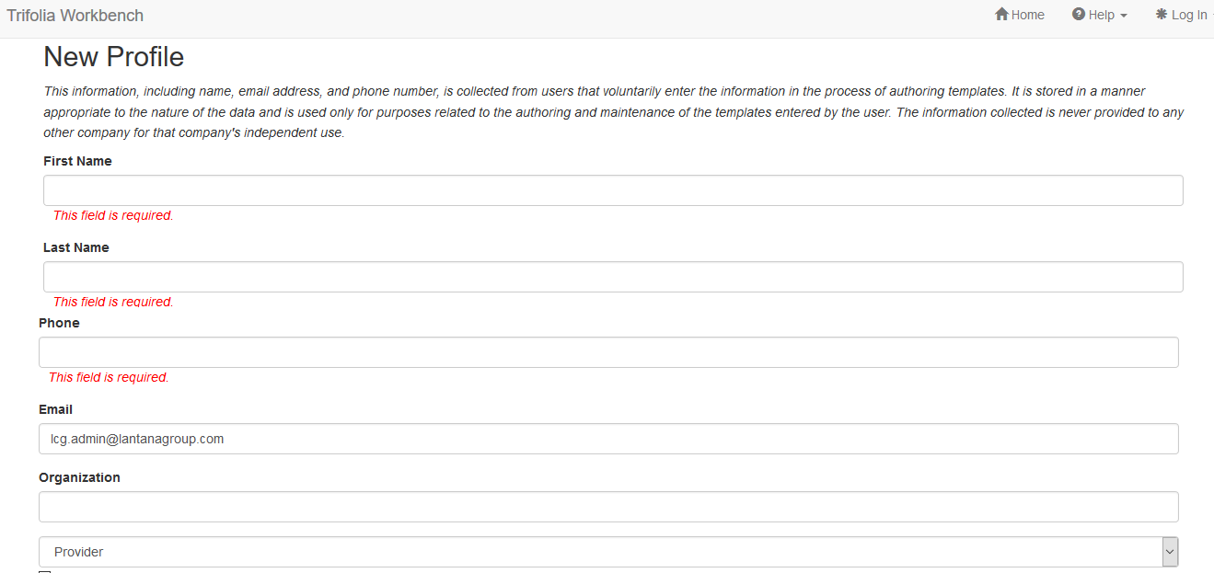

**Navigation**

Use the Trifolia Workbench menus to access all available features. Note that editors and administrators have additional features that are not available to Read-only accounts. Menus are arranged across top of the window, in tabbed fashion.

* Home - The home page provides a brief overview of Trifolia Workbench and informs users what features are new in the current version.
* Browse - Browse and edit implementation guides, templates/profiles, value sets, and code systems. See The Browse Menu.
* Export - Export data in a number of formats. See The Export Menu.
* Import - Allows users to select an XML file for import. This XML file should be the "Proprietary" export format of an implementation guide and its associated templates. The "Import" permission is set with the "Administrators", "Template Authors" and "IG Admins" roles by default.
* Reports - Choose from a variety of report types, then generate, format, and export or print a report. See The Reports Menu.
* Administration - Perform administrative tasks. See The Administration Menu.
* Help - Provides the help topic for the current page. If you are on the home page, you can view the complete help system with a navigation tree.

**Terminology**

Below is some information about the value sets and code systems used in Trifolia exports.

## Value Set Members

Trifolia treats value sets as though they are fully expanded. When Trifolia presents a value set that contains another value set, it displays all the members of the value set in an expanded view. This represents a fully expanded view of the value set.

## Value Set Status & Date

Each member of a value set contains status and date fields. Date and Status fields are used to determine which members will be exported to XML and MS Word output.

**Calculated Date**

For each member of a value set, a date is calculated, and this date, along with the status determines whether to include that member in an export. The date is derived using this priority:

1. If the constraint includes a value set binding date, it is used.
2. If no value set binding date is present, the implementation guide's publish date is used.
3. If no implementation guide publish date is available, the XML or MS Word export date is used.

## Status

The value set member status can be entered when a new value set member is added. Once the date is calculated, the status (if entered) and date are used to determine whether the member is included in the export as follows:

* The member is included in the export if the status is Unspecified (empty) or the calculated date is prior to the date for the member's active status.
* The member is excluded from the export the calculated date falls on or after the member's Inactive status date.

Example

Given the following value set:

|  |  |  |  |  |
| --- | --- | --- | --- | --- |
| **Code** | **Display Name** | **Code System** | **Status** | **Date** |
| Value 1 | Display 1 | SNOMED | Unspecified (blank) | Unspecified |
| Value 2 | Display 2 | LOINC | Active | 1/1/2013 |
| Value 3 | Display 3 | SNOMED | Active | 1/1/2013 |
| Value 2 | Display 2 | LOINC | Inactive | 3/1/2013 |

For an export generated on 1/15/2013, the resulting list is:

* Value 1
* Value 2
* Value 3

For an export generated on 5/1/2013, the resulting list is:

* Value 1
* Value 3

## Code Systems and Value Sets

Trifolia creates a relationship between a code system and a value set member. Code systems are used to reference a name/identifier combination.

A code system is referenced in one of the following ways:

* A value set’s member is a member of a specified code system
* A constraint indicates that an element/attribute in a template/profile must be selected from a code system
* A constraint, in combination with the constraint value, indicates that the value is a member of a specified code system

## Vocabulary XML

Vocabulary XML is used for Schematron validation. Value sets are bound to constraints in the Template Editor. Only a value set with a Binding value of **static** is validated by the Schematron. When you export vocabulary XML, only a value set with a Binding value of **static** is included. A value set with a Binding value of **unspecified** (empty) or **dynamic** is ignored. For more information on binding value sets see Bindings in the Constraints section.

**User Profiles**

## My Profile

The "My Profile" screen shows the data associated with your currently logged-in user. When a user logs into Trifolia for the first time, the My Profile screen appears, and the user completes the required fields. This information is specific to Trifolia and is maintained separately from external accounts (such as an HL7 account). The information captured in the user profile is used in several ways:

* To display a user's name as an author on templates/profiles
* On the "Edit Implementation Guide" screen's permissions
* By Lantana to determine who can be contacted with information relating to Trifolia news/announcements/inquiries

The following fields are captured on the "My Profile" screen (* = required):

* First Name*
* Last Name*
* Phone*
* Email*
* Organization
* Organization Type
* "It is OK to contact me" - This indicates if it is OK for Lantana to email or call the user regarding Trifolia news/announcements/inquiries.

Changes to the "My Profile" screen are not persisted until the "Save" button is selected.

**Security**

Trifolia uses two different methods of security:

* **Role-based security** - Controls what a user can do. This includes all actions and controls. It controls what a user can select to initiate an action. Roles are assigned on a system-wide basis, meaning that the role does not change for the different areas of functionality within the application.
* **Permissions-based security** - Controls what a user can view or edit. This controls the user's ability to view and edit implementation guides and Templates/Profiles. Permissions are assigned to implementation guides using the Permissions tab in the Implementation Guide Editor. See the Permissions section in Authoring Implementation Guides.

## Organizations

Trifolia organizes users and groups for each configured organization. For example, Lantana Consulting Group is configured to be an organization that has access to Trifolia, using it's own authentication method, and granting access to implementation guides and templates/profiles to users within that organization. HL7 is another organization configured to have access to Trifolia with its own set of users and roles.

**Roles**

Administrators can Assign users to roles. Roles determine which functionality (or securables) the user can access. Roles are specific to a particular organization.

The following roles are always available.

* Administrators - Access to all securables.
* Template/Profile Authors - Access to viewing, editing and exporting of templates/profiles, code systems, and value sets, and viewing of a number of reports.
* Users - View and export implementation guides, value sets, and code systems.
* IG Admins - View, edit, and export implementation guides, and view and export vocabulary and Schematron.

Administrators can also create additional roles, selecting sets of securables that are specific to those roles.

**Permissions**

Permissions can be specific to an implementation guide. Two kinds of permissions are available:

* **View Permissions** - Grant permission to a user or group to view a particular implementation guide.
* **Edit Permissions** - Grant permission for a user or group to edit the templates/profiles in a particular implementation guide.

Implementation guides can control who has permissions to edit templates owned by the implementation guide.

* User can indicate that a user can have view and/or edit permissions
* User can indicate that a group can have view and/or edit permissions
* User can indicate that an entire organization can have view and/or edit permissions
* User can indicate that a user or group from another organization can collaborate on templates within the IG.

**Groups**

Each user can create their own groups, and can request to join any existing groups. These groups are used by implementation guide permissions to assign multiple users read/edit access to an implementation guide and its templates/profiles.

To manage groups, select the menu for your name in the top-right corner of Trifolia, and click "My Groups".

The top portion of the screen shows groups that you manage as well as groups that you are joined to.

The bottom portion of the screen shows groups that you may request to join.

If you are a manager of a group, you will have options to Edit and/or Delete the group. If you are only a member of the group, you will have options to view the group, but no options to edit the group.

## Editing a group

Create a new group by clicking the "Add" button in the top-right of the "My Groups" screen.

Edit an existing group (if you are a manager of the group) by clicking the "Edit" button to the right of the group.

|  |  |
| --- | --- |
| Name | The name of the group that is displayed to all users |
| Description | The description is shows to all users so that they know what the group represents |
| Anyone can join | When checked, anyone can join the group without approval, and joining the group is automatic as soon as the user clicks "Join". When not checked, an email is sent to the managers of the group to indicate which user would like to join the group. The managers are responsible for logging into Trifolia and adding the user to the group. |
| Disclaimer | Disclaimers are shown in two places:   1. When users request to join the group, the disclaimer is shown to the user prior to them joining. When the user clicks "Join", they are effectively agreeing to the terms of the disclaimer. 2. Users that are members of a group with a disclaimer are shown the group's disclaimer under the "Help" > "Disclaimers" menu. |
| Managers | The list of users that are responsible for managing the group. These users can edit the details of the group, including adding/removing other managers and members. |
| Members | The list of members that belong to the group. These members are granted permissions to implementation guides when the group is assigned permissions to the implementation guide. |

**Implementation Guides**

Use the Browse Implementation Guides page to see a list of implementation guides and to search for a specific guide or set of guides.

## Locate an Implementation Guide for Review or Editing

1. From the Browse menu, choose **Implementation Guides**. The Implementation Guides page appears.
2. Use the Trifolia's Automatic Lookup feature to find the implementation guide you want to view or edit. A list of implementation guides that match your search criteria appears.
3. Once you have found the implementation guide you want, select **View**, or **Edit** (depending on your permissions) from the Actions menu for the selected guide. Refer to the Viewing an Implementation Guide details below or Authoring Implementation Guides section for more information.

## Requesting Permission to an Implementation Guide

To access an IG, you must be granted permission to access. Permission is granted by the Editor of the IG. Only those IGs to which you have access will display in the list of available IGs. IG Editors may allow users to “request access”. The list of IGs will include all those set a “can request access”. If you have not been granted access, you will see a link below the search field on the Browse Implementation Guides screen to "request access".

### Fields in the "Request Access" Window

* Access Level: Indicates if you would like "view" or "edit" permissions to the IG.
* Message: An optional message that is sent to the access manager of the IG.

### Request Access to an IG

* Select thee access level you would like to have for the IG
* Click the "Request" button, or optionally you can create a message to send to the access manager,.

**Note**: The request alone does not guarantee that you will be granted permission to an IG; it is the decision of the access manager to grant permissions.

## Viewing an Implementation Guide

In the Browse Implementation Guides page, in the row containing the guide you want to view, select View or WebView in the last column. The selected guide appears in the viewer.

Select a tab to view information about the guide:

* **Templates/Profiles** - View a list of templates/profiles in the guide, with a description of each. Select a template/profile's View or Edit link to view or edit the selected template/profile. Clear the Show Descriptions check box to view only the template/profile names and OIDs.
* **Notes** - View any notes attached to templates/profiles. Use the filters to limit the notes you are viewing.
* **Primitives** - View any primitive text attached to templates/profiles. Use the filters to limit the primitives you are viewing.
* **Audit Trail** - View the audit trail for any changes that have been made to templates/profiles in your guide. Use the filters to limit the audit entries you are viewing.
* **Files** - View a list of files attached to the implementation guide. Download an individual file or download all files at one time.

**Templates/Profiles**

Use the Templates/Profiles page to view a list of CDA, HQMF and E-Measure templates and FHIR profiles. Use the View Template/Profile page to view the template/profile details.

## Viewing a Template/Profile

There are two ways to view a template/profile:

* From the Implementation Guides list
* From the Templates/Profiles list

### View a Template/Profile from the Implementation Guides List

1. From the Browse menu, choose **Implementation Guides**.
2. Use the Automatic Lookup feature to find the implementation guide containing the template/profile you want to view. A list of implementation guides that match your search criteria appears.
3. In the implementation guides list, select **View** for the implementation guide you want to view.The implementation guide appears, showing you a list of templates/profiles contained in the guide.
4. Review the list of templates for the type of template you want to view. Locate the template/profile you want to view and select **View**. The template/profile viewer opens, containing the template/profile details.

### View a Template/Profile from the Templates List

1. From the Browse menu, choose **Templates/Profiles**.
2. Use the Trifolia's Automatic Lookup feature to find the templates/profiles you want to browse. A list of templates/profiles that match your search criteria appears.
3. In the Template/Profile list, choose **View** for the desired template/profile. The template/profile viewer opens, containing the template/profile details.

## Viewing the Template/Profile

* **Constraints** - View a list of the template/profile's constraints as they appear in the implementation guide.
* **Samples** - View a code sample attached to the template/profile. The "Samples" tab does not appear in the template/profile viewer if no samples exist for the template/profile.
* **Relationships** - View the relationship of the current template/profile to other templates/profiles.
  + **Implied By** the current template/profile - lists any templates/profiles that reference the current template/profile
  + **Contains** a template/profile - lists any templates/profiles contained within constraints in the current template/profile
  + **Contained By** a template/profile - lists any templates/profiles that reference the current template/profile
  + **Implies** a template/profile - lists a single template/profile referenced in the **Implies** field of the current template/profile
* **Changes** - View changes to the template/profile. View the changes **Inline** or as a **List**. (See below)

### Viewing Changes - List

When you view changes to a template/profile as a List, each constraint change is listed in a table. The type of change is listed as:

* Added
* Modified
* Removed

**Notes**:

* Each entry contains the constraint reference number, the old narrative, and the new narrative.

**Terminology**

Use the Terminology Browser to view and edit existing value sets and code systems, and to create your own.

## Browse Available Value Sets and Code Systems

1. From the Browse menu, choose **Terminology**. The Terminology Browser appears.
2. Select the **Value Sets** tab to browse and edit value sets, and the **Code Systems** tab to browse and edit code systems.
3. Use the Terminology Browser's **Search** field to find the value sets or code systems you want to view. A list of value sets or code systems matching your search criteria appears.
4. Select the drop-down menu on the value set or code system to view and edit.

## Viewing a Value Set

1. Browse to the value set you would like to view via Browse > Terminology > Value Sets.
2. Select the drop-down menu on the value set you would like to view.
3. Select the "View" menu.
4. The "View Value Set" screen appears, showing the meta-data about the value set, where the value set is used, and the codes/concepts included in the value set.

### Concepts

The Concepts tab shows each of the codes/concepts included in the value set.

Only 20 codes/concepts are shown at a time. The paging options at the bottom of the Concepts tab appears when the value set has more than 20 codes/concepts and allows you to page through the codes/concepts in the value set one at a time, or jump to the beginning and end of the list of codes/concepts.

A search option is available where you can enter a keyword and select the "Search" button. The codes/concepts list will refresh to filter only codes/concepts that contain the specified keyword.

### Relationships

The Relationships tab displays an expandable table of which implementation guides and templates/profiles use the value set. By expanding a row, you can see what constraints have a binding to the value set.

**Authoring**

**Implementation Guides**

## Fields for an Implementation Guide

* **Name**: Required. A name for the implementation guide.
* **Display Name**: The display name is used in publishable artifacts. If no display name is specified, the "name" is used instead.
* **Type**: Required. The type of templates/profile that will be stored in the implementation guide (ex: "CDA", "E-Measure" or "FHIR"). The type selected here directly corresponds to the XML schema that is used to build templates/profiles in the template/profile editor.
* **Organization**: Optional. The organization for which the implementation guide is being created
* **Identifier/Base URL:** Required.
* **Consolidated Format**: Exports MS Word documents using the consolidated formatting guidelines. This option is made available to support legacy implementation guides that were published prior to the guidelines defined by the consolidation project.
* **Access Manager**: A user with "edit" permissions that is responsible for receiving access requests emails and granting access to the IG.
* **Allow Access Requests**: Select "Yes" to make the implementation guide available in the "request access" window (when an access manager is defined). For more information, see Access Requests in the Permissions section.

## Creating a New Implementation Guide

1. From the **Browse** menu, choose **Implementation Guides**. The Implementation Guides page appears, showing a list of available implementation guides.
2. At the right of the column header bar, select **Add**. The Add Implementation Guide page appears, as shown below.
3. In the **Name** box, enter a name for your implementation guide.
4. From the **Type** drop-down menu, choose an implementation guide type.
5. Select the **Organization** the IG is being created for.
6. Enter the Identifier/Base URL for the implementation guide that is a URL (ex: https://trifolia.lantanagroup.com/my_base_id").
7. In the **Display Name** box enter the name that displays in forms and reports.
8. Enter the **Web Display Name** for a the name that displays in the Web Viewer.
9. In the **Use** **Consolidated Constraint Format** box, choose **Yes** or **No**.
10. Optionally specify the **Access Manager**" of the implementation guide (IG), and if you want the IG to be available for access requests. See Access Requests for more details.
11. Optionally specify whether or not to **Allow access requests** for this implementation guides.
12. Select **Save**. The Implementation Guides page appears, and includes the new guide.

## Adding Templates / Profiles to an Implementation Guide

1. From the **Browse** menu, choose **Templates/Profiles**. A list of templates/profiles appears.
2. Select the template/profile you want to add to the implementation guide. Use Trifolia's Automatic Lookup features to find the template/profile you want to add.
3. In the **Template/Profile** browser , select the **Edit** icon. The **Edit Template/Profile** page appears with four tabs – Template/profile (active), Constraints, Preview, Validation.
4. Select an implementation guide from the **Implementation Guide** drop-down, or type in the Implementation Guide box to use Trifolia's Automatic Lookup feature to locate the implementation guide to which you want to add the template/profile.
5. At the bottom of the page, select **Save**. The template/profile is added to the implementation guide.

See Authoring > Templates/Profiles for more information

When you set the status of an implementation guide to Published, the templates associated with the guide are locked so they cannot be edited.

## Publish an Implementation Guide

1. From the **Browse** menu, choose **Implementation Guides**. The Implementation Guides page appears, showing a list of available implementation guides.
2. Locate the implementation guide you want to publish.
3. Select **View** to the right of the selected guide. The **View Implementation Guide** page appears, showing the details of the selected guide.
4. From the Quick Buttons **Workflow** menu, choose **Publish**. A **Select Publish Date** box appears.
5. Enter a date in the **Publish Date** box, or select a date in the pop-up calendar and select **OK**.
6. The **Publish Date** is set to the specified date, the **Publish Status** is set to **Published**, and *all associated templates/profiles, value sets, and code systems* for the implementation guide are locked. The guide is published.

## Delete an Implementation Guide

1. From the **Browse** menu, choose **Implementation Guides**. The Implementation Guides page appears, showing a list of available implementation guides.
2. Locate the implementation guide you want to delete.
3. From the **Actions** menu for the selected guide, choose **View**. The Implementation Guide viewer appears, showing the templates used in the selected guide.
4. Select **Delete** in the Quick Buttons selection.The **Delete Implementation Guide** page appears.
5. Choose a **Replacement Implementation Guide** from the drop-down menu. Templates in the deleted guide are assigned to this guide after you delete.  
   **Note**: If you do not select a replacement guide, no guide is assigned to the templates/profiles in the selected guide. You will need to assign them manually to a template/profile.
6. Select **Delete**! A confirmation message box appears indicating “Are you absolutely sure you want to delete this implementation guide?”.
7. Click **OK** on the confirmation message if you wish to delete the IG, and the implementation guide will be deleted, and the templates/profiles will be assigned to the specified replacement guide.

**Permissions**

Permissions for an implementation guide determine who can view and who can edit the implementation guide and the templates that the implementation guide owns.

## Add Permissions for an Implementation Guide

1. Go to **Browse** > **Implementation Guides**
2. Select **Edit** on the desired implementation guide
3. Select the **Permissions** tab
4. Select **Add** for the desired permission type (either **View** or **Edit**)
5. Select the group shown, or search for an individual user using the **Search** text and **Search** button and select one (or more) of the search results
6. Select the **OK** button to confirm adding the selected concepts as permissions to the implementation guide

Changes to the permissions of the implementation guide are not persisted until the implementation guide's **Save** button has been selected.

The "Add Permission" dialog allows you to select one of the following types of concepts:

* **Group** - a group that is defined within Trifolia for the selected organization.
* **User** - an individual user that belongs to an organization. Individual users are only displayed after searching the organization within the "Add Permission" dialog.

## Notify Users About New Permissions

When permitting a user access to the implementation guide, you may select "Notify new users and groups that they have been granted permissions". This option sends an email to any users with new permissions informing them of the change in permissions.

The email message includes their user information, what permission they have been granted, and a link to the imlementation guide they have been granted permissions to.

Notifications are only sent to individual users that have been granted permissions, and users within groups that have been granted permissions to the implementation guide. When sending notifications to a group, be aware of the users that are included in the group. The notification will be sent to *every* user in the group.

## Access Requests

When the implementation guide (IG) has an access manager and allows access requests, the display name (or name, if no display name is specified) of the IG will be available in a list of IG's to which a user does not have access. The Browse Implementation Guides screen prompts the user with a message indicating that they may not have access to an IG they are looking for. When the user selects the "request access" link, a dialog is presented to the user listing each IG that meets the following criteria:

* The IG allows access requests
* The IG has an access manager defined
* The user does not have access to to the IG

Trifolia does not enumerate users from groups in the "access manager" drop-down. In order for a user to be selected as an "access manager", the user must have a separate "edit" permission (and not just be part of a group that has "edit" access to the IG).

**Cardinality**

You can specify the way in which cardinality appears in constraints.

**Template Types**

You can specify the way in which document types appear in implementation guides and other exports.

**Custom Schematron**

You can specify custom Schematron patterns for use in templates.

**Categories**

During the export of Trifolia artifacts, users can select which constraints can be exported in the artifact using Categories.  The Implementation Guide categories allow the grouping of constraints associated with an implementation guide.  The constraint editor allows the selection of the IG categories.  During the export of template XML, MSWord and Schematron user can select multiple categories of constraints to export.  When a category is selected, constraints will be included in the implementation guide that either have no category specified, or a category matching the selected category on the export settings. If no category is selected on the export screen, all constraints will be exported regardless of the constraint's category.  The category selection on the export screens allows for multiple selections. Select multiple categories by holding CTRL while you click on each category

An implementation guide may contain one or more categories. These categories, once defined, may be associated with constraints within templates of the implementation guide. Categories may be used to generate different exports, exporting the constraints associated with the selected category.

## Create a Category

1. Go to the **Edit Implementation Guide** screen for the implementation guide you want to modify categories for
2. Select the **Categories** tab
3. Specify the name of the category in the "NEW CATEGORY" text field
   * It is suggested that you choose a *short* name for the category (example: "CAT1")
4. Select the **Add** button
5. **Save** the implementation guide

## Delete a Category

1. Go to the **Edit Implementation Guide** screen for the implementation guide you want to modify categories for
2. Select the **Categories** tab
3. Select the **Remove** button next to the category you want to remove
4. **Save** the implementation guide

## Associate the Category to Constraints

See the Template/Profile > Editor > Constraints > Categories section.

**Bookmarks**

Bookmarks provide reliable, consistent and unique links to templates and other implementation guide content. Bookmarks can be generated and edited. Bookmarks are included in the exported implementation guides. One bookmark is automatically created for each template.

Use the Edit Bookmarks page, available from the Quick Buttons (found on the View Implementation Guides page) to review and edit the bookmarks used in the selected implementation guide.

## Review and Edit Bookmarks

1. From the **Browse** menu, choose **Implementation Guides**. Select **View** on an implementation guide. The **View Implementation Guide** screen appears.
2. Select the **Edit** drop-down menu
3. Choose **Bookmarks** from the drop-down menu. The **Edit Bookmarks** page appears, showing a list of templates, with the bookmark assigned to each.
4. Select **Edit** for the bookmark you want to change. The title and bookmark entries for the selected bookmark change to editable fields.
5. Edit the title and bookmark, the select **Update**. The title and bookmark entries are updated as edited.
6. Select **Return** to return the **View Implementation Guide** page. If you edited the title, your changes appear in the template/profile list.

**Files**

You can attach files to an implementation guide. Once attached, those files appear in the Files tab of the Files tab of the View Implementation Guide Page.

## Attach a File to an Implementation Guide

1. View the implementation guide you want to attach the file to.
2. From the **View Implementation Guide** page, choose **Files** from the **Edit** menu.
3. The **Manage Implementation Guide Files** page appears.
4. Select **Add File**. The Add File window appears.
5. Select **Choose File** and locate the file you want to attach.
6. Select a file type from the Type menu, enter a **Description**, and enter a **Note** about the file, then select **OK**. The file appears in the file list.
7. Select **Save**. The file is uploaded and attached to the implementation guide.

**Note**: The Notes field is used to track changes to a file. When you upload a new version of the same file, the file is replaced, but the note remains with the file's history.

## Remove a File from Implementation Guide

1. View the implementation guide's Manage Files page containing the file you want to remove.
2. Select Remove File next to the file you want to remove. A confirmation message appears.
3. Select Save. The file is removed from the implementation guide.

## Edit File Information

1. View the implementation guide's Manage Files page containing the file you want to update.
2. Select Edit Description next to the the file you want to edit. The Edit Description box appears, as shown below.
3. Make changes as needed and select OK.
4. Select Save. The description is updated.

## View a File's History

Select History next to the file's name.

**Versioning**

You can link a version of an implementation guide to a previous version. This allows you to view changes to the implementation guide and all of its templates.

**Note**: You can create a new version of an implementation guide only if it has been published. Each time you publish a version, you can create a new version and link it to the previous version.

## Create a New Version of an Implementation Guide

1. From the Browse > Implementation Guides page, select New. A blank implementation guide appears in the editor.
2. Enter the name of the previous version of the implementation guide.
3. Note: Do not include a version number - it is added automatically.
4. From the Previous Version drop-down menu, choose the previous version of the implementation guide. Select X to clear the previous version.
5. Select Save. The new version of the implementation guide is saved. It contains all the templates from the previous version, but its Publish Status is set to Draft.
6. Once you have saved the new version, the Previous Version link appears in the View Implementation Guide page.
7. Once you publish the new version, you can reference it as a Previous Version in a new implementation guide.

**Note about versions**: Version history is saved with a template. When a new version of a template/profile is created, use the Changes tab of the Template Viewer to see the changes in the template/profile since the previous version.

**Editor**

An asterisk (*) indicates that the template/profile has been modified.

Use the template/profile editor to create new templates and to edit existing templates. The editor contains these tabs:

* **Template/Profile** - view and edit template/profile meta-data, such as the name, identifier, type, and status.
* **Constraints** - use a nested view of all elements and attributes from the base standard, and use the constraint editor to add constraints for this template.
* **Preview** - view the template/profile as it looks in the final export. As you make changes to constraints, the preview is updated.
* **Validation** - view validation messages for the template. Validation messages indicate structural recommendations on constraints (such as primitives and branching). Validation is only updated after saving the template.

## Quick Edit

Select "..." and select a template, then select Go to edit it.

## View Mode

Choose a role to change way you view the template/profile editor. Template fields are enabled or disabled and editing constraints show or hide fields appropriate to the specified user’s role.

* **Analyst**: Modify meta-data about the template/profile and structural information about constraints within the template/profile (add/remove constraints, conformance verbs, cardinality, etc.).
* **Editor**: Modify description, notes, and add for the template/profile and the description, notes, and heading information for constraints. This role is primarily focused on publication-related information.
* **Engineer**: Modify Schematron fields for constraints.

## Save

Save the changes you've made in the template/profile editor. Choose from these options when you save:

* Save and Continue - save the template/profile and stay in the template/profile editor.
* Save and Publish Settings - save the template/profile and view Publish Settings for it.
* Save and List - save the template/profile and view the Browse Templates page.
* Save and View - saves the template/profile view the Template Viewer.

**Note**: When you leave the template/profile editor without saving, a confirm window appears.

## Cancel

* Cancel and List - discards changes made to template/profile and view the Browse Templates page.
* Cancel and View - discards changes made to template/profile and view the View Template page.

Meta-Data

## Required Fields

* **Name**
* **Identifier** - A unique identifier for the template. Must be less than 255 characters. See Template/Profile Identifier Formats for more details.
* **Bookmark** - A hyperlink anchor used in the MS Word document formatted export to allow cross-referencing. The bookmark must be unique, and must not contain any special characters (including spaces, with the exception of underscores). The bookmark may not be greater than 40 characters.
* **Implementation Guide** - Choose from a drop-down list of implementation guides to assign the template/profile to a guide. The template/profile may also be referenced by other implementation guides (via contained or implied relationships).
* **Type** - Choose from a list of available types (document, section, entry). Templates/profiles are organized by template type when an implementation guide is exported as an MS Word document. When you select a template type, the Applies To field is set. to a pre-determined default appropriate to that type.
  + See FHIR > Extensions for information on building a FHIR extension profile.
* **Applies To** - Choose the location in the base standard/schema where this template/profile can be used. The default is based on the selected template type, but can be customized by selecting the ellipsis (”...”) button to the right.
* **Extensibility** - Choose whether instances of the template/profile can have additional information (open), or must contain only what is defined in the template/profile (closed).

## Optional Fields

* **Implied Template** - Choose a template/profile that supplies constraints implied in this template. Only those templates with the same Applies To values are available to select.
* **Extensibility** - Choose whether the template/profile is Open or Closed.
* **Status** - Choose the status of the template. Draft, Published, or Deprecated. Available options depend on the status of the implementation guide the template/profile is associated with.
* **Description** - Enter a narrative description of the template. The text appears in an exported implementation guide. This field supports wiki formatting syntax.
* **Notes** - Notes are available for review only by template/profile Analysts and Editors, and are not included in exports.

## Template Identifier Formats

Template identifiers can be in one of the following formats:

* urn:oid:XXXX  
  Where XXXX is a valid OID (ex: 2.16.1.2.3.4)
* urn:hl7ii:XXXX:YYYY-MM-DD  
  Where XXXX is a valid OID
* http(s)://XXXX  
  Where XXXX is a web address representing the template

Constraints

The Constraints tab first shows only the element/attributes from the base standard/schema. Element/nodes (or nodes) that are associated with constraints are bold.

After selecting a node in the tree, the constraint editor window opens on the right side of the screen. The view displayed in the constraint editor depends on whether the node has been constrained. The constraints editor view also varies with the “Role” selected for the template/profile editor as a whole (Analyst, Editor, and Engineer).

**Computable** constraints are constraints based on the element/attributes within the schema that can be represented using the fields supported by Trifolia (such as Conformance, Cardinality, Contained Template, Value Set, etc.). All computable constraints have a context, such as “@classCode”.

**Primitive** constraints are free-text constraints that cannot be represented using the standard computable fields within Trifolia. Primitive constraints are always shown below computable constraints so that the order of computable constraints can be preserved and accurately reflected in exports. Primitive constraints do not have a context; instead, primitive constraints show “N/A” for the context.

* To create a constraint on a node within the tree, select a node and select the + icon (Create Computable) icon in the header of the constraint editor.
* To create a primitive constraint at the top-level of the tree, select the **T** “Add Top-Level Primitive” icon located in the header of the tree, after the Value column.
* To create a primitive constraint within a computable constraint, select a computable constraint and select the **T** “Add Child Primitive” icon in the header of the constraint editor.
* To remove a constraint and return the node to the default definition of the schema, select the Trash can (Remove) icon in the header of the constraint editor.
* To create a note on a constraint (which is only available to template/profile authors, and is not included in exports), select the “Edit Note” icon in the header of the constraint editor.
* The constraint editor window can be expanded and collapsed with the "Minimize/maximize" in the upper left corner of the Constraint Editor window.

See FHIR > Extensions for information on usingpre-defined/reusable extensions.

Numbers

Each constraint has a unique number associated with it.

* The number generated is unique within the implementation guide that the template/profile is associated with.
* The same number can be used on two different constraints, as long as the constraints are in templates associated with different implementation guides.

Trifolia allows you to edit the constraint number, as long as the number follows the criteria specified above.

In addition to the *unique* constraint number, Trifolia allows constraints to have a *Display Number* which does not have to be unique. The Display Number can be contain letters, in addition to numbers (ex: "CAT1-2523").

**Note**: When creating a new constraint in the template/profile editor, the number will be displayed as **AUTO** until the template/profile is saved. Once the template/profile is saved, the database generates a unique number for the constraint. When the template/profile is refreshed after saving, the number generated will be shown in the constraint.

## Edit a Constraint Number

1. Open the **Template Editor** for the desired template
2. Go to the **Constraints** tab
3. Select a constraint
4. In the Edit Constraint pop-up window, select the pencil/edit icon next to the number of the constraint in the heading of the pop-up window.
5. Modify the **Unique Number** or **Display Number** fields
6. Select **OK**
7. **Save** the template

Cardinality and Conformance

The cardinality and conformance rules for conformance constraints in IGs (and entry into Trifolia) have certain rules that need to be followed. The information below uses the new cardinality syntax adopted in 2012.

|  |  |  |  |
| --- | --- | --- | --- |
| **Conformance Verb** | **Cadinality** | **Result** | **Schematron Result** |
| SHALL | m..n, where m > 1  and n ≥ m  Forms  1..1  1..*  1..some number | the element or attribute must be present  at least m and no more than n times | If the context node **a** is present, and the specified node **b** is absent, or is present more than n times, validation ought to yield an error message.  The lower bound of 1 indicates to the human reader that absence is an absolute error.  Examples1 |
| SHOULD | 0 .. n, where n ≥ 0  Forms  0..1  0..*  0..some number | the element or attribute should be present  at least 1 times and no more than n times | If the context node is present, and the specified node is absent, or is present more than n times, validation ought to yield a warning message.  The lower bound of 0 indicates to the human reader that absence is not an absolute error. |
| MAY | 0 .. n, where n ≥ 0  Forms  0..1  0..*  0..some number | the element or attribute may be present  at least 1 times and no more than n times | If the context node is present, and the specified node is absent, validation ought to yield no messages.  If the context node is present, and the occurrences of the specified node are greater than n, ...?  The lower bound of 0 indicates to the human reader that absence is not an absolute error. |
| SHALL NOT | 0..0 | the element or attribute is not allowed | If the context node is present, and the specified node is present, validation ought to yield an error message. |
| SHOULD NOT | 0..0 | the element or attribute should not be present, but may be | If the context node is present, and the specified node is present, validation ought to yield a warning message. |

## Examples1

**Scenario**

An observation template has the constraint SHALL 1..1 effectiveTime

**Result**

When the context node is present (the observation) and effectiveTime is not present in the context node, validation will produce an error message.

**Scenario**

A "SHOULD effectiveTime" has the constraint "SHALL 1..1 high"

**Result**

When the context node is present (the effectiveTime), and high is not present within the context node, validation ought to produce an error message.

*Note: isBranch constraints cannot be evaluated line by line as above. At least for SHALL constraints they must be evaluated as a whole.*

**Scenario**

isBranch SHALL in the form "SHOULD 0..1 effectiveTime such that it SHALL 1..1 high"

**Result**

The parent of this branch/slice ought to throw an error if it contains no effectiveTime/high.

Other effectiveTime elements that contain no high element are not precluded by this constraint.

Bindings

See CDA Best Practices and FHIR Best Practices for more information

## Single-Value Binding

A single-value binding is when you require that the element/attribute in the template/profile always have the same (pre-defined) value.

**Example #1**: SHALL contain 1..1 statusCode="completed"

**Example #2**: SHALL contain 1..1 code="42348-3" Advance Directives (CodeSystem: LOINC urn:oid:2.16.840.1.113883.6.1)

## Value Set Binding

A value set binding is when you associate an element/attribute with a (already-defined) value set. A value set specifies a set of codes drawn from one or more code systems.

Specifying a value set allows the implementer of the template/profile to choose a code within the value set that is appropriate for the scenario.

**Example**: SHALL contain 1..1 code, which SHOULD be selected from ValueSet AdvanceDirectiveTypeCode urn:oid:2.16.840.1.113883.1.11.20.2 STATIC 2006-10-17

## Code System Binding

A code system binding is when you associate an element/attribute with a (already-defined) code system. A code system is external terminology or ontology such as LOINC , or SNOMED CT.

Specifying a code system allows the implementer of the template/profile to choose a code from the code system that is appropriate for the scenario; such as allowing the implementer to choose any code from LOINC.

**Example**: SHALL contain 1..1 code, which SHOULD be selected from CodeSystem LOINC (urn:oid:2.16.840.1.113883.6.1)

Categories

## Associate One or More Categories to a Constraint

1. Open the **Template Editor** for the desired template
   * The implementation guide associated with the template/profile must have categories defined. See Authoring > Implementation Guide > Categories for more info.
2. Go to the **Constraints** tab
3. Select a constraint
4. In the Edit Constraint pop-up window, a multi-select list of categories will display, showing each of the categories associated with the implementation guide that the template/profile is associated with
5. Select on a category to assign it to the constraint
   * Hold CTRL while selecting to select multiple categories for the constraint
6. Save the template

Choice Elements

Some elements will show (for example) "effective[x]". These, elements are called "choices". These choice elements indicate that only one of its children may be used at a time. For example:

* effective[x]
  + effectiveDateTime
  + effectivePeriod

In this case, an instance of the template/profile may only contain *either* effectiveDateTime or effectivePeriod.

**Valid XML Example:**

<Observation>  
 <effectiveDateTime value="xxx" />  
</Observation>

**Invalid XML Example:**

<Observation>  
 <effectiveDateTime value="xxx" />  
 <effectivePeriod>  
 <from value="yyy" />  
 <to value="zzz" />  
 </effectivePeriod>  
</Observation

The Template/Profile editor *does* allow you to choose/constrain more than one option; effectively giving the implementer the choice to choose which option for themselves.

## Template/Profile Editor

The template/profile editor allows you to specify conformance and cardinality for the choice as a whole (ex: "effective[x]") but does not allow you to specify conformance/cardinality for the options within the choice (ex: "effectiveDateTime" and "effectivePeriod").

## Narrative Generation

Here is an example of narrative generated for choice elements when multiple options are constrained/selected:

1. **MAY** contain zero or one [0..1] **onset[x]**, where **onset[x]** is one of (CONF:3272-43)
   1. **onsetDateTime** (CONF:3272-44)
   2. or **onsetAge** (CONF:3272-45)

Preview

As changes are made to constraints within the template, the “Preview” tab allows the user to see the format of those changes in the final export. Heading levels and descriptions are included in the preview.

Validation

Upon saving a template, the Validation tab shows recommendations and warnings based on the constraints defined in the template. The following rules are taken into consideration:

* **Template context is not found within the schema**. In earlier versions of Trifolia (prior to version 2.0), users could free-text the template context-type. If the context type was spelled incorrectly, the schema validation would fail. Template context validation could also fail if we changes/updates are made to the schema, and the portion of the schema that the template represents no longer exists. One example of this is with FHIR profiles. If any resource types is removed, then the context of templates built on that resource type would not be able to be found in the schema.
* **Custom Schematron Syntax**. Trifolia compiles all custom Schematron when the template/profile is saved and determines if the Schematron is syntactically correct.
* **Primitive constraint with no prose**. Occurs when creating a primitive constraint but not specifying the constraint prose. Primitive constraints without any prose are ignored during export.
* **Constraint’s context not found in schema**. This can occur in templates that were designed using legacy versions of Trifolia, which allows template/profile authors to freely edit the context of the constraint. This can also occur when a template/profile has been moved from one type/context to another type/context (ex: section to entry) and the constraints within the template/profile have not been reconciled to the new type’s structure.
* **Branch/slice without identifiers**. At least one identifier should be present within every branch/slice to indicate how the one branch/slice is different from other branches.
* **Invalid contained template**. The context of a contained template/profile does not match the data-type of the constraint containing the template.
* **Invalid constraint cardinality**. The constraint loosens the cardinality requirements from the base standard/schema (ex: base schema requires 1..1 code and a constraint in the template/profile indicates 0..1 code).

**Versioning**

TODO

**Copying**

TODO

**Design Patterns**

This page is used to describe patterns that may be re-used in template/profile design. The goal of this page is to demonstrate methods of writing computable constraints for more complicated scenarios.

## Alternative Entry Templates

**Scenario**: You have a section that needs to contain one of two entry templates, or both.

Example

1. SHALL contain 1..* entry
   1. SHOULD contain 1..1 entry, such that it
2. SHALL contain 1..1 XXXX (template: oid)
   1. SHOULD contain 1..1 entry, such that it
3. SHALL contain 1..1 YYYY (template: oid)

Explanation

* The first constraint requires that at least one entry be present. It does not care what type of entry, just that at least one exists.
* The second and third constraints indicate what types of entries you should use.

**CDA Best Practices**

## Assert the Template Identifier as a Constraint(s)

1. On every template, create a constraint for "templateId"
   1. Create a constraint for "@root" equal to the OID of the template's identifier
   2. Create a constraint for "@extension" equal to the extension of the template's identifier (if any)

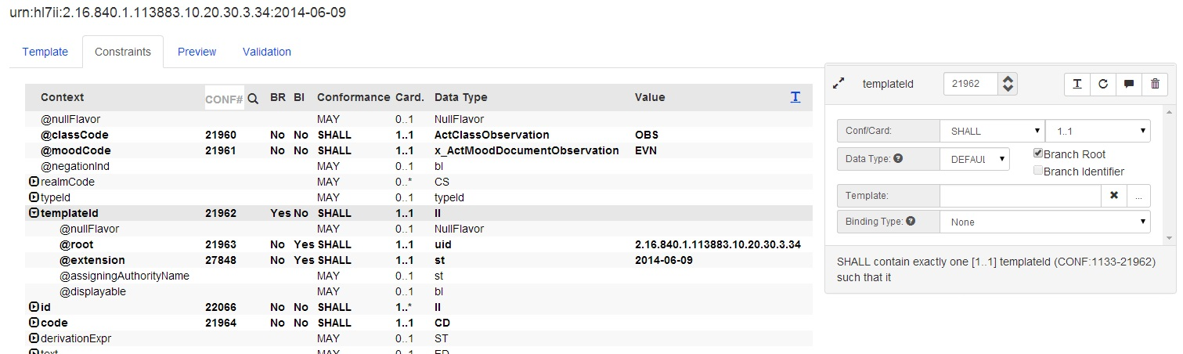

## Constraints with Data-type CS

Coded Simple Value (CS)

Definition: Coded data in its simplest form, where only the code is not predetermined. The code system and code system version are fixed by the context in which the CS value occurs. CS is used for coded attributes that have a single HL7-defined value set.

This means that you should only specify the "Code" attribute for a single-value binding. An example of where this is commonly the case is with the "statusCode" element.

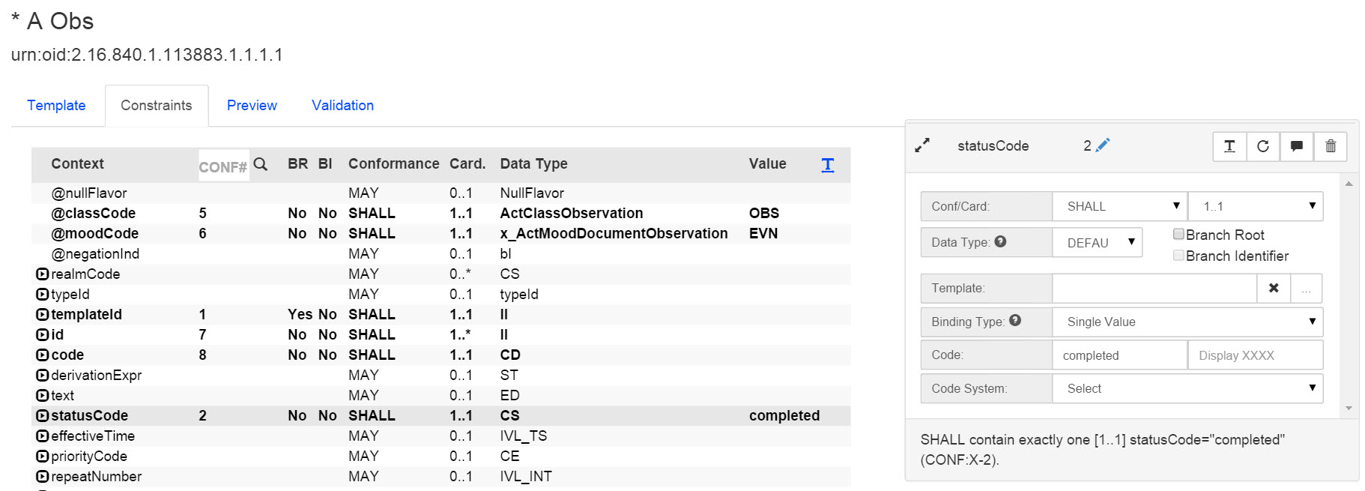

**FHIR Best Practices**

## Bindings on Data-type Elements

When binding terminology (single-value, value set or code system) to an element in a FHIR profile, it is preferred that the binding be applied to the data-type elements. Trifolia gives you the freedom to assign the binding to elements/attributes *within* data-types, but this is not preferred.

Bad Example #1

1. SHALL contain 1..1 name
   1. SHALL contain 1..* coding
   2. SHALL contain 1..1 code, which SHOULD be selected from ValueSet AdvanceDirectiveTypeCode urn:oid:2.16.840.1.113883.1.11.20.2 STATIC 2006-10-17

Bad Example #2

1. SHALL contain 1..1 name
2. SHALL contain 1..* coding, which SHOULD be selected from ValueSet AdvanceDirectiveTypeCode urn:oid:2.16.840.1.113883.1.11.20.2 STATIC 2006-10-17

**Good Example**

1. SHALL contain 1..1 name, which SHOULD be selected from ValueSet AdvanceDirectiveTypeCode urn:oid:2.16.840.1.113883.1.11.20.2 STATIC 2006-10-1

**Publish Settings**

Use the Publish Settings page to control the way a template/profile appears in an implementation guide.

You can control the following:

* Generate and customize code samples to associate with the template.
* Control whether one or more constraints has its own heading in the implementation guide.

## View the Publish Settings page

Select Publish Settings from the Template Viewer's Quick Buttons.

## Constraint Headings

For complex template/profile structures, it is best practice to document certain elements of the template/profile in greater detail.

Use the Constraints tab of the Publish Settings page to add headings to constraints that appear in an implementation guide. This allows complex templates to be broken into sections within the implementation guide.

### Add a Heading to a Constraint

1. In the Constraints section of the Publish Settings page, select Edit for the constraint you want to edit.
2. To add to the constraint heading text, select the Heading check box. The Heading Description box appears.
3. Enter text in the Heading Description, Description, and Label boxes. The text appears as shown in the example below.
4. To add an inline code sample, select Add. The Edit Constraint Sample window appears. Enter a Name for the sample, and enter the sample code in the Sample Contents box, then select OK. The sample name appears in the sample list.
5. When finished, select OK. Heading text, Description text, Label text, and Sample Code are added to the selected constraint. The effect is shown below.
6. When finished, select Save in the Edit Publish Settings.

## Samples

Use the **Template Samples** tab of the **Publish Settings** page to generate, customize, and format code samples to associate with a particular template.

### Generate a Code Sample

1. In the Template Samples tab, select Add. The Edit Sample page appears.
2. Enter a Name for the sample.
3. Enter or paste the text you want to use in the sample, or select Generate to create a code sample based on the template's constraints.
4. If you generated a sample, edit it as needed.
5. To format the sample automatically, applying standard indentation, Format and Indent.
6. When finished, select OK. The sample is saved, and is available for export with the implementation guide.

**Terminology**

## Edit a Value Set

1. In the Value Sets tab, locate the value set you want to edit, or select Add Value Set to add a new set. The Edit Value Set screen appears.
2. Enter the value set's meta data as described below.
3. For each member of the value set, select Add Member.
4. When finished, select Save. The value set is saved.

### Value Set Meta Data

* **Name** - Enter a name for the value set.
* **Identifier** - Enter an identifier for the value set in one of two formats
  + urn:oid:XXXX
  + http[s]://XXXX
* **Code** - Enter a code value set.
* **Intensional** - Indicate whether the value is computable.
* **Intensional Definition** - Describe how to compute the value set. You may want to use custom scripting; the ultimate goal is to demonstrate that “this value set references Value Sets X and Y”
* **Description** - A description of the value set and its purpose.
* **Source URL** - Indicate the source of this value set.  
  For example: http://www.phconnect.org/group/phinvads (CDC's Public Health Information Network Vocabulary Access and Distribution System)
* **Incomplete** - Check this box if the value set is not yet complete.

### Value Set Member Data

* **Code** - Enter a code for the value.
* **Display Name** - Enter a display name for the value.
* **Code System** - Choose the code system that contains value set.
* **Status** - Indicate whether the value is currently active or inactive.
* **Status Date** - Enter the date the status was changed.

## Edit a Value Set's Codes / Concepts

1. In the Value Sets tab, locate the value set you want to edit.
2. Select the menu drop-down on the value set.
3. Select Edit Concepts. The Edit Value Set Concepts screen appears.
4. Add concepts by completing the fields in the bottom row of the top table and selecting Add. After adding a concept, the concept will move to a new table called"Pending Changes.
5. Edit concepts already in the value set by finding the concept in the top table and selecting the Edit button. The values in the columns of the first table will change to represent editable fields. When done making changes, select the OK button to the right of the row. The changes made to the concept are reflected in the Pending Changes table.
6. Remove an existing concept from the value set by finding the concept in the first table and selecting the Remove button to the right of the row. The concept will be moved to a Pending Removal table at the bottom of the screen.
7. When done adding, editing and removing concepts in the value set, select the Save button at the bottom of the screen to persist the changes.

## Edit a Code System

1. In the Code System tab, locate the code system you want to edit, or select New to add a new code system. The Add/Edit Code System window appears.
2. Enter the code system information as described below.
3. When finished, select Save. Your changes are saved.

### Code System Meta Data

* **Name** - Enter a name for the code system.
* **Identifier** - Enter the code system's identifier in one of the following formats:
  + urn:oid:XXXX
  + http[s]://XXXX
* **Description** - Enter a description for the code system.

## Delete a Value Set

1. From the Value Sets tab of the Terminology Browser, locate the value set you want to delete.
2. Select the drop-down menu arrow to the right of the value set name and choose Remove. A confirm message appears.
3. Select OK. The value set and its members are removed.

## Delete a Code System

1. From the Code Systems tab of the Terminology Browser, locate the code system you want to delete.
2. Select the drop-down menu arrow to the right of the code system name and choose Remove. A confirm message appears.
3. Select OK. The code system is removed.

**MS Word**

## Export Templates

1. From the Export menu, choose Templates to MS Word. The Export MS Word page appears displaying a list of implementation guides. See Browsing Implementation Guides for more information.
2. In the row containing the implementation guide you want to export, choose Select (in the column at the far right). The Export Templates to MS Word page appears.
3. In the **Content tab**, choose the content you want to include in the export file. You can also choose a sort order for the templates.
4. In the **Value Sets tab**, choose whether to include value sets in the export file, the maximum number of values to include, and where they are located in the export file.
5. In the **Templates tab**, choose the templates you want to include. By default, all templates are selected. You can also choose to Include Inferred templates.
6. In any of the tabs, select Export. A Word document is created and downloaded to your computer.

## Export Settings

Each tab of the Export Templates to MS Word page contains settings specific to the tab.

### The Content Tab

* **Sort Order** - choose Alphabetically to sort by template/profile name, or Alpha-Hierarchical to sort by template/profile name within the referenced template/profile hierarchy. Templates are sorted first by type, then by template/profile relationship, then alphabetically within that relationship. This is much easier to understand if you look at the Containment table in the export document, as described in the following section.
* **Document Tables** - choose from the drop-down menu to include the Template List table, the Template Containment table, or Both.
* **Template Tables** - choose from the drop-down menu to the Context table, the Constraint Overview table, or Both.
* **XML Samples** - select the Include check box to include XML samples in the export file.
* **Change List** - select the Include check box to include the Change List in the export file.
* **Publish Settings** - select the Include check box to include Publish Settings in the export file.
* **Notes** - select the Include check box to include Notes in the export file.

**Note**: For more information about how vocabulary information is represented in by Trifolia template, vocabulary, and Schematron exports, see Terminology & Trifolia.

### The Value Sets Tab

* **Tables?** - choose whether to include value set tables in the export file.
* **Maximum Members** - specify the maximum number of members that should be exported for a given value set.
* **Create as Appendix** - choose whether the value sets are included as an appendix.

Each value set included in the implementation guide may have a separate "maximum members" setting. When changing the "Maximum Members" setting at the top of the "Value Sets" tab, all individual value sets are defaulted to the same "Maximum Members" value. After selecting a default for all value sets, you can change individual value sets to reflect a different "maximum members" value that is more appropriate for the individual value set.

### The Templates Tab

The Templates tab shows a list of templates that appear in the selected implementation guide.

* **Parent Template** - choose a template/profile to export only a subset of the templates in a guide. The export file includes the parent template/profile and any templates referenced by it. The Include Inferred check box includes all referenced templates; if not selected, the export file includes only those templates contained in the implementation guide.
* **Include Inferred** - choose whether to include inferred templates in the export file. For larger guides, this may increase generation time and may result in a significantly larger document.
* **Template List** - select or clear check boxes to select the templates you want to include in the export file. Select or clear the check box in the table's header row to select or clear the boxes for all templates.
* **This IG? column** - Yes indicates that the template/profile is contained in the implementation guide. No indicates that the template/profile is referenced by one of the templates in the implementation guide, but is not contained in it.

## Document Tables

You can choose to include two automatically-generated tables in the export document:

* **List table** - lists the templates in the implementation guide.
* **Containment table** - list the templates within their referenced hierarchy.

To choose the document tables to include:

* Choose **None** to exclude both tables.
* Choose **Both** to include both tables.
* Choose **List** to include only the List table
* Choose **Containment** to include only the Containment table.

## Template Tables

For each template, the default setting is “both” to export context and constraint-overview tables in the document export. However, you can choose to include none, one or both automatically-generated tables.

* **Context table** - lists the templates that use this template, and the templates that are used by it.
* **Constraint Overview table** - provides an overview of all constraints in the template, with a link to each constraint.

To choose the template/profile tables to include:

* Choose **None** to exclude both tables from each template.
* Choose **Both** to include both tables in each template.
* Choose **Context** to include only the Context table in each template.
* Choose **Containment** to include only the Containment table in each template.

## Save Default Export Settings

Users that have "Edit" permission for the implementation guide being exported have the option to save the current configuration settings as the default settings for all users. For these permitted users, a checkbox is available at the bottom of the "Export Templates to MS Word" screen which, when checked, saves the current configuration of settings as the default settings. When any user exports the same implementation guide's templates to MS Word, these default settings will be used. Users that do not have edit permissions to implementation guide will still be able to make their own customizations to the settings; however, they will not be able to store them as the default settings.

**Schematron**

Use the Export Menu's **Standard IG Schematron** command to export Schematron for the selected implementation guide. The Export Schematron page is also available from the View Implementation Guide page.

## Export Schematron

1. From the Export menu, choose **Standard IG Schematron**. A list of implementation guides appears. See Browsing implementation guides for more information.
2. In the row containing the implementation guide you want to export, choose **Select** (in the column at the far right). The Export Schematron page for the selected guide appears.
3. In the **Options** tab, choose the **Value Set Format**, specify the **Value Set File Name** to use for value set output, and choose whether to use custom Schematron.
4. In the **Templates/Profiles** tab, select or clear check boxes to indicate the templates you want to include in the export file. Select or clear the check box in the table's header row to select or clear the boxes for all templates.
5. Select **Export**. A standard Schematron file is generated and saved to your local machine.

### The Options Tab

* **Value Set Format** - choose the format you want to use from the drop-down menu
* **Include Custom Schematron** - choose whether to include any custom Schematron entered on the Edit implementation guide > Custom schematron screen.
* **Value Set File Name** - enter a new filename to use for value set output, or use the default, voc.xml.
* **Default Schematron** - specify the assertion that should be used when a primitive constraint is defined that does not have custom schematron defined for it.

### The Templates/Profiles Tab

When "Include Inferred" is "Yes", all templates/profiles owned by the implementation guide and all templates referenced by templates within the selected implementation guide will be included in the list of templates. When "Include Inferred" is "No", only templates owned by the selected implementation guide will be included in the list of templates. See Common Features > Inferred Templates for more information.

Select or clear check boxes to choose the templates you want to include in the guide. A **No** in the **This IG?** column indicates that the template/profile is referenced by, but not contained in the implementation guide. Select or clear the check box at the top of the column to select or clear all check boxes.

**Web-Based IG**

TODO

**Terminology**

Use the Export menu's Vocabulary command to export pre-defined value sets and single-value bindings from templates in an implementation guide.

**Note**: For more information on how vocabulary information is represented in Trifolia template, vocabulary, and Schematron exports, see Terminology & Trifolia.

## Export Vocabulary

1. From the Export menu, choose Vocabulary. A list of implementation guides appears. See Browsing Implementation Guides for more information.
2. In the row containing the implementation guide you want to export, select Actions (in the column at the far right) then choose Export Vocabulary. The Export page for the selected guide appears, showing the available value sets.
3. Choose a Format for the export. Vocabularies can be exported in these formats:
   1. Lantana standard (SCH)
   2. Sharing Value Sets (SVS)
   3. Excel (XSLX)
4. In the Maximum Members box, enter or use the arrow buttons to set the number of members a value set must contain in order to be excluded from the export.
5. Choose an Encoding format.
6. Select Export. A vocabulary file in the selected format is generated and saved to your local machine.

The "Value Sets" tab on the export settings screen shows the user the value sets that will be included as part of the export. No changes can be made to this tab, it is only for informational purposes.

## Export Formats

Value sets that are **dynamically** bound to an implementation guide (via a template's constraint) are only included in the following export formats:

* Excel
* FHIR

### Lantana Standard (XML)

The "Lantana Standard" XML format is a proprietary format developed by Lantana. This format is used by schematron for validating value set bindings.

### Sharing Value Sets (SVS/XML)

The Sharing Value Sets (SVS) profile provides a means through which healthcare systems producing or consuming clinical or administrative data, such as diagnostic imaging equipment, laboratory reporting systems, primary care physician office EMR systems, or national healthcare record systems, can access value sets built from common, uniform nomenclatures managed centrally. Shared nomenclatures with specific derived value sets are essential to achieving semantic interoperability.

[Download Specification](http://www.ihe.net/Technical_Framework/upload/IHE_ITI_Suppl_SVS_Rev2-1_TI_2010-08-10.pdf)

### Excel (XLSX)

The Excel format includes two sheets:

* Affected Value Sets
  + **Value Set Name**
  + **Value Set OID**
* Value Set Members
  + **Value Set OID**  
    This is the identifier of the value set that the memeer belongs to (a reference to a row on the "Affected Value Sets" sheet)
  + **Value Set Name**  
    This is the name of the value set that the member belongs to (a reference to a row on the "Affected Value Sets" sheet)
  + **Code**
  + **Display Name**
  + **Code System Name**

### FHIR

The output of this export is in FHIR DSTU1 XML format. Additional details on this format can be found [here](http://www.hl7.org/fhir/DSTU1/valueset.html).

**XML/JSON**

## Export Templates to XML

1. From the Export menu, choose Template to XML. A list of implementation guides appears. See Browsing Implementation Guides for more information.
2. In the row containing the implementation guide you want to export, select Actions (in the column at the far right) then choose Export XML. The Export page for the selected guide appears.
3. Choose the templates you want to include in the guide. You can select a parent template/profile to include only the templates associated with that template.
4. Select Export. You are taken through the process of saving the file. This process differs, depending on your browser. When finished, the XML file is saved to your local machine.

### XML Type

* **Trifolia XML**: This is an XML format for templates proprietary to Trifolia. The schema for this format can be downloaded here.
* **FHIR XML**: This option is only available for FHIR implementation guides. This converts the templates in the implementation guide into the XML format defined by FHIR DSTU 1. This XML export includes both FHIR Profile and ValueSet resources. See http://www.hl7.org/fhir for more details on FHIR DSTU 1.
* **FHIR Build**: This option is only available for FHIR implementation guides. This create a zip package that can be used by the FHIR IG publisher to produce HTML files following the same styles and practices as the core FHIR standard.
* **Data Snapshot**: This is a JSON-based export of the implementation guide (including all templates/profiles, value sets, code systems, volume 1 content, etc). It can be uploaded to the "Files" section of an implementation guide and used as a point-in-time snapshot with the web-based IG.

**Importing**

## Importing using the native XML format with the web interface

Trifolia can import implementation guide and template/profile data via the "Import" tab. The Trifolia native XML format includes all information that Trifolia uses to generate various exports, including sample information for both templates/profiles and constraints, heading information, template type descriptions, etc. This export/import format is designed to transfer information between different installations of Trifolia.

To import this format:

1. Select the "Import" tab from the top navigation menu
2. Select the file to import
3. Click the "Import Now" button

After the import is complete, you will be presented with a report indicating what was changed (or not changed) during the import. Templates/profiles shown the report can be expanded to see what constraints and samples were modified.

Here are some key things to know when importing data using this method:

* The import *does* overwrite existing information..
* If the import includes implementation guides or templates that already exist, and changes are made to the implementation guides and templates/profiles, you must have access to edit the implementation guide and/or template, or the import will fail.
* If the import includes new implementation guides or templates that do not exist, then as long as the user has a role that allows for the creation and editing of implementation guides and/or templates, the import will be successful.
* Templates/profiles, constraints and samples that already exist and are not included in the import XML file are *not* deleted. For example, if Trifolia already has templates/profiles A, B and C in "My Implementation Guide", and the import XML file only contains templates/profiles A and B, then template/profile C will still remain in "My Implementation Guide" after the import is complete.

## Importing using FHIR REST interface

Trifolia provides *some* (but not all) POST/PUT/DELETE functionality for FHIR profiles. Below is a list of the operations supported by Trifolia:

* FHIR DSTU2 /api/FHIR2/
  + POST /api/FHIR2/StructureDefinition
  + PUT /api/FHIR2/StructureDefinition/{id}
  + DELETE /api/FHIR2/StructureDefinition/{id}
  + POST /api/FHIR2/ValueSet
  + PUT /api/FHIR2/ValueSet/{id}
* FHIR STU3 /api/FHIR3/
  + POST /api/FHIR3/StructureDefinition
  + PUT /api/FHIR3/StructureDefinition/{id}
  + DELETE /api/FHIR3/StructureDefinition/{id}
  + POST /api/FHIR3/ValueSet
  + PUT /api/FHIR3/ValueSet/{id}

**Reports**

Use the Reports menu to choose and generate a variety of reports. The following reports are available from the Reports menu.

* **Template Review** - lists templates and their details. Filter and group in many ways.
* **Template Validation** - select the implementation guide you want to validate. Select to show Warnings, Errors, or All. Shows the status of any templates containing warnings or errors.
* **Organization** - lists all users in an organization, along with their permissions and contact info.

## View a Report

1. From the Reports menu, choose the report you want to view. A report page appears, with a page summary and navigation at top. A filter box appears at the top of each column.
2. Enter filters in the top row of the report to limit the data that appears in the report as described in Report Filters, below.
3. Print the report as needed.

### Report Filters

You can filter by the contents of a column to limit the data that appears in the report.

* **String filter** - Enter text in one or more columns.
* **Dropdown filter** - Choose a filter from the drop-down menu at the top of a column to view only entries with that value.

**Formatting Text**

Trifolia allows you to format descriptions, notes, and narrative constraint text using wiki syntax. When you render the output to HTML or Word, the text is formatted correctly.

## Fields That Support Wiki Syntax

The following fields support wiki syntax formatting:

* Primitive Constraint Narrative
* Constraint Description
* Constraint Heading Description
* Template Description
* Template Note
* Template Type Description (ex: “Document Templates” description)

## Bold Text

Input Example

This is *an example of bold* text

Output Example

This is **an example of bold** text

## Italics

Input Example

This is _an example of italic_ text

Output Example

This is *an example of italic* text

## Links

You can create links to templates, or to external resources such as websites or reference documents. Depending on the syntax, Trifolia can insert information into the link's text.

### Link to Template by OID

Input Example

Example of a link to [URL:#1.2.3.4.5]

Output Example

Example of a link to My Template Name (1.2.3.4.5)

### Link to External Website, without Link Text

Input Example

Example of a link to [URL:http://www.lantanagroup.com]

Output Example

Example of a link to http://www.lantanagroup.com

### Link to External Website, with Link Text

Input Example

Example of a link to [URL:Lantana Consulting Group|http://www.lantanagroup.com]

Output Example

Example of a link to Lantana Consulting Group

## Tables

Input Example

|| Name || Email || Location

| Joe | joe@lantanagroup.com | Texas

| Sally | sally@lantanagroup.com | Arkansas

| John | john@lantanagroup.com | Pennsylvania

Output Example

|  |  |  |
| --- | --- | --- |
| **Name** | **Email** | **Location** |
| Joe | joe@lantanagroup.com | Texas |
| Sally | sally@lantanagroup.com | Arkansas |
| John | john@lantanagroup.com | Pennsylvania |

## Bullets and Numbers

Wiki syntax supports ordered (numbered) and unordered (bulleted) lists.

### Unordered List (Bullets)

Input Example

* Bullet 1

* Bullet 2

* Bullet 3

Output Example

* Bullet 1
* Bullet 2
* Bullet 3

### Ordered List (Numbers)

Input Example

# Bullet 1

# Bullet 2

# Bullet 3

Output Example

1. Bullet 1
2. Bullet 2
3. Bullet 3

**Inferred Templates**

Inferred templates are templates not directly owned by a given implementation guide, but are referenced by it.

Example Scenario

**Implementation Guide A** directly contains **Template A, B** and **C**

**Implementation Guide B** directly contains **Template D, E** and **F**

**Template D** contains **Template A** from **Implementation Guide A**

For "Implementation Guide B", "Template A" is an "inferred template" because it is not directly owned by "Implementation Guide B" but it is referenced by a template/profile that is directly owned by "Implementation Guide B".

**Importing**

Administrators can import data into Trifolia. If you would like your data imported into Trifolia, please use the information below to format your import in a way that can be easily interpreted by Trifolia administrators, and send the Trifolia development team a request to import your data.

## Value Sets

TODO

**FHIR**

Trifolia's implementation of the FHIR specification is documented here. This topic includes information on the latest implementation of FHIR in Trifolia; previous versions are kept for backwards compatibility, but are not actively maintained. **Trifolia currently supports the STU3 version of FHIR.**

The following table(s) indicate what properties Trifolia uses of the FHIR specification, and any relevant notes about the property's usage in Trifolia.

## StructureDefinition

| **Property** | **Notes** |
| --- | --- |
| id |  |
| name |  |
| description |  |
| url |  |
| type |  |
| context |  |
| contextType |  |
| derivation |  |
| extension |  |
| contact | Not imported with POST/PUT. Exported with GET, represents the author of a profile. |
| baseDefinition |  |
| differential |  |
| snapshot | Not imported. Only differential definitions are imported. |

### ElementDefinition

|  |  |
| --- | --- |
| **Property** | **Notes** |
| id |  |
| short | Constraint's label if specified, or the element/attribute name if not |
| label | Constraint's label if specified |
| comment | Constraint's notes, if any |
| path |  |
| min |  |
| max |  |
| slicing | When the constraint, or a parent constraint is a branch/slice |
| slicing/discriminator | The first "identifier" within the branch/slice or "@type" when constraint is a schema-based choice |
| slicing/rules | Always set to "open" when constraint is a schema-based choice |
| binding[x] |  |
| binding/strength |  |
| bindingReference/reference |  |
| bindingReference/display |  |
| pattern[x] |  |
| patternCodeableConcept | When there is a single-value binding and the data-type is CodeableConcept |
| patternCoding | When there is a single-value binding and the data-type is Coding |
| patternCode | When there is a single-value binding and the data-type is code |
| patternString | When there is a single-value binding and the data-type is not one of the above. |
| type |  |
| type/code | "Extension" when the profile is for an Extension, otherwise "Reference" |
| type/profile | Contained profile's "url", when profile is for an extension |
| type/targetProfile | Contained profile's "url", when profile is not an extension |

## ImplementationGuide

TODO

## ValueSet

TODO

**API**

Trifolia includes limited functionality for the [FHIR REST API](http://www.hl7.org/fhir/http.html).

## Versions

Trifolia supports three different versions of the FHIR REST API for backwards compatibility. However, only the latest version is actively developed and improved.

Each of the base endpoints correlate to their version of the FHIR standard:

|  |  |  |
| --- | --- | --- |
| **Version** | **Endpoint** | **Notes** |
| DSTU1 | /api/FHIR1 | No longer maintained |
| DSTU2 | /api/FHIR2 | No longer maintained |
| STU3 | /api/FHIR3 | Current, actively maintained |

Additionally, each of these endpoints correlate to the appropriate Implementation Guide Type in Trifolia. For example, only Implementation Guides associated with the Implementation Guide Type "FHIR Latest" will be returned by requests to the /api/FHIR3 endpoint. Similarly, only Implementation Guides associated with the Implementation Guide Type "FHIR DSTU2" will be returned by the /api/FHIR2 endpoint.

## Authentication

All REST endpoints are authenticated with OAuth 2.0 using a Authentication header with a "Bearer" token.

To get a token to use for authentication, login to Trifolia and click on the "My Profile" menu under your name in the top-right corner. In the "My Profile" page, the authentication token for your logged-in user will be shown in a separate panel.

Use the authentication token in the "My Profile" page in REST API calls by adding an "Authorization" header with a value of "Bearer <TOKEN>".

## Customizations

* StructureDefinition.id cannot exist in the Profile when performing a POST
* StructureDefinition.id must not be changed when performing a PUT

## Supported Operations

See Developer Docs for more details.

|  |  |
| --- | --- |
| **Method** | **Endpoint** |
| GET | /api/FHIR3/metadata  /api/FHIR3/CapabilityStatement |
| GET | /api/FHIR3/ImplementationGuide  /api/FHIR3/ImplementationGuide/_search |
| GET  PUT  DELETE | /api/FHIR3/ImplementationGuide/{implementationGuideId} |
| POST | /api/FHIR3/ImplementationGuide |
| GET | /api/FHIR3/StructureDefinition  /api/FHIR3/StructureDefinition/_search |
| GET  PUT  DELETE | /api/FHIR3/StructureDefinition/{id} |
| POST | /api/FHIR3/StructureDefinition |
| GET | /api/FHIR3/ValueSet  /api/FHIR3/ValueSet/_search |
| GET  PUT | /api/FHIR3/ValueSet/{id} |
| POST | /api/FHIR3/ValueSet |

**Extensions**

## Re-usable Extensions

Trifolia supports re-usable extensions for FHIR DSTU2 implementation guides and profiles.

### Creating a Re-usable Extension

1. Create a new profile in a FHIR DSTU2 implementation guide.
2. Select FHIR DSTU2: Extension for the "type" of profile.
   1. Note that the Applies To button is disabled for Extension profiles.
   2. After selecting Extension as the type of profile, a constraint is automatically created by Trifolia for the "@url" attribute and matches the identifier specified for the extension. Any time the identifier is updated, the constraint will automatically be updated as well.
3. Define a constraint for the type of value your extension will require (such as "valueCodeableConcept").
4. Save the profile.

Trifolia treats all profiles that are of type FHIR DSTU2: Extension as re-usable extensions. The behavior of Trifolia's template/profile editor adjusts slightly (such as disabling the Applies To selection button, and automatically adding a @url constraint) to account for requirements in the core FHIR DSTU2 standard when editing extension profiles.

### Using a Pre-defined Extension

1. Open any FHIR DSTU2 profile.
2. In the constraint editor, select an "extension" element that does NOT already have a constraint defined for it.
3. A drop-down list shows in the constraint editor panel that provides a list of all extensions for which you have permissions.
4. Select the extension you want to add to the profile and select the "+" (add) button.
5. The "extension" element is turned into a constraint, and automatically creates constraints for each of the constraints defined in the extension.
6. The "extension" element itself should be marked as a slice and the @url constraint within the extension should be marked as a descriminator. The conformance and cardinality is set to "SHALL 1..1" for the new extension constraint, as well as the @url descriminator.

## Profile Extensions

The profile may define extensions in addition to the constraints. These are extensions that add information to the profile as a whole, but are not required to be implemented where the profile is used/asserted.

Both FHIR DSTU1 and FHIR DSTU2 profiles support extensions on the profile.

### Adding Extensions to a Profile

1. Edit any FHIR profile.
2. The bottom entry in the Extensions panel of the Template/Profile tab always represents a "new" extension.
3. Fill in the identifier, type, and value of the extension (all three fields are required).
4. Select the Add button to the right of the fields.
5. The extension is now added to the profile, and the profile can be saved. The extension added may be edited, but the type of the extension may not be changed; only the identifier and the value may be changed after extension is added.

Note: A future version of Trifolia will incorporate re-usable extensions in the profile extensions.

**Developer Docs**

This topic provides documentation to developers that would like to integrate with Trifolia or contribute to Trifolia's open source code-base.

## API Help Documentation

Trifolia's API help documentation is automatically generated based on code-comments. The help documentation can be found at http://your.installation/api/Help.

Lantana's installation of Trifolia exposes the help documentation here: <https://trifolia.lantanagroup.com/api/Help>

## WADL (rest endpoint specification)

The WADL can be found here:http://your.installation/api/Help/Wadl

Lantana's installation of Trifolia exposes the WADL here: <https://trifolia.lantanagroup.com/api/Help/Wadl>

**Version 4.3.1**

## Version 4.3.1

Released on Friday, Jan 14, 2017

### Rollback of Schema Choice Support for CDA-based templates

In version 4.3.0, we release preliminary support for Schema Choices for all implementation guides and templates. Through-out the last month we have identified a number of unforeseen issues with Schema Choices in CDA-based implementation guides and templates. As a result, we are rolling back these features for non-FHIR implementation guides until we can assess how to properly address the issues we have identified.

**Version 4.3.0**

## Version 4.3.0

Released on Friday, Dec 2, 2016

### Schema Choice Support

XML Schema supports a notion of "choices", where you can select one element out of several options. Prior to this release, Trifolia showed those options as though you could select more than one of the options at a time. Now, Trifolia fully supports the notion of a schema choice, by wrapping the options in a parent element (such as "effective[x]"). The conformance and cardinality is defined in the parent element and does not apply to the options within the parent element.

Narrative generation is modified so that it is clear that only one option may be used at a time. For example:

* SHALL contain 1..1 effective[x], where effective[x] is one of:
  + effectiveDateTime
  + or effectivePeriod

Note: The schematron generation engine has not been updated yet to handle schema choices. This will be done in a future (most likely the next) release.

### FHIR Build Package

The export for "FHIR Build Package" (available under Export > "Templates/Profiles to XML/JSON" menu) has been updated to work with the latest version of the FHRI IG Publisher.

* Template/Profile samples are added to the control file
* "sct-edition" property is added to the control file, and defaulted to the US edition
* The url for the ImplementationGuide resource includes the base identifier
* Invalid UTF-8 characters are automatically removed from the description
* The "resources.html" include file is auto-generated by Trifolia, and includes profile descriptions
* StructureDefinition exports are modified to support schema choices
* The fhir-net-api is updated based on the ft-connectathon2017 branch which includes the latest updates
  + As a result of this, the FHIR REST API (/api/FHRI3/) has been updated to support CapabilityStatement instead of Conformance

### Development Log

|  |  |
| --- | --- |
| **Type** | **Description** |
| Feature | UI changes for schema choices |
| Feature | Narrative generation updates for schema choices |
| Improvement | Include implementation guide files in Native XML export/import |
| Improvement | FHIR Resource Instances in Web-based IG |
| Defect | Trifolla FHIR Build: Review/resolve errors in IG Publisher for Trifolia export |

**Version 4.2.x**

## Version 4.2.1 and 4.2.2

Released on Wednesday, Nov 16, 2016

### Home page update

The home page of Trifolia always shows the latest changes regardless of whether or not a user is logged in.

### Support Methods

Added functionality to allow administrators of the OAuth2 directory to set the preferred support method for individual users. A default support method is used, unless the logged-in user has been configured with a specific support method.

### Bug Fixes

These two releases are primarily focused on critical bug fixes that were blocking users from editing certain templates/profiles and implementation guides.

### Development Log

|  |  |  |
| --- | --- | --- |
| **Type** | **Version** | **Description** |
| Defect | 4.2.2 | Exporting FHIR Build Package producing an error |
| Defect | 4.2.2 | Exporting HQMF R2 based implementation guide producing an error |
| Defect | 4.2.2 | Value set relationships showing incorrect data |
| Improvement | 4.2.2 | Allow admin to set support method (JIRA vs. Email vs. URL redirect) for individual users |
| Defect | 4.2.1 | Base identifier for implementation guides can't always be unique |
| Defect | 4.2.1 | Template Edit causes templateId to change to be invalid |
| Defect | 4.2.1 | Template Editor: Intermittent "An Error Occurred" message |

**Version 4.2.0**

## Version 4.2.0

Released on Wednesday, Oct 5, 2016

### Open-Source Authentication

The existing Active Directory and custom HL7 authentication has been replaced with a generic authentication method (OAuth 2.0). **OAuth** is an open standard for authorization, commonly used as a way for Internet users to log in to third party websites using their Google, Facebook, Microsoft, GitHub, etc. accounts without exposing their password.

As part of this migration, all existing Trifolia user accounts have been added/imported to the new OAuth Trifolia directory. Existing Trifolia users will receive a Password Reset link via e-mail that will allow them to use their Trifolia credentials when logging in using the Auth0. Clicking on the link in the email will direct the user to auth0.com and prompt the user to create a new password for your Trifolia account.

When users click the "Login" option in Trifolia version 4.2.0, they will now see the Auth0 login form. Existing users can use their Trifolia credentials to login, and pre-existing permissions to implementation guides, templates, value sets, code systems, etc., will persist. Each authentication method (Facebook, Microsoft Account, Username/Password, etc.) represents a separate user in Trifolia, with separate permissions. In the future, Trifolia *may* support linking these multiple authentication methods to a single account.

### Trifolia open source Github support request

Three options are now available for support requests, that are configurable

* JIRA, when JIRA is configured and enabled
* Email, when a support email address is specified
* If a support request is initiated in Trifolia, but JIRA is not configured and enabled, and a support e-mail address is not configured, a redirect URL will

be opened in a separate window to allow users to log a ticket in GitHub.

Lantana's installation of Trifolia (<https://trifolia.lantanagroup.com>) re-directs all users to the [Github Trifolia repository's issues page](https://github.com/lantanagroup/trifolia/issues).

### Remove association between User and Organization

Users and groups are not organization-specific; they are now managed individually. Each user can have their own groups that they can assign members to. Any user can request to join any group.

When editing an implementation guide, the user no longer needs to select an organization prior to selecting a user/group; searching is performed globally and returns any matching user or group.

### Group disclaimers

Group Disclaimers can now be added in a new option called My Groups when the logged-in user clicks on their name. Users can see disclaimers for groups they are associated with by clicking "Disclaimers" from the Help menu.

### Identifier/Base identifier field for Implementation Guides

In FHIR implementation guides, it is important to have a base identifier for the implementation guide that each profile follows. A new field has been added to the implementation guide editor which will require identifying a base identifier for all existing implementation guides.

### FHIR data type

The MS Word and web-based Implementation Guide exports will now include a column for the "Data Type" of the constraint in the "Constraints Overview" tables.

### FHIR build export

Trifolia has a new option under Export XML/JSON to export a "FHIR Build" package. The "FHIR Build" package option is only available for FHIR-based implementation guides. The export produces a ZIP file that includes all files pre-configured to run the FHIR IG Publisher.

### Development Log

|  |  |
| --- | --- |
| **Type** | **Description** |
| New Feature | Add field to IG for "Identifier / Base URL" |
| New Feature | Use OAuth2 to authenticate users |
| New Feature | Show Group Disclaimers |
| New Feature | Create a migration path for user account |
| New Feature | Removed association between User and Organization |
| New Feature | Generate FHIR build/export |
| Improvement | Include the FHIR data-type in IG exports |
| Improvement | Default new FHIR profiles to use IG's base URL |
| Task | Redirect Trifolia Support Requests to Trifolia Open Source GitHub |
| Defect | Cannot download Web-IG for C-CDA on FHIR |

**Version 4.1.0**

## Version 4.1.0

Released on Thursday, Sept 8, 2016

### FHIR STU3 Updates

StructureDefinition resources exported from Trifolia include some additional information that is required by the FHIR build process. A couple minor bugs were fixed related to searching for resources.

### Web IG UML Diagram

The web-based IG UML diagram now works in the latest version of chrome, and the components used for generating the diagram have been updated to the latest version; requiring some minor changes to how the UML diagrams are built. Small improvements may be noticed in the layout of the diagrams as a result.

### Development Log

|  |  |
| --- | --- |
| **Type** | **Description** |
| Improvement | Always specify context and contextType for StructureDefinition exports |
| Improvement | Full URL is needed for value set |
| Improvement | Base definition must have a full URL |
| Improvement | Terminology: Problem Type - vocabulary export does not include LOINC and SNOMED codes |
| Defect | MS Word Export is not formatting constraint overview tables properly. |
| Defect | Unspecified error removing constraints with a comment |
| Defect | Make sure failed support requests, show failed to the user |
| Defect | Value set static binding date is removed when a template is versioned. |
| Defect | Web IG Relationships diagram tab not working in Chrome 48+ |
| Defect | Value set static binding date is removed when a template is versioned. |

**Version 4.0.0**

## Version 4.0.0

Released on Thursday, Aug 4, 2016

### Open-Source Release

Trifolia’s source code is available to the open-source community via a Github repository (<https://github.com/lantanagroup/trifolia>). This first release to open source is simply a dump of the Trifolia code-base. In the coming months, we will simplify the installation process, include exports of publicly available implementation guides (such as “IHE Health Story Consolidation”), and improve the developer documentation.

### Support for FHIR STU3

Trifolia includes support for FHIR STU3 in addition to DSTU1 and DSTU2. (HL7 recently changed the naming convention of draft specifications from DSTU—Draft Standard for Trial Use— to STU—Standard for Trial Use.) Support focuses on exporting, although some import functionality exists. Trifolia users can edit profiles using the STU3 schemas, and /api/FHIR3 endpoints allow integration with Trifolia.

### Non-Google Captcha

We have had reports from users in China that they were not able to successfully login due to the Google-based captcha system. We found that China restricts the google.com domain, which is required for Google’s captcha use. We have replaced the Google captcha, enabling China-based users to access Trifolia.

### Importing Data

A new “Import” menu item is available to editors for importing Trifolia-formatted data. This allows multiple installations of Trifolia to exchange implementation guides. In the near future, exported implementation guides will be exchangeable between installations of Trifolia using this Import functionality.

### Development Log

|  |  |
| --- | --- |
| **Type** | **Description** |
| Task | Open-source release |
| New Feature | Provide method of importing data into Trifolia |
| New Feature | Database installation scripts for open-source release |
| New Feature | FHIR STU3 Support |
| Improvement | Use non-google captcha for validating humanity during login |
| Improvement | Fix issues with FHIR exports found from testing |
| Improvement | Change exported publish statuses in MS Word |
| Improvement | Support for FHIR “must support” and “is modifier” flags on constraints |
| Defect | Web IG relationships diagram tab not working in Chrome 48+ |
| Defect | Versioning an IG does not copy the Web IG Volume 1 HTML and/or Sections |
| Defect | StructureDefinition not valid against latest FHIR schema |

**Version 3.0.0**

## Version 3.0.0

### FHIR DSTU2 Support

Both Trifolia's FHIR REST API and the user interface have been improved to support FHIR profile designing.

1. Bug fixes in the FHIR DSTU2 REST API
2. Improvements to content-type and _format support in the REST API
3. Profile editor enhancements for re-usable extensions
4. Extensions supported directly on a profile
5. Viewing a profile shows the JSON and XML representation of the profile
6. General update to user interface (UI) to use the term "profile", "slice", and "descriminator"

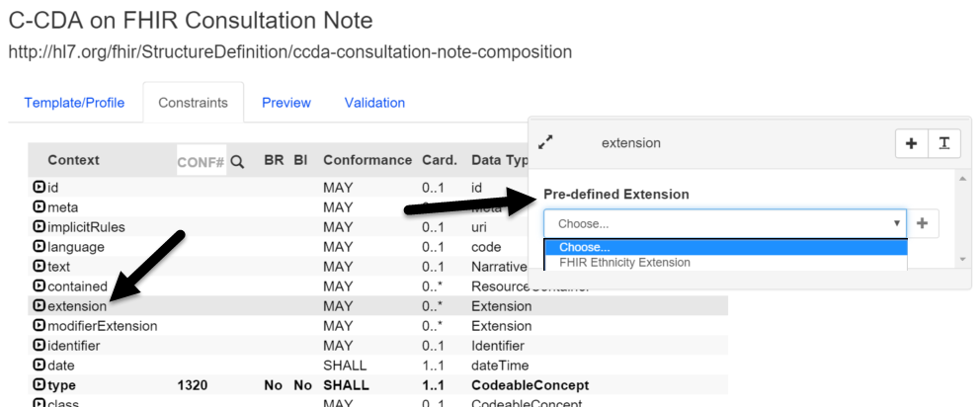

### Browsing / Editing Value Sets

Improvements to the UI to support very large value sets:

* A separate screen to view value sets so that larger value sets do not slow down the process of browsing/searching value sets
* Viewing a value set includes information about where the value set is used within Trifolia (i.e., which template/profile)
* A separate screen to support editing the codes/concepts of a value set

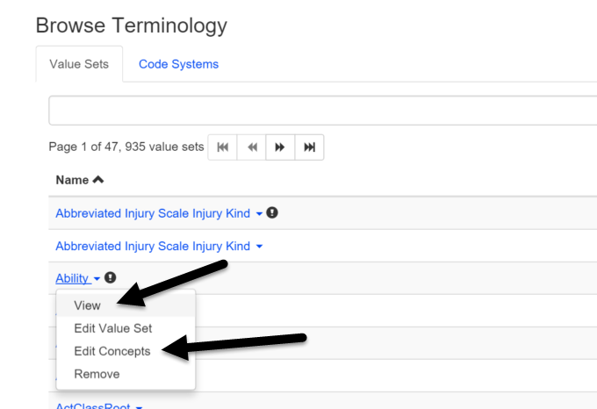

### Human Verification During Login

Commercial users are now prompted to verify that they are a human during login.

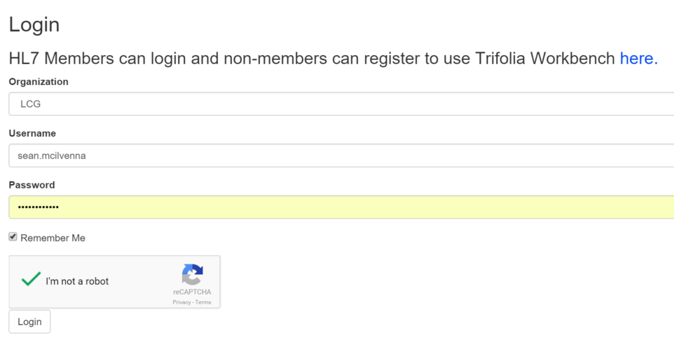

## Development Log

|  |  |  |
| --- | --- | --- |
| **Issue Type** | **Key** | **Summary** |
| New Feature | TRIF-921 | Allow FHIR extensions on template meta-data |
| New Feature | TRIF-916 | Add Captcha to Login screen |
| New Feature | TRIF-794 | New Version of template - copy example from previous version |
| New Feature | TRIF-909 | Remove closed template rules from Trifolia Schematron generation |
| New Feature | TRIF-984 | Drop-down in constraint editor for FHIR extensions |
| Improvement | TRIF-981 | Create interface to test REST API |
| Improvement | TRIF-978 | Show template/profile relationships when viewing a value set |
| Improvement | TRIF-976 | Create a separate screen for viewing a value set |
| Improvement | TRIF-977 | Allow users to initiate terminology searches with <enter> key |
| Improvement | TRIF-964 | Add export settings options to define the default behavior for missing primitive custom Schematron |
| Improvement | TRIF-967 | Change "Templates" to "Templates/Profiles" globally |
| Improvement | TRIF-962 | Use slice and descriminator when the IG type is FHIR |
| Defect | TRIF-979 | cda prefix being used by export of Schematron for hqmf implementation guide |
| Defect | TRIF-968 | Move generates error for unowned FHIR profiles |
| Defect | TRIF-915 | Cardinalities no longer allow custom ranges e.g., [1..4] |
| Defect | TRIF-969 | Value set - active status and date appear not to be working |
| Defect | TRIF-951 | Statically bound valueSet not appearing in list of value sets on export screen |
| Defect | TRIF-895 | Schematron Generation Branch Rules Issue |
| Defect | TRIF-953 | Template will not load for editing |
| Defect | TRIF-826 | HQMF Schematron contexts are completely wrong |
| Defect | TRIF-894 | Invalid Schematron being generated for new extensions |

**Version 2.19.0**

## Version 2.19.0

### Web-based IG

Trifolia can now generate a web-based IG. You can view the web-based IG in real-time while the IG is being developed, or you can generate a JSON snapshot of the data in the IG and generate a URL in Trifolia that represents that specific point-in-time snapshot of the IG. The IG can be viewed directly within the Trifolia web application, or it can be downloaded for offline viewing.

#### Create Sections for the "Overview" of an IG

You can either specify plain HTML or use the wysiwyg editor to create the content of the section in the **Edit Implementation Guide** screen

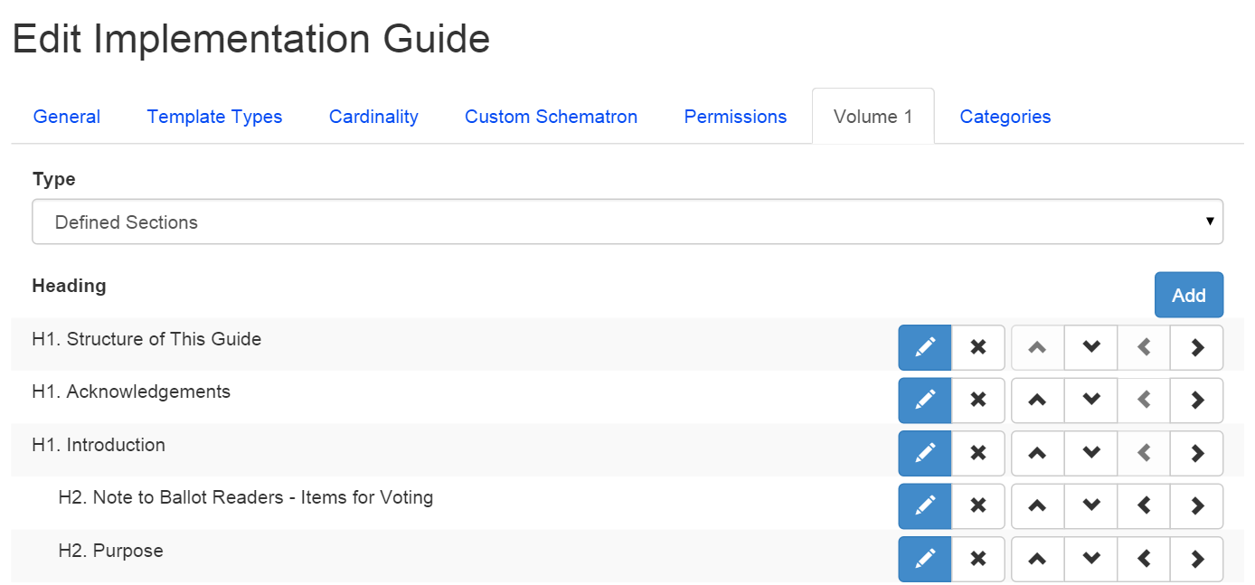

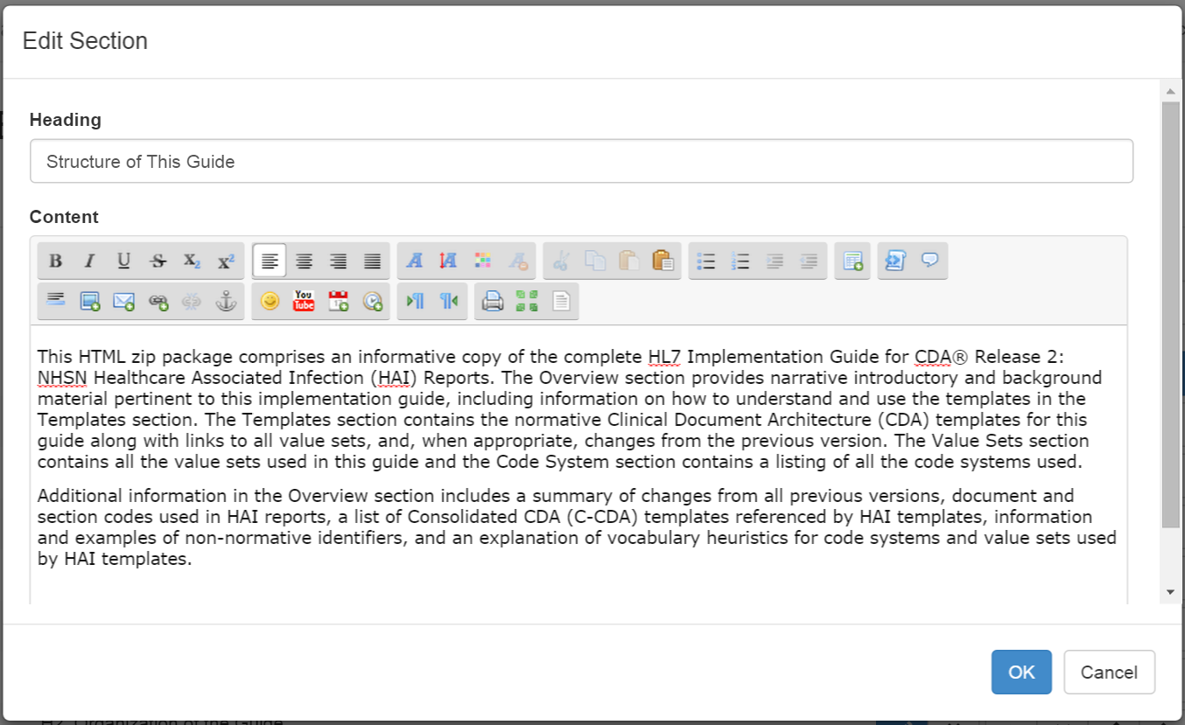

#### Associate a URL with a JSON Snapshot Export

After exporting a JSON snapshot of an implementation guide, you can upload the snapshot as a file for the implementation guide, and associate a URL that displays the web-based IG for the snapshot.

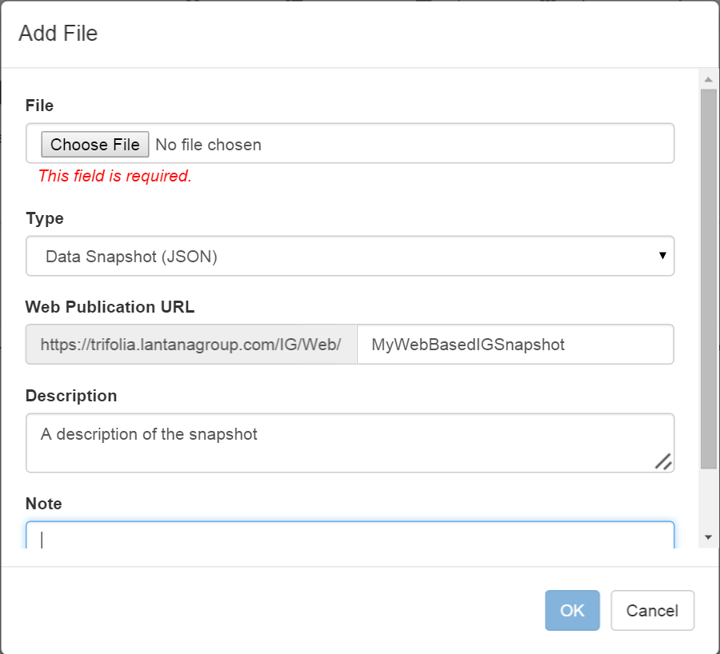

#### Web-Based IG Features

All web-based IGs have the following features:

* An overview section that shows either the HTML or well-defined sections associated with the implementation guide
* The templates section contains both an filtered alphabetical list and a hierarchy view of templates
* Viewing a template/profile displays the following information
  + UML Relationship Diagram
  + Relationships
  + Constraints Table
  + Narrative Constraints
  + Samples (if any)
  + Value Sets (if any)
* An appendix section of all value sets used by the implementation guide
* An appendix section of all code systems used by the implementation guide
* Options for the web-based IG allow the user to change the template/profile display mode from "Paneled" to "Tabbed" mode, where each of the major sections of data are shown in tabs instead of vertical panels
* Breadcrumbs are always displayed showing a chronological history of how you got to the page you are viewing
* The web-based IG can always be downloaded for viewing offline
* Users can search the entire IG (include templates, constraints, value sets and code systems) for a specific term

### Value Set Editing

The value set editing screens have been updated so that members of a value set are edited separately from the value set meta-data.

The "Value Set Member" editing screen supports paging and searching (specifically for large value sets). When adding/updating/deleting members from a value set, it is clearly shown what changes are pending until the **Save** button is selected.  
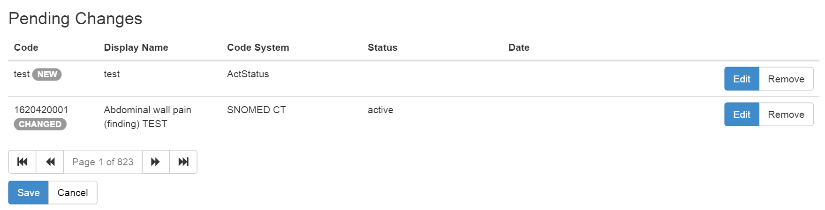

## Development Log

|  |  |
| --- | --- |
| TRIF-902 | Allow concepts to be paged editing viewing and editing large value sets |
| TRIF-890 | Show related templates when editing a template in the validations tab |
| TRIF-888 | Collapsible value sets |
| TRIF-887 | Show all value sets in the web-based IG |
| TRIF-886 | Web-based IG Searching |
| TRIF-885 | View templates in tabbed mode |
| TRIF-884 | View templates in web-based IG |
| TRIF-883 | Two different listing formats for templates |
| TRIF-882 | Show bread-crumbs of user's navigation |
| TRIF-881 | Entering "Volume 1" information as an Overview |
| TRIF-880 | Allow uploading JSON to an implementation guide's files |
| TRIF-879 | Allow exporting an implementation guide in JSON format |

**Version 2.17.0**

Released on Thursday, Feb 19, 2015

## Requesting Permissions

Editing permission is controlled by the settings of each implementation guide (IG). In earlier versions, it was not obvious when a user did *not* have permissions to access (or edit) an IG. An addition to the permissions feature now allows the user to request access to an IG for viewing and editing.

IG settings control whether or not the guide is listed as available for access through “Allow Access Control” in the Edit Implementation Guide window.In the Browse Implementation Guides list, those that have the option to be accessed show a “Request Access” link. Requests for access are directed via email to the individual selected in the new “Access Manager” field of the IG.

*Note: IGs only show up on the “Request Access” window if an “Access Manager” is defined* ***and*** *“Allow Access Requests” is set to “Yes”.*

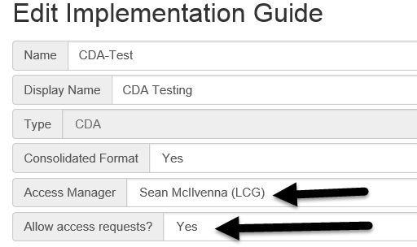

Figure : Request Access Window

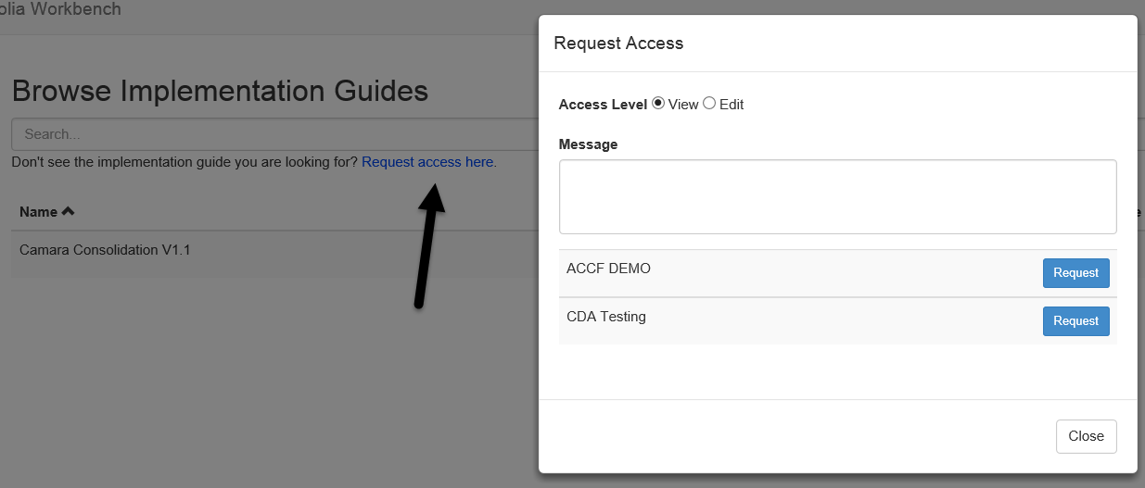

## Permission Notifications

A new checkbox on the “Edit Implementation Guide” screen allows permission notifications to be sent to the new users or groups being granted access to the IG. Notifications are only sent out to *new* users/groups; pre-existing permissions are not re-notified. The notification email sent to each user includes a link to view the IG, and specifies what types of permission have been granted.

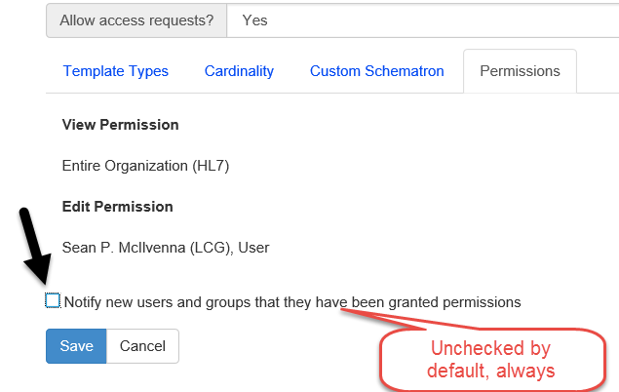

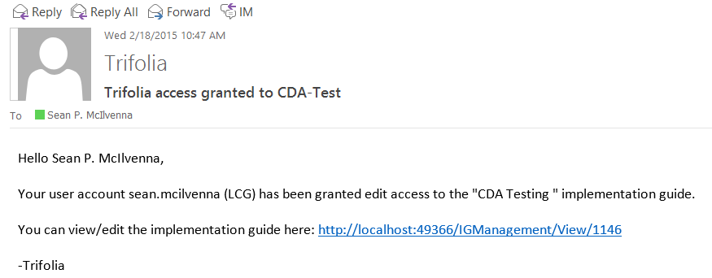

## MS Word Export Default Settings

There are many options for exporting templates to the MS Word format. Appropriate publication settings vary from one implementation guide to the next and re-applying those settings for every export to MS Word takes time.

Template authors can now customize “default” settings for an IG on the MS Word Export screen. A new checkbox at the bottom of the export settings screen allows the currently selected settings to be saved as the default settings for that IG.

*Note: This option is only available to template authors that have “edit” permission on the selected IG.* *The new default settings remain in effect when other users export the IG.*

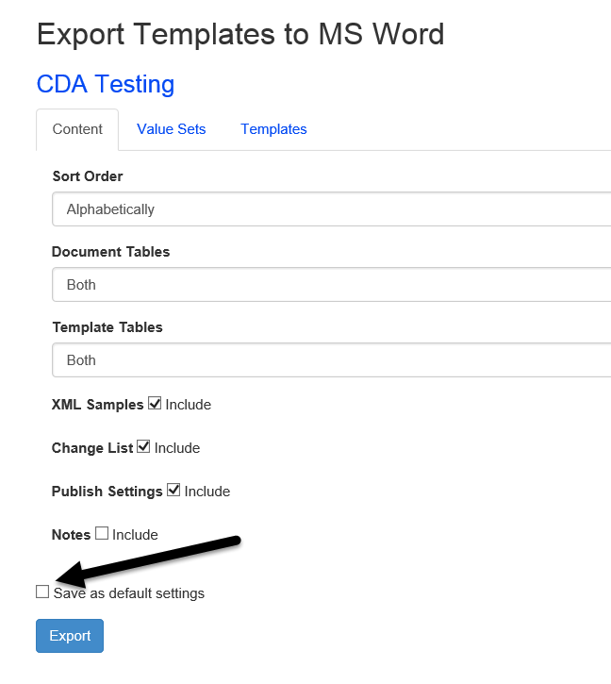

## MS Word Export Value Set Settings

Export Templates to MS Word now allows users to define the “value set member maximum” for each value set. The “Value Set” tab in the Export Templates window contains a list of all value sets used in that IG. This feature allows the user to customize the maximum number of members printed for each value set.

*Note: The “MS Word Export Default Settings” applies to each value set setting; customizations of these settings are also saved as part of the default settings, when selected.*

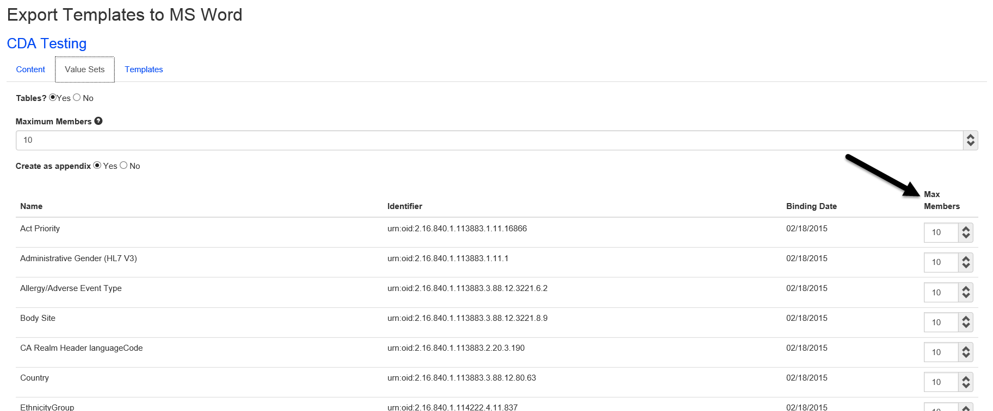

## Development Log

|  |  |
| --- | --- |
| Defect | Empty CodeSystem element appearing in XML export |
| Defect | Template editor's datatype validation should be ignored for FHIR templates |
| Defect | Value sets exported with ellipses even when there are no more active values in the set |
| Improvement | Editing code systems should not allow duplicate identifiers |
| Improvement | Code system identifiers should be treated similarly to template identifiers |
| Improvement | Value set identifiers are not required to be unique |
| Improvement | Treat value set identifiers the same as template identifiers |
| Improvement | Schematron should include disclaimer |
| Improvement | Export IG: Allow override of default number of printed out values in a value set |
| Improvement | Copy Template - have the implied template come up in the metadata fields |
| New Feature | Notify users when they are given permissions to an implementation guide |
| New Feature | Allow authors to "request access" to implementation guides |
| New Feature | Add "Implies" type to "Relationships" tab on Template Viewer |
| New Feature | Select a Value Set dialog has a link for "more results" |
| New Feature | Default settings for MS Word Export on IG |

**Version 2.16.0**

Released on Thursday, Oct 23, 2014

## Retired Template Status

Trifolia now supports a “Retired” template status, representing a template that should no longer be used. The Retired status is only used on templates that have been versioned. The Retired status omits the template from the main body of the MS Word document and includes an additional appendix table listing all retired templates and their descriptions. Upon retirement, a template's description should be modified to describe why the template was retired.

After selecting the “Retired” status, you will be reminded that the “implied template” reference and all constraints in the template will be automatically removed. This ensures that template references do not linger in the retired template, inadvertently causing additional templates to be included in the exports.

## View Template and Implementation Guide

The “View Template” and “View Implementation Guide” screens have been improved for consistency and visibility of clickable links.

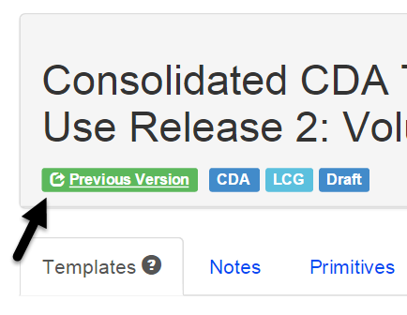

## Export Schematron Inferred Templates Option

The option to exclude inferred templates from a Schematron export has been reintroduced. Implementation guides that repeat constraints from implied templates in the implying template need this ability so that validation messages aren’t duplicated.

## Development Log

|  |  |
| --- | --- |
| New Feature | Export Schematron: Bring back "Include inferred templates" check box |
| New Feature | Add "Retired" status to templates |
| New Feature | Appendix in MS Word exports for retired templates |
| Improvement | Links in labels on View Template and View Implementation Guide should be obvious |
| Defect | Single Value bindings being changed to other when you save and re-open |
| Defect | Add "Source URL" validation to "Value Set" dialog |

**Version 2.15.0**

Released on Thursday, July 24, 2014

## Template Identifier Changes

Templates do not require identifiers to be OIDs any longer. They can be one of four formats:

* OID: “oid:2.17.840.113883…”
* II: “urn:hl7ii:ROOT:EXTENSION”
* HTTP/HTTPS: “http://myidentifier.com” or “https://myidentifier.com”

MS Word exports use the label “identifier” instead of “templateId” when outputting the template identifier.

Schematron is updated to detect if the identifier as in II format and look for @root=XXX and @extension=YYY

Creating a copy of a template automatically converts OID identifiers to II type and creates an extension for the identifier based on the date that the template is copied.

Note: Only “oid:XXX” and “urn:hl7ii:XX:YY” are valid formats for CDA documents.

**Known Bug: Trifolia 2.15 supports a URI:XXXX format for identifiers. We have identified that this is invalid and support for this format of identifier will be removed in the 2.16 release of Trifolia.**

## Export Notes

Template and constraint notes can now be exported as part of the MS Word document. Trifolia notes will be exported as MS Word “Review Comments” so that readers can easily navigate through the notes.

Remember: Notes are not intended to be included in balloted artifacts. They are only intended to help manage the lifecycle of template design.

The “Export Settings” for MS Word has a checkbox for “Notes” which is un-checked by default.

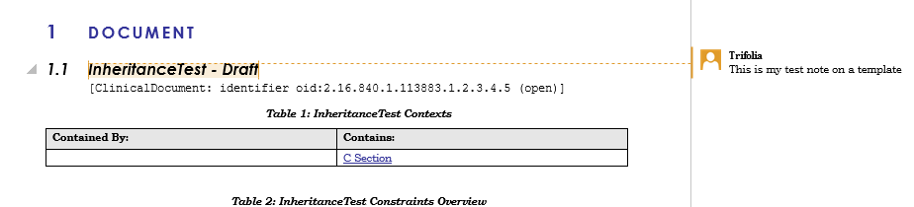

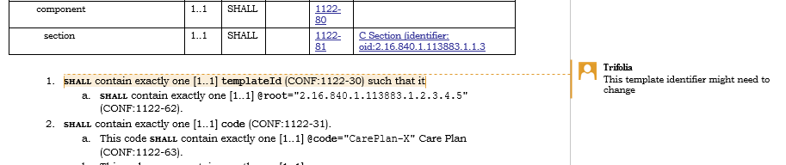

## Implementation Guide Changes

Implementation guides now contain a “Display Name” which are used by exports. The display name is not required. When display name is not specified, exports will use the name of the implementation guide.

MS Exports now include a footer and a header. The footer contains page numbers and the name of the implementation guide. The header contains the date of the export and the calculated name of the implementation guide.

## Navigation

The “View Template” and “View Implementation Guide” pages have a more user-friendly navigation bar for selecting actions.

The “View Implementation Guide” page allows users to search for templates within the implementation guide.

View Implementation Guide Navigation

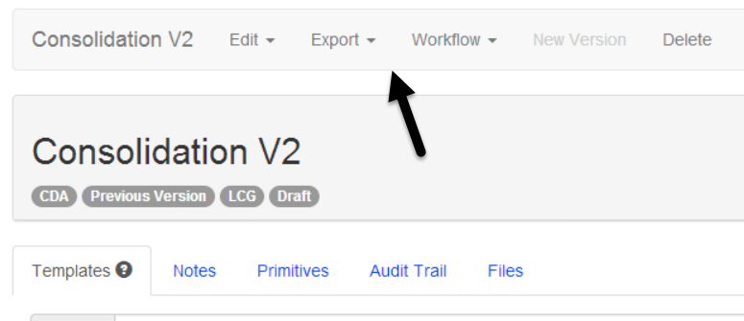

View Template Navigation

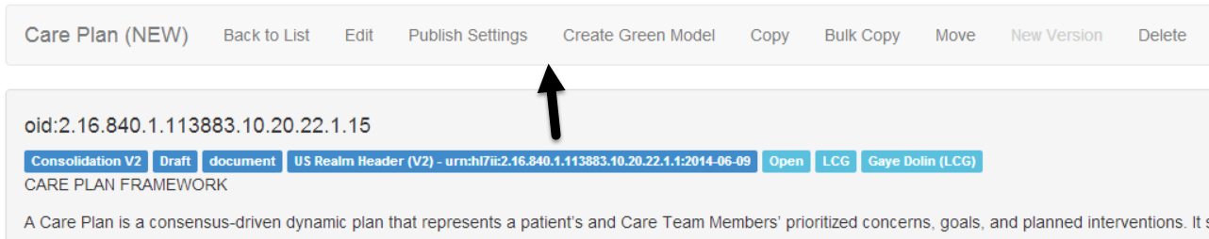

View Implementation Guide Template Search

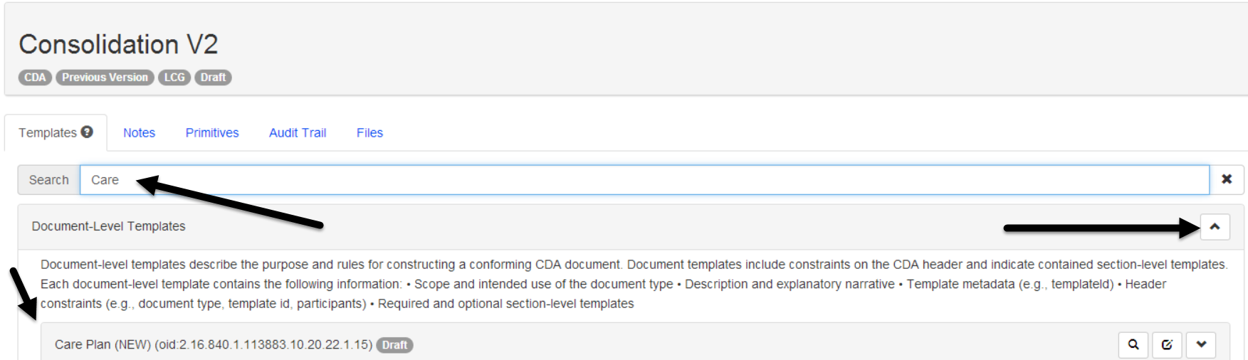

## Development Log

|  |  |
| --- | --- |
| New Feature | Option to export Notes |
| New Feature | MS Export footer and title page |
| New Feature | Create a new field that has the "display" name of the IG |
| New Feature | Document/Section level tables - add templates to "Fixed Value" column (& maybe change name) |
| New Feature | Drop-down on View IG to select template |
| Improvement | Export templates to MS Word - value sets create as appendix default |
| Improvement | Use plugin interfaces in Schematron engine |
| Improvement | Use interfaces for Schematron Engine |
| Improvement | Improved navigability of "View Implementation Guide" and "View Template" |
| Improvement | Warn user when leaving publish settings without saving changes |
| Improvement | Make the description text boxes of IG Template Type Descriptions larger |
| Improvement | Allow typing a binding date for valueset |
| Improvement | Allow typing a template oid in addition to opening dialog |
| Improvement | Allow typing value set oid instead of opening dialog |
| Improvement | Version without new template oid |
| Improvement | Sample Generation w/ Data |
| Improvement | Automatically refresh client-side javascript files after release |
| General | Can't edit description or source URL for value set |
| Defect | Terminology: Description and URL fields missing |
| Defect | Allows the creation of members with duplicate user names. |
| Defect | IG Viewer - Exception appearing when Versioning an IG |
| Defect | IG Deletion - Error appearing when removing a Versioned IG |
| Defect | Constraint Editor - can't add value set to a primitive |
| Defect | Template Editor - Exception appearing when user clicks "Move" |
| Defect | FHIR - Templates Identifiers with plain “http” and “https” based URIs |
| Defect | Move Template - Server error in '/' Application. |
| Defect | Export templates to MS Word: Inferred templates radio not working |
| Defect | Browse Terminology - Complete : Yes/No -appears to be opposite |
| Defect | Can't add sdtc:dischargeDispositionCode to template |
| Defect | Template- constraint order not appearing the same in Editor and Viewer for pre-existing templates |

**Version 2.14.0**

Released on Thursday, June 5, 2014

**IMPORTANT: Your web browser caches JavaScript. In order for Trifolia to work properly, you may need to force your browser to refresh individual Trifolia pages for it to retrieve the latest version of the application’s JavaScript files. If you encounter any issues within Trifolia, try refreshing your browser before submitting a support request.**

## User interface

The user interface for Trifolia has been re-designed to provide a more responsive experience. The Twitter Bootstrap API and Javascript are used to provide a clean, consistent and client-side-oriented user interface. Users of Trifolia should see a notable increase in performance.

## Template Editor

The template editor has been re-designed to maximize screen real-estate and reduce the amount of time that the user spends waiting for popup dialogs to load.

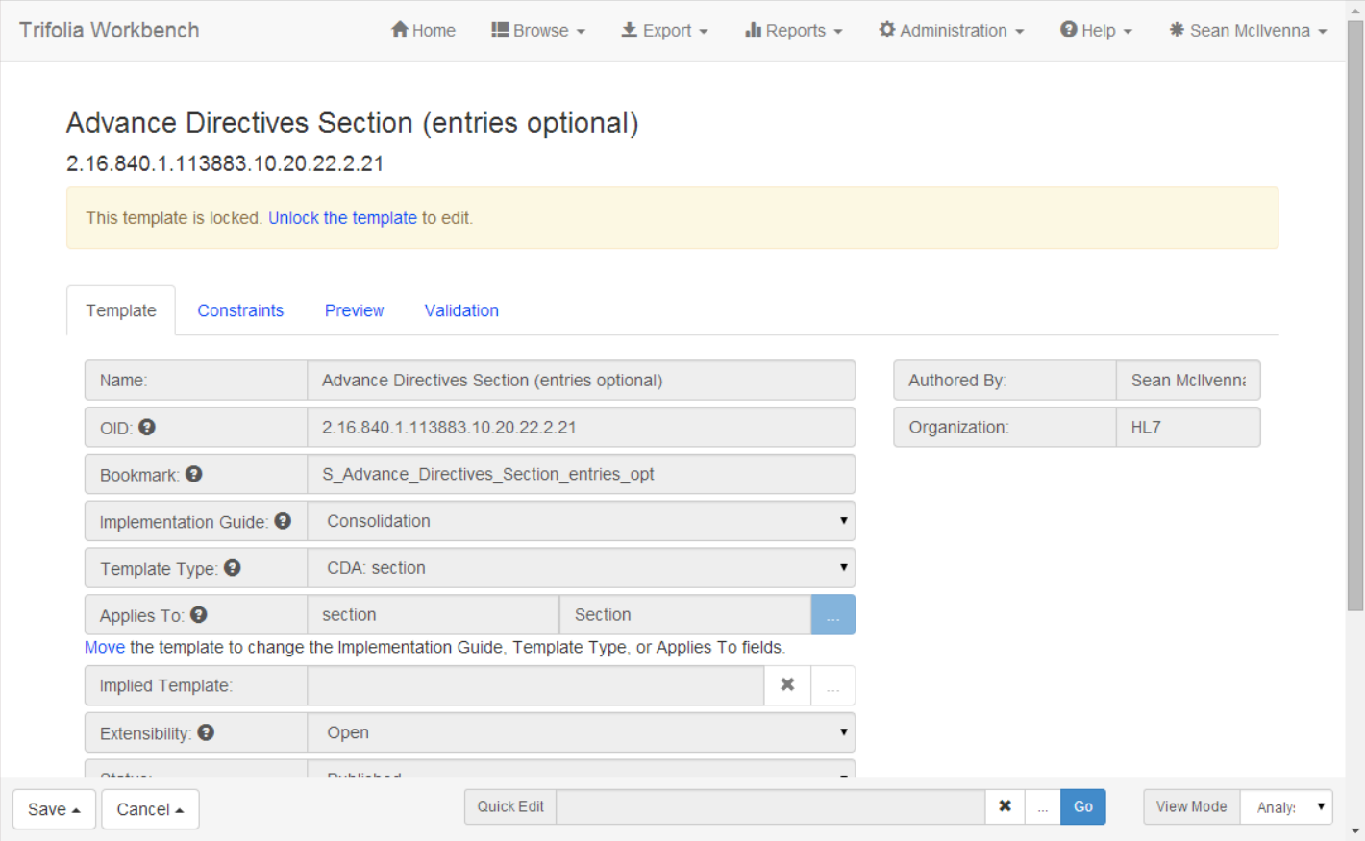

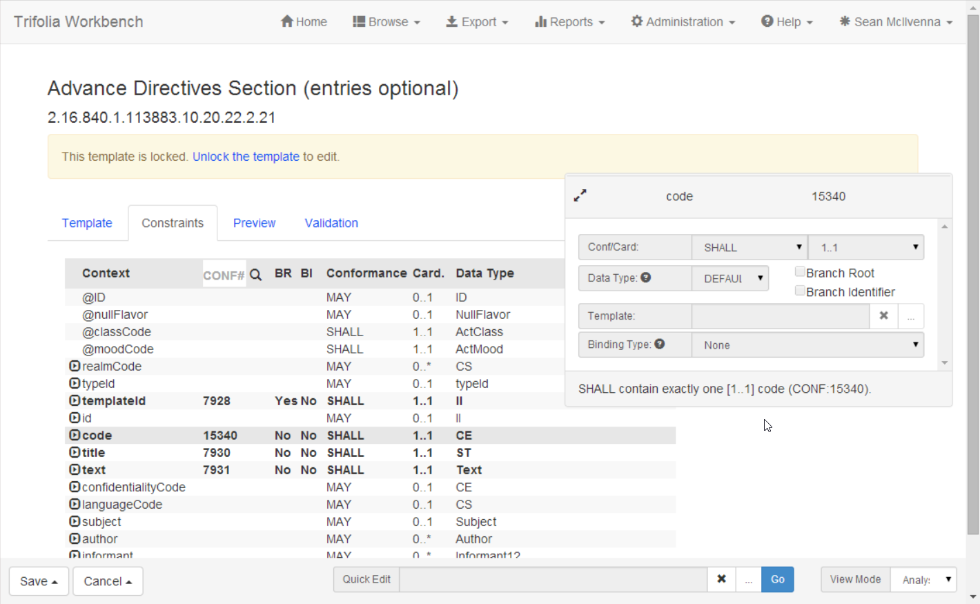

## Template Viewer

The template viewer now has an additional tab called “Relationships”, which shows how *other* templates relate to the template you are viewing.

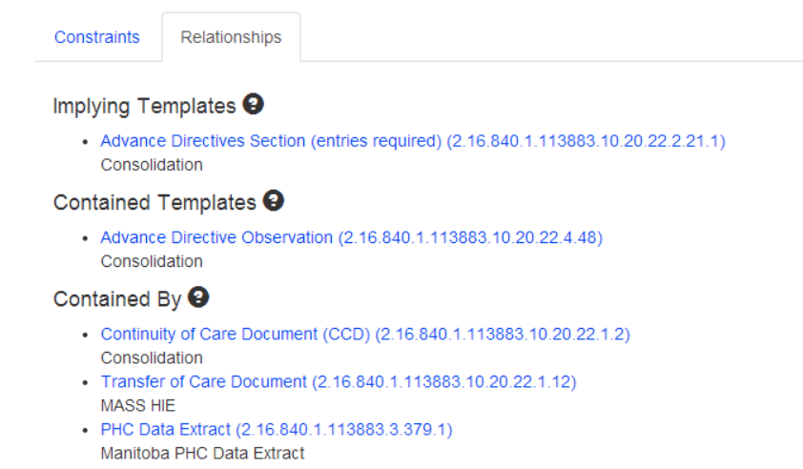

## Template Editing View Modes

Instead of using tabs in the constraint editor to separate the types of meta-data a user can view/edit for a constraint, a new “View Mode” option has been implemented. When a view mode is selected, it will show the fields available for that view mode in the constraint editor. The view mode stays the same when switching from one constraint to another.

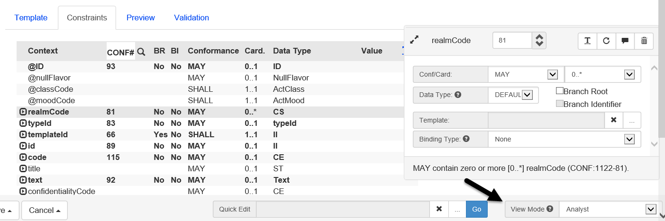

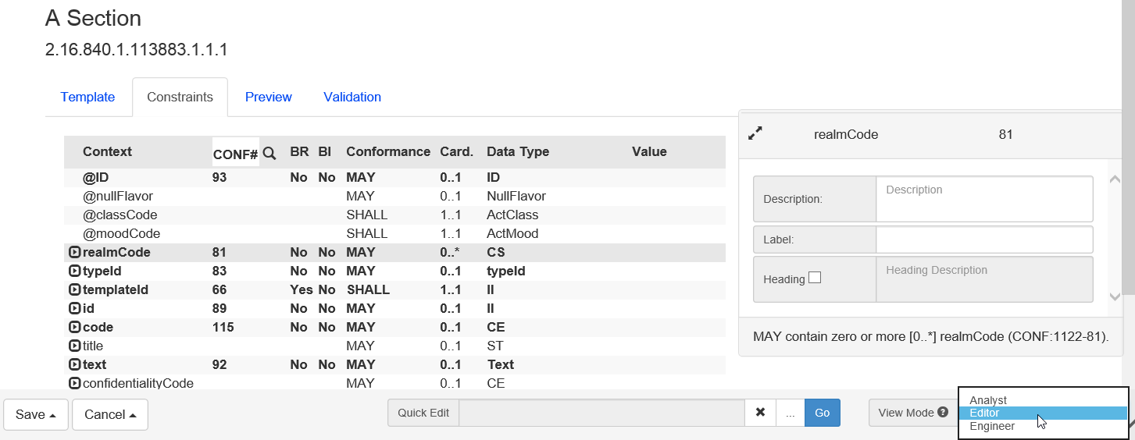

## Browsing

In addition to the column filters that already exist in the browse screens, a broad search field has been added that will search multiple fields at once. For example, when searching for templates, the name, oid, implementation guide, and even conformance number fields are used by the broad search.

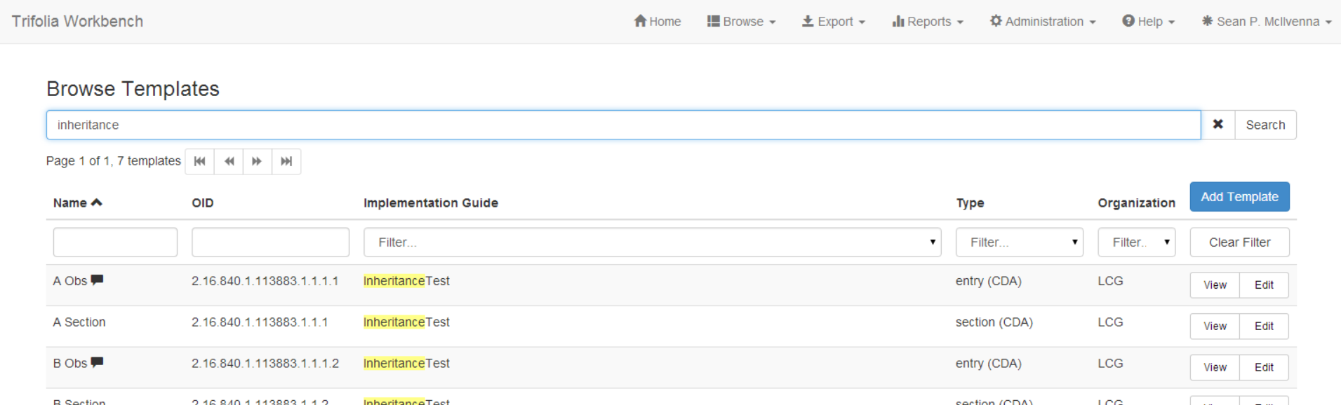

# Development Log

|  |  |
| --- | --- |
| New Feature | Provide list of sections using a template. |
| New Feature | Implement bootstrap for UI design |
| New Feature | Re-design template editor |
| Improvement | Layout/performance of "View Template" screen |
| Improvement | Default "Is Open" field to "Open" in template editor |
| Improvement | Export option for template statuses |
| Improvement | Value Set Binding - Default to DYNAMIC |
| Improvement | Expand the Terminology Browser window to use more screen real estate. |
| Improvement | Link to contained template in template viewer |
| Improvement | Name of template on Publish Settings Screen |
| Defect | Template editor must unmark identifier for children when branch is unmarked |
| Defect | Auto-resize terminology grids |
| Defect | Duplicate assert IDs |
| Defect | Export globally unique conformance numbers |
| Defect | Vocabulary export using incorrect publish date |
| Defect | Template Review returning wrong template oid |
| Defect | Template Editing - Constraints Search option not functioning correctly |
| Defect | Date picker for publish date - not obvious that there is a date picker |

**Version 2.12.0**

Released on Monday, January 20, 2014

## Maximizing Screen Real Estate

The layout of the entire Trifolia application has been altered to make use of 100% of the width of the browser window. This will improve readability and navigability on many of the screens.

## Navigating Implementation Guides and Templates

The actions available on the template and implementation guide list have been moved to the implementation guide and template view screens (which is a pattern that Trifolia has been moving towards for quite a while). Navigating between templates and implementation guides now consists of a pattern in which you:

1. Search
2. Select & Confirm
3. Perform Action

However, due to the extent at which templates are edited (commonly), an “Edit” link is still available on the template list so that users can bypass viewing the template and go straight to the editor.

*Note: An un-expected side-effect of this change is an increased performance in the template list screen.*

## MS Word Export Improvements

A number of improvements have been made to the MS Word exports from Trifolia, include:

* Styling
* Sample indenting
* Code System OID column in value set table
* Additional line breaks

## Schematron Export Timestamp

A timestamp has been added to the top of all schematron documents generated by Trifolia. This will help users of the schematron documents know what “version” of schematron they are working with (and if it is the latest).

## Development Log

|  |  |
| --- | --- |
| Improvement | Expand layout to use entire browser's width |
| Improvement | Table Caption Limit |
| Improvement | Context table |
| Improvement | Valueset table changes |
| Improvement | Styles |
| Improvement | Figures |
| Defect | Code System OIDs not appearing in value set tables. |
| Improvement | Localization strategy fixes and single page implementation |
| Improvement | add date/time stamp to generated schematron |
| Improvement | Move actions from Template/IG List to View |

**Version 2.10.0**

Released on Friday, October 11, 2013

## General

The Trifolia development team has implemented new technology so the tool will perform with increased response times and behave in a more user-friendly manner, particularly as its user-base grows. Users may notice that Trifolia’s interface is migrating to a new application framework. As this migration occurs, menus, popups, and grids may look slightly different, they will, however, remain functionally the same.

Lantana is working with HL7 to release an “HL7 Member Write-Enabled” version of the tool. This new version will allow HL7 members to develop templates within Trifolia. The team has focused their QA efforts on security and auditing to ensure that when HL7 members begin to develop templates, they will not impact existing ones.

## Navigation

Users now have the ability to quickly navigate between different templates while working in the template editor. There is a new drop down menu in the template editor that lists all the templates the user has access to. This can be filtered by typing in the text box of the drop-down menu, and selecting the ’Edit’ button.

Several buttons have been moved from the implementation guide and template listscreen to the ‘View Implementation Guide’ and ‘View Template’ screens.

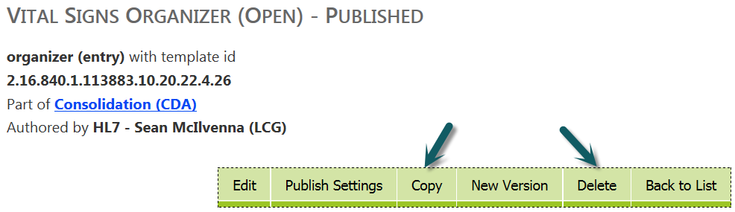

## Simplified Versioning

In the last release, versioning implementation guides in Trifolia was made easier due to the ‘New Version’ button on the ‘View Implementation Guide’ screen. This release includes a similar functionality for templates. There is now a ‘New Version’ button on the ‘View Template’ screen. This automatically copies the templates into the new version of the implementation guide, and links the template with its old version. There is no longer a need to do this manually.

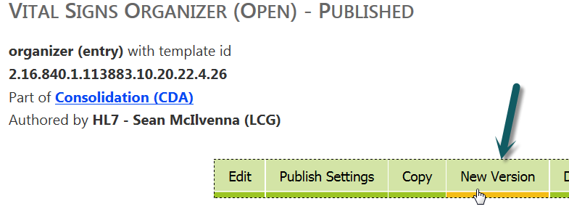

## Publish Settings Validation

The ‘Publish Settings’ screen for templates now includes more user-input validation. For example, Trifolia will warn the user before saving a template sample without a name.

## Exporting

Historically there has been a wait for other working groups to establish a standard template exchange format before an XML format could be provided. However, given the demand for access to computable template definitions, the Trifolia team has created a proprietary format which may be used until a standardized format is established. Users can now export their templates to XML via the ‘Export’ screen.

In addition, Trifolia has a new ‘Excel’ format for vocabulary exports. This option is available in the ‘Export Format’ drop-down menu in the ‘Export Vocabulary’ settings screen.

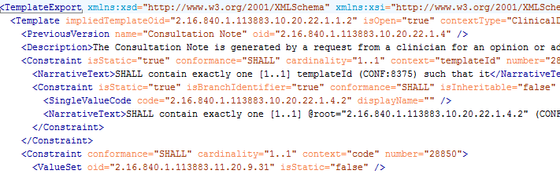

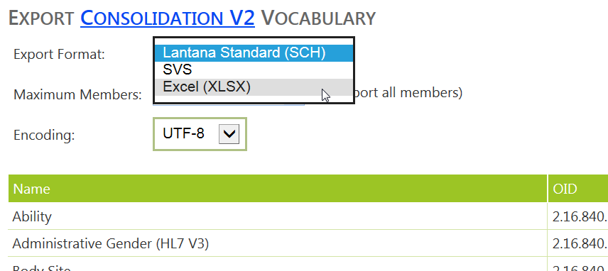

## Workflow

In this release, templates now have a ‘status’ in addition to the implementation guide status. When editing a template, a ‘Status’ field is available to allow new versions of a template to indicate that it is deprecated.

The introduction of this status field provides the opportunity for Trifolia to make use of ‘Workflow’. Users can easily change the ‘Status’ of an implementation guide (and its associated templates) via a ‘Status’ drop-down menu on the ‘View Implementation Guide’ screen. Users may choose between ‘Draft,’ ‘Ballot,’ and ‘Published’ statuses.

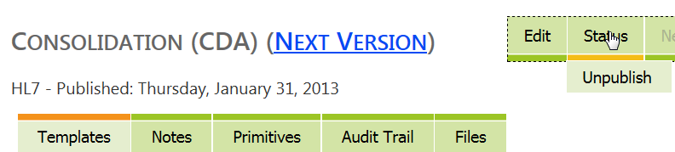

## Development Log

|  |  |  |
| --- | --- | --- |
| Improvement | [TRIF-607](https://jira.lantanagroup.com/browse/TRIF-607) | Template Editing Navigation |
| Improvement | [TRIF-594](https://jira.lantanagroup.com/browse/TRIF-594) | UI Validating Publish Info |
| Improvement | [TRIF-588](https://jira.lantanagroup.com/browse/TRIF-588) | Consistent approach to end-user messaging |
| Improvement | [TRIF-81](https://jira.lantanagroup.com/browse/TRIF-81) | Action Confirmations/Messages |
| New Feature | [TRIF-599](https://jira.lantanagroup.com/browse/TRIF-599) | Template copying and versioning improvements |
| New Feature | [TRIF-598](https://jira.lantanagroup.com/browse/TRIF-598) | IG File Management |
| New Feature | [TRIF-591](https://jira.lantanagroup.com/browse/TRIF-591) | Simplifying Versioning IGs |
| New Feature | [TRIF-590](https://jira.lantanagroup.com/browse/TRIF-590) | IG and Template Status |
| New Feature | [TRIF-589](https://jira.lantanagroup.com/browse/TRIF-589) | Export templates to XML |
| New Feature | [TRIF-570](https://jira.lantanagroup.com/browse/TRIF-570) | Export Vocabulary Spreadsheet |