**Assignment 6**

1. **What are keywords in python? Using the keyword library, print all the python keywords.**

Ans: Keywords are predefined and reserved words in Python. They cannot be used as identifiers.

All the keywords can be printed using the following code:

help("keywords")

Output of the above code is:

False class from or

None continue global pass

True def if raise

and del import return

as elif in try

assert else is while

async except lambda with

await finally nonlocal yield

break for not

1. **What are the rules to create variables in python?**

Ans:

1. Variable name cannot start with digits.
2. Variable name cannot start with special characters.
3. Keywords cannot be used to for naming a variable.
4. Variable name cannot contain spaces.
5. **What are the standards and conventions followed for the nomenclature of variables in python to improve code readability and maintainability?**

Ans:

1. Descriptive names may be used for naming variables e.g. to declare radius of a circle we can use the variable, circle_radius = 5.
2. Name of a variable should not be more than 79 characters.
3. In case if we use abbreviations for naming variables, they must be consistent throughout the program.
4. Variable names should not be ambiguous.
5. What will happen if a keyword is used as a variable name?

Ans: It would lead to syntax error.

Example:

True = 6

File ["<ipython-input-1-a4d6f1772eea>"](https://localhost:8080/), line 1 True = 6 ^ SyntaxError: cannot assign to True

1. For what purpose def keyword is used?

Ans: In Python def keyword is used to define a user-defined function.

1. What is the operation of this special character ‘\’?

Ans: In Python, the special character ‘\’ is also called as the escape character. Generally it is used to represent white space characters. ‘\t’ introduces a tab while ‘\n’ introduces a new line.

Example:

print("Binod Kumar Sahu")

print("Binod \nKumar \nSahu")

print("Binod \tKumar \tSahu")

Output of above code is:

Binod Kumar Sahu

Binod

Kumar

Sahu

Binod Kumar Sahu

1. Give an example of the following conditions:
2. Homogeneous list
3. Heterogeneous set
4. Homogeneous tuple

Ans:

1. Homogeneous list: In Python, a homogeneous list contains all the elements of the same data type.

Example: list1 = [120, 130, 56, 98]

1. Heterogeneous set: A heterogeneous set contains elements of different data types.

Example: set1={‘Binod’, 200, 1.5}

1. Homogeneous tuple: A homogeneous tuple contains elements of same data type.

Example: tuple1=(“Apple”, “Banana”, “Orange”)

1. Explain the mutable and immutable data types with proper explanation & examples.

Ans:

Mutable data type:

1. These data types can be changed after creation.
2. When a mutable object is modified, its memory location remains the same but the changes are reflected in the specified place.

list1=["Binod", 102.53, "ineuron"]

print(list1)

list1[0]="Bhubaneswar"

print(list1)

Output of the above code is:

['Binod', 102.53, 'ineuron']

['Bhubaneswar', 102.53, 'ineuron']

Mutable data type:

1. Immutable data types cannot be changed after creation.
2. When we modify an immutable object, a new object is created with the updated value, but the original object remains the same.

tuple1=(1,2,3,"Binod")

print(tuple1)

tuple[0]=45

(1, 2, 3, 'Binod')

------------------------------------------------------------------------

TypeError Traceback (most recent call last)

[<ipython-input-14-1c715b79b1b5>](https://localhost:8080/) in <cell line: 3>()

**1** tuple1=(1,2,3,"Binod")

**2** print(tuple1)

----> 3 tuple[0]=45

TypeError: 'type' object does not support item assignment

1. Write a code to create the given structure using only for loop.

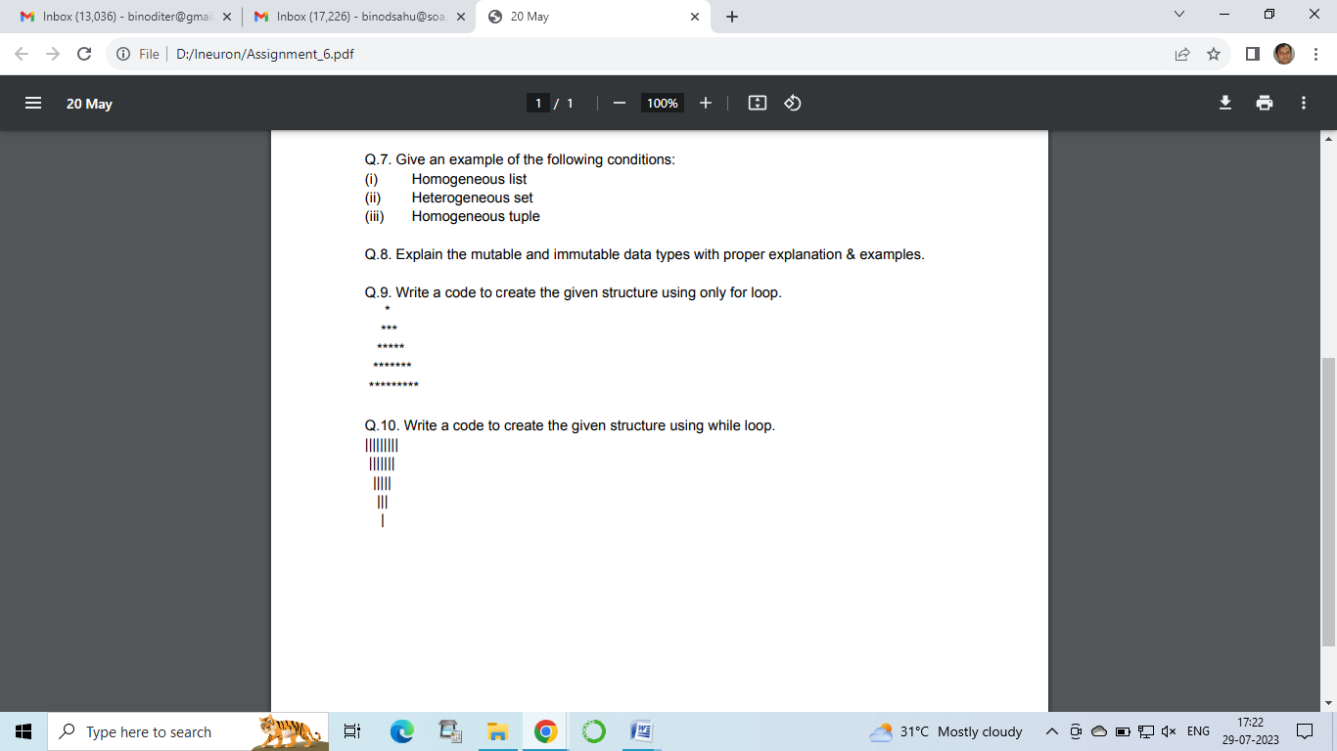

Ans:

n=5 # Number of Rows

j=1

for i in range(n):

  print((n-i)* " ", (i+j)*"*")

  j+=1

1. Write a code to create the given structure using while loop.

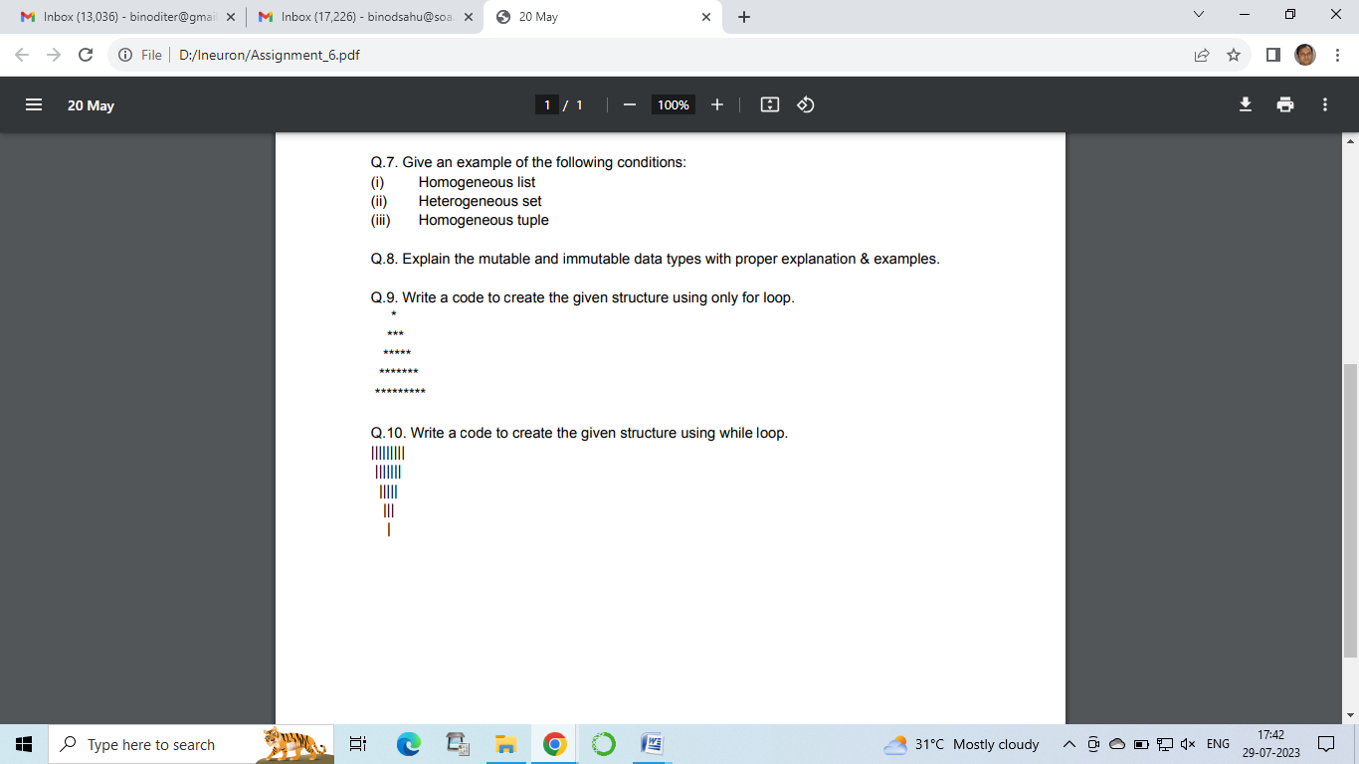

Ans:

n=5 # Number of Rows

j=n

for i in range(n):

  print(i* " ", (2*j-1)*"|")

  j-=1