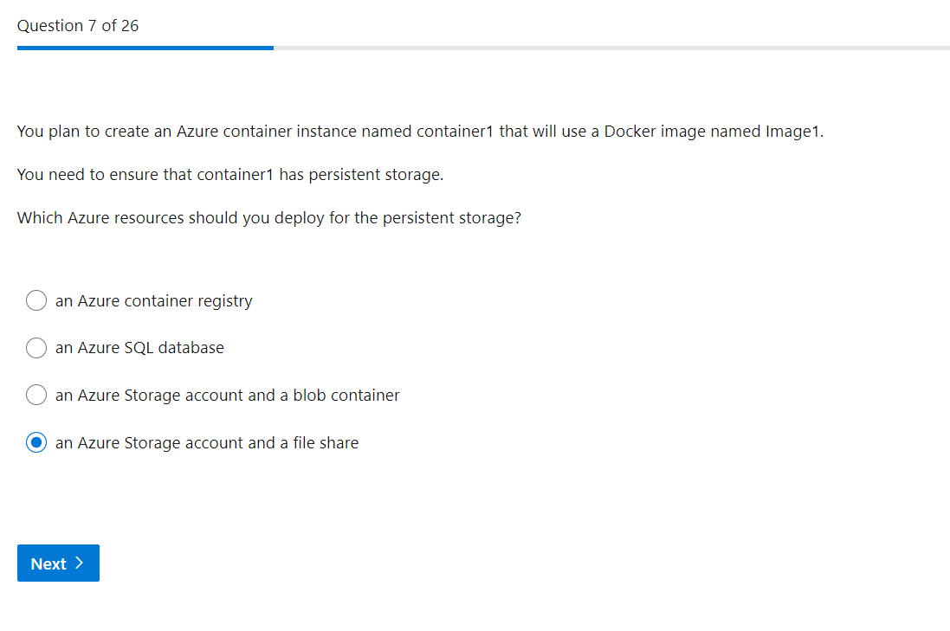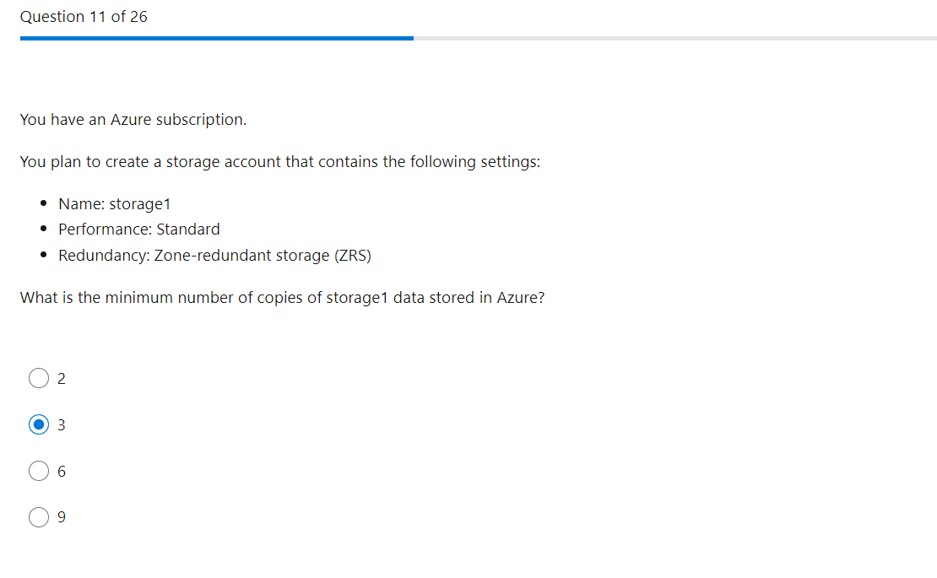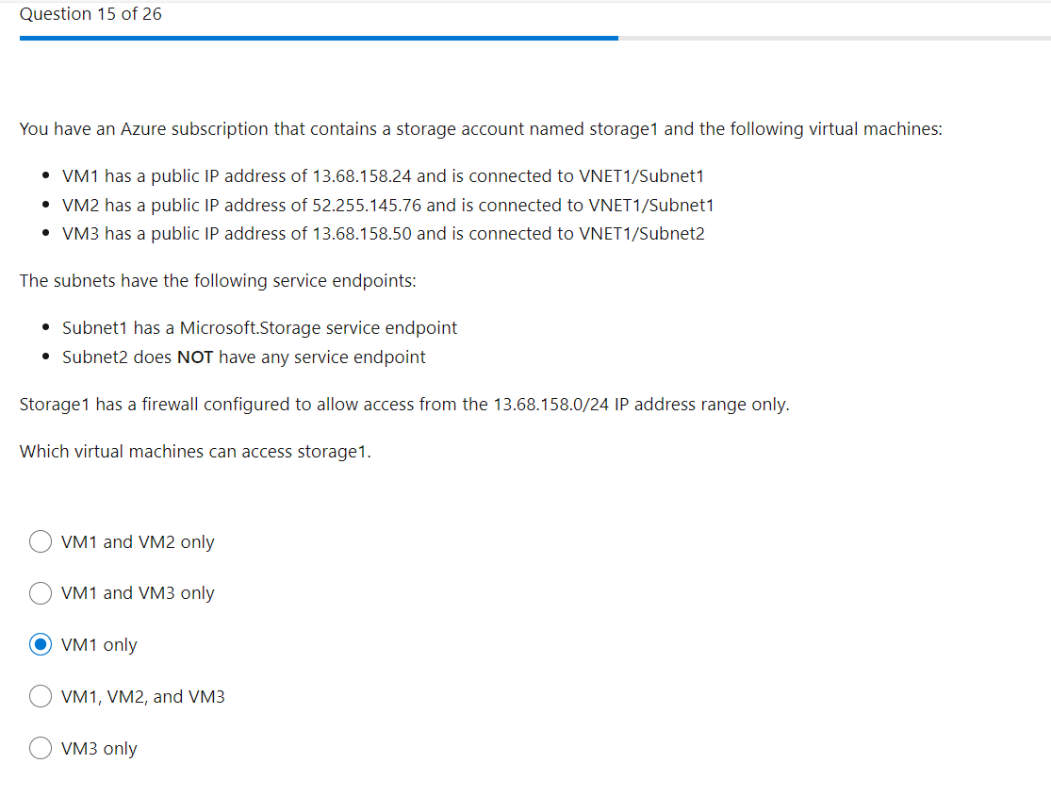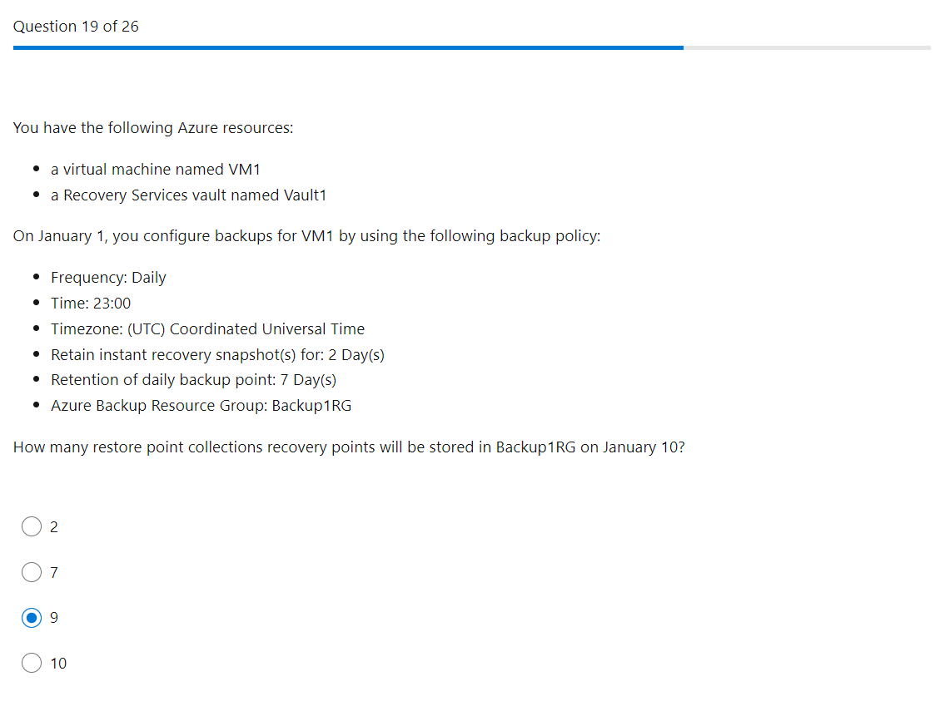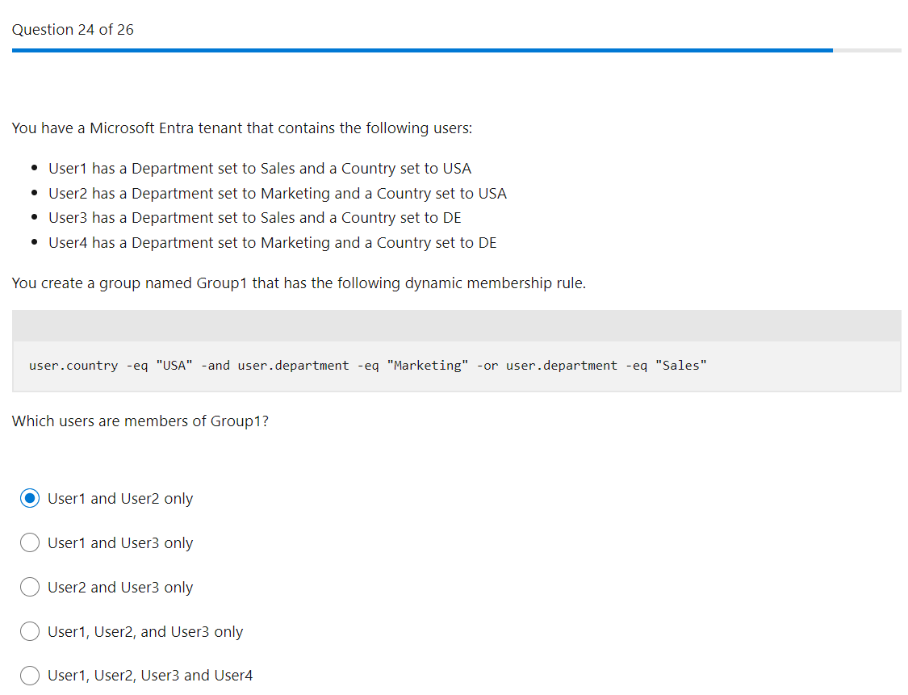

May27

