Air Hockey
Joel Larsen
Michael Picerno
David Shelley

Art: John Conelea



Overview:

The overall theme of our air hockey is from playing too much Brutal Legends, so it has a dark metal theme to it. The field is comprised of a background, a table, two paddles and a puck. The physics we used is based on the Box2D physics engine. Paddles are limited to half of the table each with a semi-circle. Lights are used to illuminate the table along with the colors and textures. To control each paddle in multiplayer, the keyboard is used for the top paddle while the mouse is used for the bottom. Menus are all done within OpenGL with highlights and sound effects.

Extra Credit:
- Sound Effects/Music
- Persistent settings
- Fog
- Customizable SFX Level, Music Level, Fog settings, Display settings
- Realistic Physics
- Human/AI play
- Network Play
- Animated UVs

User Manual:

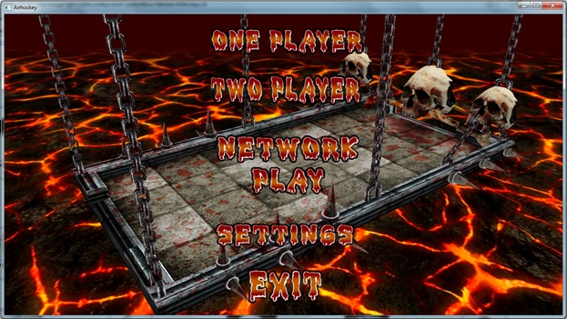
One Player:
Battle versus a incredibly strong Artificial Player.
Two Player:
Player one controls their paddle with the mouse.
Player two controls their paddle with the keyboard.

Network Play:
Play between two computers over a TCP/IP network

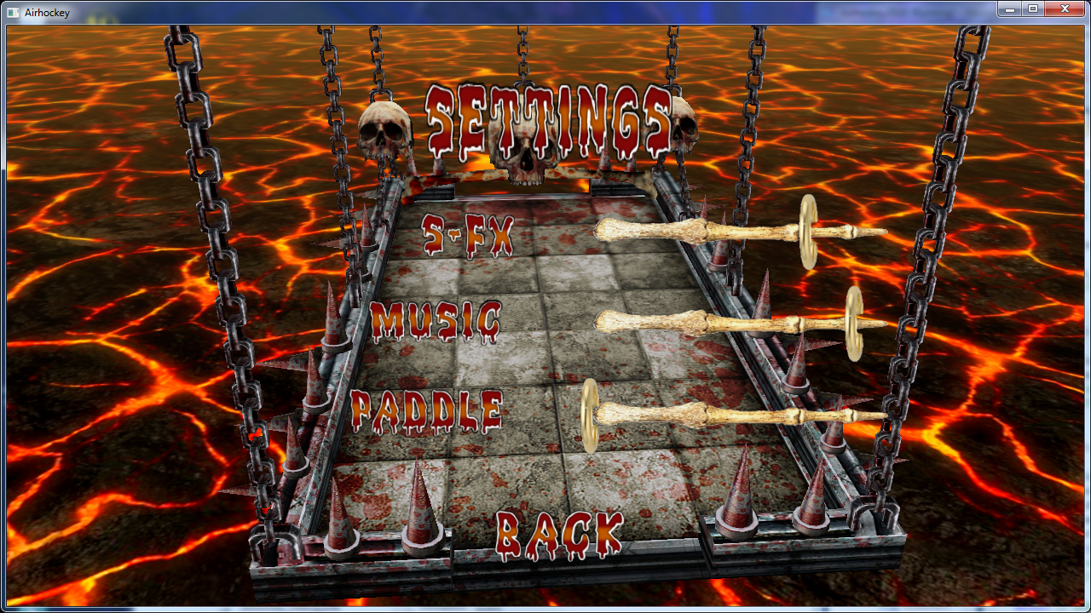
Change sound effect volume.
Change Music volume.
Change paddle shape.

These settings are saved to a local file automatically each time you exit the game.

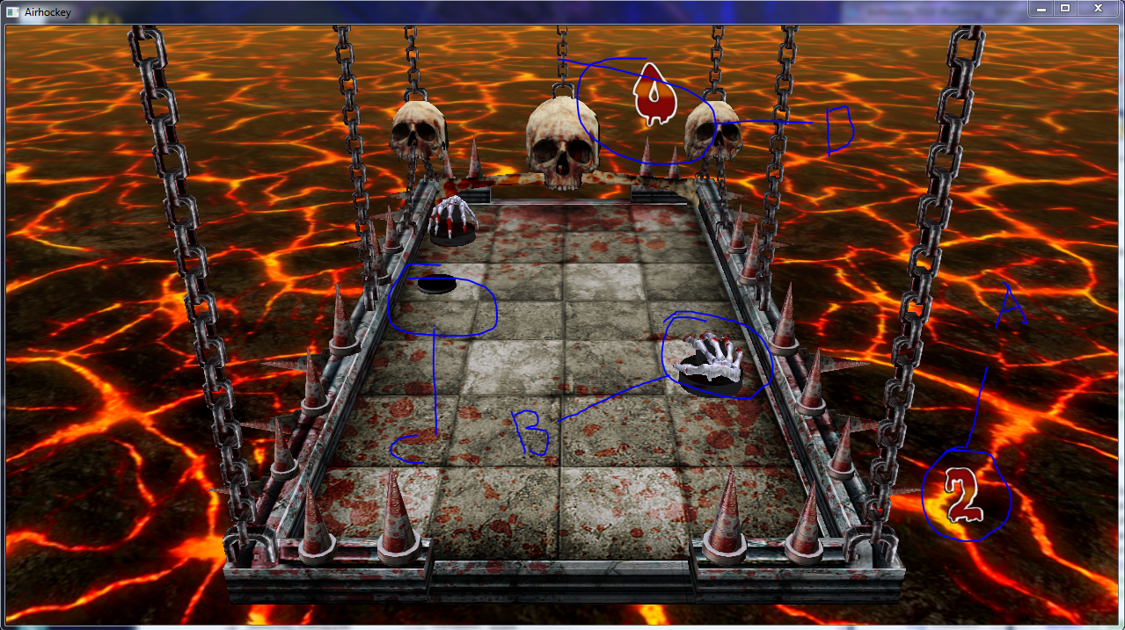
A. Your score
B. Your paddle
C. The puck
D. Your opponents score

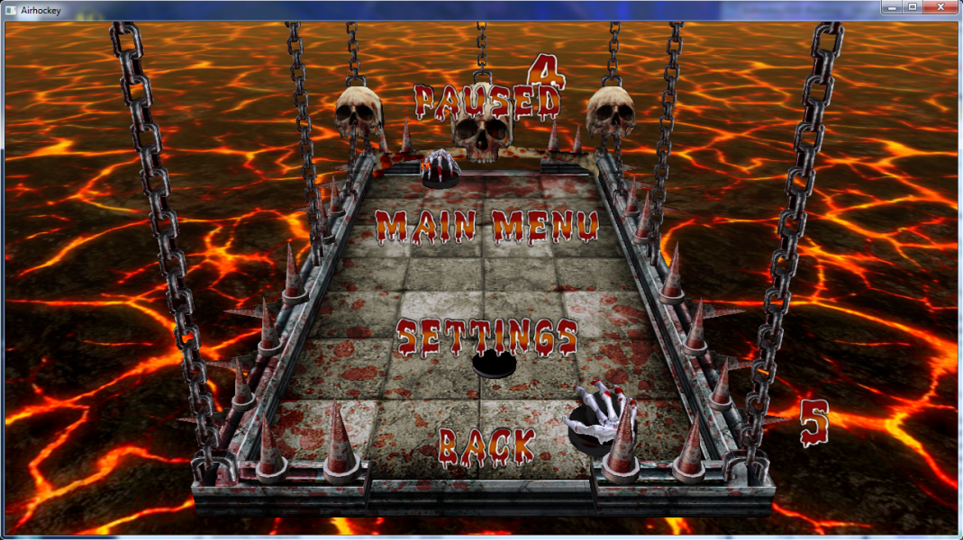
Press 'Escape' during a game to bring up the Pause Menu
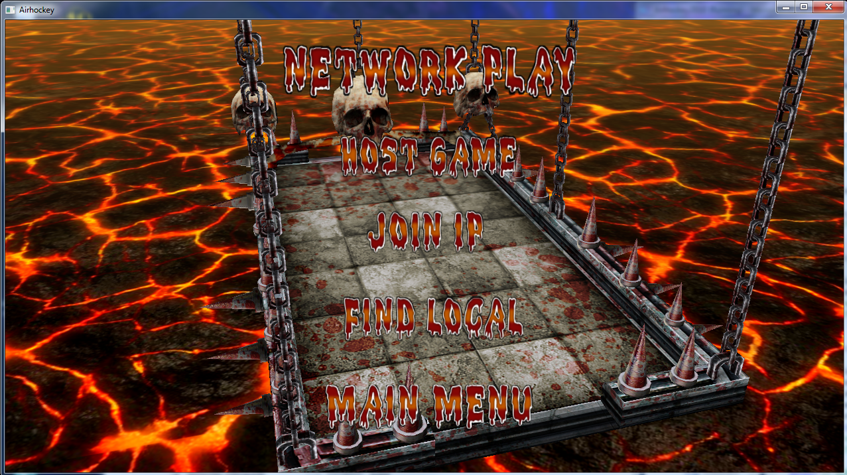
Host Game:
Starts a network game
Join IP:
Joins the ip address you specified in the "settings.ini" file
Find Local:
Not Implemented yet

Technical Manual:

The models in the game were loaded into the game using a model loader. This made it possible to get more intricate models like the table. Physics turned out to be simple once we understood how Box2D functioned. Basically it creates a physics world on top of the game world to do all of the physics calculations, like velocity and collision detection. Dealing with the UV coordinates took some time to sort out. At first the textures were rather warped and didn’t look that good, once straightened out a lot of things came together. Another issue was dealing with the font for the menu and scoring and so forth since this game is all done within OpenGL. Windowing systems weren’t used. Some other issues are the AI getting stuck at times but it works for what it is supposed to do.

